Delegated report. Application for advertisement consent
18-20 Wokingham Road, Reading
PL/25/1807: Application for advertisement consent for the display of a banner secured to wall facing Eastern Ave and the display of one replacement fascia sign and window privacy film (retrospective).
The application site
The application site is a former shop, for many years as ‘Berkshire Cycles’ and then from about 2021, a series of temporary shops, until the present occupier moved in. It consists of a double-fronted shop and then a further shopfront to the left on an angle, all as one single demise. According to Google Streetview, the temporary shops had temporary canvas banner signage (for about a year or so each, so therefore these were unauthorised). The shopfronts all have unattractive shutters, but these appear to be immune from enforcement action, having been installed over 17 years ago. The rear of the site backs onto a service yard on Eastern Avenue, the closest part of which forms part of the South Park Conservation Area. The site is also opposite Reading Cemetery, a Registered Park and Garden, which also contains some listed structures. Wokingham Road is the A329 and a Red Route. The site is within the Cemetery Junction District Centre (LP Policy RL1 refers) and is also a Key Frontage (Policy RL3), although the use of the shop unit is considered to comply with these policies and is not relevant to this ADV application.

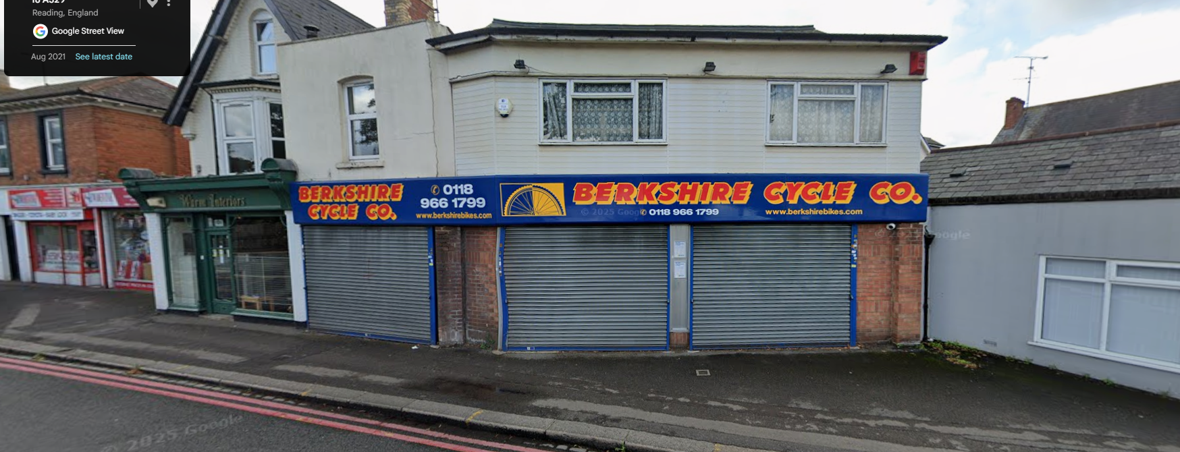
Streetview image when the former shop had closed in 2021. Traditional shopfront and signage shown in the ‘Warm Interiors’ shop to the left.

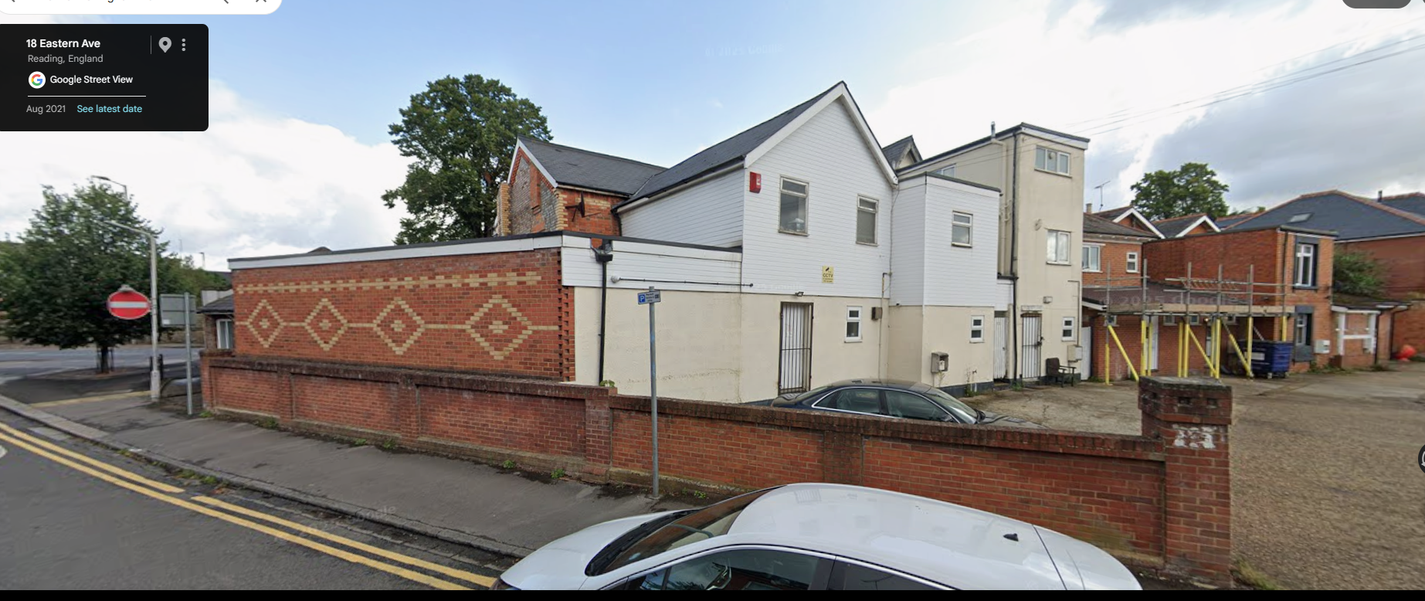
Streetview image of side/rear elevation from Eastern Avenue.
Proposal
The application seeks advertisement consent under the Advertisement Regulations. None of this signage is considered to be covered by any Classes of the Regulations to quality for Deemed Consent.
The proposed signage is part-retrospective and consists of:
- A banner sign (not installed) on the rear/side elevation facing Eastern Avenue
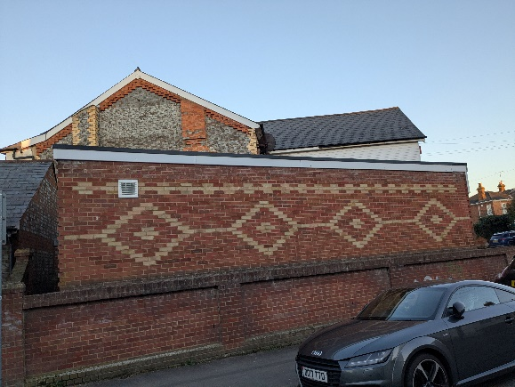
- Fascia signs (retrospective) on the Wokingham Road frontage; and
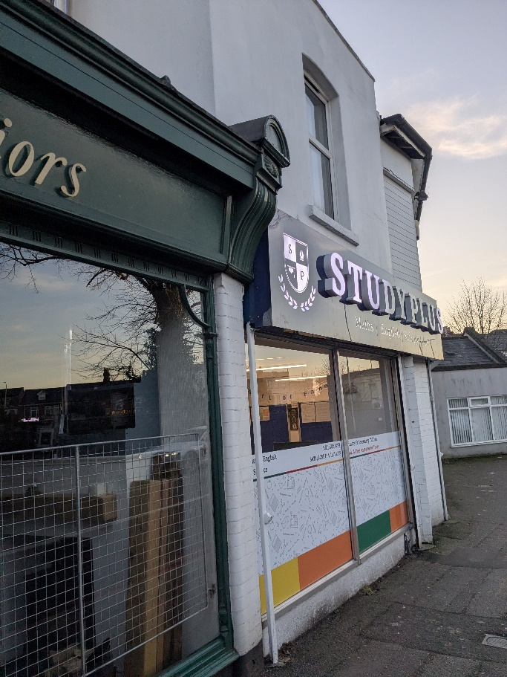
- Window film advertisements (retrospective) on the plate glass windows on the Wokingham Road frontage.
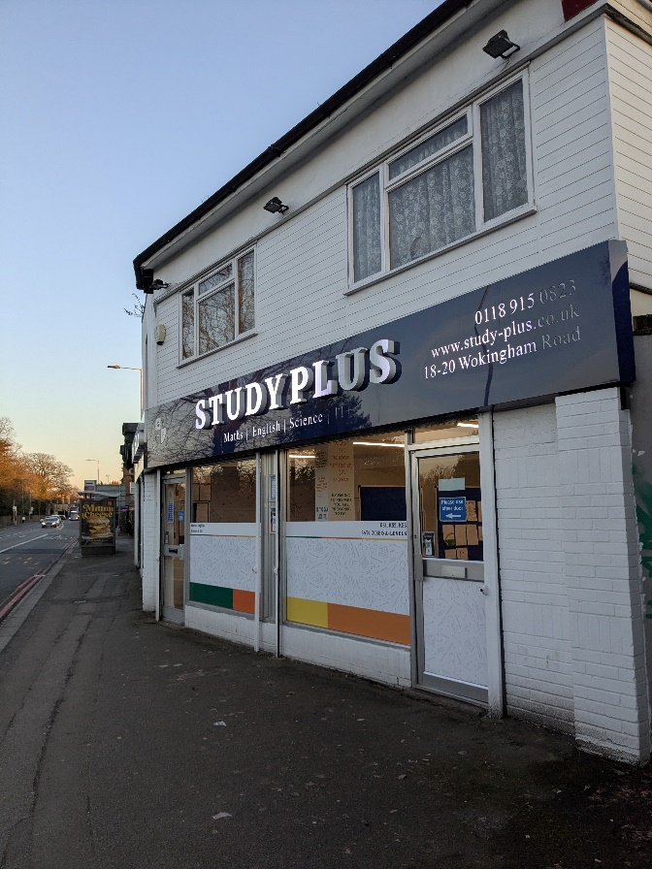
- It is noted that a further plastic sign has also been installed on the rear elevation of the building facing the car park. This is shown below.
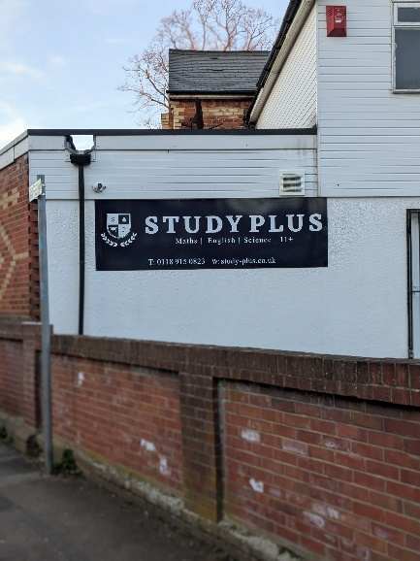

Relevant Planning History
PL/25/0275
Change of use of ground floor from Shop (E use class) to Non-residential educational facility (F1 use class). PERMISSION 17/4/25 and implemented.
PL/92/0679 Erection of single storey rear extension and demolition of existing outbuilding. This is likely to be the single-storey element with patterned brickwork flank wall sited towards Eastern Avenue.
Consultations
Public consultation
It was not clear whether the original site notice had been erected by either the original planning case officer or the planning agent (update-15/5/26-case officer finds original sign but it is displayed some way away, on the lamppost between 26 and 28 Wokingham Road) . As a precautionary measure the new case officer affixed a further site notice. 2x additional site notices were produced and affixed on site. The consultation period ended on 3/4/26 (Good Friday).
The application attracted three responses:
Cllr Cross: I would like to request that this application be considered by the Committee, should officers not otherwise be minded to refuse under delegated authority. The reason for this is the size and visual impact of the signage on the surrounding heritage assets of the conservation area, and detrimental impact on the patterned brickwork.
Cllr Williams was concerned about the advertising of the application, see discussion above.
Matt Rodda MP objects to the banner sign element due to its effects on the residential impacts on Eastern Avenue residents and its impact on the Conservation Area.

Other consultations:
RBC Transport Strategy: none of the proposed signage is illuminated. There are no transport objections to this application.
Further comment following Case Officer’s advice that the fascia signage is in fact, illuminated:
If this was an illuminated sign (application does not confirm this) it would need to be in accordance with required luminance levels. The application states the proposed facia would be 0.9m (Height) and 12.9m (in length). Based on these dimensions the maximum illumination levels from the fascia should not exceed 300cdm²

Legislation Policy and guidance
Section 16(2) of the Planning (Listed Buildings and Conservation Areas) Act 1990 requires the LPA to have special regard to the desirability of preserving a listed building or its setting or any features of special interest which it possesses.
Section 72 requires special attention to be paid to the desirability of preserving or enhancing the character or appearance of the area when making planning decisions
Section 38(6) of the Planning and Compulsory Purchase Act 2004 requires that proposals be determined in accordance with the development plan unless material considerations indicate otherwise. Material considerations include relevant policies in the National Planning Policy framework (NPPF) - among them the 'presumption in favour of sustainable development'. However, the NPPF does not change the statutory status of the development plan as the starting point for decision making (NPPF paragraph 12).
Regulation 3 of the Town and Country Planning (Control of Advertisements) (England) Regulations 2007 requires the Local Planning Authority to exercise its powers under these regulations in the interests of amenity and public safety taking into account the provisions of the development plan, so far as they are material; and any other relevant factors. Regulation 3 states that factors relevant to amenity include the general characteristics of the locality, including the presence of any feature of historic, architectural, cultural, or similar interest.
Factors relevant to public safety include highway safety and whether the advert would hinder security or surveillance devices, including speed cameras.

National Policy and Guidance
National Planning Policy Framework 2024, as amended February 2025
National Planning Practice Guidance

Reading Borough Local Plan (2019)
CC7: DESIGN AND THE PUBLIC REALM
EN1: PROTECTION AND ENHANCEMENT OF THE HISTORIC ENVIRONMENT
OU4: ADVERTISEMENTS
TR3: ACCESS, TRAFFIC AND HIGHWAY RELATED MATTERS
Local Plan Partial Update:
The current version of the Local Plan (adopted in November 2019) turned five years old on Tuesday 5th November 2024. The Local Plan was reviewed in March 2023 and around half of the policies in the plan are considered still up to date. However, the rest need to be considered for updating to reflect changing circumstances and national policy. The submission draft of the Local Plan Partial Update was submitted on 9th May 2025 and examined earlier this year.

Although there is a five-year period for carrying out a review of a plan after it is adopted, nothing in the NPPF or elsewhere says that policies automatically become “out of date”
when they are five years old. It is a matter of planning judgement rather than legal fact whether a plan or policies within it are out-of-date. This will depend on whether they have been overtaken by things that have happened since the plan was adopted, either on the ground or through changes in national policy, for example. Officer advice in respect of the Local Plan policies pertinent to this application is that they remain in accordance with national policy and that the objectives of those policies remain very similar in the draft updated Local Plan. Therefore, they can continue to be afforded weight in the determination of this planning application and are not considered to be ‘out of date’.

Other documents
Design Guide for Shopfronts SPD (2022)
South Park Conservation Area Appraisal (2008)

APPRAISAL
Policy and principle
The policies above require high-quality signage and particularly in sensitive locations (which in this case is the proximity to a conservation area and a registered park). The application has not been submitted with a Heritage Statement, nor even a DAS and the covering letter submitted with the application fails to mention the relevant Heritage Assets. The application was therefore validated by the LPA in error.
In summary:
- Policy EN1 requires the protection of Heritage Assets commensurate with their importance/significance and the level of harm of the proposal to be weighed against this
- CC7 requires development to be high quality and to reflect the character of the locality.
- OU4 requires signage to respect the building they are attached to and its surroundings. In particular, signage should not ‘run across’ multiple frontages, block windows, use inappropriate materials or inappropriate illumination or be harmful to heritage assets
- TR3 requires highway safety to be maintained
The South Park Conservation Area Appraisal (2008) identifies the nearest part of the Conservation Area (opposite the application site, northern extent of the CA on Eastern Avenue) as a mix of Victorian/Edwardian houses. Although the houses themselves are perhaps not the best examples in the CA, the flank wall patterned brickwork at the application site makes a pleasing entrance to the CA.
The Council’s Shopfronts SPD is relevant and in particular pages 29-32 ‘Advertisements related to shopfronts’:
Para. 4.17 “Text should not occupy the entire fascia and should be well-proportioned”.
Para. 4.23 “Temporary signage, such as banners, should be avoided. Temporary signage applied to windows either internally or externally should never occupy more than 30% of the frontage”.
The National Planning Policy Framework’s sections on good design are relevant, namely the following paragraph of section 12 (Achieving well-designed places):
Para. 139 “Development that is not well designed should be refused, especially where it fails to reflect local design policies”.
Para. 141 “The quality and character of places can suffer when advertisements are poorly sited and designed. A separate consent process within the planning system controls the display of advertisements, which should be operated in a way which is simple, efficient and effective. Advertisements should be subject to control only in the interests of amenity and public safety, taking account of cumulative impacts”.
Also the NPPF Section 16 Conservating and enhancing the historic environment:
para. 202 Heritage Assets should be conserved in a manner appropriate to their significance.
Para. 207, 208, 210 and 212: heritage assessments are required to assess impact on an Asset’s significance and the importance of the Asset to maintaining character and distinctiveness.
Also paras 8 (safe places), 96, 117
In general, the signs are/would be poor, would not comply with Local Plan policies
Amenity considerations
Banner sign
This is not affixed at this time (although a larger banner was). A canvas banner sign would be a poor-quality sign, harmful to the character of the building, especially the attractive patterned brickwork on this elevation, and harm views within/into the (residential) South Park Conservation Area and this element of the application is not supportable.

Replacement fascia sign.
This aspect appears to be attempting to receive consent for what has been installed already; however, the plans are an inaccurate refection of the proposal as the detail is not there (no section), and the font is not reflective of what has been installed. The text is much larger and poorly proportioned, and the fascia runs continuously, all aspects which as detailed above are contrary to the Shopfronts SPD. The box illuminated lighting, as installed/proposed is considered to be a poor quality design solution and the brightness also excessive in this sensitive location (the case officer visited at dusk and witnessed this). Further, the box also retains the box shutter system, a poor quality and unsuitable design, contrary to the SPD. Whilst the shutters themselves are immune, a suitable signage would be able to conceal the shutters.
Window privacy film.
This is attached to the outside of the plate glass windows, and is not an attractive/suitable design response, given its poor quality and its removal of surveillance into the unit. It covers over half of the windows and completely obscures views either way, contrary to the advice in the Shopfronts SPD.
(other sign)
A plastic sign has been erected on the rear of building. This is not part of the application but is not acceptable either, being poor quality and unsuitable to the character of the residential nature of the conservation area.
Other issues:
Highway safety
There is no objection from the Highway Authority, subject to suitable control on the level of illumination. There are no other issues and the application is therefore considered to be suitable in terms of highway safety and complies with Policy TR3.
Impact on heritage assets
For completeness, the advertisements, whilst harmful where indicated above, are not considered to be harmful to the settings of listed structures (tombs, etc.) within the Cemetery itself or Cemetery Junction Arch and as such, need no further discussion in this report.
Conclusion
The application submitted is not reflective of what has actually been installed, nor are they suitable or demonstrate an improvement. The ‘temporary period’ indicated by the applicant (ten years) is not an acceptable mitigation for a poor-quality design and moreover would appear to signal immunity for enforcement at that point also.
Ultimately, no element of this poor-quality and poorly-presented application is considered suitable and consequently, the recommendation is of refusal. The applicant’s planning agent has been advised of these concerns but the applicant has advised that this application should continue to a decision on its merits.

Recommendation:
Refuse Advertisement Consent for the following reasons:
- The proposed canvas banner sign would be a poor quality installation which would fail to provide a suitable standard of sign suitable for permanent retention. Furthermore, the siting of the sign in this location would obscure patterned brickwork on the flank elevation of the building which contributes to the character of the Conservation Area. For these reasons, the proposed sign would be harmful to views into and out of the South Park Conservation Area and the residential streetscene of Eastern Avenue generally, contrary to policies EN1 (Protection and Enhancement of the Historic Environment, CC7 (Design and the Public Realm) and OU4 (Advertisements) of the Reading Borough Local Plan (2019) and paragraphs 139, 141, 202, 207, 208, 210 and 212 of the National Planning Policy Framework (December 2024, as amended).

- The unauthorised fascia signage which has been installed is of poor quality, being a slim internally illuminated light-box attached to existing shutters, which ae long and continue across the shop unit frontages. Illumination of the poor quality signage (not confirmed in the application) is detrimental to the character of the area. This sign is consequently harmful to the streetscene of Wokingham Road and the setting of Reading Cemetery (a Registered Park and Garden) contrary to policies EN1 (Protection and Enhancement of the Historic Environment, CC7 (Design and the Public Realm) and OU4 (Advertisements) of the Reading Borough Local Plan (2019), the Council’s adopted Design Guide for Shopfronts SPD (2022) and paragraphs 139, 141, 202, 207, 208, 210 and 212 of the National Planning Policy Framework (December 2024, as amended).

- The unauthorised privacy film which has been installed obstructs windows and removes surveillance into the ground floor of the building, which is a retained shop/shopfront in this key retail frontage in the Cemetery Junction District Centre. This installation is of poor-quality and harmful to the appearance of the District Centre and with the unacceptable fascia signage, causes further cumulative harm. For these reasons, the privacy film is causing harm to the streetscene of Wokingham Road and fails to produce a safe environment through interaction with the street, contrary to policies CC7 (Design and the Public Realm) and OU4 (Advertisements) of the Reading Borough Local Plan (2019), the Council’s adopted Design Guide for Shopfronts SPD (2022) and paragraphs 8, 139 and 141 of the National Planning Policy Framework (December 2024, as amended).

Informatives
- The Local Planning Authority has been positive and proactive in dealing with this application by communicating issues with the application to the applicant and giving them the opportunity to withdraw.
2. This application was considered against the following plans (although noting that the plans are also considered to be inaccurate):
-Plan LOC01 O/S Location Map Extract (received 16/12/25)
-Plan 25/06/05 Advertisement Signage Front Elevation (received 16/12/25)
3. This signage was installed and this application submitted without the benefit of seeking pre-application advice from the Local Planning Authority which can often avoid the need to refuse applications for consent. The Council’s pre-application advice service can be accessed here: https://www.reading.gov.uk/planning-and-building-control/planning-applications/before-making-a-planning-application/pre-application-planning-advice/
4. These signs do not have advertisement consent and this matter will now be passed to RBC Planning Enforcement to consider for enforcement action, if considered expedient to do so. It should also be noted that the plastic sign on the rear (car park) elevation on the building is unauthorised, and if it does not enjoy Deemed Consent, may also be subject to enforcement action.

