12 May 2026
Planning Application Ref: PL/26/0494
Officer: Catrin Davies
Application Type: Full planning permission
Address: 2 WAVERLEY ROAD, READING, RG30 2PX
Proposal: Change of use of the existing property from Class C3
(Dwellinghouse) to Class C2 (Residential Children’s Care Home) for up to three children.

The proposal seeks to provide accommodation and support for up to three children with emotional and behavioural difficulties (EBD), learning disabilities (LD), and associated mental health needs within a domestic-scale setting.

In terms of transport and accessibility, developments are required to provide car and cycle parking appropriate to the level of accessibility to sustainable transport modes, particularly public transport, in accordance with the Council’s adopted parking standards. These standards require provision at a rate of one parking space per full-time equivalent (FTE) staff member and one space per four residents.

Given the nature of the development as a children’s facility, it is not considered appropriate to provide parking spaces for residents. However, visitor parking should be provided at the same ratio (i.e. one space per four residents). Based on the application details—comprising a maximum of three resident children and two staff per shift—the required provision equates to three parking spaces.

While the submitted plans indicate the provision of three on-site parking spaces, it is noted that there is currently no authorised vehicular access to the site. Any vehicular movements taking place across the footway at present are unauthorised and therefore unlawful.

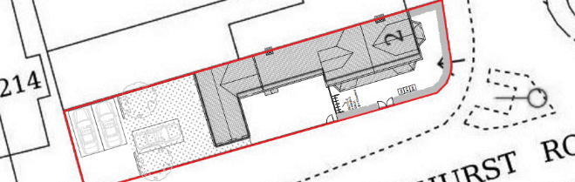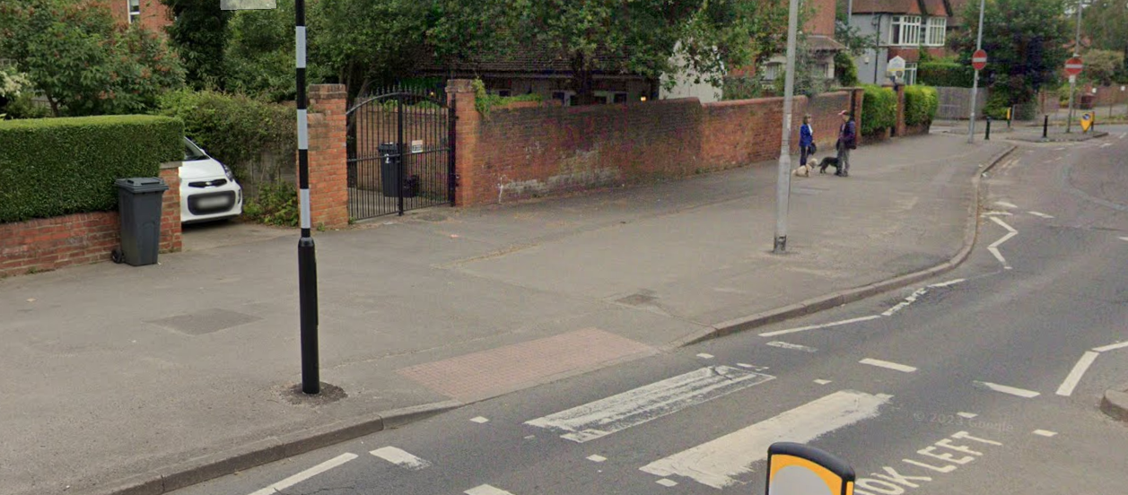

The Highway Authority raises objection to the introduction of a new vehicular access to serve the proposed parking area. This is due to conflicts with existing highway infrastructure, including a pedestrian crossing and a lamp column within the footway. In addition, the proposed access point would be located in close proximity to a roundabout junction, which would give rise to significant highway safety concerns.

In light of the above, the proposed parking provision cannot be considered acceptable, as it is not supported by a safe or lawful means of access, and the formation of such an access would be likely to result in unacceptable impacts on highway safety.

It should be noted that the Highway Authority did not support an application that was presented in 2016 (160666) for reasons relating to access arrangements.

Reason for Refusal
The introduction of a new access in close proximity to the junction of Tilehurst Rd Waverley Road, Liebenrood Rd Roundabout and Zebra Crossing would result in conflicting traffic movements which would have an adverse effect on road safety and the flow of traffic and in conflict with local plan policies TR3 and TR5 of the Reading Local Plan 2019.

N. Hussain
Transport Development Control Advisor

