CONSERVATION

Memo
To: Catrin Davies
From: Buju Can Cetin, Conservation Officer
Date: 19/05/2026
Re: Conservation Officer response
Application Number: PL/26/0408 AND PL/26/0416
Application Type: Full Planning Application AND Listed Building Consent
Address: Acacia Road, Reading
Proposal: Full planning for proposed public realm and highway improvements to Acacia Road and its junction with Redlands Road, to include the partial demolition of one section of existing wall to enable wider access to MERL, the reconfiguration of parking areas, enhancement of pedestrian routes and associated landscaping. AND Listed Building Consent for proposed public realm and highway improvements to Acacia Road and its junction with Redlands Road, to include the partial demolition of one section of existing wall to enable wider access to MERL, the reconfiguration of parking areas, enhancement of pedestrian routes and associated landscaping.

Summary
Objection - The proposed removal of a section of the historic front boundary wall of the listed St Andrew’s Hall and widening the entrance would result in the loss of historic fabric, the legibility of the historic layout, and the character of the front garden, and the disruption of the continuity of historic walls along Redlands Road in the Kendrick Conservation Area. Therefore, there would be less than substantial harm to the historic fabric, setting of the listed building and character and appearance of the Kendrick Road Conservation Area. The proposal(s) would be contrary to the Policies EN1, EN3 and EN6 of the Reading Borough Local Plan and Chapter 16 of the NPPF. It is considered that the proposed improvements to vehicular circulation do not provide sufficient public benefit to outweigh this harm to the heritage assets.

Relevant policies and legislation
From the point of view of the historic environment, the main statutory tests are set out within the Planning (Listed Buildings and Conservation Areas) Act 1990. Sections 16(2) and 66 require that special regard be given to the desirability of preserving listed buildings, their settings or any features of special architectural or historic interest which they possess.
Section 72(1) of the Planning (Listed Buildings and Conservation Areas) Act 1990 also requires the Council to pay special attention to the desirability of preserving or enhancing the character and appearance of designated Conservation Areas.
National Planning Policy and Guidance
The NPPF outlines government policy, including its policy in respect of the historic environment. Chapter 16 of the NPPF 'Conserving and enhancing the historic environment' sets out the Government's high-level policies concerning heritage and sustainable development.
Paragraph 207 states, “In determining applications, local planning authorities should require an applicant to describe the significance of any heritage assets affected, including any contribution made by their setting. “ Paragraph 208 says, “Local planning authorities should identify and assess the particular significance of any heritage asset that may be affected by a proposal (including by development affecting the setting of a heritage asset) taking account of the available evidence and any necessary expertise. They should take this into account when considering the impact of a proposal on a heritage asset, to avoid or minimise any conflict between the heritage asset’s conservation and any aspect of the proposal.”
Paragraph 212 of the NPPF requires that ‘when considering the impact of a proposed development on the significance of a designated heritage asset, great weight should be given to the asset’s conservation….’ And paragraph 213 says, ‘any harm to, or loss of, the significance of a designated heritage asset (from its alteration or destruction, or from development within its setting) should require clear and convincing justification’.
Paragraph 215 requires that ‘where a development proposal will lead to less than substantial harm to the significance of a designated heritage asset, this harm should be weighted against the public benefits of the proposal…’
National Planning Practice Guidance on Historic Environment provides context to the NPPF.

Local Planning Policy and Guidance
Policy EN1 ‘Protection and enhancement of the historic environment’ of the Reading Borough Local Plan sets out the Council’s aspirations for the historic environment. The policy requires that all proposals to protect and, where possible, enhance the significance of heritage assets and their settings, historic character and local distinctiveness of the area in which they are located. It echoes the NPPF by stating, “Proposals should seek to avoid harm in the first instance. Any harm to or loss of a heritage asset should require clear and convincing justification, usually in the form of public benefits”.
Applications which affect Listed Buildings are expected not to have an adverse impact on the elements that contribute to their special architectural or historic interest, including their settings.
Policy EN3 ‘Enhancement of conservation areas’ of the Reading Borough Local Plan (2019) requires that development proposals within Conservation Areas contribute positively to local character and distinctiveness. This policy further states “Positive consideration will be given to proposals which take opportunities to enhance the character of conservation areas. These may include:
- Reducing visual clutter caused by negative factors, such as poles and overhead wires, satellite dishes or unnecessary street furniture;
- Restoring original building features;
- Removing inappropriate additions or alterations to buildings;
- Protecting and encouraging the maintenance of green spaces and important trees, particularly where they are intrinsic to the history and character of the area;
- Improving signage and street furniture;
- Restoring or re-establishing appropriate paving, railings or walls;
- Sympathetic landscaping and planting;
- Improving or restoring green spaces, including front gardens, that are appropriate to the historic interest of a Conservation Area;
- Signage that reveals and promotes the Conservation Area and its boundaries;
- Interpretation panels to inform the public of the area’s historical significance.”
Policy EN6 ‘New development in a historic context’ also requires “New development will make a contribution to the historic character of the area by respecting and enhancing its architectural and visual qualities and considering how heritage considerations can influence the design of new development. When determining planning applications for new development, the following factors will be taken into consideration:
a. The positive contribution of the development to the existing historic townscape (scale, height, mass, proportion, plot size, street form, materials, significant vistas and views, and open space);
b. Sensitivity to historic context;
c. Reflection of borough-wide major heritage themes that contribute to local distinctiveness (e.g. patterned brickwork or former worker terraced housing);
d. Whether development promotes and/or improves access to previously undiscovered or neglected historic significance.”
Kendrick Road Conservation Area Appraisal is also a material consideration in determining development applications.
Other Guidance
Historic England Advice Note 2 – Making changes to Heritage Assets illustrates the application of policies set out in the NPPF in determining applications for Planning Permission and Listed Building Consent.
English Heritage’s “Conservation Principles” provides policy and guidance for the “sustainable
management of the historic environment”.

Relevant heritage assets
The application site relates to Acacia Road which lies between the boundaries of the listed curtilage of the Grade II Listed Building Front Block of St Andrew's Hall and Stable Lodge to North (Front Block of St Andrew's Hall and Stable Lodge to North, Non Civil Parish - 1321880 | Historic England) and University of Reading London Road Campus where buildings of townscape merits in the campus located within the Kendrick Road Conservation Area, as illustrated below. It not only covers Acacia Road but also, partially, the front gardens/private open areas of the listed building and BTMs facing Redlands Road.
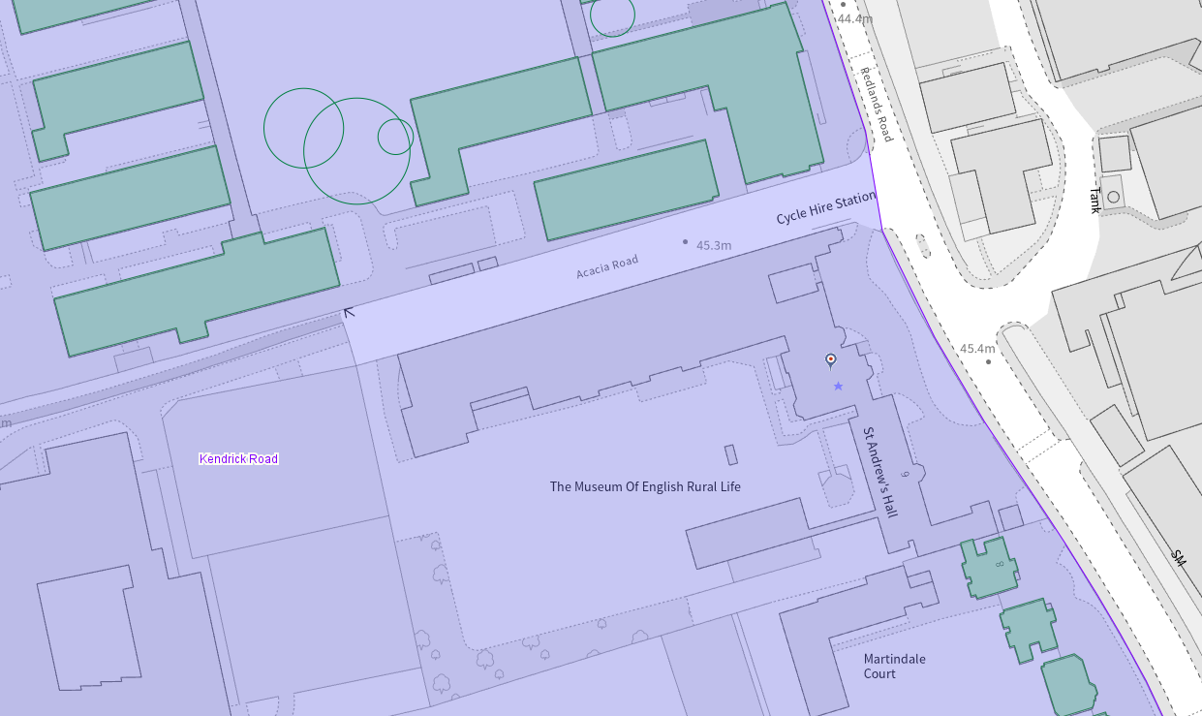
Application Site (marked red), listed buildings (starred), buildings of townscape merit (green), and the conservation area (light purple)

Significance of heritage assets
The NPPF defines significance as the “value of a heritage asset to this and future generations because of its heritage interest.”

The interest may be architectural or historic, as set out in the Town and Country Planning (Listed Building and Conservation Areas) Act 1990 Section 1.

“Significance derives not only from a heritage asset’s physical presence, but also from its setting.” (NPPF, 2023)

Historic England assesses significance in a similar manner, referring to evidential, historic, aesthetic and communal values of a place.

The official listing description of the Front Block of St Andrew's Hall and Stable Lodge to the north, in use as the Museum of English Rural Life at No. 6 Redlands Road, reads as follows

“Details
In the entry for
REDLANDS ROAD (west side)
9/162A St. Andrew's Hall
the address shall be amended to read Front block of St. Andrew's Hall and stable lodge to north
------------------------------------
REDLANDS ROAD 1. 5128 (West Side) St Andrew's Hall SU 7272 9/162A II 2. Formerly East Thorpe. 1880. Designed by Alfred Waterhouse as a house for Alfred Palmer. 2 and 3 storeys red brick with gables. Tiled roof. Careful detailing. Terracotta window details. Sash windows with segmental heads. Entrance front has single storey porch of Gothic inspiration. 2 gables and a mullion and transom window behind. To right is a gable and a 2 storey canted bay window. To left is a 3 storeyed block with octagonal turret. Stable court with 2 storey lodge attached. Interior altered but retains spacious stair hall to north with original fireplace and dado and 1st floor landing, doors retain Waterhouse furniture and 3 windows and 1 door have Waterhouse grisaille glass. Entrance lobby to north also retain Waterhouse details and glass.
Listing NGR: SU7238272733”

In line with the official description of the listed building, the historical map regression shows the construction of East Thorpe/St Andrews Hall/Museum of English Rural Life after the 1870s, with the entrance to the front garden from Redlands Road and ancillary buildings to the west/rear of the original curtilage of the asset.

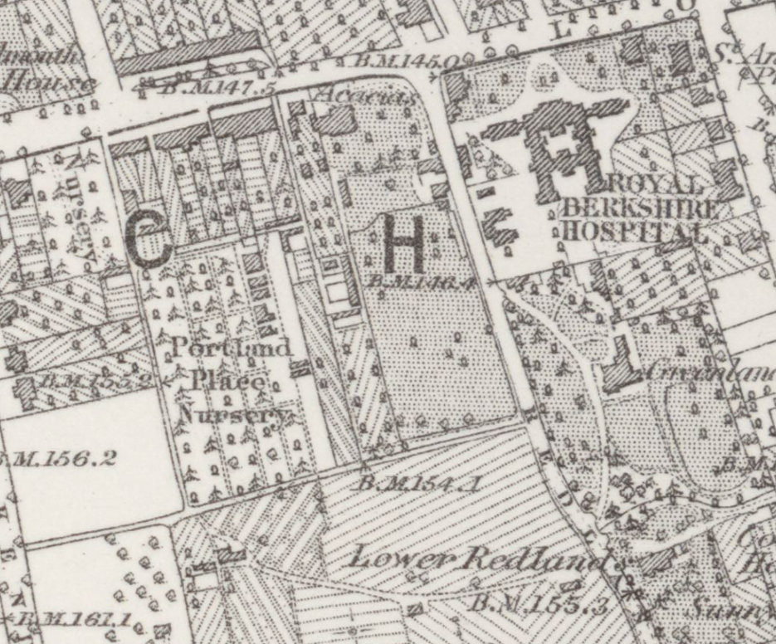
The Ordnance Survey Map dated 1872 to 1877 (published in 1883)

The BTMs of the London Road Campus of the University of Reading also appear on the OS Maps dated 1909 to 1910. Whilst the footprint of the listed main building has been altered historically, the main entrances and circulation paths in the front garden and the original boundary walls have been retained/preserved/survived.
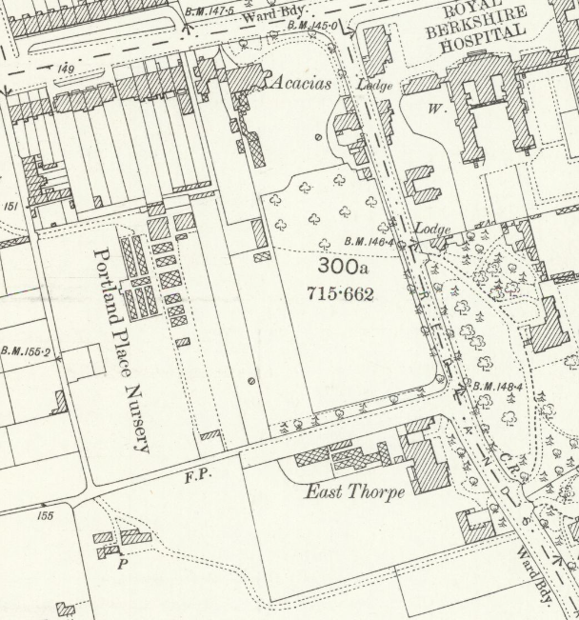
The OS Map of 1898 (published in 1900)

It is also noted that the current built forms of the university buildings/BTMs appeared in the 1930s, and after the 1960s, some modern extensions were constructed, which were replaced by the current extension of the Museum of English Rural Life after 2002, located to the south of Acacia Road.
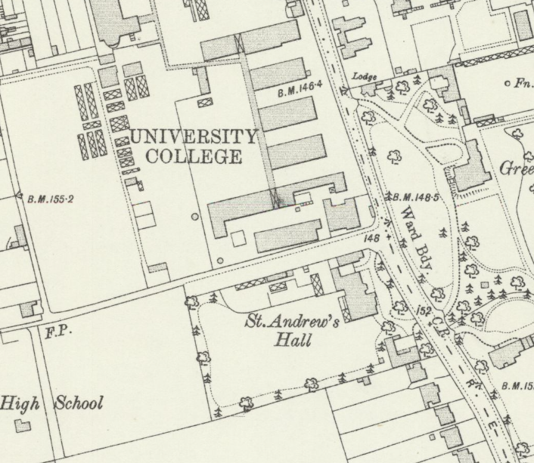
The OS Map dated 1909 to 1910 (Published in 1912)

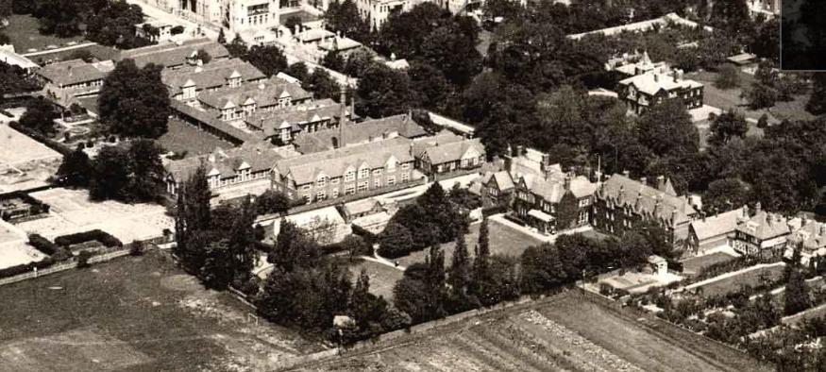
Snip showing Acacia Road within the historic environment of Kendrick Road Conservation Area, Aerial view over part of central Reading, looking northwards, from Morgan Road to the River Thames, c. 1920. Part of Kendrick Road and the Abbey School appear in the bottom left-hand corner. Reading University and the Royal Berkshire Hospital are prominent. The playing-field between Kendrick Road, Redlands Road and Morgan Road has been turned into allotments. Huntley and Palmers biscuit factory and the gas works appear in the distance. 1920-1929 : photograph by Aerofilms, from the Reading Library’s Online Archive

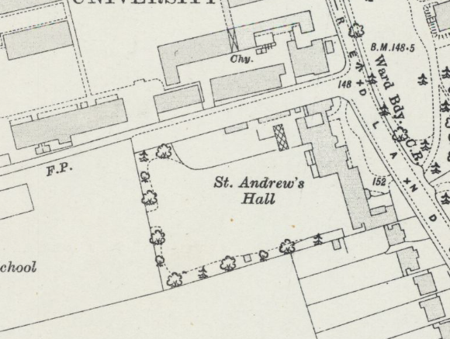
The OS Map dated 1931 to 1932 (Published in 1934)

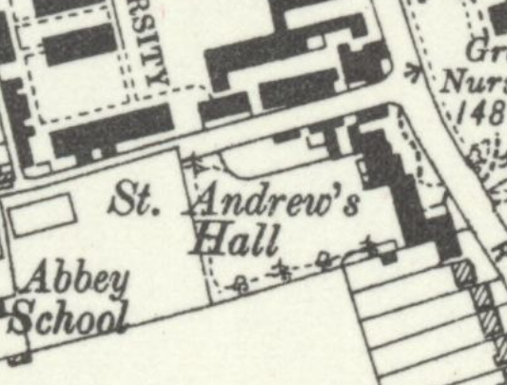
The OS Map of 1938 (Published in 1947)

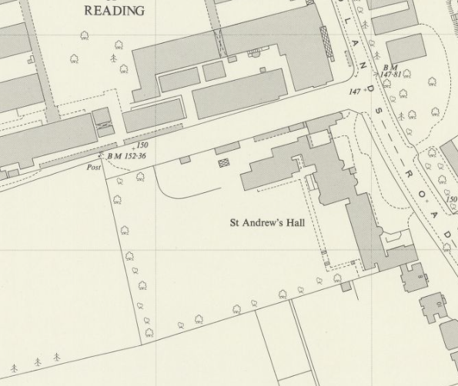
The OS Map of 1957 (Published in 1958)

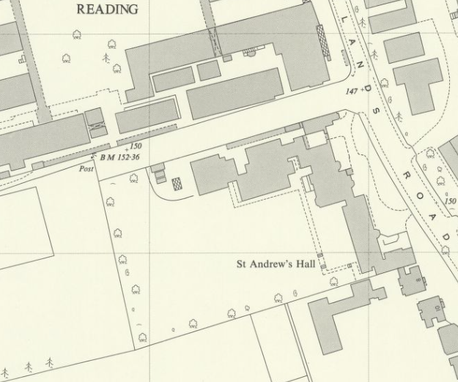
The OS Map of 1967 (Published in 1968)

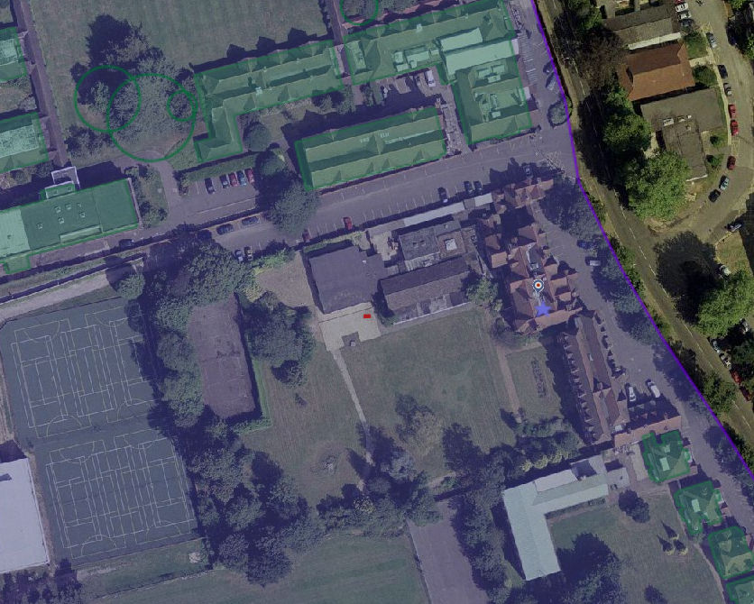
Aerial Photograph of 2002 (from the Council’s Historic Mapping Tool)

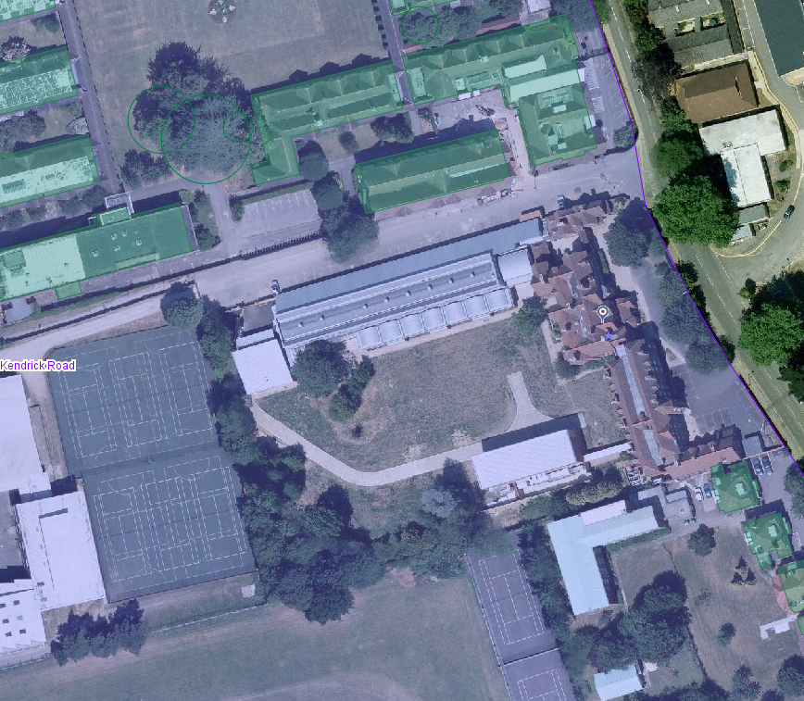
Aerial Photograph of 2006 (from the Council’s Historic Mapping Tool)

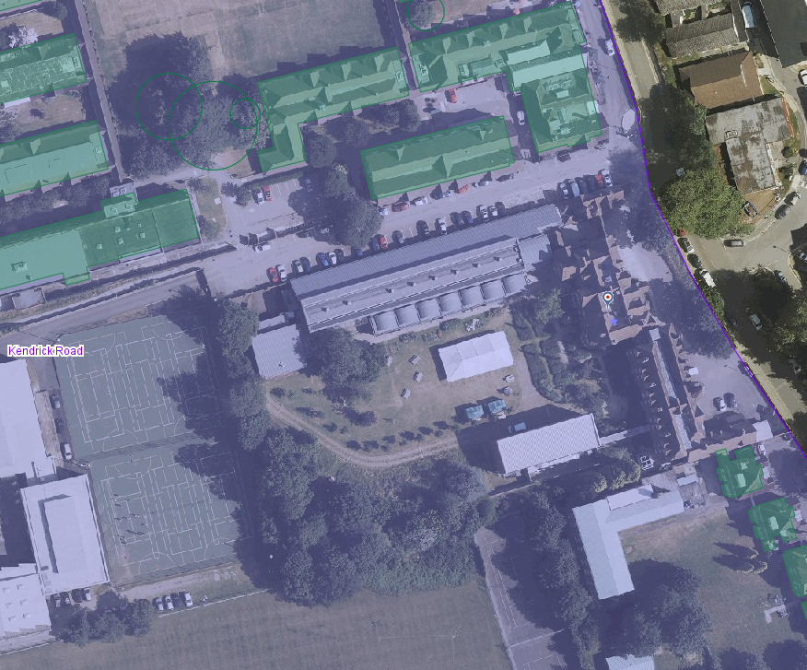
Aerial Photograph of 2013 (from the Council’s Historic Mapping Tool)

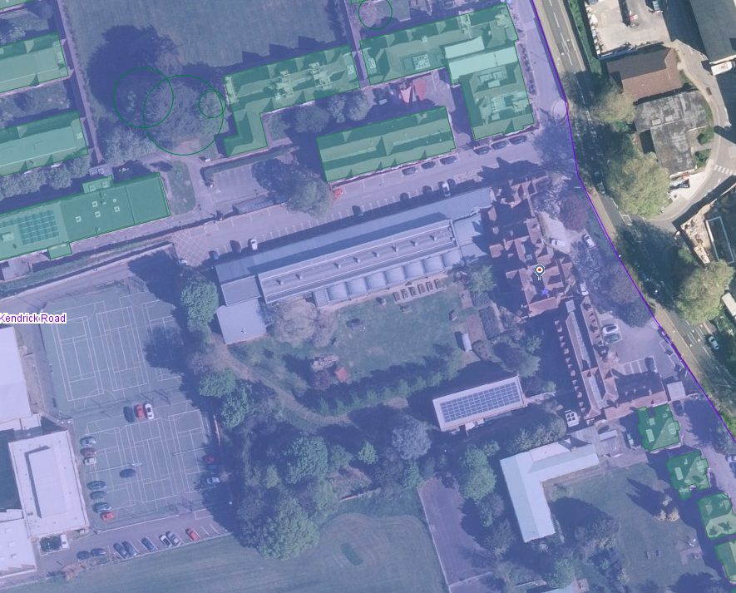
Aerial Photograph of 2026 (from the Council’s Historic Mapping Tool)
From the Summary of the Character and Appearance of the Kendrick Road Conservation Area, I noted the following from the conservation area appraisal:

“• The architectural quality and coherence of late Victorian and Edwardian dwellings in Kendrick Road and Redlands Road;
• The early 20th century planned campus of the University of Reading, the only university established between the two World Wars;
• Notable red brick boundary walls and historic iron railings.”

As the application site lies in and between the Character Area 3 – Redlands Road and the Character Area 4 - University London Road side, the appraisal also notes “The most notable building in Redlands Road is St. Andrews Hall; a grade II listed building designed in 1880 by the architect Alfred Waterhouse as a home for Alfred Palmer. ... It is characterised by many original features including steep gables, prominent chimneys and sash windows with terracotta window detailing. The intricate detailing of the eccentric two and three storey building provides an interesting frontage to Redlands Road.

Nos. 8-40 (even) Redlands Road are large early 20th century dwellings slightly elevated from the road, set back behind boundary wall or railings and a small front garden, often containing evergreen shrubs. …”

“The area of land bounded by London Road, Redlands Road, Crown Place and Acacias Road forms the London Road site of the University of Reading and has a distinctive character quite different to the rest of the conservation area.”

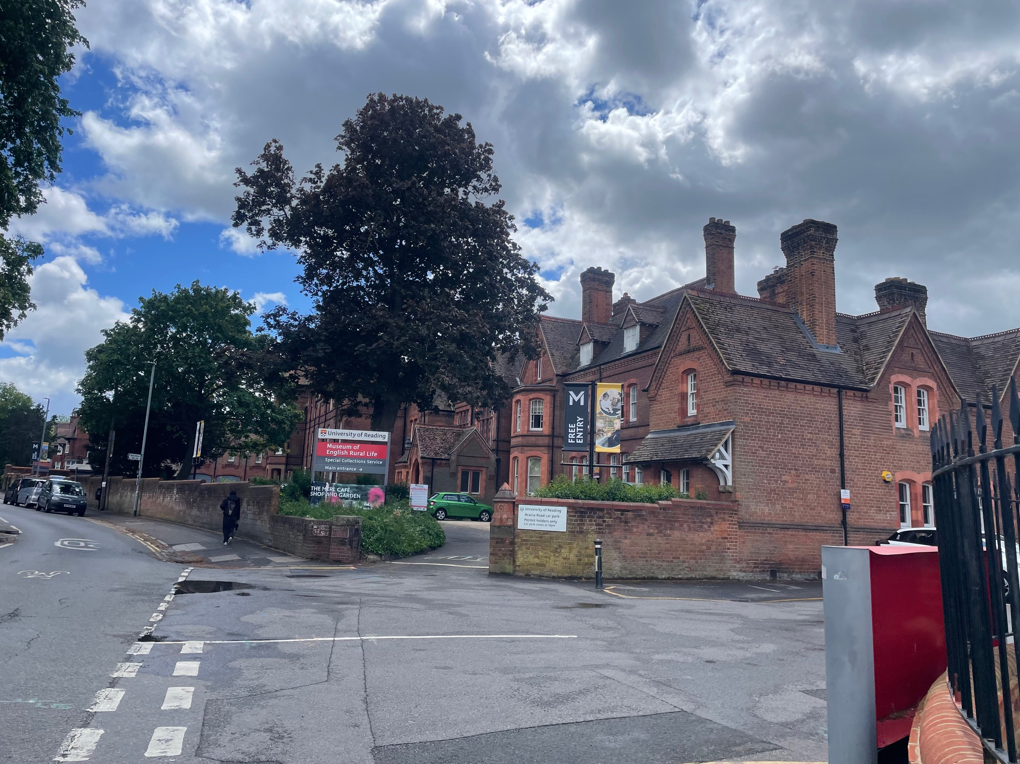
View of listed St Andrew’s Hall from the corner of Redlands Road and Acacia

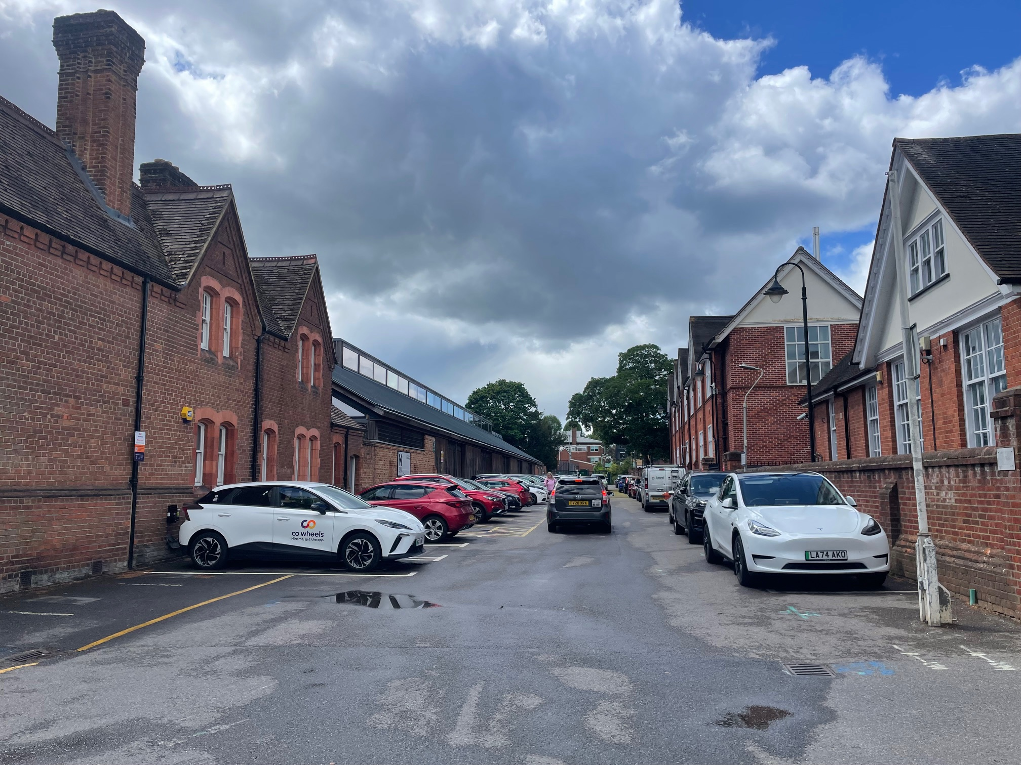
View of Acacia Road from its junction with Redlands Road

Impact of proposal upon heritage asset(s)
In addition to the formal description of the proposed development, the submitted Planning Statement states:

“1.1.4 The improvements seek to address long standing pedestrian and cyclist safety concerns, rationalise vehicular movements, and enhance the character and setting of this key entrance to the campus. The scheme provides an opportunity to improve the visual quality of the gateway, strengthen the heritage setting of nearby Listed Buildings, and create a more welcoming approach for visitors.”

However, a 2m loss of the historic brick front boundary wall, which has been defined as the original entrance to the listed curtilage, only for vehicular entrance, would not preserve and/or enhance the significance of the heritage asset. I find the proposed traffic improvement cannot justify or cause any heritage benefit.

Although the submitted planning statement mentions that there is no planning history for the application site, there are many listed building consents and planning applications that relate to the listed St Andrew’s Hall. The relevant ones are given below. There is also an application for ‘Reconstruction of existing wall demolished for safety reasons, wall to be rebuilt to reduced height with new brick piers and railings and new gates installed’ with ref nos PL/06/1226 and PL/06/1227 (06/01327/CON and 06/01328/FUL proposed for the southern corner of Acacia Road, for the historic boundary walls of the university which was refused due it its harmful impact on the character and appearance of the Kendrick Road Conservation Area.

PL/00/1328 (00/00358/LBC) and PL/00/1327 (00/00357/FUL) - Repair and conversion of Grade II Listed Mansion, (including the installation of a lift, re-servicing and minor alterations to provide disabled access) to house library and archive facilities – Granted

PL/02/1046 (02/01143/FUL) - New boundary wall and single storey sub-station. Minor re-landscaping around new building and existing tree.-Granted

PL/05/0715 - Provision of an archive storage facility for the Museum of English Rural Life – Granted

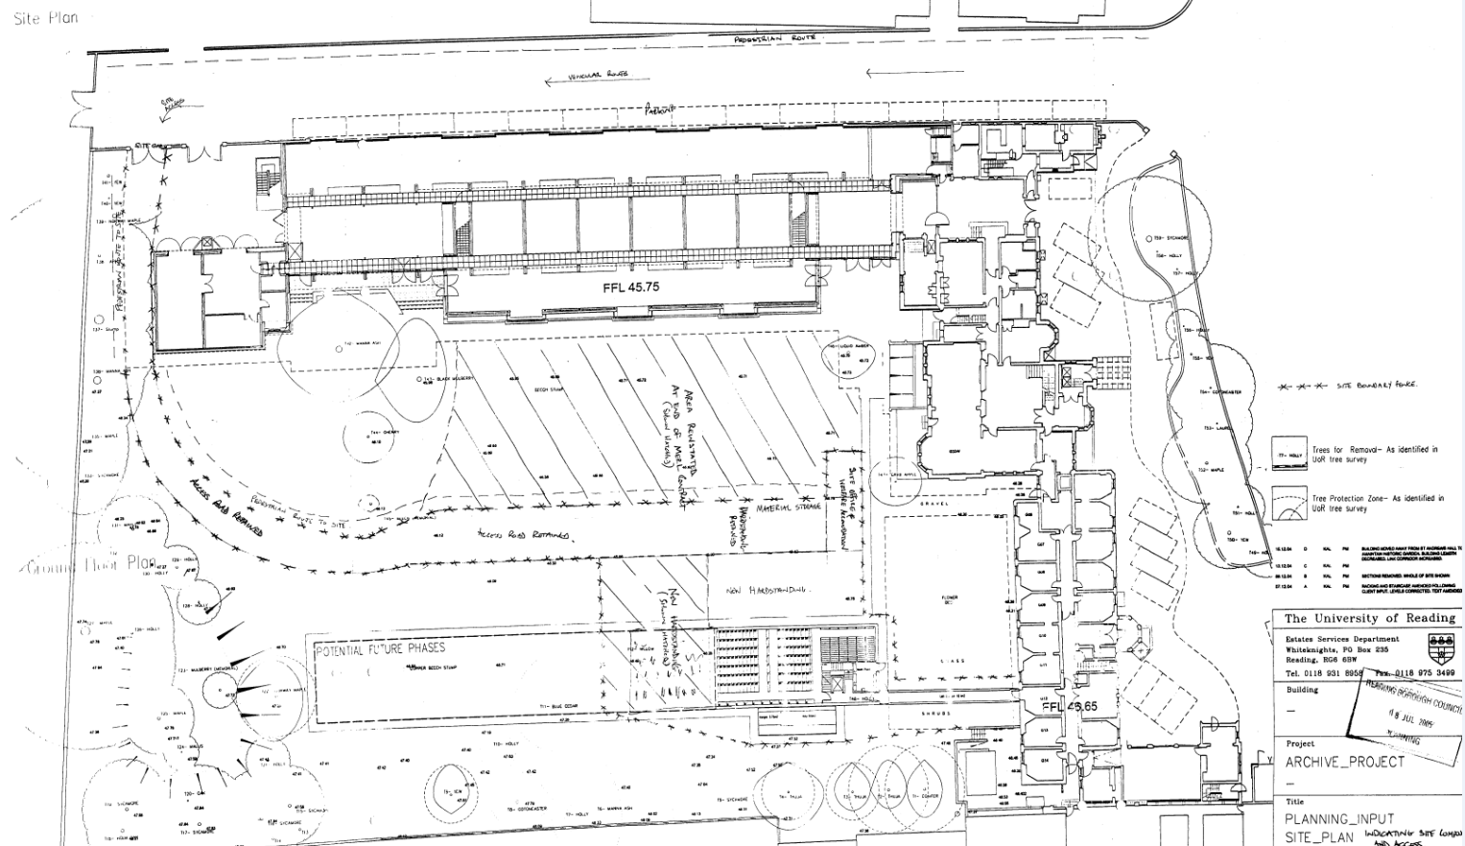
Ground Floor Plan, including the front garden layout of the listed St Andrew’s Hall, among the documents of application PL/05/0715 (above) and PL/05/0376 (below)

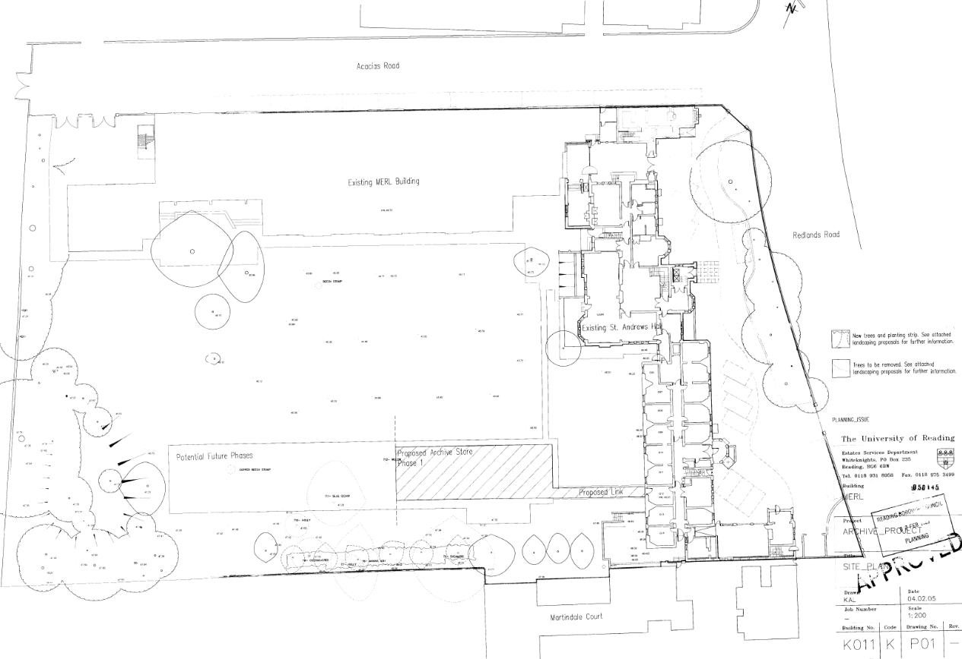

It is noted from the historic map regression, historic photographs and planning history of St Andrew’s Hall that the front garden of the heritage asset has retained its original entrances, while the vehicular use, including car park spaces, has dominated it. The original gates of the site have been lost/removed to provide easy vehicular access. Organic layout and natural appearance of the front garden have been altered with the parking spaces and tarmac surfacing, all resulting in harm to the character of the listed curtilage and the conservation area.

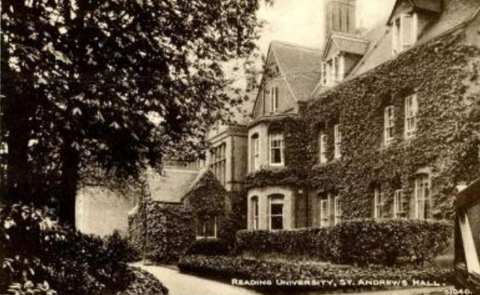
The dominance of the natural environment in the front garden of the listed building, prior to the introduction of vehicle circulation, from the University of Reading. St. Andrew's Hall, Redlands Road, seen from the front, c. 1930. 1930-1939: postcard, Exclusive Phototype Series, by the Photochrom Company, with the caption, "Reading University. St. Andrew's Hall.”, Reading Libaray’s Online Archive

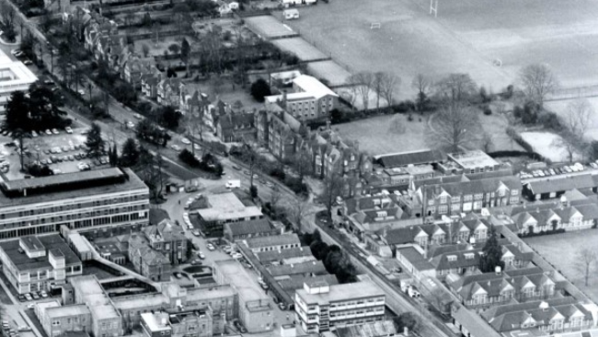
The continuous historic boundary walls along the western side of Redlands Road, highly contributing to the significance of the conservation area and setting of listed St Andrew’s Hall, whose historic entrances are easily recognisable from the photo, when the asset is listed. This photo is Snip from Aerial view of the Royal Berkshire Hospital and surrounding area, looking south, including Redlands Road, Craven Road, Addington Road and Eldon Square (including the gardens), c1971. Abbey School playing fields can be seen on the right of the picture. 1970-1979 [picture] : Photograph by Gerard Gadney, Reading Library’s Online Archive

It should be emphasised that the historic boundary walls along the western side of Redlands Road, as seen in the aerial view from the 1970s above, have survived, leading to one of the key features of the Kendrick Road Conservation Area.

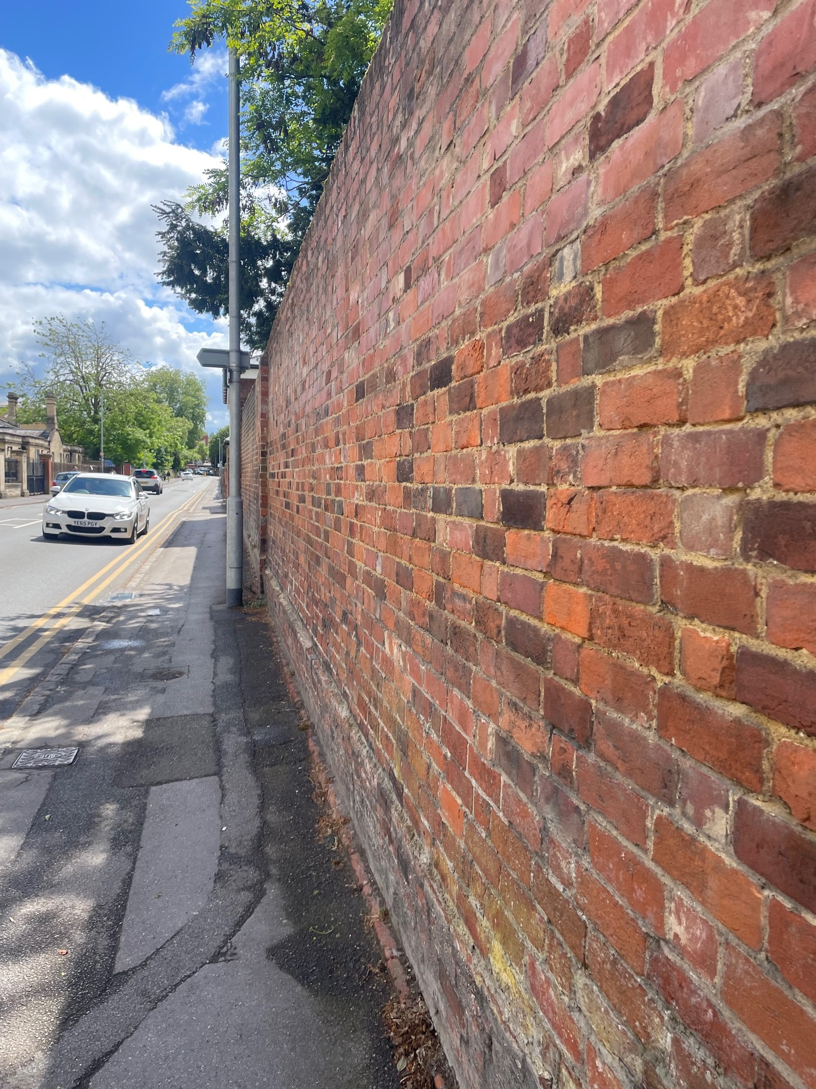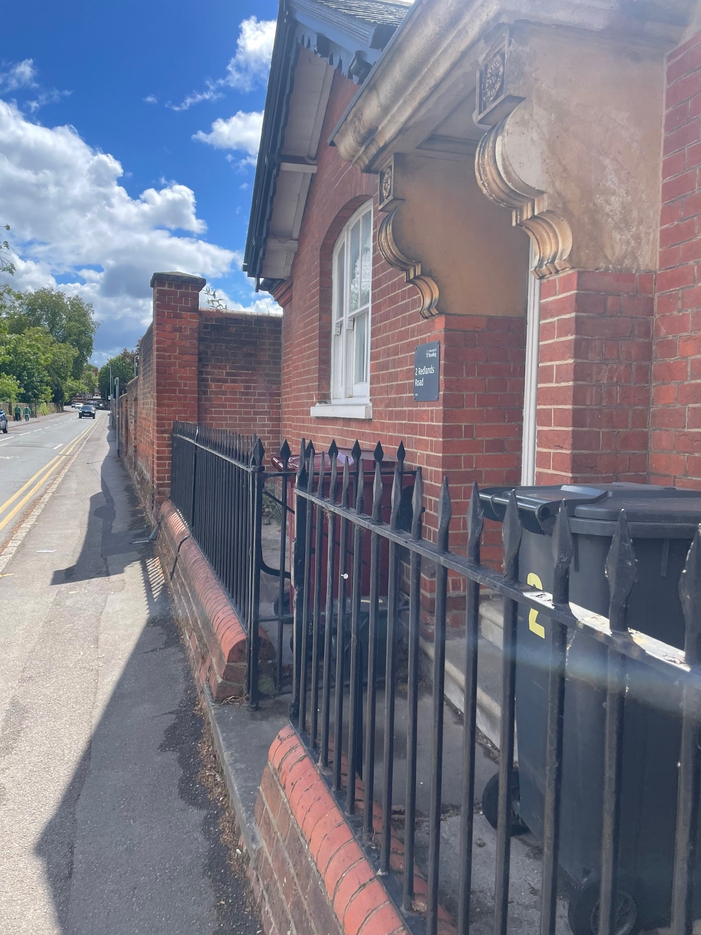

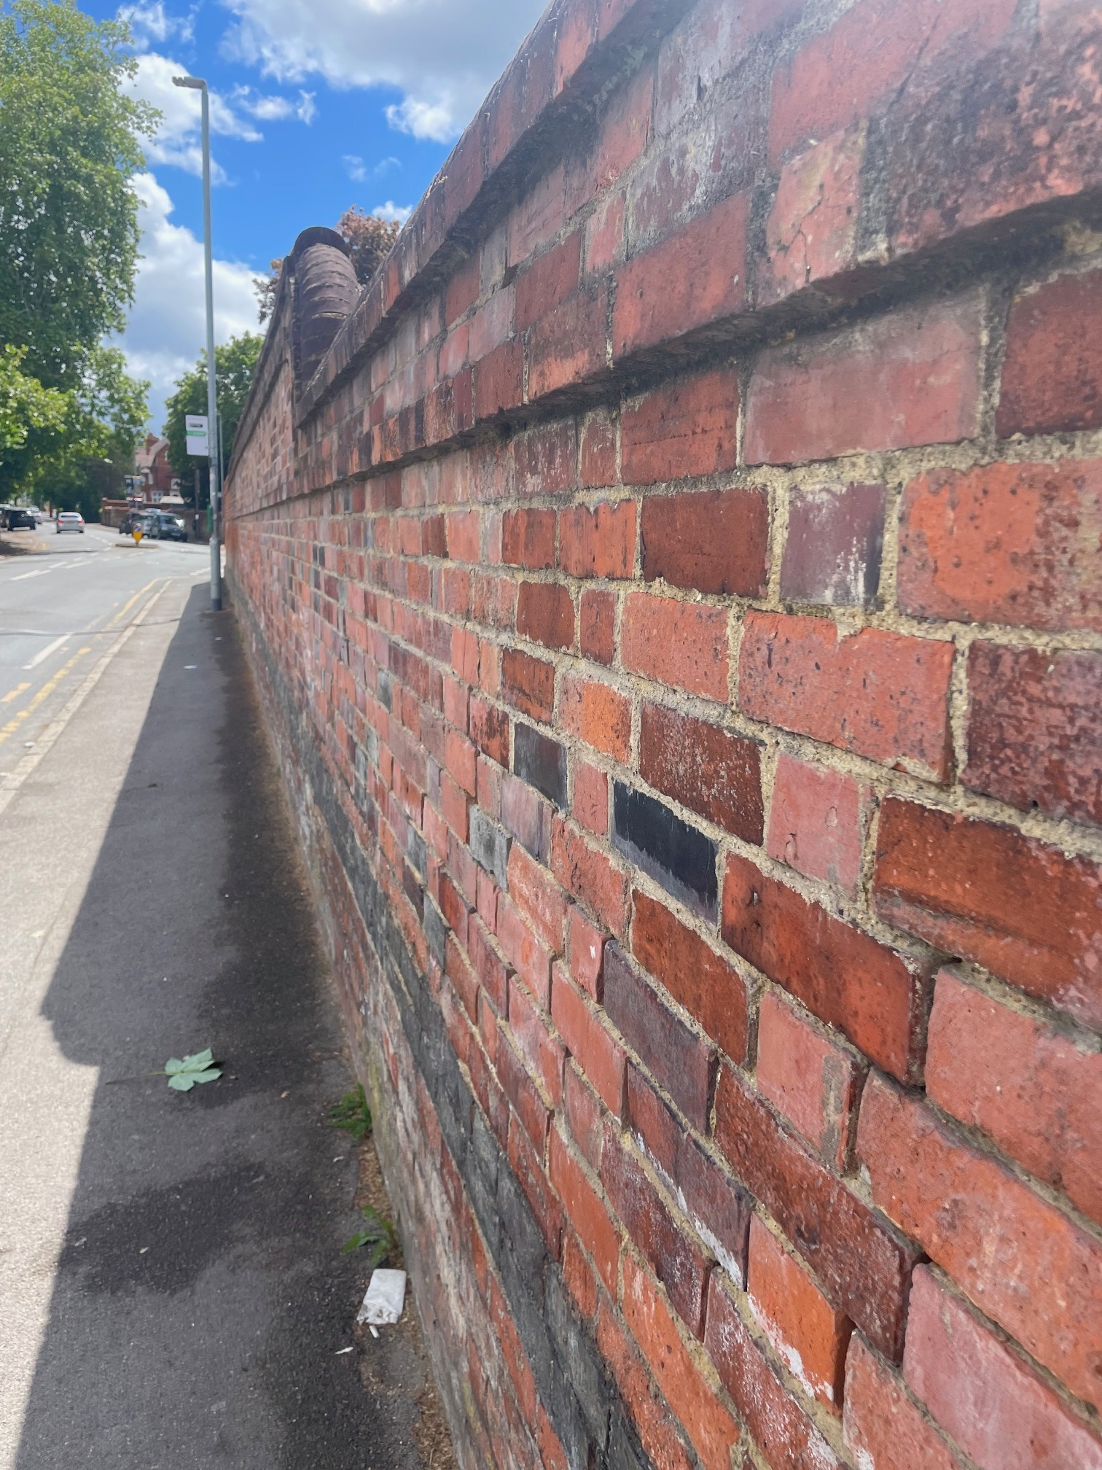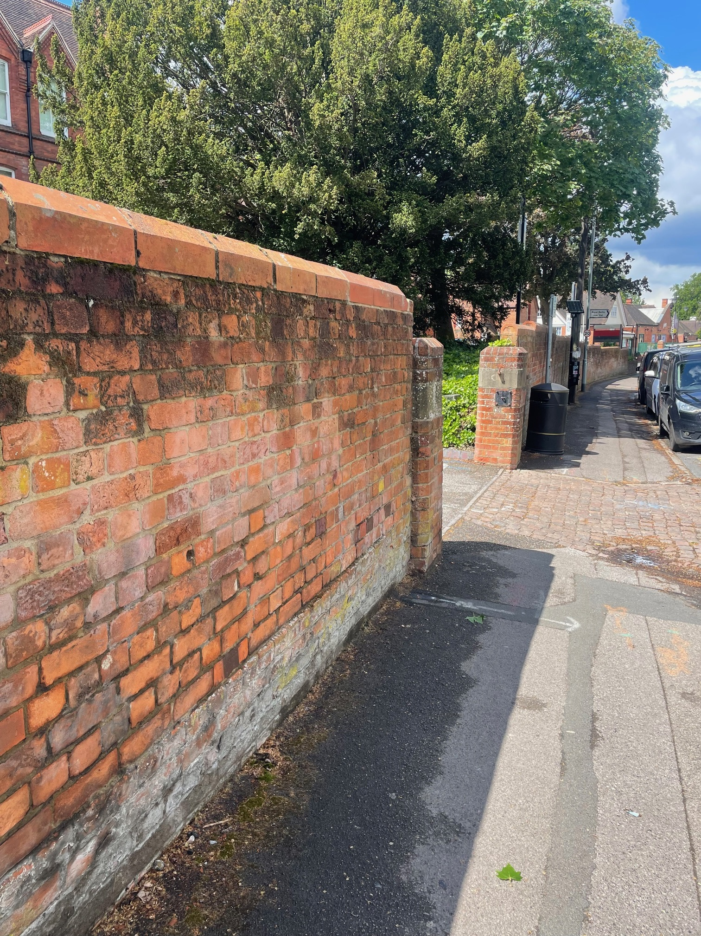
Photos of the boundary walls along Redlands Road in Kendrick Conservation Area – the last one is the entrance to the listed curtilage of St Andrew’s Hall proposed to be widened 2 m

Among the ‘Negative features and opportunities for enhancement’ listed in the conservation area’s appraisal ‘, ‘Loss of front boundaries and gardens to create car parking’ draws attention. Therefore, in addition to its impact on the listed curtilage of St Andrew’s Hall, the proposal would also have a negative impact on the character and appearance of the conservation area, as it would be a loss of original elements without a strong justification and heritage benefit. I disagree with ‘benefits’ or ‘Improvements to MERL Frontage’ advised by the planning statement and the application(s) and ‘3.3 Impact Assessment’ section of the submitted Heritage Statement, as such, the proposed works cannot be supported on heritage grounds.

I suggest the applications be refused based on:
The proposed removal of a section of the historic front boundary wall of the listed St Andrew’s Hall and widening the entrance would result in the loss of historic fabric, the legibility of the historic layout, and the character of the front garden, and the disruption of the continuity of historic walls along Redlands Road in the Kendrick Conservation Area. Therefore, there would be less than substantial harm to the historic fabric, setting of the listed building and character and appearance of the Kendrick Road Conservation Area. The proposal(s) would be contrary to the Policies EN1, EN3 and EN6 of the Reading Borough Local Plan and Chapter 16 of the NPPF. It is considered that the proposed improvements to vehicular circulation do not provide sufficient public benefit to outweigh this harm to the heritage assets.

Conservation response
No objections
No objections subject to conditions attached
Clarification required
Object

Contact details
Buju Can Cetin, Conservation Officer
Burcu.CanCetin@reading.gov.uk

