13/05/2026
Planning Application Ref: PL/26/0495
Officer: Catrin Davies
Application Type: Full planning permission
Address: 32 BRUNSWICK HILL, READING, RG1 7YU
Proposal: Change of use of the existing property from Class C3
(Dwellinghouse) to Class C2 (Residential Children’s Care Home) for up to three children.

The site is located within Zone 2 (Primary Core Area) of the Revised Parking Standards and Reading Design SPD. This zone surrounds the Central Core and extends to approximately 2 kilometres walking distance from Reading town centre. It is well served by public transport, with frequent bus services operating to and from the Central Core through this area.

The application proposes a change of use from a dwellinghouse (Use Class C3) to a children’s care home (Use Class C2). The facility would accommodate up to three children with emotional, behavioural, learning disabilities, or mental health needs.

There are no specific parking standards for this type of development within the SPD. Therefore, in line with other C2 uses, the Highway Authority considers it appropriate to apply the standards for nursing homes. These require provision at a rate of one space per full-time equivalent (FTE) staff member and one space per four residents. However, given the nature of the proposed use as a children’s care facility, it is not considered appropriate to provide dedicated parking for residents. Instead, visitor parking should be provided at an equivalent ratio (i.e. one space per four residents).

The applicant has not submitted details of staffing levels or shift patterns, and therefore compliance with staff parking standards cannot be assessed. The submitted plans indicate that the site benefits from two existing parking spaces. However, it appears from google imagery that this area may not currently be served by a formal vehicular crossing. Clarification is therefore required, and the means of access should be clearly illustrated on the submitted plans.

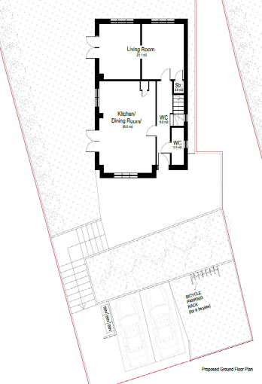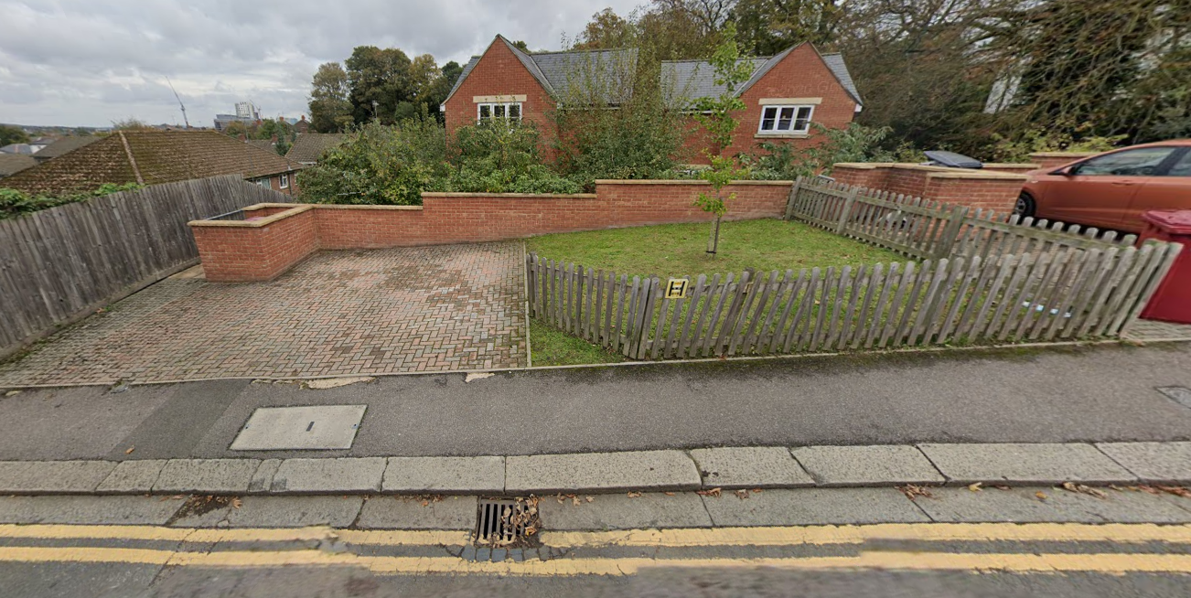

If a new vehicular access is proposed, visibility splays of 2.4m x 43m will be required and must be clearly illustrated on the submitted plans. In addition, a licence from the Highways Authority will be required to undertake any works within the public highway. Existing street furniture and apparatus, including the utility cover within the footway and the highway gully, should also be accurately shown on the drawings.

There are extensive parking restrictions in place within the surrounding area, and as such, overspill parking cannot be accommodated on the adjacent highway network. The Councils Residential Permit Parking Scheme operates in this area and therefore conditions and informatives would be applied to ensure that future occupants are not eligible to apply for permits. It is noted that healthcare professionals may be eligible for healthcare permits, which are issued by the Council’s Permits Team in accordance with their specific eligibility criteria.

In accordance with the Council’s Parking Standards and Design SPD, secure and covered cycle storage should be provided for C2 uses at a ratio of one space per three members of staff. The submitted plans indicate the provision of six cycle racks; however, these are neither secure nor covered. Revised plans are therefore required demonstrating compliant cycle storage. The layout should also clearly illustrate the opening of any access doors to ensure that cycle parking spaces can be accessed without obstruction.

Refuse storage should be located within 15 metres of the site access to minimise the need for service vehicles to remain on the carriageway for extended periods. Provision should accord with the guidance set out in Manual for Streets and BS 5906:2005 (Waste Management in Buildings). The submitted plans show bin storage adjacent to the proposed parking bays, and it is assumed that bins will be presented kerbside for collection. The applicant is advised to liaise with the Council’s Waste and Recycling Team to confirm the appropriate number and type of bins required.

Given the site’s location, a Construction Management Statement (CMS) will be required to manage the impacts of construction activity on the surrounding highway network.

Whilst it is acknowledged that the proposed change of use is unlikely to result in a material increase in trip generation, the matters outlined above must be addressed to ensure the development is acceptable in highways terms. The applicant should therefore be requested to provide confirmation of staffing numbers and shift patterns, along with revised plans addressing cycle storage and access arrangements.

N. Hussain
Transport Development Control Advisor

