DELEGATED APPLICATION REPORT
Ward: Abbey
App Ref:
26/0399
Address:
Station Hill – North Site

Proposals:
Application for Non-material amendment to planning permission reference PL/19/2032 to facilitate amendments Condition 90 (Access)
Applicant: SH Reading Master LLP
Received date: 25 March 2026
Target Decision date: 23 April 2026

- SITE DESCRIPTION
Large scale 3 phase regeneration scheme to south of station. Phases 1 and 2 now substantially complete/occupied. Phase 3 – affected by this condition is an Outline permission.

- PROPOSAL AND SUPPORTING INFORMATION
The condition restricting vehicular access is currently worded as follows:
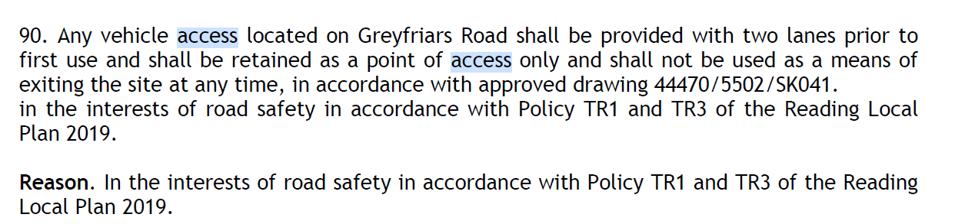

Submitted documents:
Covering Letter

- CONSULTATIONS
Applications under S96A are not applications for planning permission, so are not covered by the publicity requirements as set out in the DMPO.

- APPRAISAL

Condition 90 was necessary due to the large number of parking spaces approved under the original permission (up to 835) and the lack of detail at the time of that permission being granted. By contrast the current Reserved Matters application 26/0415 proposes only two parking spaces and a service bay accessed from Greyfriars Road. It is proposed to amend the condition to allow vehicles to enter and exit from the approved access in accordance with details approved under a Reserved Matters application. As Access is a Reserved Matter this would retain control over the design and nature of the access but allows for a reasonable degree of flexibility specific to the actual detailed Reserved Matters proposal at the point it is approved.

- RECOMMENDATION

CONDITIONS
Amended Condition 90:
No vehicle access shall be provided from Greyfriars Road otherwise than in strict accordance with details submitted concurrently with, and approved pursuant to, the Access, Layout and Appearance Reserved Matters for each Plot within Phase 3 served by that access.
Reason: In the interests of road safety in accordance with Policy TR1 and TR3 of the Reading Local Plan 2019.

INFORMATIVES

1. This notice relates only to the changes to condition 90 of planning permission 192032. It shall only be read in the context of the substantive planning permission and is bound by all the conditions and obligations attached to that permission. That permission still stands and this notice (and any other notices issued under section 96a for this development) should be read together.

2. In reaching this decision, the local planning authority is satisfied that the changes proposed by this application do not constitute material changes to the approved planning permission.

3. This NMA relates to matters under the Planning Acts only. Other licences/approvals may be required.

