17/04/2026
Planning Application Ref: PL/26/0366
Officer: Catrin Davies
Application Type: Listed building consent (Alt/Ext)
Address: Yeomanry House, 131 Castle Hill, Reading
Proposal: Listed Building consent for the conversion of the former Council offices of the Registry and Bereavement
Service to 8 residential dwellings (5 apartments and 3 houses), associated tree works, internal and external alterations, repair works, removal of existing external staircase and extension to the eastern side of the Grade II Listed Property.
Application seeks a change of use from Class E to C3 to provide 8 residential units comprising of 5 Flats and 3 houses on land previously occupied by the Council’s Registration and Bereavement Service. The site is accessed from Castle Hill and shared with the adjacent Berkshire Record Office building.
Yeomanry House is a Grade II listed building and is within the Castle Hill / Russell Street / Oxford Road Conservation Area.
The site is located in Zone 2, Primary Core Area, of the Revised Parking Standards and Design SPD. This zone directly surrounds the Central Core Area and extends to walking distances of 2 kilometres from the centre of Reading. Typically this zone is well served by public transport, with buses continuing either into or out of the Central Core Area via this zone.
In accordance with the adopted Parking Standards and Design SPD the following vehicle parking will be required:

Type of Dwelling | Parking Standards | Required Provision
5 x 1 Bedroom Flats | 1 parking space per unit | 5 spaces
3 x 3 and 4 Bedroom Houses | 2 parking space | 6 Spaces
TOTAL Required |  | 11 Spaces

Submitted site plan (extract below) illustrates 11 parking spaces which is in accord with the requirements of the SPD. However, Parking spaces allocated to plots 6 and 7 should be a minimum of 6m in length. All other parking bays are provided in line with Councils current Parking Standards and Design SPD. Revised plans required.

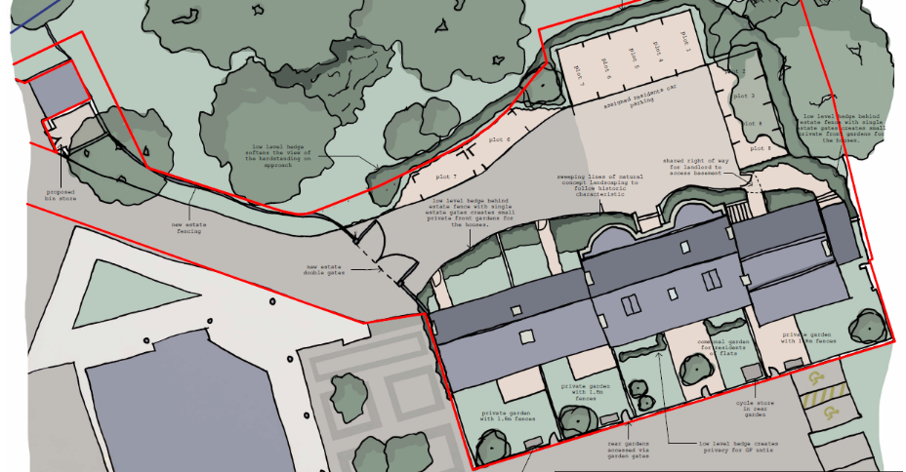

The Council’s Local Transport Plan 3 Strategy 2011 – 2026 includes policies for investing in new infrastructure to improve connections throughout and beyond Reading which include a network of publicly available Electric Vehicle (EV) charging points to encourage and enable low carbon or low energy travel choices for private and public transport. The Councils Local Plan was adopted in November 2019 and this includes a requirement at Policy TR5 for each new house to be provided with an electric charging point. This will need to be illustrated on plans.

The path outside the records office is outside the application redline and therefore the applicant will need to confirm whether they have a right of access over it should they propose to utilise it.

A footway is required from the end of the existing footway 14m into the site to the entrance to the furthest dwelling in line with the below paragraphs from Manual for Streets.

7.2.10 However, shared surfaces can cause problems for some disabled people. People with cognitive difficulties may find the environment difficult to interpret. In addition, the absence of a conventional kerb poses problems for blind or partially-sighted people, who often rely on this feature to find their way around. It is therefore important that shared surface schemes include an alternative means for visually-impaired people to navigate by.

7.2.12 Consultation with the community and users, particularly with disability groups and access officers, is essential when any shared surface scheme is developed. Early indications are that, in many instances, a protected space, with appropriate physical demarcation, will need to be provided, so that those pedestrians who may be unable or unwilling to negotiate priority with vehicles can use the street safely and comfortably.

7.2.13 When designing shared surface schemes, careful attention to detail is required to avoid other problems, such as:

• undifferentiated surfaces leading to poor parking behaviour.
• vulnerable road users feeling threatened by having no space protected from vehicles; and
• the positioning and quantity of planting, street furniture and other features creating visual clutter.

7.2.14 Subject to making suitable provision for disabled people, shared surface streets are likely to work well:

• in short lengths, or where they form cul-de-sacs
• where the volume of motor traffic is below 100 vehicles per hour
• where parking is controlled or it takes place in designated areas.

A electronic gate is proposed serving the proposed residential units set within the site, which is deemed acceptable.

In accordance with the adopted Parking SPD, each house will require a minimum of 2.00 cycle parking spaces. These can be provided in the private garden areas of each dwelling. Each flat would require 0.5 cycle spaces; these should be provided in a secure and covered storage area utilising Sheffield type stands. Submitted plans illustrate storage locations within each private dwelling and communal storage for the flats accessed via the rear of the site. The type of storage unit proposed has not been provided. Clarification is required.

A Bin collection point has been illustrated near the site access. Tracking diagrams of a refuse vehicle entering and exiting the site are required illustrating a refuse vehicle entering and exiting the site. The Councils refuse team should be consulted to ensure the correct type and number of bins are provided.

The number of trips generated by the proposed use would be less than the original Council services operating from the building and therefore the change of use is acceptable.

A CMS would be required for this development if the application was approved.

Please ask the applicant to address the points above so that the application can be fully determined.

N. Hussain
Transport Development Control Advisor

