72 Cressingham Road
Reading, RG2 7 JS
Mr. Gary Miles
Planning, Development & Regulatory Services
Reading Borough Council
Level 2 Front Civic Offices
Bridge Street
Reading, RG1 2LU 12 May 2026

Reference: Application No: PL/26/0509 – 70 Cressingham Road – VAR

Dear Mr. Miles,
Being the adjoining neighbour to 70 Cressingham Road, I would like to comment regarding the application raised with the above reference number.
The drawings provided in favour of the application do not state the measurements of the walls and the roof heights. Since the building has already been constructed, one can make an estimate of the measurements against the neighbouring property which due to being semi-detached has the same measurements.
I evaluated the drawings with my comments as below ( the base picture is extracted from one of the drawings provided titled “PROPOSED PARTY WALL ELEVATION”)
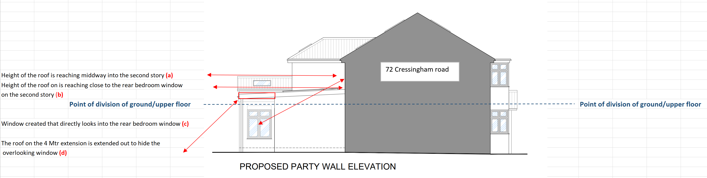

The roof height on the 6 meter extension that is marked in the drawing with (a) possibly extends beyond 6 meters in height as it is raised well into the middle of the second storey, which seems to level with the middle point of the back bedroom window in 72 Cressingham road. The height is restricting the views by not maintaining the 45 degree angle rule.

The roof height on the 4 meter extension that is marked in the drawing with (b) possibly extends to 5 meters in height as it is raised to one-third of the second storey reaching to the lower point of the back bedroom window in 72 Cressingham Road, which is overwhelming as it is built up in close proximity.
My understanding from reading the guidelines from the government site (below link and extract) is that roofs must not exceed more than 3 meters, if the enlargement is close to the boundary line and must not exceed more than 4 meters in height if away from the boundary line.
Permitted development rights for householders: technical guidance - GOV.UK (www.gov.uk)
Relevant extract from the above link:
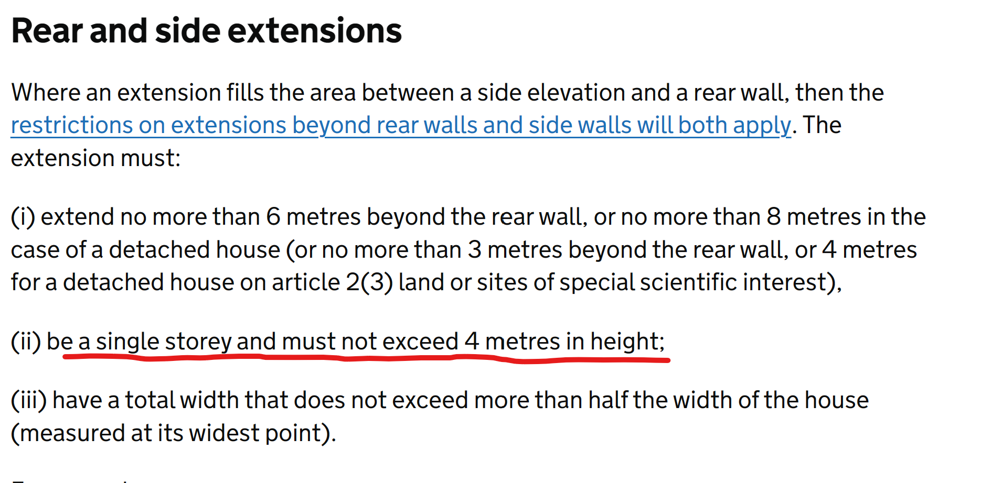

An additional window (that was not included in the plan for application 210199 approved by RBC Planning in 2021 ) has been created on the side of the 6 meter extension (kitchen area), that directly overlooks into the back bedroom window in 72 Cressingham Road, because of the length of the extension that gives a leverage point/ angle to look from. This has compromised the privacy for that bedroom. I have explained it in the drawing with point (c). The roof of the 4 meter extension has been extended forward by approx. 1.5 meters beyond the building to hide that side window (my reference point (d) in the drawing). The extension of the roof makes the total extension look deeper than it is, considering the 4 meter extension has already been built more than 4 meters in depth. Once again this extension of the roof or the overhang was not included in the application.

From the viewpoint of a resident living in the 72 Cressingham Road, the views from the back bedroom window represent an overly built up neighbourhood within close proximity that makes one feel overwhelmed. The semi-detached house unit of No. 72 and No. 70 was built closer towards the road than No. 74, which means that looking out from the direction of back bedroom window at No. 72, on the left side is the No.74 extending out, and now on the right side is No. 70 extending out with raised roofs and walls that make the No.72 feel like being put into a tunnel with building and build up on both sides. The roof on the 4 meter extension at No. 70 as it extends forward, has an approx. 5.5 meter in total depth gives an impression of a much deeper extension and a feeling of setting No.72 more towards the back than it should have been.
I can understand that the roof extended/ overhang on the 4 meter extension is to hide the overlooking window, but that has put a negative impact on No. 72, either in the form of overlooking or the extension of the roof that sets No.72 further towards the back.

My request is that my points of objection are considered where the building works do not comply with regulatory requirements and thus have impacted my property negatively on the points stated above in terms of restriction on views, overly built structure that gives a feeling of being pushed back into a tunnel.

Kind Regards
Kausar Shahid

