27/04/2026
Planning Application Ref: PL/26/0375
Officer: Huimin Chen
Application Type: Householder planning permission
Address: 15 COLEY AVENUE, READING, RG1 6LJ
Proposal: Proposed Single storey Rear and side extension and a Porch
conversion.

Coley Avenue is classified as a C400 road. The application proposes the creation of a new vehicle crossing from Coley Avenue to serve two on-site car parking spaces.
However, aerial imagery indicates the presence of parking provision at the rear of the site. Confirmation is therefore required as to whether this rear area is currently available and usable for parking purposes.

While it was not possible to access the site during the inspection, the aerial images clearly show double gates at the rear (see below), which appear to have been used historically to facilitate vehicle access and parking.

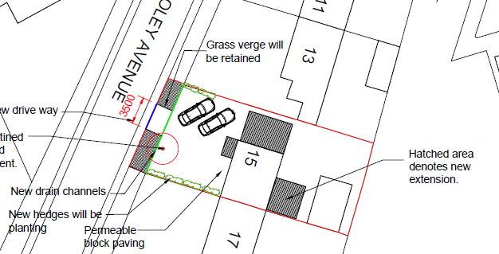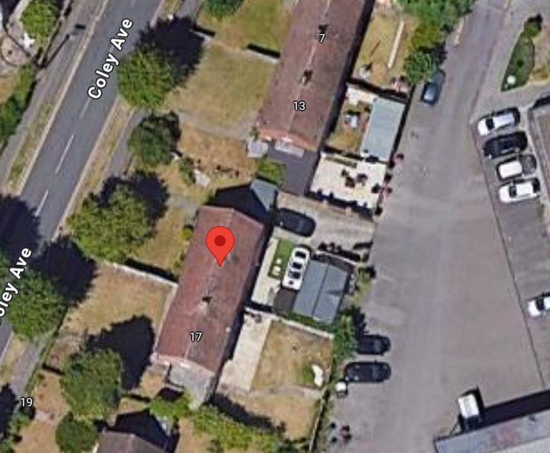

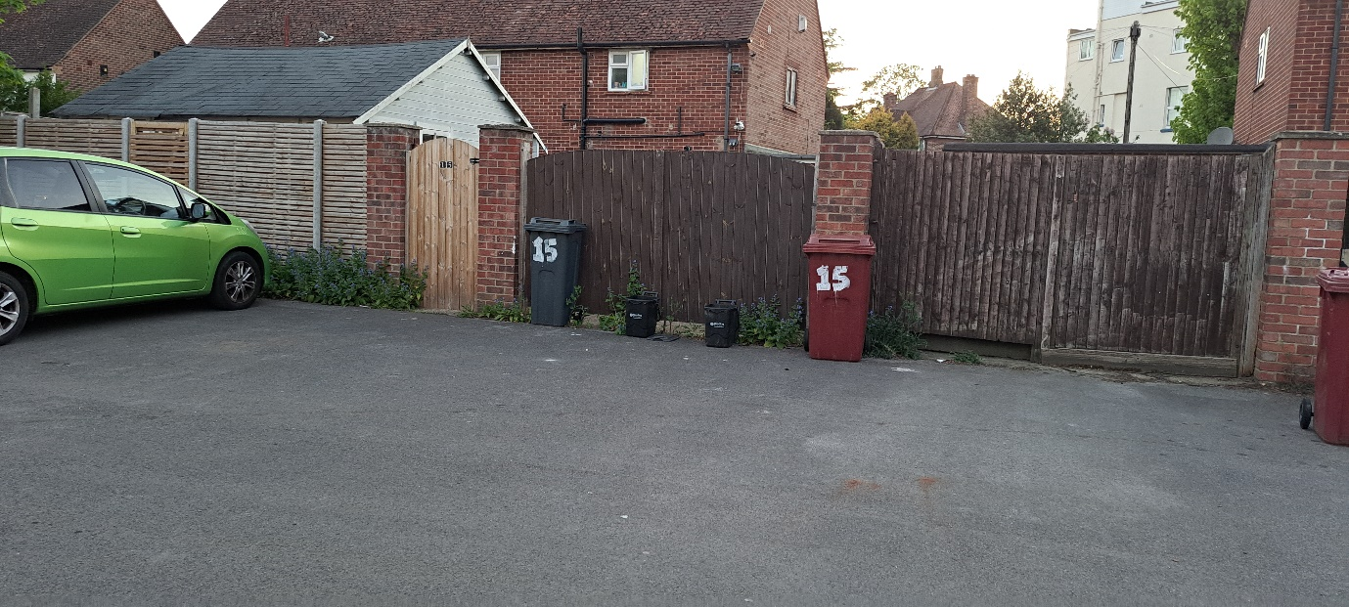
Further information is required to clarify the current status and permitted use of this rear space. If the area is, or can be, used for parking, then in accordance with highway guidance, the creation of a new access onto Coley Avenue would not be supported, as vehicular access would already be available via the classified road network.

In addition, confirmation is required as to whether the applicant has a legal right of access to the area at the rear of the site.

Please provide clarification on:

- The current use of the rear parking area, and
- Whether the applicant benefits from a right of vehicular access to this rear land.

N. Hussain
Transport Development Control advisor

