CONSERVATION

Memo
To: Gary Miles
From: Buju Can Cetin, Conservation Officer
Date: 21/04/2026
Re: Conservation Officer response
Application Number: PL/26/0363
Application Type: Householder planning permission
Address: 20A ELDON PLACE, READING, RG1 4ED
Proposal: Formation of habitable room in roofspace with rear dormer and front velux rooflights

Summary
Object – Reason for Refusal
Because of its width, height, scale, massing, and form, the proposed dormer would be of a boxy appearance and unduly prominent on the host building and the roofscape of Eldon Square Conservation Area, failing to preserve or enhance the character of the conservation area. This would not meet Policies EN1, EN3 and EN6 of the Reading Borough Local Plan, the National Planning Policy Framework, and the Planning (Listed Buildings and Conservation Areas) Act 1990, which seek positive contribution to local character and distinctiveness and enhancement of the significance of the conservation areas.

Relevant policies and legislation
From the point of view of the historic environment, the main statutory tests are set out within the Planning (Listed Buildings and Conservation Areas) Act 1990. Section 72(1) of the Planning (Listed Buildings and Conservation Areas) Act 1990 also requires the Council to pay special attention to the desirability of preserving or enhancing the character and appearance of designated Conservation Areas.
Section 66 of the Act also requires that special regard be given to the desirability of preserving listed buildings, their settings or any features of special architectural or historic interest which they possess.

National Planning Policy and Guidance
The NPPF outlines government policy, including its policy in respect of the historic environment. Chapter 16 of the NPPF (2024) 'Conserving and enhancing the historic environment' sets out the Government's high-level policies concerning heritage and sustainable development.
Paragraph 207 states, “In determining applications, local planning authorities should require an applicant to describe the significance of any heritage assets affected, including any contribution made by their setting. “ And Paragraph 208 says, “Local planning authorities should identify and assess the particular significance of any heritage asset that may be affected by a proposal (including by development affecting the setting of a heritage asset) taking account of the available evidence and any necessary expertise. They should take this into account when considering the impact of a proposal on a heritage asset, to avoid or minimise any conflict between the heritage asset’s conservation and any aspect of the proposal.”
Paragraph 212 of the NPPF requires that ‘when considering the impact of a proposed development on the significance of a designated heritage asset, great weight should be given to the asset’s conservation….’ And paragraph 213 says, ‘any harm to, or loss of, the significance of a designated heritage asset (from its alteration or destruction, or from development within its setting) should require clear and convincing justification’.
Paragraph 215 requires that ‘where a development proposal will lead to less than substantial harm to the significance of a designated heritage asset, this harm should be weighed against the public benefits of the proposal…’
National Planning Practice Guidance on Historic Environment provides context to the NPPF.

Local Planning Policy and Guidance
Policy EN1 ‘Protection and enhancement of the historic environment’ of the Reading Borough Local Plan sets out the Council’s aspirations for the historic environment. The policy requires that all proposals to protect and, where possible, enhance the significance of heritage assets and their settings, historic character and local distinctiveness of the area in which they are located. It echoes the NPPF by stating, “Proposals should seek to avoid harm in the first instance. Any harm to or loss of a heritage asset should require clear and convincing justification, usually in the form of public benefits”.
Policy EN3 ‘Enhancement of conservation areas’ of the Reading Borough Local Plan requires that development proposals within Conservation Areas contribute positively to local character and distinctiveness. This policy states, “Development proposals within Conservation Areas must make a positive contribution to local character and distinctiveness. Positive consideration will be given to proposals which take opportunities to enhance the character of conservation areas.”
Policy EN6 ‘New development in a historic context’ also requires “New development will make a contribution to the historic character of the area by respecting and enhancing its architectural and visual qualities and considering how heritage considerations can influence the design of new development. When determining planning applications for new development, the following factors will be taken into consideration:
a. The positive contribution of the development to the existing historic townscape (scale, height, mass, proportion, plot size, street form, materials, significant vistas and views, and open space);
b. Sensitivity to historic context;
c. Reflection of borough-wide major heritage themes that contribute to local distinctiveness (e.g. patterned brickwork or former worker terraced housing);
d. Whether development promotes and/or improves access to previously undiscovered or neglected historic significance.”

Eldon Square Area Appraisal (March 2026) is also a material consideration in determining applications for development.
Other
Historic England Advice Note 2 – Making changes to Heritage Assets illustrates the application of policies set out in the NPPF in determining applications for Planning Permission and Listed Building Consent.
English Heritage’s “Conservation Principles” provides policy and guidance for the “sustainable
management of the historic environment”.

Relevant heritage assets
The application relates to a semi-detached, two-storey, modern, unlisted building located within the Eldon Square Conservation Area. As illustrated below, 28 and 30 Eldon Road, 20 and 22 Eldon Road, face their rear boundaries, and buildings of townscape merit (BTMs) No. 20 Eldon Place, adjacent to the site to the north and the rear boundary of 26 and 24 Eldon Road.
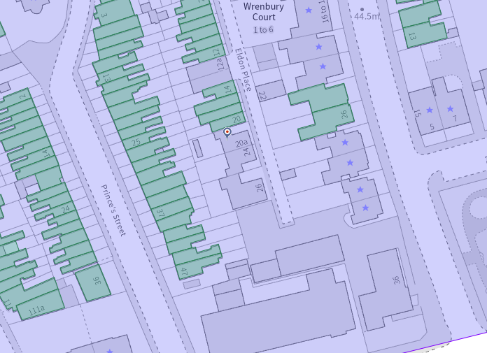
The application site (circled in red) within the Eldon Square Conservation Area (light purple), the buildings of townscape merit are shown in green, and the listed buildings have stars on them

Significance of heritage assets
The NPPF defines significance as the “value of a heritage asset to this and future generations because of its heritage interest.”

The interest may be architectural or historic, as set out in the Town and Country Planning (Listed Building and Conservation Areas) Act 1990 Section 1.

“Significance derives not only from a heritage asset’s physical presence, but also from its setting.” (NPPF, 2023)

Historic England assesses significance in a similar manner, referring to evidential, historic, aesthetic and communal values of a place.

The application site is situated in the Character Area 2 – Terraced streets west of Eldon Road of the conservation area. About the Eldon Place, the Eldon Square Conservation Area Appraisal States:

“The other side-streets in this area are narrower and have a more intimate feel than Watlington Street and two storeys is the norm. St Johns Street, St Johns Road, St Johns Hill, Princes Street and Eldon Place are characterized by short rows of modest two-storey terraced housing built to accommodate Reading’s expansion in the mid/late nineteenth century.”

“Eldon Place is accessible from St Johns Road and is a service road for Eldon Road properties. There are five modern infill properties, three built on the rear gardens of Princes Street and two in the middle where there was a large property which was last used as a warehouse but had had previous light industrial uses.”

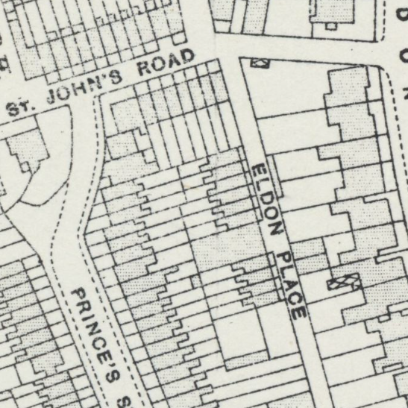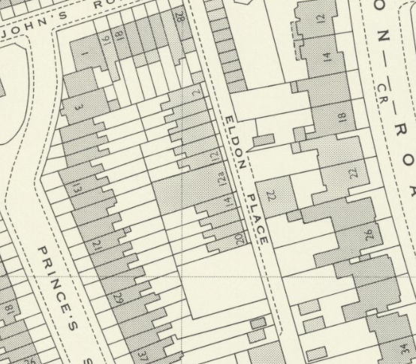
The OS Maps of 1931 to 1932 (Published in 1934, Left) and 1971 (Right) with the application site circled in red

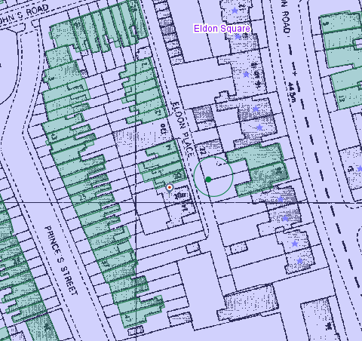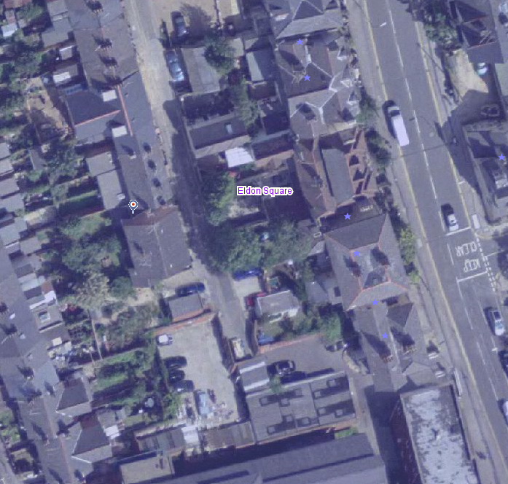
The application site in the 1990s (from the Council’s Historic Mapping Tool, Left) and on Aerial Photograph of 2002 (from the Council’s Historic Mapping Tool, Right)

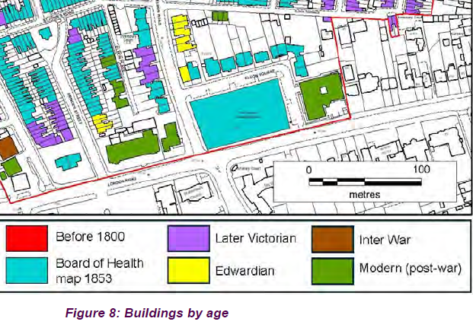
Period of buildings in Eldon Square Conservation Area with the application site circled in red (from the Eldon Square Conservation Area Appraisal, page 20)

Whilst the subject building is modern, it has a width, height, scale, design, façade organisation and materials that are in harmony with the characteristics of the conservation area, not detracting from the significance of the area or the settings of listed buildings and BTMs.

Impact of proposal upon heritage asset(s)
The proposal is for a loft conversion with a rear dormer that would have a flat roof in line with the ridge level, occupying 4.4m in width, almost the same as the main building, a little set back from the eaves, and two rooflights on the front roof slope.
Whilst the building is modern and a loft conversion could be acceptable in principle, given the modest scale of the building and the character of the conservation area with a roofscape of small dormers, traditional roof forms and generally one rooflight, the proposed dormer would not be a suitable addition to the area or a subordinate or subservient element to the host building (see the aerial view below).
In terms of proposed dormer windows, they are not in proportionate with the existing openings of the main building. Although the proposed materials would match the existing ones, the design of the rear dormer would differ from the rest of the building.
Therefore, the proposed rear dormer would be bulky and boxy, adversely affecting the character of the conservation area. Due to its height, scale and massing, the proposed dormer would be a dominating addition to the host building, failing to comply with policies EN1, EN3 and EN6 of the Reading Borough Local Plan and is recommended for refusal, whilst the proposed rooflights could be acceptable.

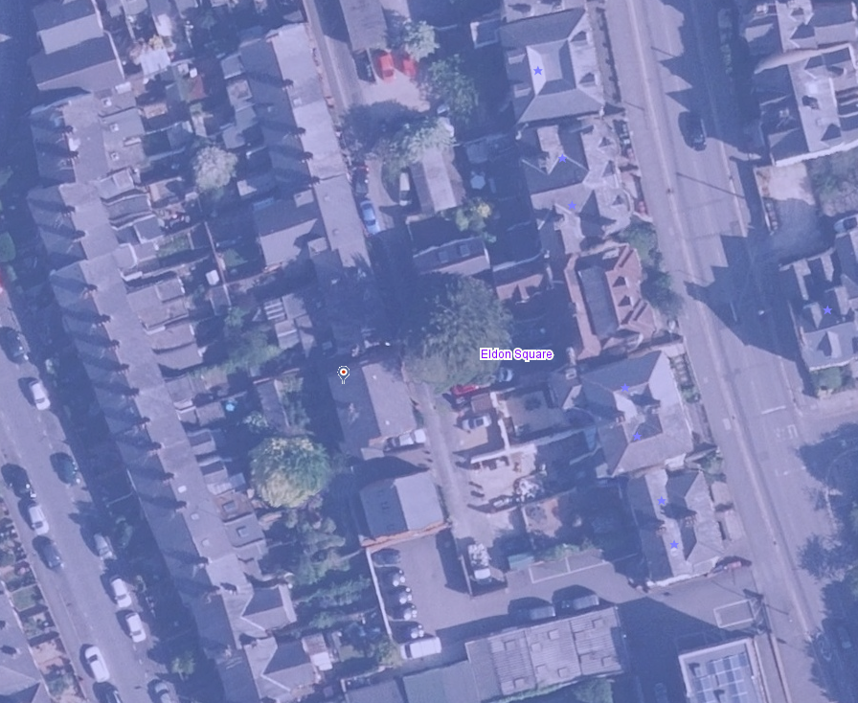
Aerial Photograph, present time (from the Council’s Historic Mapping Tool, Right) – Existing Roofscape
Suggested Reason for Refusal
Because of its width, height, scale, massing, and form, the proposed dormer would be of a boxy appearance and unduly prominent on the host building and the roofscape of Eldon Square Conservation Area, failing to preserve or enhance the character of the conservation area. This would not meet Policies EN1, EN3 and EN6 of the Reading Borough Local Plan, the National Planning Policy Framework, and the Planning (Listed Buildings and Conservation Areas) Act 1990, which seek positive contribution to local character and distinctiveness and enhancement of the significance of the conservation areas.
Conservation response
No objections
No objections subject to conditions attached
Clarification required
Object

Contact details
Buju Can Cetin, Conservation Officer
Burcu.CanCetin@reading.gov.uk

