DELEGATED APPLICATION REPORT
Ward: Katesgrove
App Ref: PL/24/0307 Full planning permission
Address: 176 Northumberland Avenue Reading RG2 7PU
Proposal: Application to redefine boundaries between 176 & 176a, internal alterations, and elevation changes
Applicant: Mr Rishi Mosaheb
Received date: 2024-03-08
Target Decision date: 20th September 2024 (EXT)
Case Officer: Chukwudi Onwudinanti

- SITE DESCRIPTION
The site is a two-storey building on the eastern side of Northumberland Avenue, in a predominantly residential area. The area is characterised by dwellings of varied styles and sizes. The building is divided into two addresses, 176a (ground floor flat) and No 176 (two storey apartment). The existing garden to the rear is shared by the two addresses.

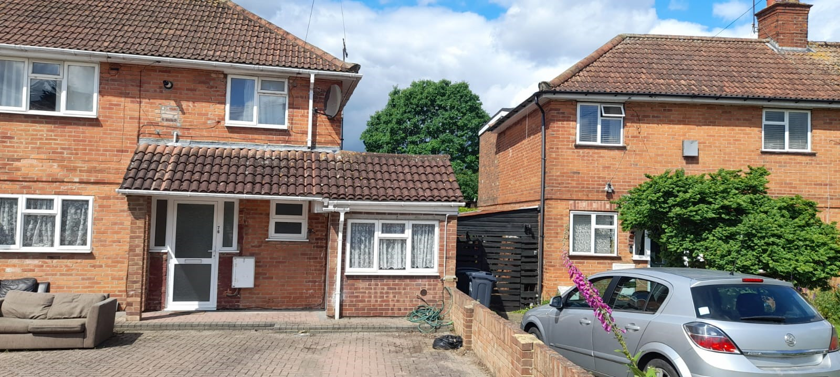
Site Photo

- PROPOSAL AND SUPPORTING INFORMATION
The proposal seeks to include boundary fencing to create a garden specific to 176a, such that no. 176’s garden would be ‘l’ shaped (see proposed block plan extract below). The proposal also includes proposed rear patios and internal alterations and changes to the elevations which include the following: changes to the fenestration on the front elevation and consequent relocation of the front door to the flat at 176a. The paved parking area to the front would remain unchanged.

Plans considered dated 02/2024 received 11/03/2024:

Drawing No 02-00 Location Plan
Drawing No 02-01 Block Plan as Existing
Drawing No 03-00 Floor Plans as Existing
Drawing No 05-00 Elevations as Existing
Drawing No 02-10 Block Plan as Proposed
Drawing No 03-10 Floor Plan as Proposed
Drawing No 05-10 Elevations as Proposed

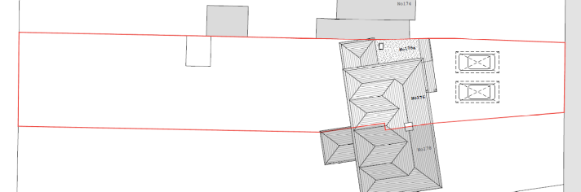
Existing Location Plan

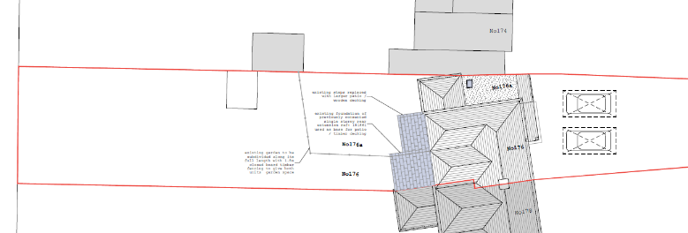
Proposed Block Plan

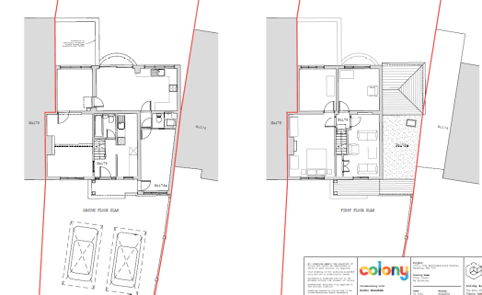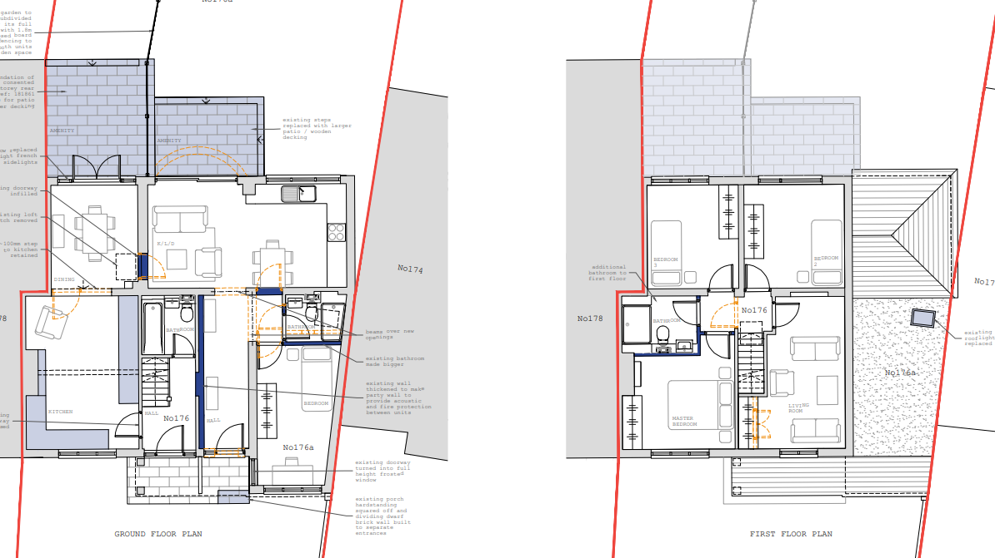
Existing Floor Plans Proposed Plans

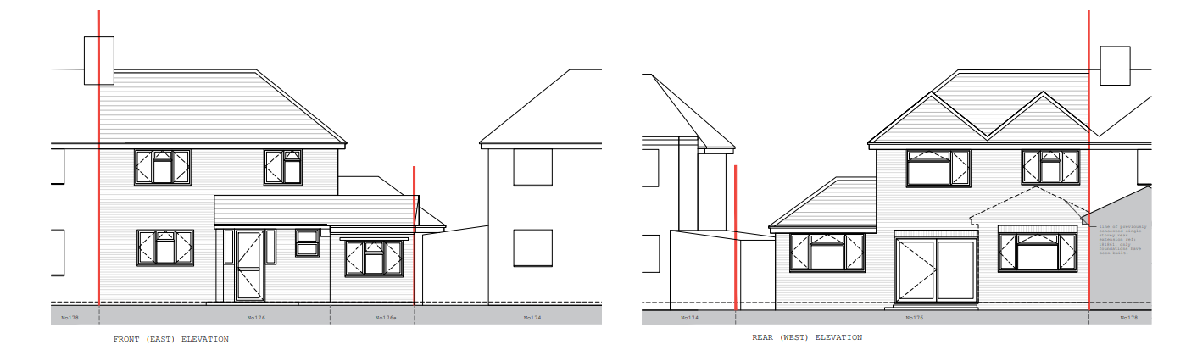
Existing Elevations
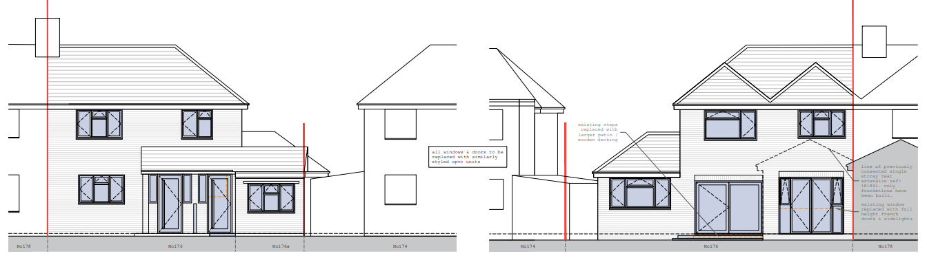
Proposed Elevations
- RELEVANT PLANNING HISTORY
App Ref: 131531/CLE
Description: Certificate of Lawfulness for existing use of property as 2 flats
Decision: Granted
Decision Date: 13/1/2014

App Ref: 140071/HOU
Description: First floor rear extension to 176 Northumberland Avenue and first and
second floor rear extensions to 178 Northumberland Avenue.
Decision: Application Permitted
Decision Date: 09/06/2014

App Ref: 190053/HOU
Description: Single storey rear extension
Decision: Application Permitted
Decision Date: 26/2/2019

- CONSULTATIONS
A site notice was displayed on site.

No letters of representation have been received.

- LEGAL AND PLANNING POLICY CONTEXT

Equality Act 2010:
In determining this application, the Council is required to have regard to its obligations under the Equality Act 2010. However, there is no indication or evidence (including from consultation on the application) that the protected groups identified by the Act have or will have different needs, experiences, issues and priorities in relation to this particular planning application. Therefore, in terms of the key equalities protected characteristics it is considered there would be no significant adverse impacts as a result of the development.

National Policy
National Planning Policy Framework
National Planning Practice Guidance

Reading Borough Local Plan (2019)
CC7: (Design and The Public Realm)
CC8: (Safeguarding Amenity)
H1: (Provision of Housing)
H7: (Protecting the Existing Housing Stock)
H9: (House Extensions and Ancillary Accommodation)
H10: (Private and Communal Outdoor Space)

- APPRAISAL

Principle of development

The development proposed in this application seeks to create a new entrance door to the ground floor flat (No 176a). It also seeks to create a hallway for the ground floor flat, using the existing open plan stairs/kitchen area of No 176 while creating a new kitchen for that address. The common garden behind (Nos 176 and 176a) would be split into two exclusive gardens, with the garden for No 176 being the much larger.

In general, it is considered that the principle of the development would be supported, as the ground floor flat is increased in size and the amenity overall for the two addresses are enhanced through better layout and better standard of accommodation.

Character and Appearance

Policy H9 states that an extension to a house will be acceptable where it respects the character of the house in terms of scale, location, materials, and design and respects the character and pattern of neighbouring properties and the street as a whole in terms of scale, location, materials and design, and any important existing building line. Policy CC7 also sets out relevant considerations for design.

The alteration to the position of the entrance door for No 176a is minimal and would not significantly impact on the character of the building. Whilst this development would create an additional door on the Principal Elevation, the impact on the existing fenestration is not significant as there are no other changes to the fenestration proposed.

In general terms, it is considered that the scale of the alterations proposed would not have a significant impact on the character of the original dwelling.

Residential Amenity

Policy H9 states that an extension will be acceptable where it does not result in an overbearing impact on neighbours. Policy H10 seeks to ensure that the amenity of gardens and other outdoor areas are not compromised. Policy CC8 states an extension to a house will be acceptable where it will not cause a significant detrimental impact to the living environment of existing or new residential properties.

The development increases the size of the ground floor flat internally without negatively impacting on the amenity of No 176. The creation of exclusive gardens for the two addresses is also considered to be an enhancement in the amenity of the two addresses. The proposed patios to the rear would not have any negative impacts on the amenity of the users of the two apartments.

It is not considered that there would be any negative impacts on the amenity of no. 174 and 178. The existing parking arrangement would also be sufficient for the new arrangements.

- CONCLUSION
The proposed development has been assessed as set out above and is considered to be acceptable on that basis, subject to the following conditions.

- RECOMMENDATION
Approve with Conditions

Recommended Conditions:
Time Limit Standards
Approved Plans
Materials As Specified

