 | RBC Comment | Packaged Living response | Comments
1 | ATE Assessment - Updated to account for routes to Public Transport and Local Amenities | Updated information to be provided to RBC Transport for comment | Stantec have agreed with RBC that the ATE Tool is not required and that the previous Tech Note can be updated to include all facilities, not focus on Education. This will be issued to RBC via separate issue.
2 | Cycle Parking Spaces and seating cubes within public highway (Tow-path) - Need to be relocated to count towards visitor parking | Cycle Parking spaces have been removed from the towpath. Relocation options are now provided for RBC Transport and Planning’s consideration. | Extract below identifies relocation of spaces to the public courtyard.  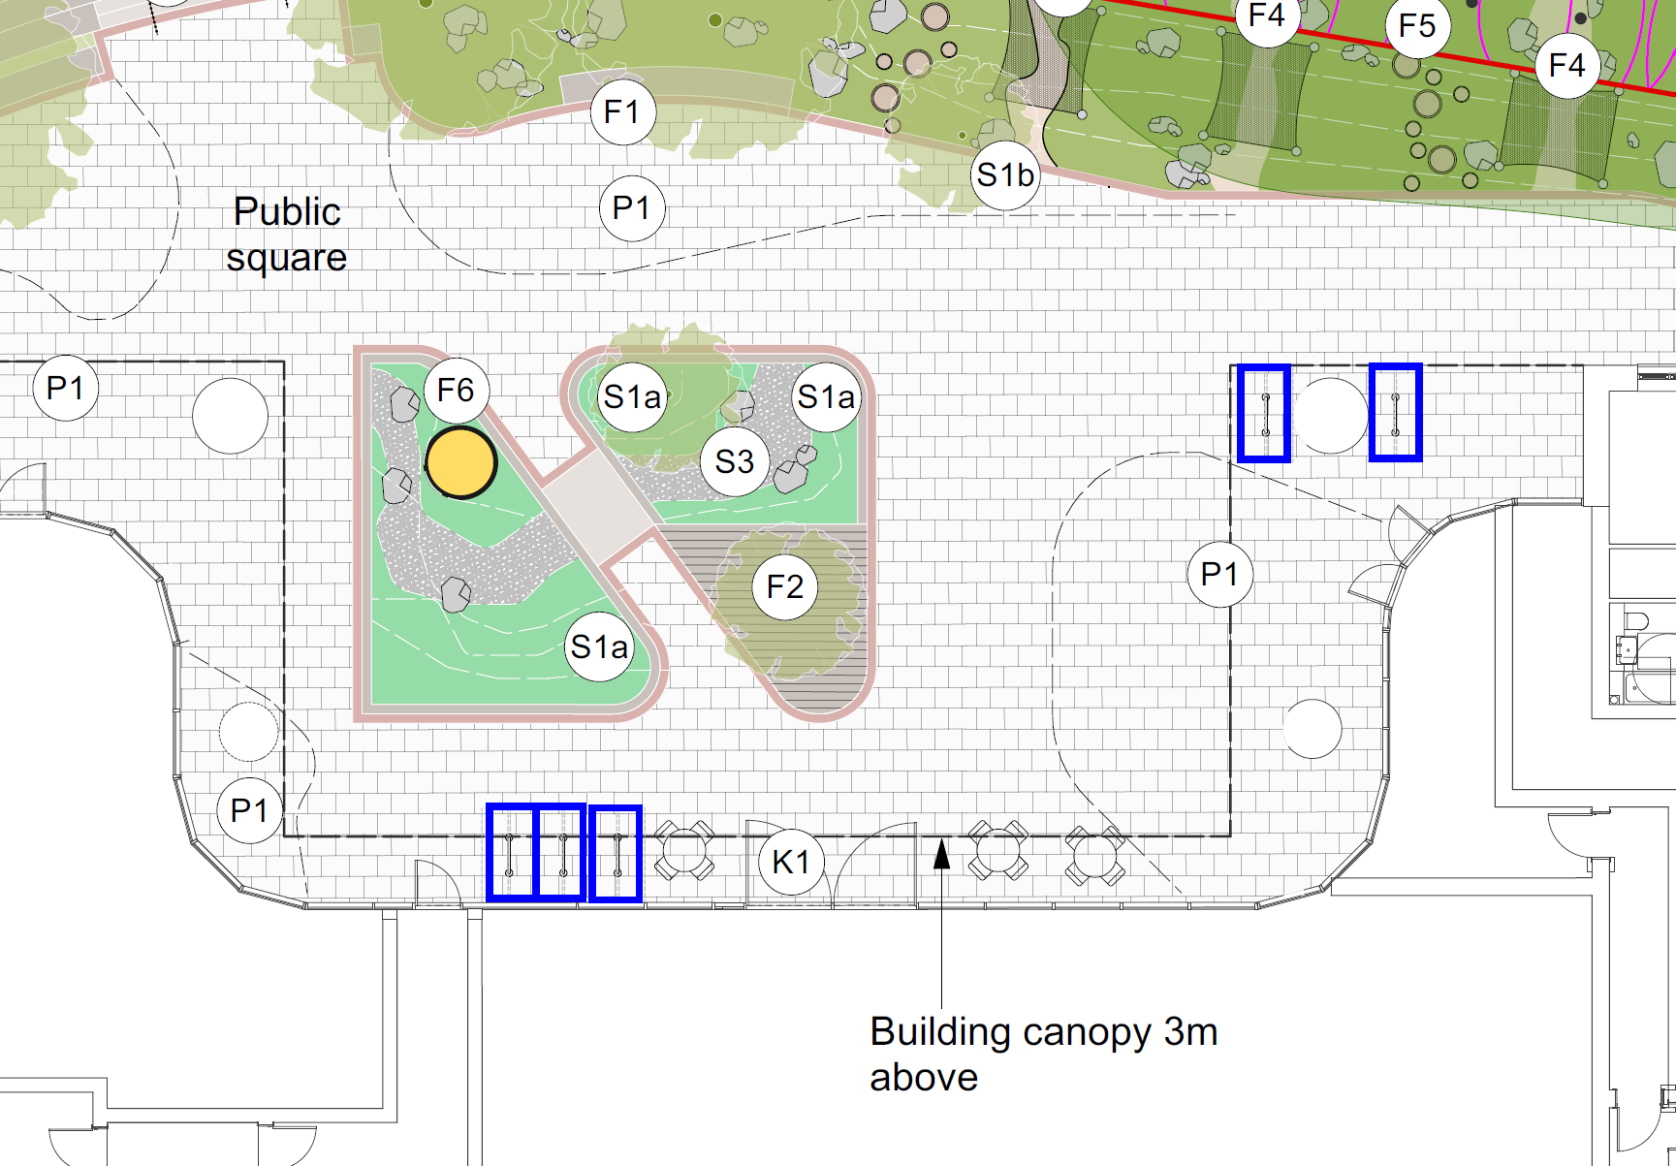
3 | Pedestrian route north of the bin presentation area needs to be 2m, currently there are conflicts with the landscaped area | See updated drawing 0006_P11  Extract inserted to show path provision | 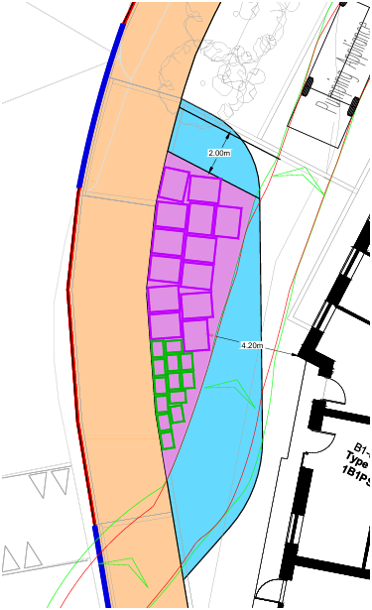
4 | Bin presentation area is considered not to work in practice. There are potential conflicts with pedestrians and vehicles | See updated drawing 0006_P11  Extract of Plan inserted  Extract of Landscape inserted | Plan shows that refuse area will be denoted by metal studs  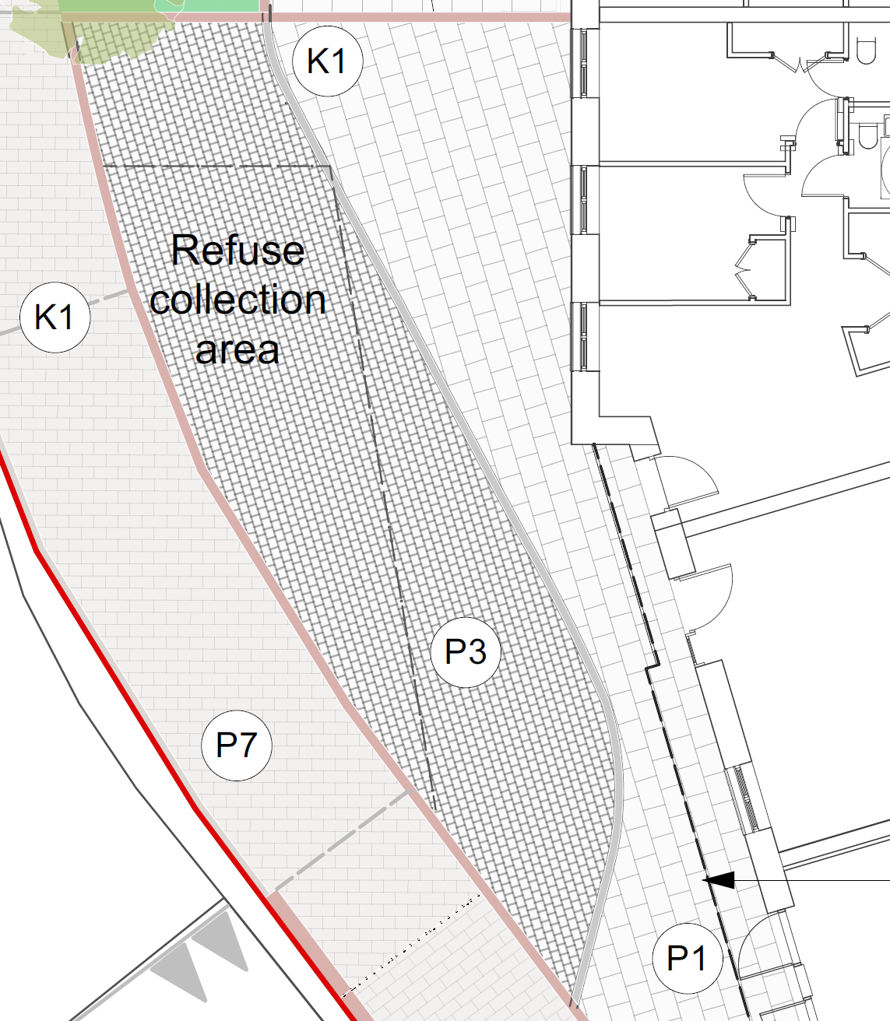
5 | Refuse strategy - Agreement with the RBC Waste team to ensure drawings are illustrating the correct number of bins | 13no 1,100l Eurobins and 13no 240l are shown. See updated drawing 0006_P11 | For the purpose of planning we believe that we have shown sufficient evidence to support the application, however if RBC seek a formal Waste Strategy agreement this can be conditioned.
6 | Vastern Road Trees - Interaction between trees, signs and Clearwater Court  Western tree position has been moved and reduces the effective cycleway width, this needs to be relocated to its original position | Further to input from Hexa, 3no trees are proposed to the front of the building, which accounts for the 2no trees previously proposed on Vastern Road and relocation of the tree previously located on the south-western corner of the building. See updated drawing A4012E-ASA-XX-00-DR-L-0200, Rev P5 | Visibility issues no longer relevant to trees given relocation within the red line and to the front of the building.
7 | Norman Place – location that visibility is taken from needs updating |  | Not Required following Tree Removal
8 | Vastern Road – dimensions and location that visibility is taken from needs updating |  | Not Required following Tree Removal
9 | Car Park Access – Corduroy paving/Visibility Splay to the North / Give Way markings, needs updating | See updated drawing 0023A_P05 | Landscape plan also updated to remove tactile paving.
10 | Loading Area – southern drop kerb to be extended | See updated drawing 0023A_P05 | Extended Drop Kerbs Provided
11 | Cycle parking to front of building – to be updated in line with standards | See updating drawing A4012E-ASA-XX-00-DR-L-0200, Rev P5 | Amendments as per RBC Standards included
12 | Pumping Appliance Tracking – illustrate the distance between the vehicle and building is greater than 500mm | See updated drawing 0021_P09 | Minor encroachment inside clearance areas, but these are minimal and plans shows sufficient safe width to support fire access to rear of building

