DELEGATED APPLICATION REPORT
Ward: Southcote
App Ref: PL/25/1592 Householder planning permission
Address: 80 HATFORD ROAD, READING, RG30 3HP
Proposal: Proposed first floor side extension (Amended)
Applicant: Mr Khalid
Received date: 06/11/2025
Target Decision date: 05/05/2026 (EXT)
Case Officer: Chukwudi Onwudinanti

1. SITE DESCRIPTION

The application site comprises a detached residential dwelling located on Hatford Road within a predominantly residential area characterised by a mix of detached and semi-detached properties of varied design and scale. The site benefits from a relatively generous plot with front parking provision and a rear garden area. The area is characterised by properties with extensions similar to the one proposed, including on the other side of the semi.
The surrounding area is suburban in character with established building lines and consistent residential use. As stated above, the adjoining property on the side of the extension has a similar first floor side extension, as shown in the site photos below.
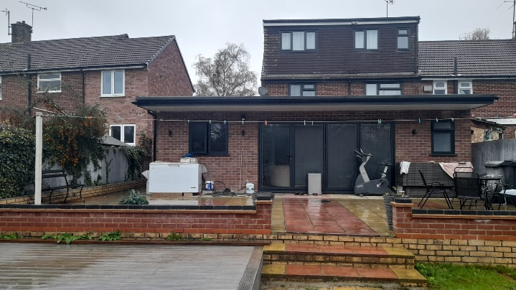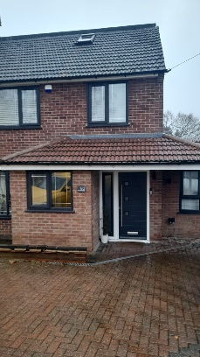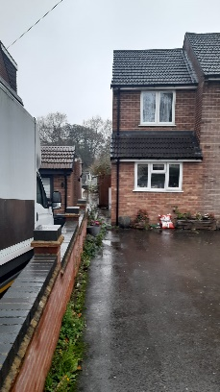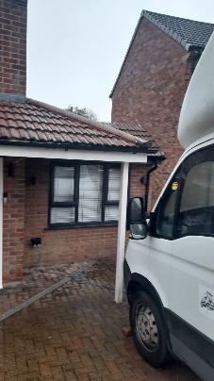
Site Photos

2. PROPOSAL AND SUPPORTING INFORMATION

The application seeks planning permission for a first floor side extension.

The proposed development includes:
- Two-storey side extension integrated with the existing dwelling
- Internal reconfiguration to provide additional bedroom accommodation

The proposed materials include fair-faced brickwork, roof tiles and UPVC windows to match the existing dwelling.

Plans and Documents
Dated May 2022
Location Plan
Drawing No E-X-001: Existing Plans & Elevations received 06/11/2025
Drawing No A-L-001 Rev A: Proposed Plans & Elevations received 11/02/2026

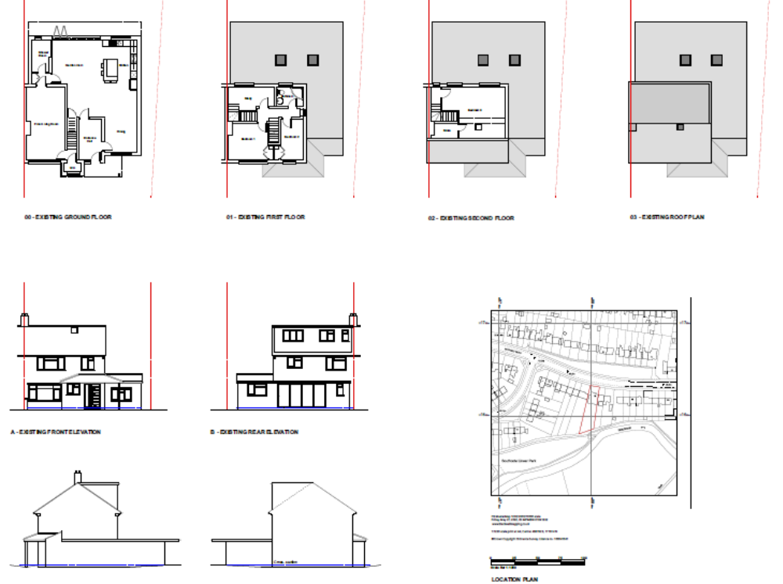

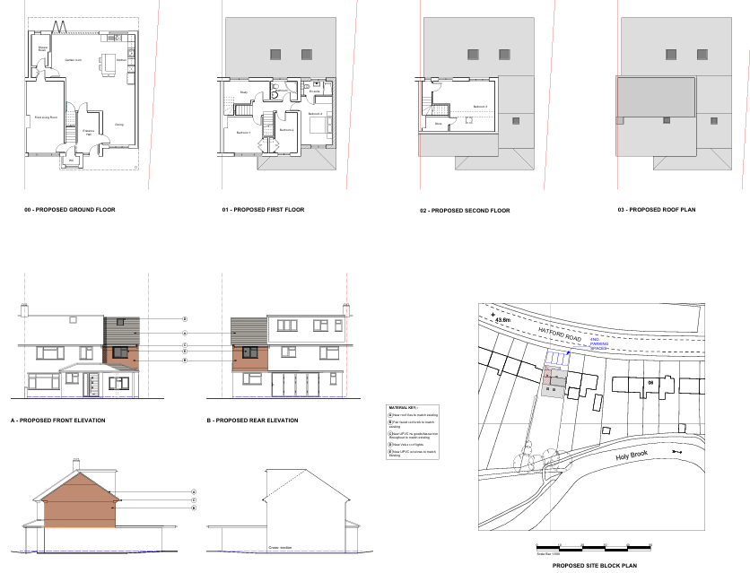
Existing and Proposed Plans and Elevations

3. RELEVANT PLANNING HISTORY

App Ref: PL/00/1220
Description: Erection of extension at 1st and 2nd storey level above existing single storey extension to dwelling
Decision: Refused
Date: 06/02/2000

App Ref: PL/02/1283
Description: Detached garden room
Decision: Refused
Date: 06/03/2003

App Ref: PL/07/1213
Description: Single storey rear extension
Decision: Approved
Date: 17/09/2007

App Ref: PL/22/1086
Description: Proposed rear extension following removal of
existing conservatory
Decision: Approved
Date: 02/02/2023

4. CONSULTATIONS
A Site Notice was put up 14/11/2025
No letter of objection has been received.

Discussions with Agent.
The revised scheme represents a reduction in scale compared to the originally submitted proposal, with the ridge stepped down from the existing roof ridge and the loft extension removed. The development now presents as a more modest and subordinate addition to the host dwelling

Equality Act 2010:
In determining this application, the Council is required to have regard to its obligations under the Equality Act 2010. However, there is no indication or evidence (including from consultation on the application) that the protected groups identified by the Act have or will have different needs, experiences, issues and priorities in relation to this particular planning application. Therefore, in terms of the key equalities protected characteristics it is considered there would be no significant adverse impacts as a result of the development.

5. LEGAL AND PLANNING POLICY CONTEXT
Section 38(6) of the Planning and Compulsory Purchase Act 2004 requires that proposals be determined in accordance with the development plan unless material considerations indicate otherwise.

National Policy
National Planning Policy Framework
National Planning Practice Guidance

Reading Borough Local Plan (2019)
CC1 (Presumption in Favour of Sustainable Development)
CC7 (Design and the Public Realm)
CC8 (Safeguarding Amenity)
H9 (House Extensions and Ancillary Accommodation)
H10 (Private and Communal Outdoor Space)

SPD
Design Guide to House Extensions SPD 2021

Local Plan Update
The current version of the Local Plan (adopted in November 2019) turned five years old on Tuesday 5th November 2024. The Local Plan was reviewed in March 2023 and around half of the policies in the plan are considered still up to date. However, the rest need to be considered for updating to reflect changing circumstances and national policy. A submission draft was submitted on 9th May 2025.

Although there is a five-year period for carrying out a review of a plan after it is adopted, nothing in the NPPF or elsewhere says that policies automatically become “out of date” when they are five years old. It is a matter of planning judgement rather than legal fact whether a plan or policies within it are out-of-date. This will depend on whether they have been overtaken by things that have happened since the plan was adopted, either on the ground or through changes in national policy, for example.

Officer advice in respect of the Local Plan policies pertinent to this application listed above is that they remain in accordance with national policy and that the objectives of those policies remain very similar in the draft updated Local Plan. Therefore, they can continue to be afforded weight in the appraisal below and are not considered to be ‘out of date’.

Equality Act 2010:
In determining this application, the Council is required to have regard to its obligations under the Equality Act 2010. However, there is no indication or evidence (including from consultation on the application) that the protected groups identified by the Act have or will have different needs, experiences, issues and priorities in relation to this particular planning application. Therefore, in terms of the key equalities protected characteristics it is considered there would be no significant adverse impacts as a result of the development.

6. APPRAISAL

Character and Appearance
Policy CC7 requires development to be of a high design quality that respects and enhances the character and appearance of the area. Policy H9 requires extensions to be proportionate and sympathetic to the host dwelling.
The proposed extension would increase the scale and mass of the dwelling, through the addition of a first floor side element. However, the extension is designed to integrate with the host dwelling through matching materials and a roof form that reflects the existing structure, stepped down from the host dwelling’s ridge. The front porch extension will mimic what is already existing on the other side of the semi.
The proposal would not appear incongruous within the street scene and would maintain the residential character of the area.
The development is, therefore, considered to comply with Policies CC7 and H9.

Residential Amenity
Policy H9 states that an extension will be acceptable where it does not result in an overbearing impact on neighbours. Policy H10 seeks to ensure that the amenity of gardens and other outdoor areas are not compromised. Policy CC8 states an extension to a house will be acceptable where it will not cause a significant detrimental impact to the living environment of existing or new residential properties.

The proposed extension would introduce additional built form; however, it is not considered that the development would result in unacceptable loss of light, outlook or privacy to neighbouring properties. The two-storey extension does not project beyond the backline of the existing dwelling and there are no side windows on the adjoining property which could be additionally impacted by the new gable end wall. It is also pulled back from the boundary between the two dwellings, maintaining gaps between dwellings. The positioning and design of the extension ensure that any impacts are limited and typical of residential extensions.
The proposal is therefore considered to comply with Policy CC8.
Private Amenity Space
Policy H10 seeks to ensure that adequate outdoor amenity space is retained.

Whilst the proposal increases the roof height of the outrigger to the side, the built footprint remains same, therefore sufficient private amenity space would remain to serve the dwelling.

The proposal complies with Policy H10.

7. CONCLUSION

The proposed development has been assessed as set out above and is considered to be acceptable.

8. RECOMMENDATION: Grant

Recommended Conditions:
Approved Plans
Time Limit Standards
Materials to Match Existing
No New Openings

