29/04/2026
Planning Application Ref: PL/26/0481
Officer: Huimin Chen
Application Type: Householder planning permission
Address: 91 SWALLOWS CROFT, READING, RG1 6EH
Proposal: Proposed single storey rear extension and a garage
conversion.

Application will result in the loss of the integral garage and therefore the loss of parking.

To compensate for the loss of parking an extra parking space is to be provided to the frontage of the site, this will result in the loss of some landscaping as shown in the google image below, but will allow for the retention of the required parking provision of two cars.

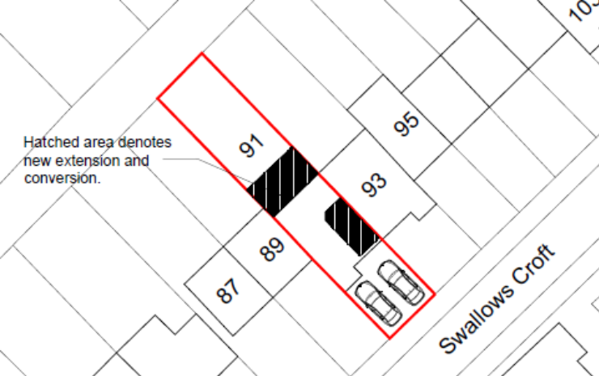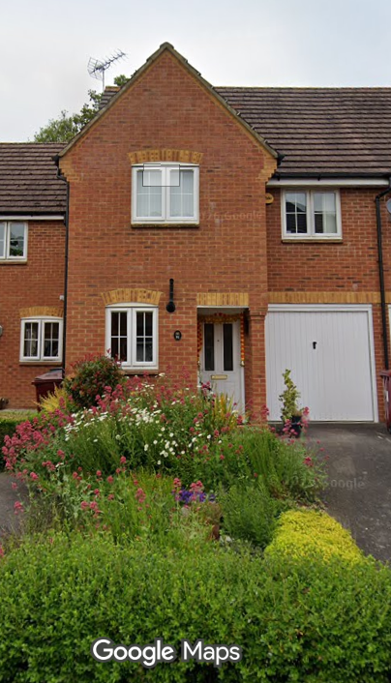

No change to the existing vehicle access is proposed. Provision is deemed acceptable from a Highways perspective. The NE officer should be consulted regarding the loss of the planting in the front garden area.

N. Hussain
Transport development Control Advisor

