DELEGATED APPLICATION REPORT
Ward: Emmer Green
App Ref: PL/25/1343 Householder planning permission
Address: 51 KNIGHTS WAY, EMMER GREEN, READING, RG4 8RJ
Proposal: Proposed single storey front and rear extension
Applicant: Mrs Kate Elsby
Received date: 23/09/2025
Target Decision date: 24/04/2026 (EXT)
Case Officer: Chukwudi Onwudinanti

1. SITE DESCRIPTION

The application site comprises a detached dwelling located within an established residential area of Emmer Green. The property is set within a linear residential street characterised by similar detached dwellings with front driveways and rear gardens. There is an existing rear extension.

The surrounding area is suburban in character with a varied pattern of extensions and alterations evident.

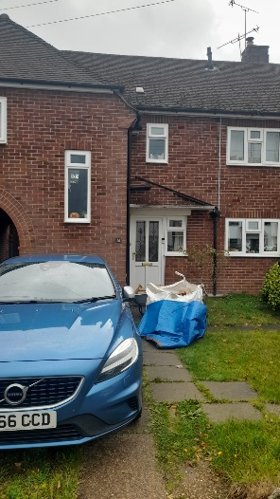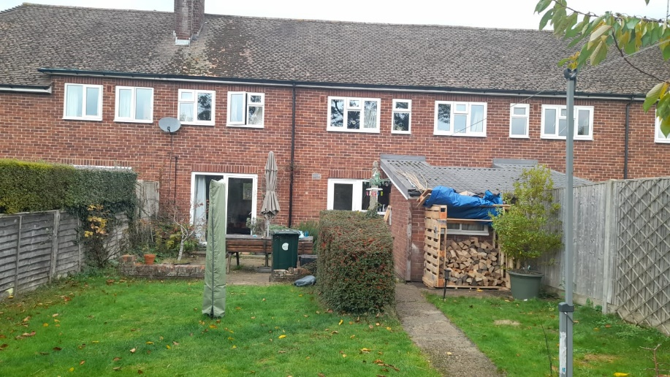
Site Photos

2. PROPOSAL AND SUPPORTING INFORMATION

The application seeks planning permission for:
- Open sided canopy front porch
- Single storey rear extension
- Associated internal reconfiguration

The proposal includes enlargement of the ground floor to provide an open-plan kitchen/dining/living space to the rear and a modest extension to the front elevation.

External materials are proposed to match the existing dwelling, including red facing brickwork and brown clay roof tiles.

Plans and Documents
Dated August 2025, Received 23/09/2026
- Drawing No 25050.PP-01 – Existing Ground Floor Plan
- Drawing No 25050.PP-02 – Existing First Floor Plan
- Drawing No 25050.PP-03 – Existing Elevations
- Drawing No 25050.PP-08 - Location Plan
- Drawing No 1BA0183 02 – Proposed Plans and Elevations received 05/11/2025

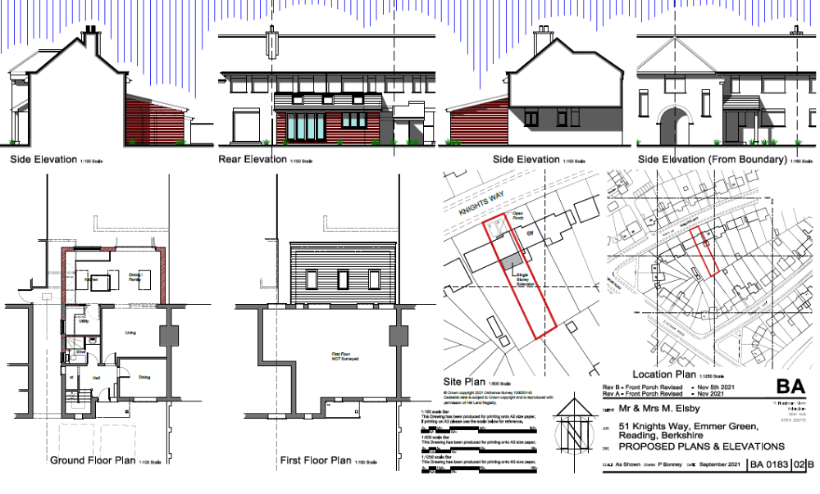

3. RELEVANT PLANNING HISTORY
App Ref: 211593/HOU
Proposals: Single storey rear extension and front porch
Decision: Approved
Date: 21/11/2021
NB: This application is same as the final iteration of the current application.

4. CONSULTATIONS
A Site Notice was put up 31/10/2025
No letters of representation were received.

Discussions with Agent.

The initial submission was deemed by the Officer to be non-compliant to CC7 as the front porch proposed ran the full width of the existing dwelling which was deemed to be negatively impactful to the character of the dwelling and the immediate environment. The proposed open sided front canopy front porch has been revised and is now deemed acceptable.

Equality Act 2010:
In determining this application, the Council is required to have regard to its obligations under the Equality Act 2010. However, there is no indication or evidence (including from consultation on the application) that the protected groups identified by the Act have or will have different needs, experiences, issues and priorities in relation to this particular planning application. Therefore, in terms of the key equalities protected characteristics it is considered there would be no significant adverse impacts as a result of the development.

5. LEGAL AND PLANNING POLICY CONTEXT
Section 38(6) of the Planning and Compulsory Purchase Act 2004 requires that proposals be determined in accordance with the development plan unless material considerations indicate otherwise. Material considerations include relevant policies in the National Planning Policy framework (NPPF) - among them the 'presumption in favour of sustainable development'. The following local and national planning policy and guidance is relevant to this application:

National Policy
National Planning Policy Framework
National Planning Practice Guidance

Reading Borough Local Plan (2019)
CC7 (Design and the Public Realm)
CC8 (Safeguarding Amenity)
H9 (House Extensions and Ancillary Accommodation)
H10 (Private and Communal Outdoor Space)

SPD
Design Guide to House Extensions SPD 2021

Local Plan Update
The current version of the Local Plan (adopted in November 2019) turned five years old on Tuesday 5th November 2024. The Local Plan was reviewed in March 2023 and around half of the policies in the plan are considered still up to date. However, the rest need to be considered for updating to reflect changing circumstances and national policy. A submission draft was submitted on 9th May 2025.

Although there is a five-year period for carrying out a review of a plan after it is adopted, nothing in the NPPF or elsewhere says that policies automatically become “out of date” when they are five years old. It is a matter of planning judgement rather than legal fact whether a plan or policies within it are out-of-date. This will depend on whether they have been overtaken by things that have happened since the plan was adopted, either on the ground or through changes in national policy, for example.

Officer advice in respect of the Local Plan policies pertinent to this application listed above is that they remain in accordance with national policy and that the objectives of those policies remain very similar in the draft updated Local Plan. Therefore, they can continue to be afforded weight in the appraisal below and are not considered to be ‘out of date’.

6. APPRAISAL

Character and Appearance

Policy H9 states that an extension to a house will be acceptable where it respects the character of the house in terms of scale, location, materials and design and respects the character and pattern of neighbouring properties and the street as a whole in terms of scale, location, materials and design, and any important existing building line. Policy CC7 also sets out relevant considerations for design.

The proposed development comprises a single storey extension to the rear of the dwelling and an open sided canpoy porch to the front. The rear extension spans a significant width of the property but remains subordinate by virtue of its single-storey height and typical domestic form.

The front open sided canopy introduces some alteration to the principal elevation; however, it is modest in scale and integrates with the existing building, utilising matching materials, especially after the revisions described above.

Overall, the proposal is considered to respect the character of the host dwelling and the surrounding street scene and is therefore compliant with Policies CC7 and H9.

Residential Amenity

Policy H9 states that an extension will be acceptable where it does not result in an overbearing impact on neighbours. Policy H10 seeks to ensure that the amenity of gardens and other outdoor areas are not compromised. Policy CC8 states an extension to a house will be acceptable where it will not cause a significant detrimental impact to the living environment of existing or new residential properties.

The proposed extensions are single storey in nature and would not result in significant loss of light, overbearing impact or overlooking to neighbouring properties.

The rear extension, whilst relatively wide, remains low in height and is not considered to adversely affect neighbouring amenity. The front extension does not introduce any material amenity concerns.

Adequate private outdoor space would remain following the development.

The proposal is therefore compliant with Policies CC8, H9 and H10.

7. CONCLUSION
The proposed development has been assessed as set out above and is considered to be acceptable on that basis, subject to the following conditions.

8. RECOMMENDATION: Grant

Recommended Conditions:
Approved Plans
Time Limit Standards
Materials As Specified

