DELEGATED APPLICATION REPORT
Ward: Church Ward
App Ref: PL/25/1654 Householder planning permission
Address: 43 WINDERMERE ROAD, READING, RG2 7HU
Proposal: Single storey rear extension
Applicant: Mrs Joy Charnley
Received date: 19/11/2025
Target Decision date: 23/04/2026 (EXT)
Case Officer: Chukwudi Onwudinanti

1. SITE DESCRIPTION

The application site is a two-storey semi-detached dwelling located within an established residential area characterised by similar detached and semi-detached properties. There is an existing outrigger to the rear, as well as an outbuilding in the garden.

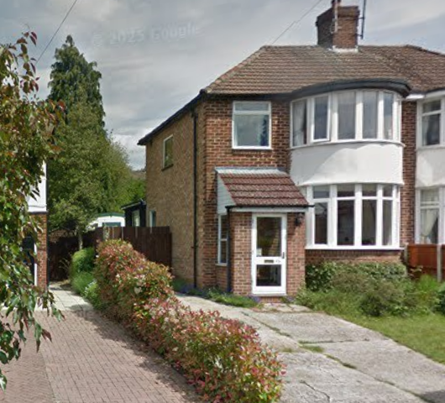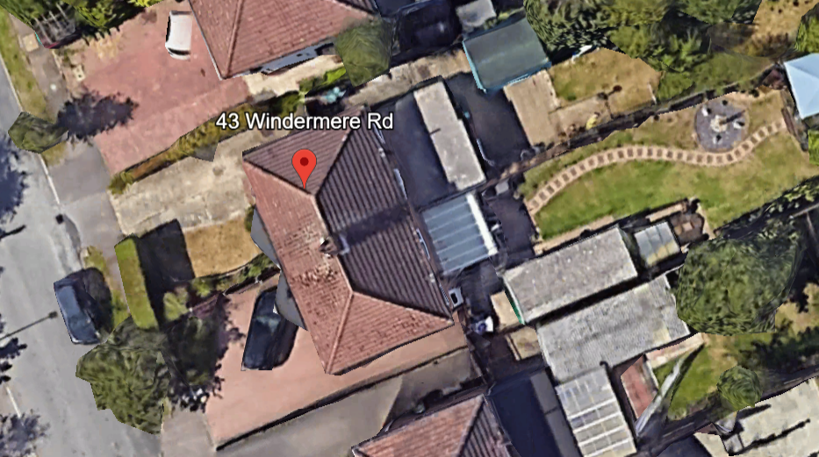
Google Photos

2. PROPOSAL AND SUPPORTING INFORMATION

Planning permission is sought for the erection of a single-storey rear extension and associated internal alterations.

The proposal includes:
- Rear extension to enlarge the kitchen area and create a utility and shower room, measuring 1.5m deep and across the width of the existing dwelling, and a ground to eaves height of 2.5m at the highest point.
- Minor alterations to fenestration

Plans and Documents
Dated October 2025, Received 19/11/2025
- Drawing No 25/WRR/01 – Existing Part Ground Floor Plan
- Drawing No 25/WRR/02 - Existing South-West and South-East Elevations
- Drawing No 25/WRR/03 - Existing North-east and North-West Elevations
- Drawing No 25/WRR/04 Rev A – Proposed Part Ground Floor Plan
- Drawing No 25/WRR/05 - Proposed South-West and South-East Elevations
- Drawing No 25/WRR/06 Rev A - Proposed North-east and North-West Elevations
- Drawing No 25/WRR/07 – Proposed Site and Location Plans
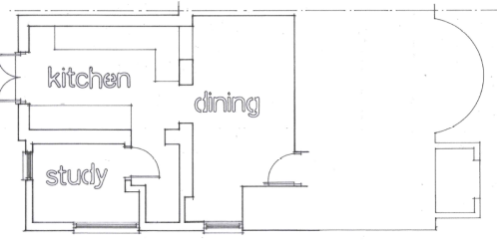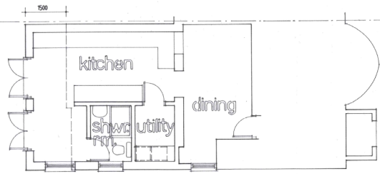
Existing Ground Floor Plan Proposed Ground Floor Plan

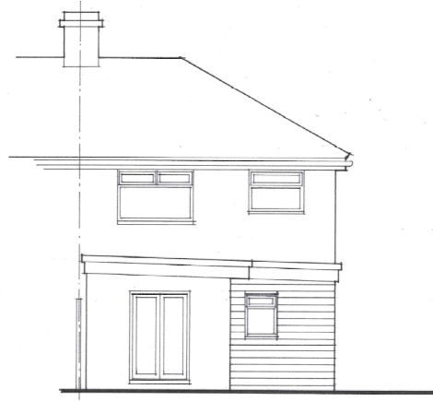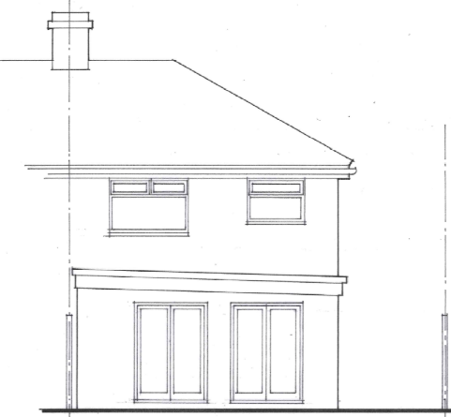
Existing Rear Elevation Proposed Rear Elevation

3. RELEVANT PLANNING HISTORY
None.

4. CONSULTATIONS
A Site Notice was put up 28/11/2025.

No neighbour comments were received.

5. LEGAL AND PLANNING POLICY CONTEXT
Section 38(6) of the Planning and Compulsory Purchase Act 2004 requires that proposals be determined in accordance with the development plan unless material considerations indicate otherwise. Material considerations include relevant policies in the National Planning Policy Framework (NPPF) - among them the 'presumption in favour of sustainable development'. The following local and national planning policy and guidance is relevant to this application:

National Policy and Guidance
National Planning Policy Framework
National Planning Practice Guidance

Reading Borough Local Plan (2019)
CC7 (Design and the Public Realm)
CC8 (Safeguarding Amenity)
H9 (House Extensions and Ancillary Accommodation)
H10 (Private and Communal Outdoor Space)

SPD
Design Guide to House Extensions SPD 2021

Local Plan Update
The current version of the Local Plan (adopted in November 2019) turned five years old on Tuesday 5th November 2024. The Local Plan was reviewed in March 2023 and around half of the policies in the plan are considered still up to date. However, the rest need to be considered for updating to reflect changing circumstances and national policy. A submission draft was submitted on 9th May 2025.

Although there is a five-year period for carrying out a review of a plan after it is adopted, nothing in the NPPF or elsewhere says that policies automatically become “out of date” when they are five years old. It is a matter of planning judgement rather than legal fact whether a plan or policies within it are out-of-date. This will depend on whether they have been overtaken by things that have happened since the plan was adopted, either on the ground or through changes in national policy, for example.

Officer advice in respect of the Local Plan policies pertinent to this application listed above is that they remain in accordance with national policy and that the objectives of those policies remain very similar in the draft updated Local Plan. Therefore, they can continue to be afforded weight in the appraisal below and are not considered to be ‘out of date’.

Equality Act 2010:
In determining this application, the Council is required to have regard to its obligations under the Equality Act 2010. However, there is no indication or evidence (including from consultation on the application) that the protected groups identified by the Act have or will have different needs, experiences, issues and priorities in relation to this particular planning application. Therefore, in terms of the key equalities protected characteristics it is considered there would be no significant adverse impacts as a result of the development.

6. APPRAISAL

Character and Appearance
Policy H9 states that an extension to a house will be acceptable where it respects the character of the house in terms of scale, location, materials and design and respects the character and pattern of neighbouring properties and the street as a whole. Policy CC7 also sets out relevant considerations for design.

The proposed development comprises an enlargement of an existing single-storey rear extension which is subordinate in scale to the host dwelling and located to the rear where it would not be visible from the street scene. The submitted elevations demonstrate that the extension would integrate with the existing dwelling and the scale and design of the proposal are typical of rear extensions within residential areas and would not harm the character or appearance of the host dwelling or the surrounding area.

Residential Amenity
Policy H9 states that an extension will be acceptable where it does not result in an overbearing impact on neighbours. Policy H10 seeks to ensure that the amenity of gardens and other outdoor areas are not compromised. Policy CC8 states that development should not cause a significant detrimental impact to the living environment of existing or new residential properties.

The proposed extension is single storey and modest in depth (1.5m), as well as height (2.5m ground to eaves at the highest point). It would not result in an overbearing impact, loss of light, or loss of privacy to neighbouring properties. The existing side facing window would be replaced with two smaller windows and it is not considered that this would give rise to any overlooking as they are relatively low compared to the height of the boundary fence. One of the windows would serve the newly created toilet.

The proposal would have a limited effect on the depth of the existing rear garden and a sufficient and usable level of private amenity space would remain.

CONCLUSION
The proposed development has been assessed as set out above and is considered to be acceptable on that basis, subject to the following conditions.

RECOMMENDATION: Grant

Recommended Conditions:
Approved Plans
Time Limit Standard
Materials As Specified

