CONSERVATION

Memo
To: Huimin Chen
From: Buju Can Cetin, Conservation Officer
Date: 22/04/2026
Re: Conservation Officer response
Application Number: PL/26/0375
Application Type: Householder planning permission
Address: 15 COLEY AVENUE, READING, RG1 6LJ
Proposal: Proposed Single storey Rear and side extension and a Porch conversion.

Summary
Object – Reason for Refusal
Because of their siting, scale, size, design and appearance, the proposed extensions, including the porch extension, would detract from the host building, its semi-detached pair and neighbours, and character and appearance of the Castle Hill/Russell Street/ Oxford Road Conservation Area. Together with the proposed driveway and parking space in the front garden, the proposed development would be an overdevelopment of the application site that fails to preserve or enhance the character of the conservation area. This would not meet Policies EN1, EN3 and EN6 of the Reading Borough Local Plan, the National Planning Policy Framework, and the Planning (Listed Buildings and Conservation Areas) Act 1990, which seek positive contribution to local character and distinctiveness and enhancement of the significance of the conservation areas.

Relevant policies and legislation
From the point of view of the historic environment, the main statutory tests are set out within the Planning (Listed Buildings and Conservation Areas) Act 1990. Section 72(1) of the Planning (Listed Buildings and Conservation Areas) Act 1990 also requires the Council to pay special attention to the desirability of preserving or enhancing the character and appearance of designated Conservation Areas.

National Planning Policy and Guidance
The NPPF outlines government policy, including its policy in respect of the historic environment. Chapter 16 of the NPPF (2024) 'Conserving and enhancing the historic environment' sets out the Government's high-level policies concerning heritage and sustainable development.
Paragraph 207 states, “In determining applications, local planning authorities should require an applicant to describe the significance of any heritage assets affected, including any contribution made by their setting. “ And Paragraph 208 says, “Local planning authorities should identify and assess the particular significance of any heritage asset that may be affected by a proposal (including by development affecting the setting of a heritage asset) taking account of the available evidence and any necessary expertise. They should take this into account when considering the impact of a proposal on a heritage asset, to avoid or minimise any conflict between the heritage asset’s conservation and any aspect of the proposal.”
Paragraph 212 of the NPPF requires that ‘when considering the impact of a proposed development on the significance of a designated heritage asset, great weight should be given to the asset’s conservation….’ And paragraph 213 says, ‘any harm to, or loss of, the significance of a designated heritage asset (from its alteration or destruction, or from development within its setting) should require clear and convincing justification’.
Paragraph 215 requires that ‘where a development proposal will lead to less than substantial harm to the significance of a designated heritage asset, this harm should be weighed against the public benefits of the proposal…’
National Planning Practice Guidance on Historic Environment provides context to the NPPF.

Local Planning Policy and Guidance
Policy EN1 ‘Protection and enhancement of the historic environment’ of the Reading Borough Local Plan sets out the Council’s aspirations for the historic environment. The policy requires that all proposals to protect and, where possible, enhance the significance of heritage assets and their settings, historic character and local distinctiveness of the area in which they are located. It echoes the NPPF by stating, “Proposals should seek to avoid harm in the first instance. Any harm to or loss of a heritage asset should require clear and convincing justification, usually in the form of public benefits”.
Policy EN3 ‘Enhancement of conservation areas’ of the Reading Borough Local Plan requires that development proposals within Conservation Areas contribute positively to local character and distinctiveness. This policy states, “Development proposals within Conservation Areas must make a positive contribution to local character and distinctiveness. Positive consideration will be given to proposals which take opportunities to enhance the character of conservation areas.”
Policy EN6 ‘New development in a historic context’ also requires “New development will make a contribution to the historic character of the area by respecting and enhancing its architectural and visual qualities and considering how heritage considerations can influence the design of new development. When determining planning applications for new development, the following factors will be taken into consideration:
a. The positive contribution of the development to the existing historic townscape (scale, height, mass, proportion, plot size, street form, materials, significant vistas and views, and open space);
b. Sensitivity to historic context;
c. Reflection of borough-wide major heritage themes that contribute to local distinctiveness (e.g. patterned brickwork or former worker terraced housing);
d. Whether development promotes and/or improves access to previously undiscovered or neglected historic significance.”

Castle Hill/Russell Street/Oxford Road Conservation Area Appraisal (March 2020) is also a material consideration in determining applications for development.
Other
Historic England Advice Note 2 – Making changes to Heritage Assets illustrates the application of policies set out in the NPPF in determining applications for Planning Permission and Listed Building Consent.
English Heritage’s “Conservation Principles” provides policy and guidance for the “sustainable
management of the historic environment”.

Relevant heritage assets
The application relates to a semi-detached, two-storey, modern, unlisted building located within the Castle Hill/Russell Street/Oxford Road Conservation Area, as illustrated below. It constitutes the middle section of the same-style semi-detached pairs on both sides of the site, dating from the post-war period. Whilst there are a number of listed buildings in the wider area of the application site, the site is not within the direct setting of any listed building. It faces the rear/side boundary and facades of a building of townscape merit (BTM) at No.1 Bath Road.
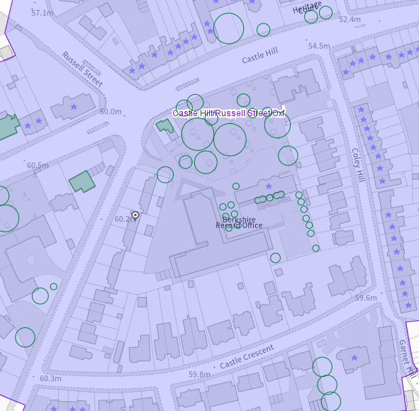
The application site (circled in red) within the Castle Hill/Russell Street/Oxford Road Conservation Area (light purple), the buildings of townscape merit are shown in green, and the listed buildings have stars on them

Significance of heritage assets
The NPPF defines significance as the “value of a heritage asset to this and future generations because of its heritage interest.”

The interest may be architectural or historic, as set out in the Town and Country Planning (Listed Building and Conservation Areas) Act 1990 Section 1.

“Significance derives not only from a heritage asset’s physical presence, but also from its setting.” (NPPF, 2023)

Historic England assesses significance in a similar manner, referring to evidential, historic, aesthetic and communal values of a place.

Whilst the application site constitutes a modern building from the post-war period, as illustrated below, due to the scale, height, form and appearance of the subject building, its setback position within the application, with open larger green front and rear gardens with natural features, the site is in harmony with the conservation area in terms of both character and appearance. This is mentioned and emphasised many times by the conservation area appraisal.

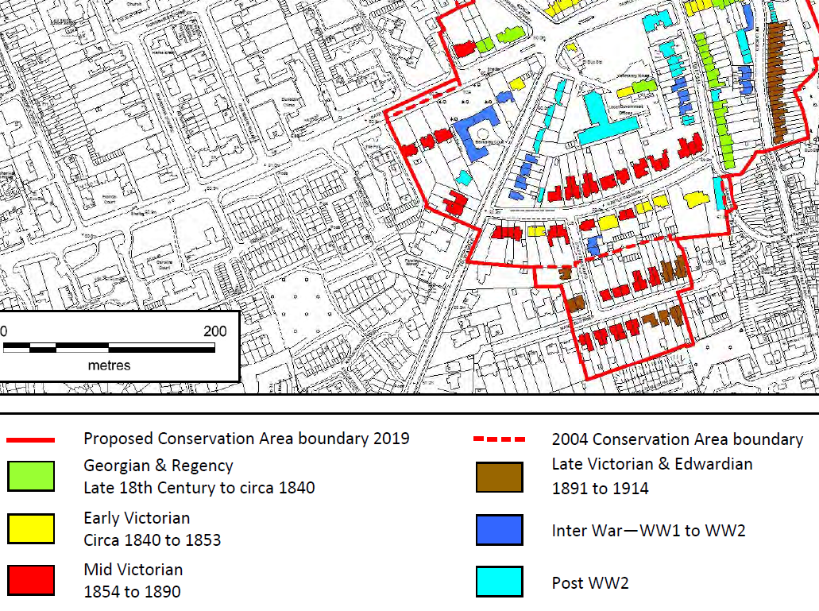
Buildings by age (from page 23 of the Conservation Area Appraisal)

About Coley Avenue, under ‘Significance and Key Positive Features’ of the Castle Hill/Russell Street/Oxford Road conservation Area, from the appraisal, I noted the following:

“• The view south along Coley Avenue and its allée of trees in place along the road for over 200 years is protected as a significant heritage view for Reading.
…
• A number of mature trees, largely along Coley Avenue, Castle Street/Castle Hill and Bath Road, create a positive green canopy and many are protected by TPOs (Tree Protection Orders).”

As the site is located within the character area - 6.5 Castle Crescent and streets south of Castle Hill, the further notes are:
“The avenue of trees along Coley Avenue originates from the late 18th century and provides a notable historic green boundary to the area. The Avenue has been noted as a protected heritage view within the new Local Plan (adopted in 2019 by Reading Borough Council).”
…
“Coley Avenue was originally the private route to the impressive Coley House, the remains of which are located to the south of today’s Berkeley Avenue. Coley Avenue’s impressive allée of trees lining the road dates back to at least the late 18th century. After having been replanted in the early 20th century, the striking tree lines survive today. The avenue of trees, the attractive high brick walls, and detached houses within large front gardens define Coley Avenue within the character area.”

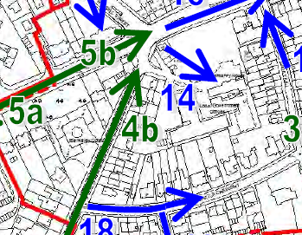
From ‘Spatial Analysis: Views into, out of and within the Conservation Area, application site is circled (from page 25 of the Conservation Area Appraisal)

From the historic map regression, as given below, although I noted that the application site was a part of the curtilage of Grade II listed Yeomanry House, which has been divided and developed separately, there is no functional or physical connection between the application site and the listed curtilage anymore.

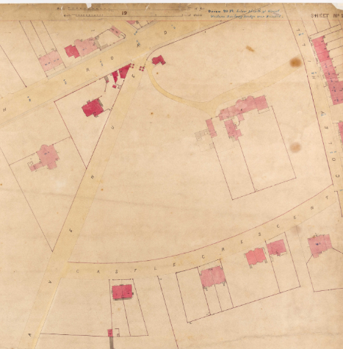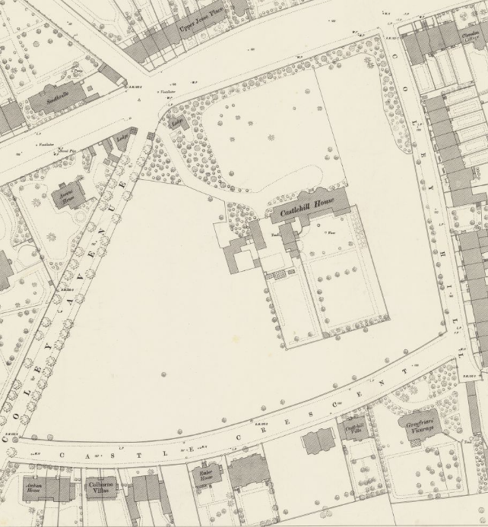
Curtilage of listed Yeomanry House in 1853 (Left) and in 1876 (Right) (Published in 1879)

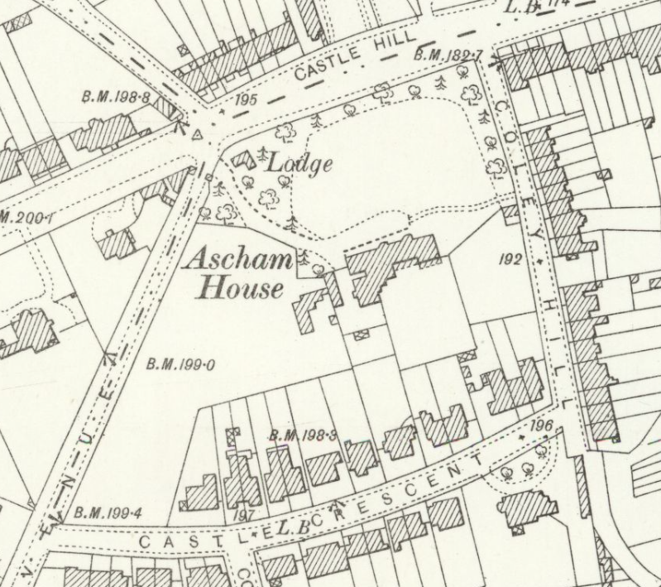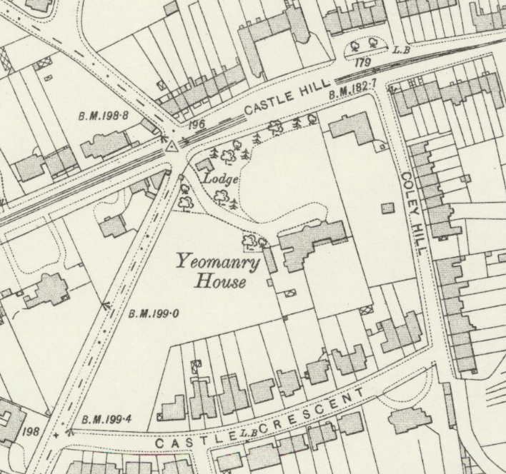
The OS Map dated 1898 (Left) (Published in 1900) and dated1909 to 1910 (Right) (Published in 1912)

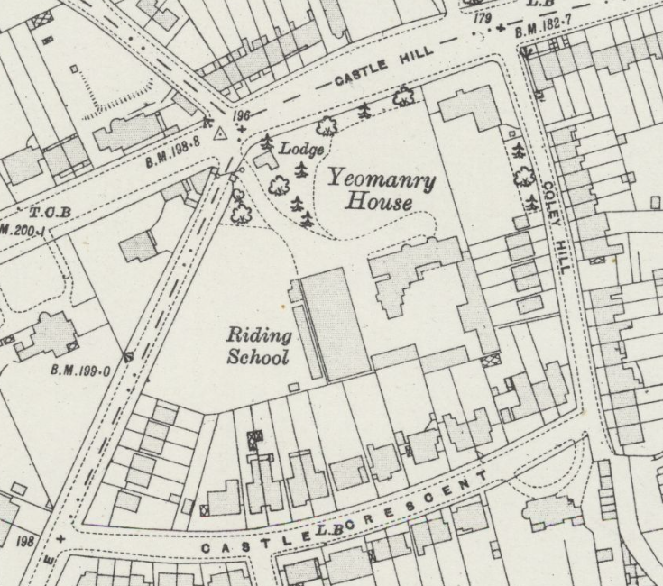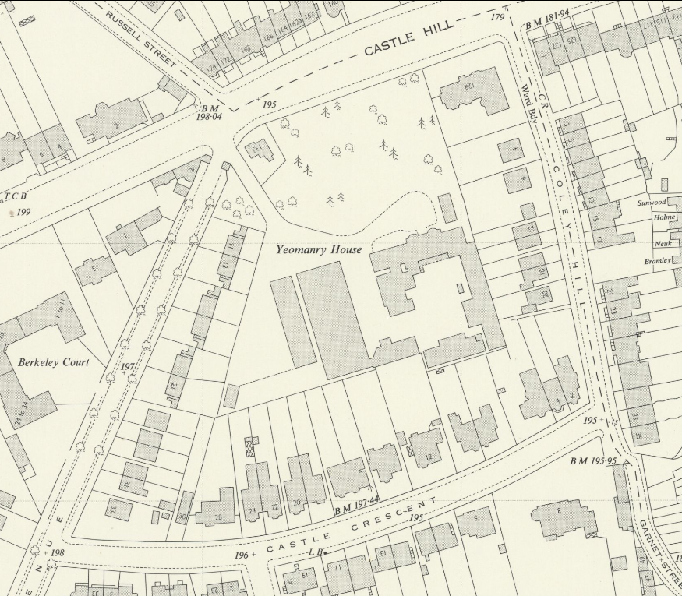
The OS Map dated 1931 to 1932 (Left) (Published in 1934) and dated 1959 (Right) (Published in 1960) – Development of the application site appears

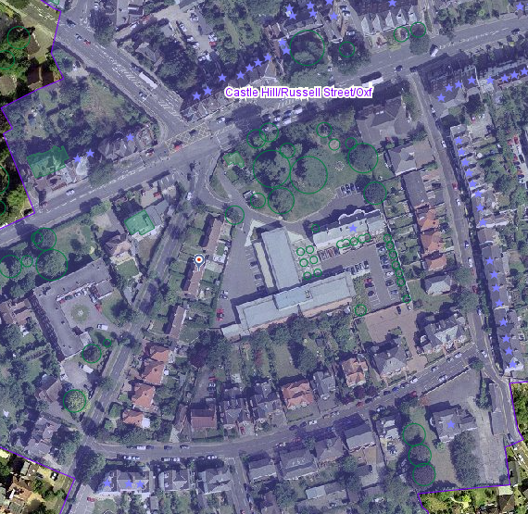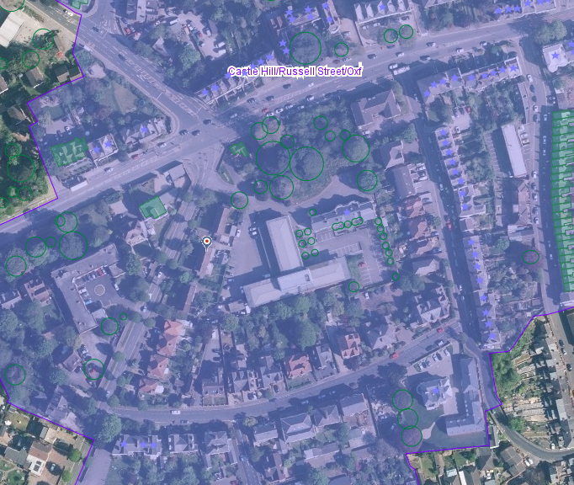
Aerial View of 2002 (Left) and 2026 (Right) with the application site circled

Impact of proposal upon heritage asset(s)
I find the proposal an ‘overdevelopment’ of the site and not acceptable on heritage grounds. The impact of each proposed element is given below.
The subject property comprises a modest red brick residential building from the mid-20th century, early post-war in origin. Therefore, the building is of simple domestic design, whose principal elevation is plainly detailed and asymmetrical with casement windows and a modestly expressed, small, flat-roofed porch. As such, it reads as a simple suburban building with traditional materials.
The proposed porch
Because the building is a part of a repetitive design from No.11 to 21, without major alteration to the front elevation, the pleasing rhythm of building lines, porches, design and appearance of principal elevations are clearly perceived from the public realm. The proposed porch would disrupt the existing continuous original building lines and porch details by creating a new enclosed porch projecting from the front building line. It would appear as a part of the proposed side extension, rather than the main entrance of the building. As such, it would be an alien feature inserted into the area, and both in heritage and design terms, it would not be acceptable.

The proposed side extension
This extension would replace the existing original side projection, which is also a consistent design feature seen in adjacent semi-detached pairs. I noted that there is a shed placed without permission that the proposed side extension would also replace that outbuilding on a larger footprint and scale. This side extension would project further than the proposed porch, making a total of more than 4m from the original front building line. This would not be a subservient or subordinate addition as it would not respect the original design or building line of the host building or the architectural features of the environment in which it is located. As such, the proposed side extension, due to its position, footprint and scale, would not be acceptable.

The proposed rear extension
I noted that there is already a built form in the rear garden, an outbuilding with considerable scale, massing and footprint. The proposed rear extension would be placed towards this outbuilding with an access from the northern side to the garden. It would have a double-pitched roof with a ridge height at the first-floor window sill level, and a width occupying more than half of the main building. Although this element could be considered to have the least impact on the character of the area and the host building, together with all other extensions, it would create a big effect on the development patterns and urban grain of the area. Therefore, it would not be acceptable.

The proposed driveway and parking in the front garden
Whilst the proposed extensions have an impact on the character and appearance of the modern era of the conservation area, the formation of a new driveway and the provision of car parking in the front garden would have a noticeable impact on the appearance of the area. As advised on the significance of the heritage assets, Coley Avenue is notable for its greenery and tree cover. There is no existing driveway at the neighbouring properties with the same original plot layout. However, if there is a need and strong justification to balance the harm from this work, given the existence of driveways of historic buildings on Castle Crescent, a narrower driveway, without removal of a tree and appropriate surface material and landscaping, could be considered acceptable. Nevertheless, this would result in the formation of further driveways to the east of Coley Avenue, and it would totally change the existing characteristics. Therefore, high-quality design and attention to detail are required for such work. As such, I am unable to support this proposal.
I also noted that there is no Heritage Statement accompanying this application, and I am unable to see the reasons behind the proposals. I suggest refusal of the proposed work on the basis of their scale, size, siting, design and appearance, with a loss of natural features in the conservation area.

Suggested Reason for Refusal
Because of their siting, scale, size, design and appearance, the proposed extensions, including the porch extension, would detract from the host building, its semi-detached pair and neighbours, and character and appearance of the Castle Hill/Russell Street/ Oxford Road Conservation Area. Together with the proposed driveway and parking space in the front garden, the proposed development would be an overdevelopment of the application site that fails to preserve or enhance the character of the conservation area. This would not meet Policies EN1, EN3 and EN6 of the Reading Borough Local Plan, the National Planning Policy Framework, and the Planning (Listed Buildings and Conservation Areas) Act 1990, which seek positive contribution to local character and distinctiveness and enhancement of the significance of the conservation areas.

Conservation response
No objections
No objections subject to conditions attached
Clarification required
Object

Contact details
Buju Can Cetin, Conservation Officer
Burcu.CanCetin@reading.gov.uk

