Nos. 187-189 Kings Road
Astec House
Reading

HERITAGE ASSESSMENT
25 March 2026



CONTENTS

1 INTRODUCTION 2
2 LEGISLATION, POLICY & GUIDANCE 3
3 THE SITE AND ITS HERITAGE CONTEXT 10
4 SIGNIFICANCE OF NOS. 187-189 KINGS ROAD
ASTEC HOUSE 17
5 ASSESSMENT AND CONCLUSIONS 26

- INTRODUCTION

  - This Heritage Assessment has been prepared by GJHP in support of the proposals for the conversion, extension and alteration of nos. 187-189 Kings Road, Astec House, Reading (the ‘Site’), in Reading Borough Council. GJHP is a consultancy that provides expert advice on heritage and townscape matters.

  - This assessment considers the effect of the proposals (the ‘Proposals’) on the significance of nos. 187-189 Kings Road, Astec House which is listed grade II, the Eldon Square Conservation Area within which it lies and the setting of nearby listed buildings.

  - The report sets out the following:

- The relevant statutory duties and national and local policy and guidance;
- A description of the Site and its heritage context including an assessment of the heritage significance of the Eldon Square Conservation Area;
- An assessments of the heritage significance of the grade II listed 187-189 Kings Road;
- An assessment of the Proposed Development and its effect on heritage significance in light of the statutory duties of the Planning (Listed Buildings and Conservation Area) Act 1990 (‘The Act’) and national and local policy and guidance.

  - This assessment is based on a site visit on the 3 April 2025, the list descriptions, material held at Royal Berkshire Archives, archival planning records, and published sources.

  - The report should be read in conjunction with the application drawings and Design and Access Statement (‘DAS’) prepared by Mountford Pigott and the Planning Statement prepared by hgh Consulting.

2 LEGISLATION, POLICY & GUIDANCE

  - This section contains an overview of the relevant statutory duties and national, regional and local planning policies and guidance that are relevant to the consideration of heritage matters.

Statutory Duties

The Planning (Listed Buildings and Conservation Areas) Act 1990

Listed buildings

  - Section 7 of The Act requires listed building consent for any works for the demolition of a listed building or for its alteration or extension in any manner which would affect its character as a building of architectural or historic interest. Section 16 (2) places the duty on the decision maker to have special regard to the desirability of preserving the building or its setting in determining applications for listed building consent.

  - Section 66 (1) of The Act states, ‘in considering whether to grant planning permission for development which affects a listed building or its setting, the local planning authority or, as the case may be, the Secretary of State shall have special regard to the desirability of preserving the building or its setting or any features of special architectural or historic interest which it possesses.’

Conservation areas

  - Section 72 of the Act requires that when considering applications for planning permission for buildings or land in a conservation area, ‘special attention shall be paid to the desirability of preserving or enhancing the character or appearance of that area’.

National planning policy and guidance

The National Planning Policy Framework, 2024

  - The Government issued the latest version of the National Planning Policy Framework (NPPF) in December 2024. The NPPF sets out planning policies for England and how these should be applied.

  - The NPPF states that the purpose of the planning system is to contribute to the achievement of sustainable development, which has three overarching objectives; economic, social and environmental. The NPPF states, at paragraph 10, that 'at the heart of the Framework is a presumption in favour of sustainable development.'

NPPF Section 16: Conserving and enhancing the historic environment

  - Section 16 of the NPPF deals with conserving and enhancing the historic environment. It applies to plan-making, decision-taking and the heritage-related consent regimes under the 1990 Act.

  - Heritage assets are defined in Annex 2 of the NPPF as 'A building, monument, site, place, area or landscape identified as having a degree of significance meriting consideration in planning decisions, because of its heritage interest. It includes designated heritage assets and assets identified by the local planning authority (including local listing).'

  - The NPPF notes, at paragraph 202, that heritage assets 'should be conserved in a manner appropriate to their significance, so that they can be enjoyed for their contribution to the quality of life of existing and future generations.'

  - The NPPF requires an applicant to describe the heritage significance of any heritage assets affected by a proposal, including any contribution made by their setting (paragraph 207). It goes on to say that 'the level of detail should be proportionate to the assets' importance and no more than is sufficient to understand the potential impact of the proposal on their significance.'

  - The NPPF (paragraph 210) identifies three key factors local authorities should take into account in determining applications:

'The desirability of sustaining and enhancing the significance of heritage assets and putting them to viable uses consistent with their conservation;

The positive contribution that conservation of heritage assets can make to sustainable communities including their economic vitality; and

The desirability of new development making a positive contribution to local character and distinctiveness.'

  - Paragraph 212 states that in assessing impact, the more important the asset, the greater the weight should be given to its conservation. Paragraph 207 notes that heritage significance can be harmed or lost through alteration or destruction of the heritage asset or from development within its setting.

  - The setting of a heritage asset is defined in Annex 2 as 'The surroundings in which a heritage asset is experienced. Its extent is not fixed and may change as the asset and its surroundings evolve. Elements of a setting may make a positive or negative contribution to the significance of an asset, may affect the ability to appreciate that significance or may be neutral.'

  - The NPPF states, at paragraph 214, that where a proposed development would lead to 'substantial harm' or total loss of heritage significance of a designated heritage asset, consent should be refused, '…unless it can be demonstrated that the substantial harm or total loss is necessary to achieve substantial public benefits that outweigh that harm or loss', or all of a number of specified criteria apply, including that the nature of the heritage asset prevents all reasonable uses of the site.

  - Where a development proposal will lead to 'less than substantial' harm to the heritage significance of a designated heritage asset, this harm should be weighed against the public benefits of the proposal including, where appropriate, securing its optimum viable use (paragraph 215).

  - The NPPF requires local planning authorities to look for opportunities for new development within conservation areas and within the setting of heritage assets to enhance or better reveal their heritage significance. Paragraph 219 goes on to say ‘Proposals that preserve those elements of the setting that make a positive contribution to the asset (or which better reveal its significance) should be treated favourably’.

Planning Practice Guidance

  - The PPG includes a section called ‘Historic environment' which was updated on 23 July 2019. It explains which bodies are responsible for the designation of HAs and provides information on heritage consent processes.

  - The PPG notes at para 20 that ‘Public benefits should flow from the proposed development. They should be of a nature or scale to be of benefit to the public at large and not just be a private benefit. However, benefits do not always have to be visible or accessible to the public in order to be genuine public benefits, for example, works to a listed private dwelling which secure its future as a designated heritage asset could be a public benefit.’ It goes on to note that examples of heritage benefits may include:

- ‘sustaining or enhancing the significance of a heritage asset and the contribution of its setting
- reducing or removing risks to a heritage asset
- securing the optimum viable use of a heritage asset in support of its long term conservation’

Local policy and guidance

Reading Borough Local Plan

  - The Reading local Plan was adopted in November 2019. It contains the policies for how Reading will develop up to 2036, which is the end date of the plan. It identifies the amount of development that will take place, the areas and sites where development is expected to be accommodated, and where it will be restricted, and sets out policies for how planning applications will be decided.

  - Policy EN1 ‘Protection and Enhancement of the Historic Environment’ states ‘historic features, areas of historic importance and other elements of the historic environment, including their settings will be protected and where possible enhanced’. These include listed buildings, conservation areas and assets on the Local List.

  - The policy goes on to say:

‘All proposals will be expected to protect and where possible enhance the significance of heritage assets and their settings, the historic character and local distinctiveness of the area in which they are located. Proposals should seek to avoid harm in the first instance. Any harm to or loss of a heritage asset should require clear and convincing justification, usually in the form of public benefits.

Applications which affect Listed Buildings will not have an adverse impact on those elements which contribute to their special architectural or historic interest including, where appropriate, their settings.’

  - Policy EN3 ‘Enhancement of Conservation Areas’ deals specifically with conservation areas and states ‘The special interest, character and architecture of Conservation Areas will be conserved and enhanced. Development proposals within Conservation Areas must make a positive contribution to local character and distinctiveness’ It goes on to say ‘Positive consideration will be given to proposals which take opportunities to enhance the character of conservation areas’, including:

- ‘Reducing visual clutter caused by negative factors, such as poles and overhead wires, satellite dishes or unnecessary street furniture;
- Restoring original building features;
- Removing inappropriate additions or alterations to buildings;
- Protecting and encouraging the maintenance of green spaces and important trees, particularly where they are intrinsic to the history and character of the area;
- Improving signage and street furniture;
- Restoring or re-establishing appropriate paving, railings or walls;
- Sympathetic landscaping and planting;
- Improving or restoring green spaces, including front gardens, that are appropriate to the historic interest of a Conservation Area;
- Signage that reveals and promotes the Conservation Area and its boundaries;
- Interpretation panels to inform the public of the area’s historical significance’.

  - Policy EN6 ‘New Development in a Historic Context’ states that ‘In areas characterised by heritage assets, the historic environment will inform and shape new development. New development will make a contribution to the historic character of the area by respecting and enhancing its architectural and visual qualities and considering how heritage considerations can influence the design of new development’. Going on to say that in determining planning applications the following factors will be taken into consideration:

‘a. The positive contribution of the development to the existing historic townscape (scale, height, mass, proportion, plot size, street form, materials, significant vistas and views, and open space);

b. Sensitivity to historic context;

c. Reflection of borough-wide major heritage themes that contribute to local distinctiveness (e.g. patterned brickwork or former worker terraced housing);

d. Whether development promotes and/or improves access to previously undiscovered or neglected historic significance.’

Supplementary Planning Guidance and guidance

Eldon Square Conservation Area Appraisal

  - The Eldon Square Conservation Area Appraisal (the ‘Appraisal’) was published in 2007. It assesses the character and appearance and significance of the conservation area and is referred to where relevant in the assessment. It notes in respect of ‘loss, intrusion or damage’ that one of the principal damaging factors in the conservation area is the loss of original architectural details stating:

‘Many of the unlisted, and some of the listed, buildings in the conservation have been adversely affected by the use of inappropriate modern materials or details. Common faults include:

• the replacement of original timber sash windows with uPVC or aluminium;

• the loss of original panelled front doors and their replacement with stained hardwood, uPVC or aluminium doors;

• loss of chimney stacks and clay pots;

• the replacement of stone slate or Welsh slate roofs with concrete tiles;

• loss of front boundary walls.’

Other guidance

Historic England Advice Note 1, Conservation Area Appraisal, Designation and Management (Second Edition) (February 2019)

  - The purpose of this note is to provide information on conservation area appraisal, designation and management to assist local authorities, planning and other consultants, owners, applicants and other interested parties in implementing historic environment legislation, the policy in the National Planning Policy Framework (NPPF) and the related guidance given in the Planning Practice Guidance (PPG). The advice in this document emphasises that evidence required to
inform decisions affecting a conservation area, including both its designation and management, should be proportionate to the importance of the asset.
  - At paragraph 4 of the introduction it states, ‘Change is inevitable, and often beneficial, and this advice sets out ways to manage change in a way that conserves and enhances the character and appearance of historic areas’, and that ‘Conservation areas can contribute to sustainable development in all its three dimensions as outlined in the NPPF’.

Historic England: Historic Environment Good Practice Advice in Planning Note 2: Managing Significance in Decision-Taking in the Historic Environment (March 2015)

  - The purpose of this note is to provide information to assist local authorities, planning and other consultants, owners, applicants and other interested parties in implementing historic environment policy in the National Planning Policy Framework (NPPF) and the related guidance given in the Planning Practice Guidance (PPG). These include assessing the significance of heritage assets, using appropriate expertise, historic environment records, recording and furthering understanding.

  - In terms of general advice on decision-taking it notes at para 4 that, ‘The first step for all applicants is to understand the significance of any affected heritage asset and, if relevant, the contribution of its setting to its significance’. The guidance goes on to suggest a number of common steps in assessing significance.

The Setting of Heritage Assets: Historic England: Historic Environment Good Practice Advice in Planning Note 3 (Second Edition) December 2017

  - This guidance states that it provides ‘information on good practice to assist local authorities, planning and other consultants, owners, applicants and other interested parties’ and that ‘alternative approaches may be equally acceptable, provided they are demonstrably compliant with legislation, national policies and objectives.’

  - At para 9 it states that ‘Setting is not a heritage asset, nor a heritage designation, although land comprising a setting may itself be designated …. Its importance lies in what it contributes to the significance of the heritage asset or the ability to appreciate that significance.’

  - At para. 18 the guidance states that the ‘Conserving or enhancing heritage assets by taking their settings into account need not prevent change; indeed change may be positive, for instance where the setting has been compromised by poor development.’ It goes on to say that ‘many places coincide with the setting of a heritage asset and are subject to some degree of change over time.

  - The guidance proposes a five stage programme of assessment: (1) identifying the assets affected; (2) assessing the degree to which the setting make a contribution to the significance of a heritage asset or allows the significance to be appreciated; (3) assessing the effect of the proposed development; (4) maximising enhancement and minimising harm; and (5) making and monitoring the decision and outcomes.

Historic England Advice Note 12: Statements of Heritage Significance: Analysing Significance in Heritage assets (October 2019)

  - The purpose of this note is to provide guidance on analysing the significance of heritage assets. It elaborates on the policy, guidance and advice set out in the NPPF and national PPG. It suggests a staged approach to assessing the effect of proposals on heritage significance which would usually include:

‘1. Understand the form, materials and history of the affected heritage asset(s), and/or the nature and extent of archaeological deposits

2. Understand the significance of the asset(s). These two stages fulfil the requirement in paragraph 189 of the NPPF and are undertaken by the applicant.

3. Understand the impact of the proposal on that significance. This stage fulfils the requirement in paragraph 190 of the NPPF and is undertaken by the LPA. However, the applicant needs to be aware of impacts so that the analysis of significance submitted to the LPA, under paragraph 189, is sufficient in its level of detail.

4. Avoid, minimise and mitigate negative impact, in a way that meets the objectives of the NPPF

5. Look for opportunities to better reveal or enhance significance’.

3 THE SITE AND ITS HERITAGE CONTEXT

The Site and its immediate context

  - The Site, nos. 187-189 Kings Road, Astec House, lies on the north side of Kings Road (A329) a wide busy route, opposite Eldon Street and close to the Reading College campus. The River Kennet lies some 150m to the north (running in a north-east/ south-west direction). Reading Railway Station lies some 1.1km to the north-west.

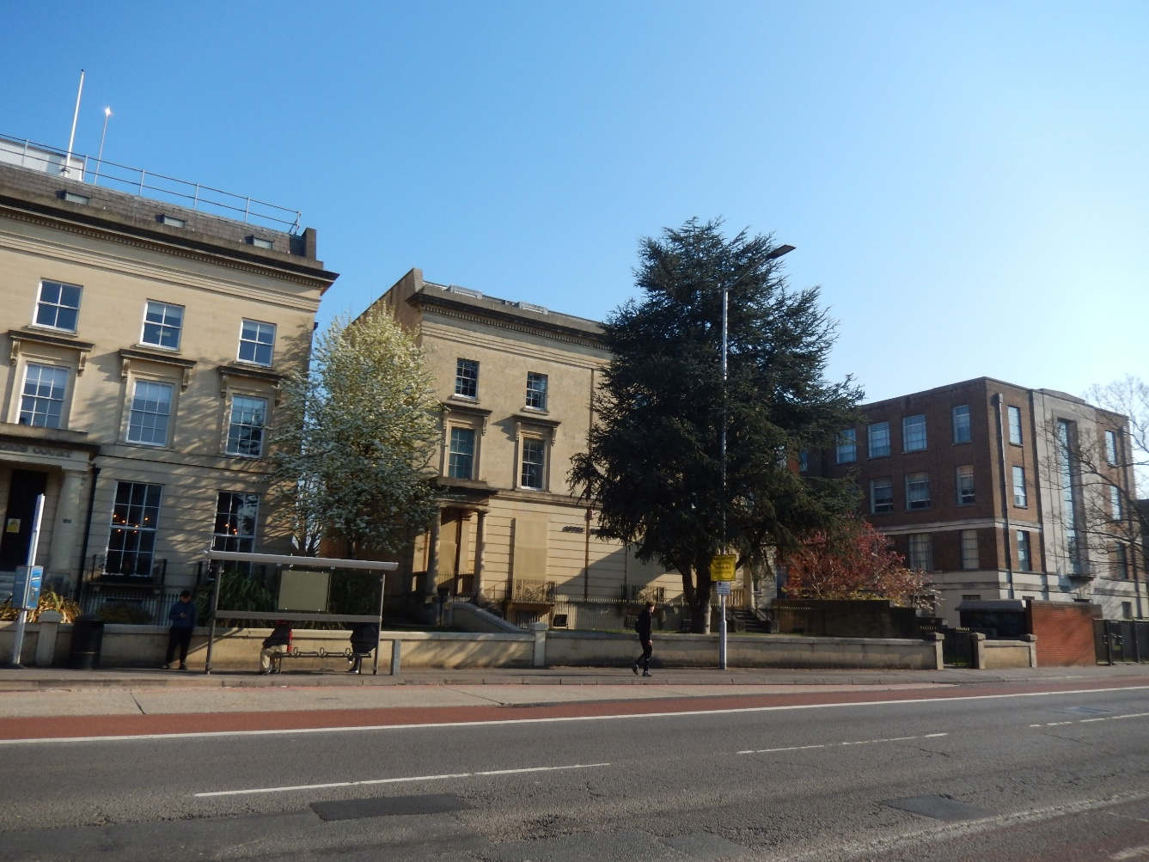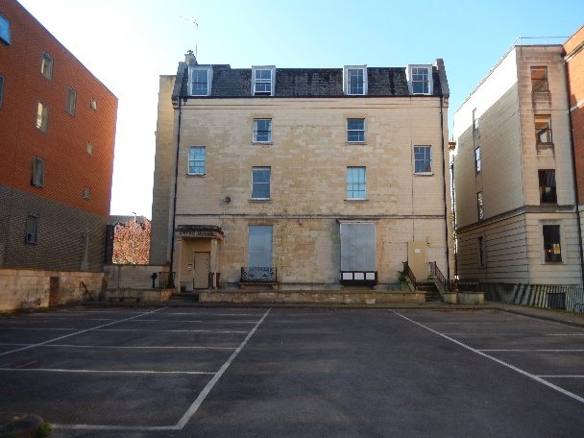
The Site, Kings Road elevation (left, facing ) and rear elevation (right)

  - Nos. 187-189 Kings Road, Astec House is listed grade II. It has been vacant since May 2014. A statement of significance of this designated heritage asset is set out at Section 4.

  - To the west of the Site is the contemporary grade II listed no. 185 (see below) which has a substantial extension to the rear and a modern mansard roof extension. To the east is the no. 191 Kings Road, a long block set back further from the street than the building on Site with a two bay elevation to the south. This 5 storey student accommodation block built of red and blue engineering brick with metal cladding, and with a flat roof, dates from the first part of the C21.

Historic development of the area

  - Reading is named after a Saxon tribe, the Readingas, who settled in the area in the C6. At the time of the Domesday Survey in 1086, Reading belonged to the King and included a small borough and two manors. The town served as a centre of royal administration, had a mint and held regular markets. The town had hardly extended beyond its medieval core but the development of the canals (which by 1810 had brought London and Bristol into direct communication by water) led to the rapid expansion of the town. Reading grew in the early C19 primarily along its approach roads.

  - The construction of the Great Western Railway which reached the town in 1840 led to further growth. It resulted in the rapid expansion of major industries which provided work for a rapidly increasing population. The terraced streets east and west of Eldon Road were among the many terraces built during the second half of the C19.

  - In the first national census, in 1801, the population of Reading was about 9,400. By 1851 the population had more than doubled, to 21,500, and at the end of the century, it stood at around 59,000. Reading became the county town of Berkshire in 1869.

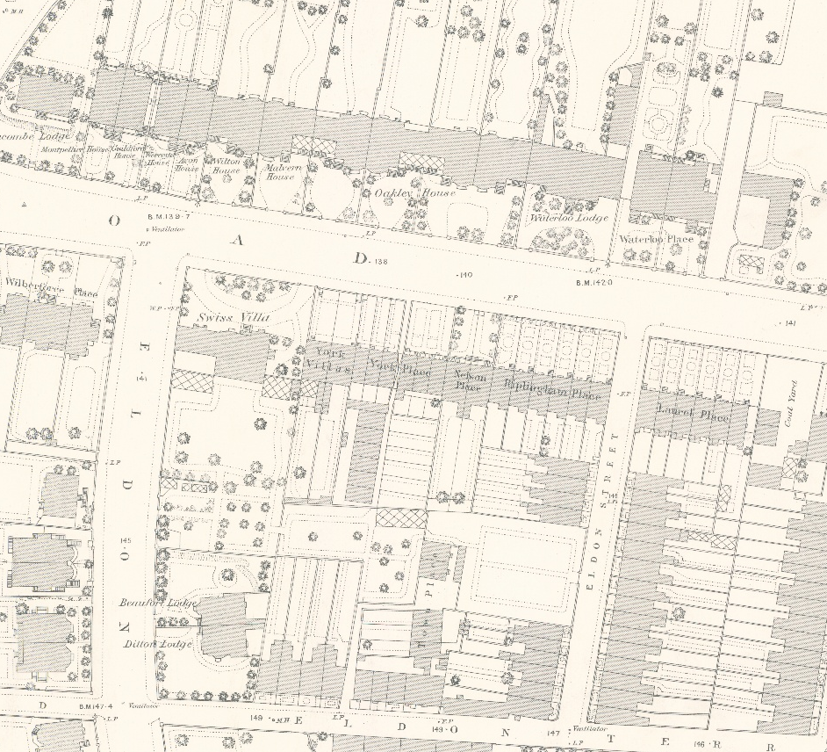

1879 OS Map 25 inch to the mile. The site is marked with a red circle

Reproduced with the permission of the National Library of Scotland

The Site

  - The Appraisal notes that the Commissioners’ ‘Map of the Borough of Reading’ (1834) illustrates Kings Road and Queens Road together with Eldon Road and Eldon Square. Both this 1834 map and ‘A New Plan of the Borough of Reading’ (1840) suggest a formal cruciform layout of streets around a central circus in the area west of Eldon Road. The proposed layout was never realised.

  - The Pevsner volume of ‘The Buildings of England: Berkshire’ notes Kings Road ‘was made from 1832 through what was Crown land’; going on to describe that part by the Site as follows:

‘Nos. 196-200 go with the 1830s group in Eldon Road etc. behind. On the N side, very big stone houses of a few years later, c. 1832-5, in pairs and singles. Attributed to H. & N. Briant. Classical, several linked by low wings. Many have been reconstructed behind. Nos. 173-183 have pairs of tall bows as if they were copied from Brighton. Then public buildings, churches, offices and flats, up to convergence with London Road by the cemetery gate’.

Heritage context

  - The Site lies in the Eldon Square Conservation Area and there are a number of listed buildings nearby. These heritage assets are considered below.

Listed buildings

  - No. 185 Kings Road is listed grade II and neighbours the Site to the west. Like the Site, it was built after 1832 and formed part of Waterloo Place development. It is 2 storeys and of rendered Bath stone. The plain front has a string at 1st floor cill level and a flat eaves cornice. There is a gabled central projection with an arched door and fanlight under an arched porch reached by steps, and at 1st floor level a window with an open pediment on console brackets. There is a slate clad double ridge roof with end gable brick chimneys which have moulded stone capping. It has a modern mansard roof extension today.

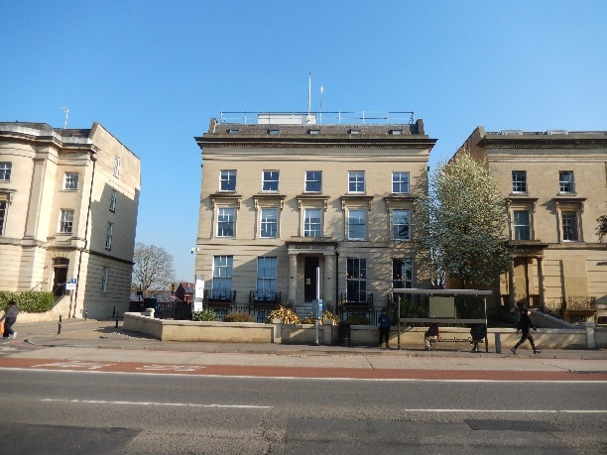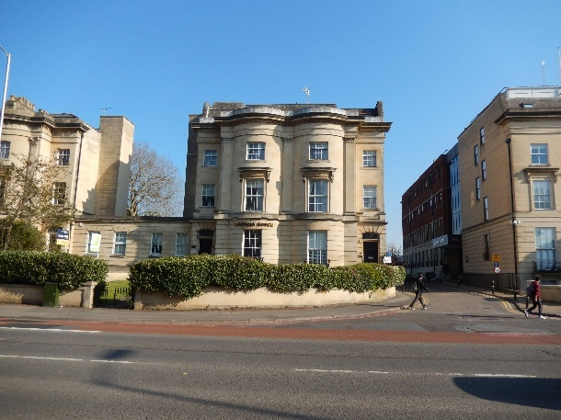
No. 185 Kings Road with modern roof extension Nos. 181 & 183 Kings Road with modern roof
extensions

  - Nos. 173 to 183 (odd) Kings Road are listed grade II* and lie to the west of the Site. Built after 1832 they were the principal houses in the former Waterloo Place development. They comprise 3 separate blocks of 2 houses each joined together by single storey links. They are of a similar design apart from the applied orders: nos. 173/175 and 181/183 modified Doric, and composite for nos. 177/179. Each block is 3 storeys with a basement, nos. 173-179 with attics. Built of Bath stone they have channelled ground floors with moulded string, entablature and blocking course, with corner and central pilasters framing two 3 storey bows, each 1 window wide. Nos. 173 & 175 and 181 & 183 have modern mansard roof extensions and the roofs of nos. 177 and 179 are altered.

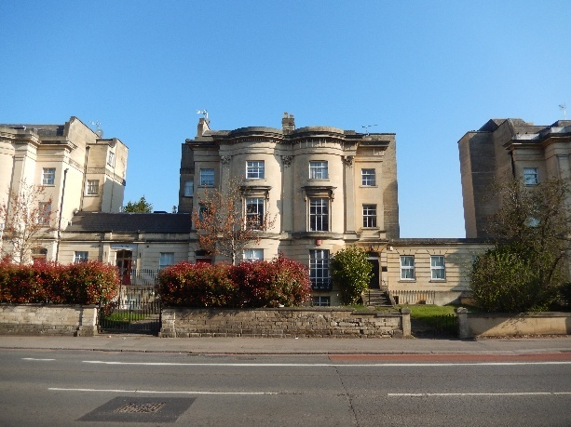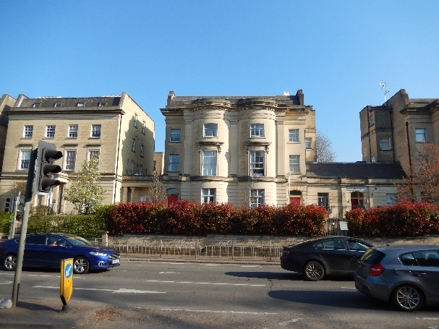
Nos. 177 & 179 Kings Road with altered roofs Nos. 173 & 175 Kings Road with modern roof
extension

  - Nos. 220 and 222 (even) Kings Road are listed grade II and lie on the opposite side of the street to the west. They date from the early C19 (restored) and were previously known as Nelson Place. Built of Bath stone, now rendered, the pair are 3 storeys over a basement and double gabled, each 1 window wide and with wide eaves to a slate roof.

  - These listed buildings are all of group value (together with the Site) and have localised settings on this wide busy route.

Eldon Square Conservation Area

  - Below we set out a statement of significance of the Eldon Square Conservation Area. It is based on a site visit and the Council’s Appraisal and is proportionate both to the importance of the asset and to the nature and extent of the application proposals. It is sufficient to understand the potential impact of the Proposals on heritage interest.

  - The national PPG states that a conservation area is an area which has been designated because of its special architectural or historic interest, the character or appearance of which it is desirable to preserve or enhance.

Designation

  - The Eldon Square Conservation Area was designated in 1972 and extended in 1982.
Boundary

  - The conservation area lies well within Reading city centre on the east side of its medieval core and about 1 km south east of the town’s modern shopping centre. With the exception of a row of grand C19 dwellings on the north side of Kings Road (nos. 163 to 189 Kings Road – which includes the Site), the conservation area lies between London Road and Kings Road. Eldon Road, the north-south ‘spine’ of the conservation area is a major route linking Kings Road and London Road. Throughout the area there is a general fall in the land northwards to the River Kennet, hence the side-street named St John’s Hill.

Character and plan form

  - The conservation area comprises a dense network of streets and roads of terraced, detached and semi-detached buildings. The most distinctive element of the street pattern is Eldon Square, a mid C19 development of houses surrounding three sides of a small enclosed rectangular public park. The large houses in Kings Road, Eldon Road and Eldon Square mostly date from the 1830s and 1840s and are built in the Classical style favoured in the first half of the C19. Several are listed, see above regarding those close to the Site (which is listed grade II).

  - The Appraisal divides the conservation area into 3 character areas. The Site lies in area 1, noted as having ‘large prestigious stone residences including Eldon Square’. The Appraisal states:

‘Area 1: Kings Road, Eldon Road and Eldon Square

This area contains the majority of the conservation area’s listed buildings and is characterised by tall detached or semi-detached residences faced with Bath stone and set back from the highway with long rear gardens. Many of these former houses have been converted to flats, offices or professional uses. Nos. 163 to 189 Kings Road form an almost continuous row of buildings of architectural interest enriched by large stone porticos, rusticated ground floors and pairs of full height bows. They rise to three storeys with basement and are approached up a flight of stone steps. Eldon Square is a formally planned composition (c1840) of houses around three sides of a park, unique in Reading….’

  - The Appraisal goes on to identify positive and negative features in this sub area of the conservation area and those relevant to the Site and the Proposals, are as follows.

  - Features that make a positive contribution include:

‘• The high concentration of listed buildings;
• The architectural cohesion of prestigious mid 19th century residential development;
• Grandeur of nos. 163 -189 Kings Road;
• Good quality townscape;
• Prevalent use of local stone.’

  - Features that have a negative impact include:

‘• Insensitive alterations to listed buildings e.g. garage door in basement of no. 2 Eldon Road;
• Continual disturbance, noise and pollution of traffic;
• Modern developments on south side of Kings Road;
• Loss of rear gardens to parking and garages;
• Loss of original front boundary walls and railings.’

Views

  - The Appraisal notes in respect of views that ‘Nos. 163 to 189 Kings Road are set well back from the road. Because of a slight bend in the road and its unusual width, these large stone houses, elevated above semi-basements, are prominent in views along Queen’s Road and Kings Road. Northward views along Eldon Road and Eldon Street are enhanced by a glimpse of the stone facades of no. 169 and no. 187/189 respectively.’

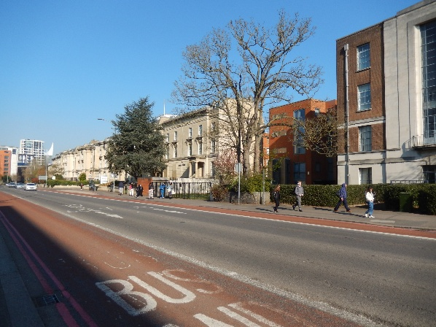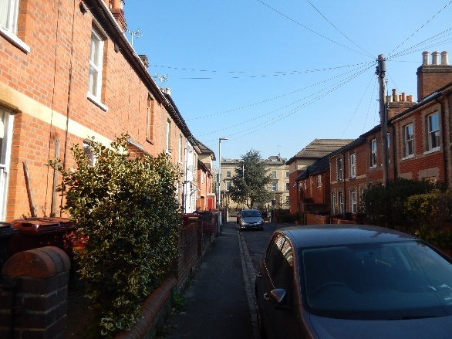
View of Site from the east on Kings Road View of Site from the south on Eldon Street

Summary of significance

  - The Appraisal summaries the significance of the conservation area, as follows:

‘The special interest that justifies designation of the Eldon Square Conservation Area derives from the following features:

- Eldon Square, a mid 19th century planned formal town square comprising an enclosed park surrounded on three sides by Bath stone detached and semi-detached buildings;
- Eldon Road, part of the formal arrangement of Eldon Square notable for a row of mid 19th century dwellings on its west side;
- The park at Eldon Square, known as King George V Gardens, which is enclosed by grade II listed railings and contains mature trees and other greenery and a large statue of the first Marquess of Reading, died 1935;
- Nos 163 to 189 (odd) Kings Road, a long row of prestigious Bath stone former early 19th century residences with good quality Classical and Italianate detailing;
- The architectural and historic interest of the area’s buildings, including two grade II* listed buildings (Watlington House and 173-183 (odd) Kings Road);
- Two churches in unusually close proximity (Wesley Methodist Church and Church of St John the Evangelist) the spires of which are a local landmark;
- 19th century street pattern on either side of Eldon Road with traces of an earlier unrealised formal layout in the vicinity of The Oval;
- Cohesive architectural development of the mid 19th century with contrasting middle-class and working class housing;
- Lengths of historic stone kerbs and gulleys and remnants of old railings;
- Good examples of small mid 19th century terraced houses probably occupied by workers in nearby Huntley and Palmers, the largest employer in 19th century Reading;
- Trees and groups of trees in the park in Eldon Square and in the curtilage of Watlington House and The Oval;
- The prevalent use of Bath stone and local brick;
- Distinctive local details such as cast iron street name signs and old lamp posts.’

  - Nos. 187-189 Kings Road, Astec House, makes a positive contribution to the significance of the conservation area for the architectural and historic interest forming part of ‘a long row of prestigious Bath stone former early 19th century residences with good quality Classical and Italianate detailing’.

- SIGNIFICANCE OF NOS. 187-189 KINGS ROAD, ASTEC HOUSE

  - This Section sets out a statement of significance of nos. 187-189 Kings Road, Astec House, Reading.

Heritage significance

  - The National Planning Policy Framework defines heritage significance at ‘Annex 2: Glossary’ as:

‘The value of a heritage asset to this and future generations because of its heritage interest. That interest may be archaeological, architectural, artistic or historic. Significance derives not only from a heritage asset's physical presence, but also from its setting.’

  - This statement of significance, in line with PPG paragraph: 006, considers the various heritage interests of nos. 187-189 Kings Road, Astec House as follows:

‘Archaeological interest There will be archaeological interest in a heritage asset if it holds, or potentially holds, evidence of past human activity worthy of expert investigation at some point.

Architectural and artistic interest These are interests in the design and general aesthetics of a place. They can arise from conscious design or fortuitously from the way the heritage asset has evolved. More specifically, architectural interest is an interest in the art or science of the design, construction, craftsmanship and decoration of buildings and structures of all types. Artistic interest is an interest in other human creative skills, like sculpture.

Historic Interest An interest in past lives and events (including pre-historic). Heritage assets can illustrate or be associated with them. Heritage assets with historic interest not only provide a material record of our nation’s history, but can also provide meaning for communities derived from their collective experience of a place and can symbolise wider values such as faith and cultural identity.’

  - Listed buildings generally hold special architectural or historic interest.

  - The following assessment of significance is proportionate to the importance of the asset and sufficient to understand the potential impact of the Proposals on heritage interest.

  - Archival material on the area and Site including historic maps was sourced at Royal Berkshire Archives.

Listing

  - Nos. 187-189 Kings Road, Astec House was listed grade II on the 24 October 1974. The list description reads as follows:

‘Nos. 187 and 189 Kings Road is listed grade II. After 1832, part of Waterloo Place. 3 storeys and basement. Bath stone. Slate roof. Rusticated ground floor, moulded let floor cill string. Dentil cornice entablature and blocking course. A symmetrical pair of houses. Bays, ground and let floors retain most glazing bar sashes. 1st floor windows have architrave surround and moulded cornice on console brackets. 2 windows on ground floor with contemporary balconies and cast-iron balustrades (honey-suckle pattern). 6 panel doors (part glazed) at sides under Doric porches, approached by steps. 2 storey extension to right of No 189 with 1 window. The contemporary Orts Road 'service' houses have recently (1977) been demolished.’

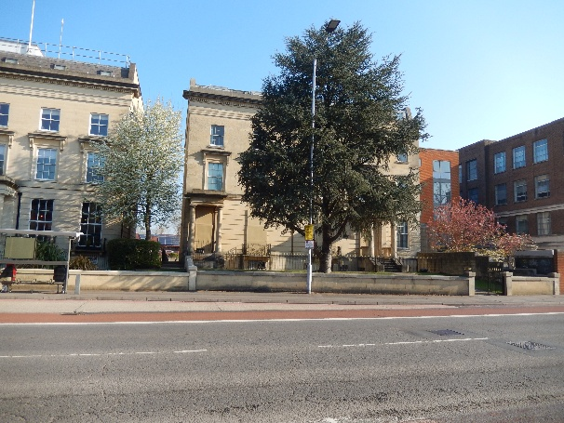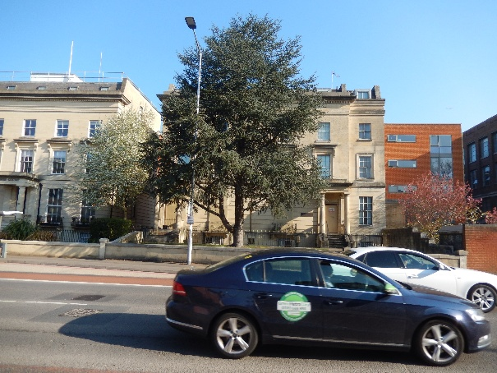

The Site, no. 187 to the left (facing) and no. 189 to the right.

Historic development

  - The houses were bult in the first half of the C19 (post 1832) and the history of the development of the area is set out at Section 3.

  - The Site was rebuilt internally as a single unit with a steel framed structure in the second half of the C20 and converted into office use. The staircases to the rear of each former house were retained (bar the stair to the basement at no. 187; and extended upwards to match existing into the new mansard roof. The 2 storey side extension to the side of no. 189 referred to in the list description is believed to have been extended full height at this time, when the lift core was built to its rear.

Description

  - Nos. 187-189 Kings Road, Astec House comprises a former handed pair of semi detached houses, now joined to form a single office building. It is 3 storeys high over a half basement with a modern mansard roof, and later side wing and modern lift core to no. 189.

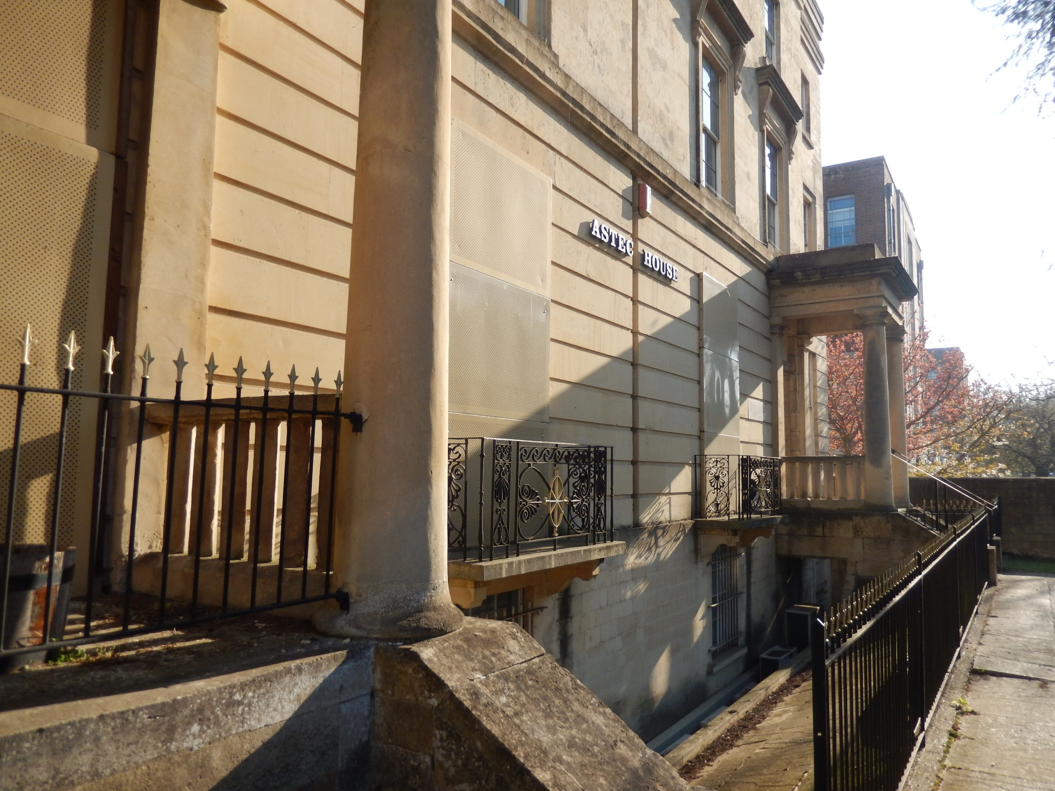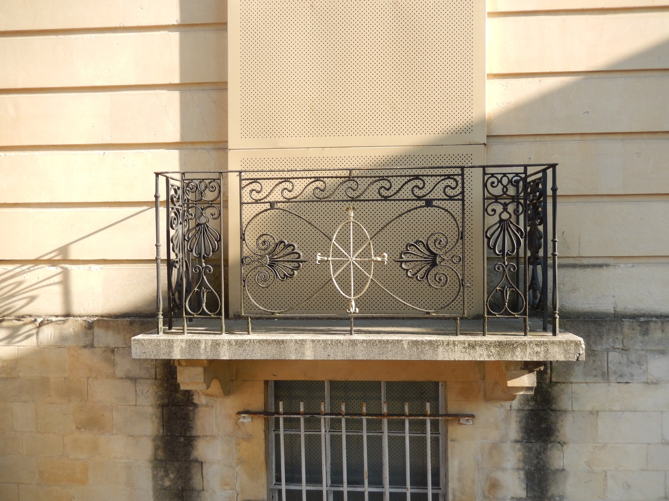
Front lightwell and porch details Balcony with cast-iron honey-suckle pattern
Balustrade

  - Each former house is 2 windows wide with the entrance in the outer bay set in a doric porch reached by 6 steps. The two tall windows in between have balconies with cast-iron honey-suckle pattern balustrades. Above, the 4 1st floor windows have architrave surrounds topped with a moulded cornice set on console brackets; and above these are 4 shorter windows with no surround details. The whole is topped by a parapet comprising a dentil cornice entablature and blocking course. The upper windows are all 6 over 6 light hung sliding sashes. There is a full height set back one bay extension to the front to the east, that steps in and stops towards the centre of the block (the later lift core).

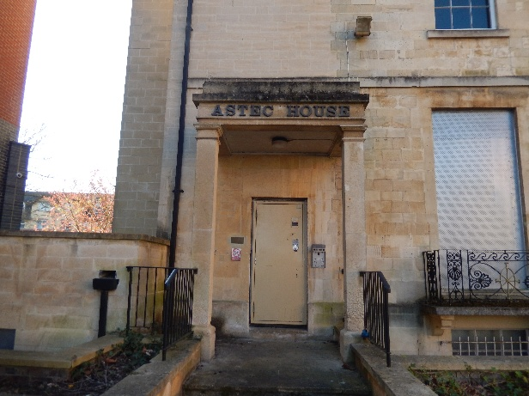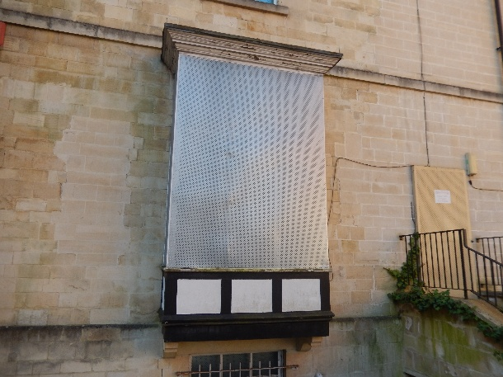
Porch (modern) to rear of no. 189 Early C20 oriel window to the rear at no. 187

  - The elevation to the rear is less decorative and more utilitarian in appearance. At ground floor level there is an entrance to the outer bay of each former house and a pair of large windows in between. At no. 189 there is a modern portico porch at the entrance and a balcony with a cast-iron honey-suckle pattern balustrade to the window (to match the front); and at no. 187 there is large oriel window, believed to date from the early C20. There is a single window at 1st and 2nd floor levels in the inner bays (decreasing in height across the floors); and a single window onto the stair well across the 1st and 2nd floors in the outer bays. There is no detail to the stonework bar a string band above the ground floor. Variations are apparent in the stonework with areas of rebuilding including likely much of the western end, and this is also found in the two flank walls (much of that to the east a modern extension).

  - The whole is topped with a modern mansard roof with a flat top with 4 windows to the front and 4 to the rear, all aligning with the window bays below. There is a modern stepped stone eaves band.

  - There are lightwells to the front and rear, the former with modern railings and the latter with a low stone wall. The front boundary wall appears to have been rebuilt.

Interior

  - As noted above the interior has been rebuilt and is largely modern in date with modern floors, walls and ceilings (based on a visual) and the historic plan form of cellular room has been lost.

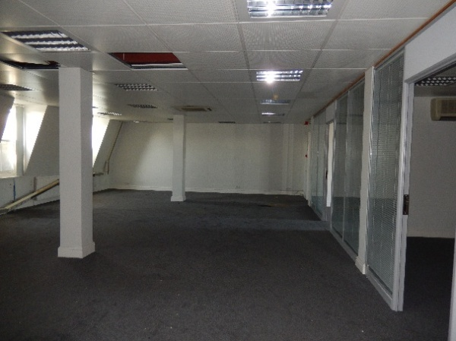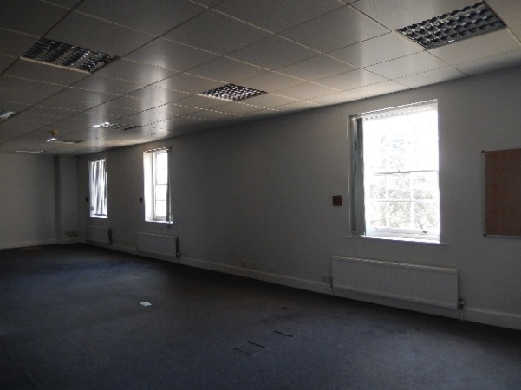
Modern office floor plate at mansard (left, facing) and 2nd floor level (right)

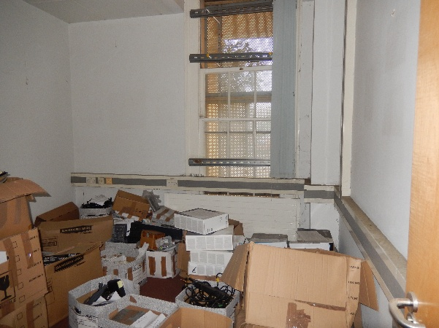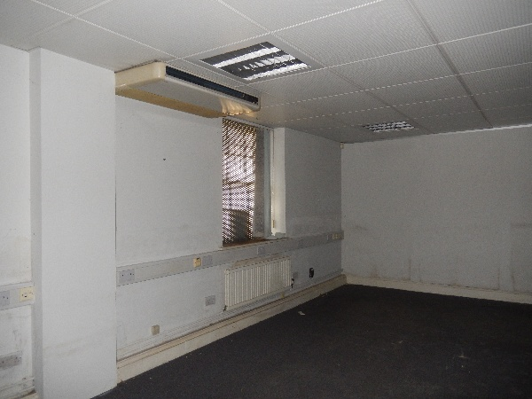
Modern office space at ground floor level (left, facing) and basement (right)
  - The interior has very few features of architectural interest with the principal exception the staircases, which are of matching designs with decorative cast-iron newel posts at ground floor level, square section timber balusters, hardwood handrails and molded strings. Both stairs have been extended upwards to match existing from the 2nd floor up to the 3rd floor mansard. There are no stairs from the ground floor to the basement at no. 187. The only other historic features that appear to survive are the architraves, shutters and boxes to the ground floor windows (bar the oriel) and the timber panels below the 1st floor windows.

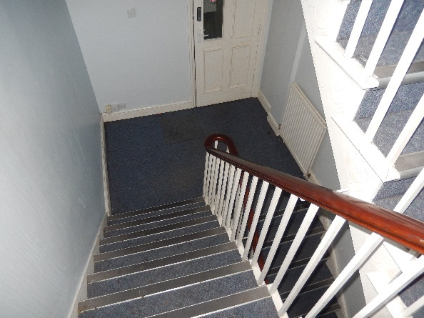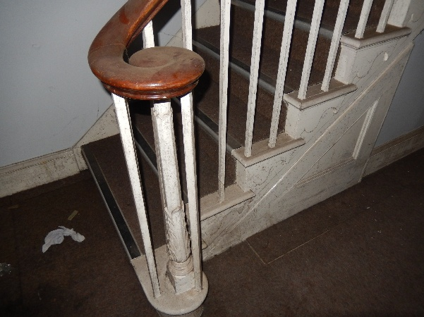
Typical staircase arrangement Cast iron newel post and carved strings

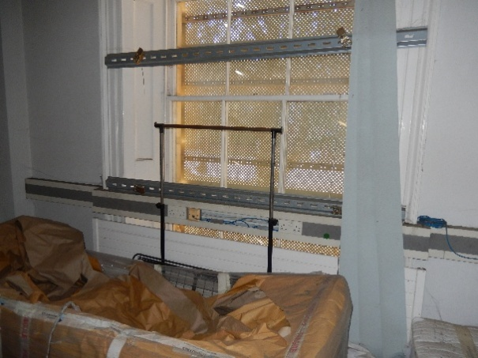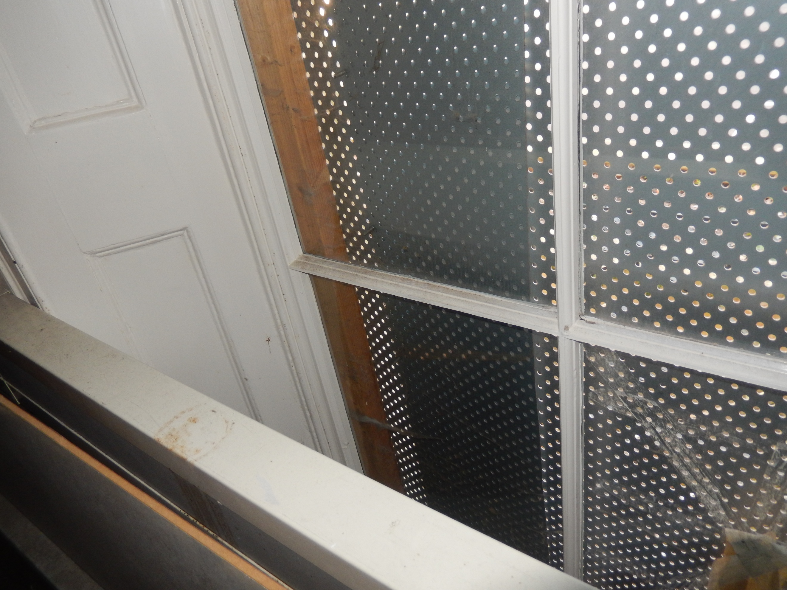
Architrave and shutter box detail at ground floor level to the front (left, facing) and rear (right)

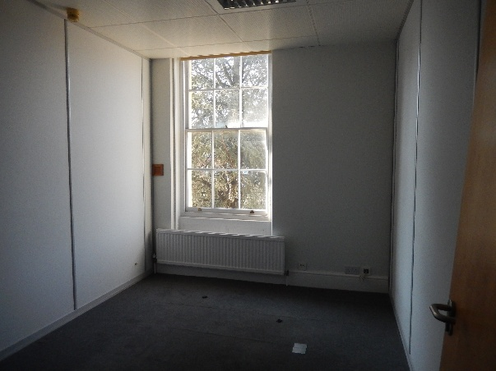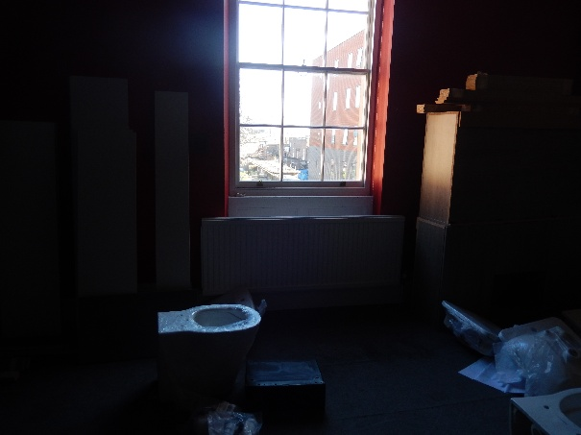
Under window panel detail at 1st floor level to the front (left, facing) and rear (right)

Heritage interest

  - The various heritage interests of nos. 187-189 Kings Road, Astec House can be summarised as follows.

Archaeological interest

  - Nos. 187-189 Kings Road, Astec House, has been largely rebuilt behind the facades and is of limited archaeological interest principally for the street facade and the limited surviving historic features internally. There is evidence of rebuilding in the flank and rear elevations.

Architectural and artistic interest

  - Nos. 187-189 Kings Road, Astec House is of principal architectural interest for the Bath stone street façade, and to a lesser degree the very limited surviving internal features. The flank and rear elevations are secondary elements and have been altered in places but are still of some significance but lesser to that of the front façade.

Historic interest

  - Nos. 187-189 Kings Road, Astec House is of historic interest as part of the original development of Waterloo Place, a residential suburb built in c.1840.

Group value

  - Nos. 187-189 Kings Road, Astec House is of group value with the contemporary listed buildings nos. 173 to 183 (odd), 185 and 220 & 222, Kings Road; see Section 3.

Setting

Nos. 187-189 Kings Road, Astec House have a localised setting on Kings Road with a surface car park to the rear and two modern developments either side – that to the west and extension to the grade II listed no. 185.

Summary

  - A summary of the significance of Nos. 187-189 Kings Road, Astec House as assessed above concludes this section. This is illustrated in the significance diagrams at Figure 1 on the following pages. It identifies areas of high significance that are most sensitive to change as well as areas of no or low significance, to help inform opportunities where enhancements can be made.

  - The level of significance attached to an element is not dependent purely on just the age of fabric (though this is one of the key considerations) but also on the contribution of that element to the importance of the building as a whole, as originally intended and as found today. The assessment takes into account the artistic value of elements, the quality of finishes and the character of spaces, in light of their original use and hierarchy within the whole, and reflects the intactness of various elements and spaces and the degree of surviving features. It considers the relative significance of a particular element in light of the various heritage interests of the building and the principal reasons for its listing.

  - The street façade and rear façade are of high significance as are the surviving staircases and linings and/ or panels to the ground and 1st floors windows.

  - The flank elevations and internal stair core side walls are of medium significance (mostly as remnants of internal plan form).

  - The main interiors, mansard roof, side extension above 1st floor level, lift core and portico porch to the rear are relatively modern and of low or no significance.

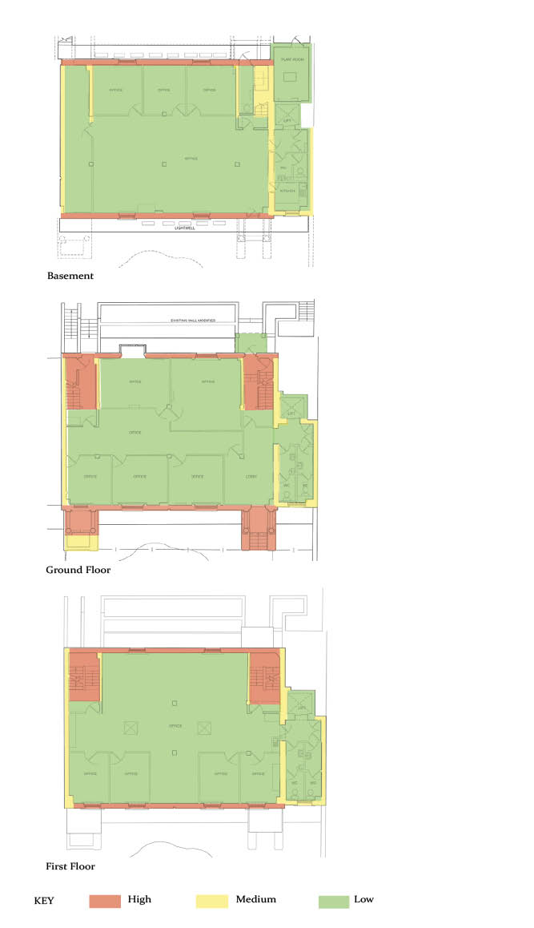

Figure 1 Significance Diagram – basement to 1st floor

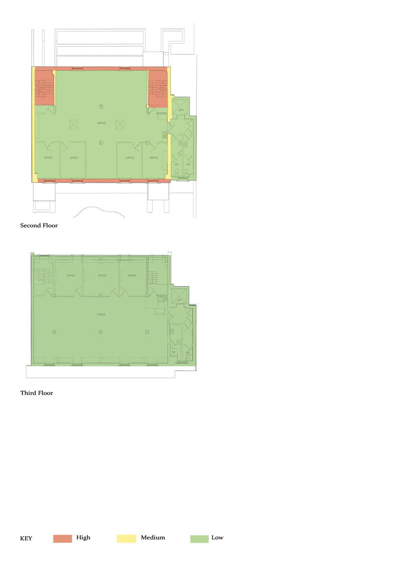

Figure 1 Significance Diagram 2nd and 3rd floors

5 ASSESSMENT AND CONCLUSIONS

  - This Section assesses the effect of the Proposals on the heritage significance of nos. 187-189 Kings Road, Astec House (listed grade II), the Eldon Square Conservation Area and the setting of nearby listed buildings. Heritage legislation, policy and guidance are set out at Section 2, the Site and its heritage context are described in Section 3, and a statement of significance of the listed building is provided at Section 4.

  - Reference should be made to the application drawings and comprehensive DAS prepared by the architects Mountford Pigott and the Planning Statement prepared by hgh Consulting.

Proposals

  - The Proposals comprise the comprehensive repair and refurbishment of the vacant listed building to provide student accommodation, comprising study bedrooms with kitchens and bathrooms and communal facilities.

External

  - The external alterations are limited and include the reinstatement of a timber front door to no. 189 and a new window (in place of a replacement window) in the former door opening at no. 187. Five roof lights are installed on top of the modern mansard roof, the 4 modern dormers in the front pitch of the mansard are replaced with conservation style roof light, and the modern roof access door is replaced. The basement door opening into the front lightwell at no. 189 will be infilled in stone work to match existing and two new windows will be created, of a style to match existing, at basement level to the rear.

  - In addition the modern low wall to the rear of the building will be removed, an area of lawn created in place of some of the existing carparking and a bin and cycle store provided.

Internal

  - The largely modern interior will be comprehensively refurbished with student accommodation rooms accessed off a central corridor. This involves the removal of the current modern fit out including the inner partition walls onto the stair lobbies, together with the provision of new wall linings (details submitted).

  - The front door of no. 189 will be retained as the main entrance with the existing stair and the lift cores retained and reused. The modern inner partition walls of the stair cores (onto the new corridors) are rebuilt as is the modern top flight of stairs leading up into the mansard at no. 187.

Assessment

  - The proposals will bring this listed building, vacant since May 2014, back into viable use.

  - External alterations are minimal and focused on the modern mansard roof or at basement level. The new skylights are set back from the roof edge and will not be visible in street views. The new conservation style rooflights, replacing the existing modern dormers, will be discreetly positioned (like the dormers). Rooflights can be found in the front roof slopes of neighbouring listed buildings. There will be no effect on historic fabric.

  - At basement level two new modest window openings are created to the rear, symmetrically positioned and with a sash window to match the style of the existing. The two modern doors at this level are replaced. At basement level to the front a door opening with a modern door at no. 189 is infilled with stone to match existing.

  - At ground floor level at no. 189 a new door of a traditional design will be installed at the main entrance, and at no. 187 the new window (there is already a modern window here) in the former entrance will have a solid panel at lower level to distinguish it from the original full height sashes with balconies at this level. This will enhance the appearance of the street elevation compared with today.

  - Other improvements to the appearance of the exterior of the listed building will include the removal of modern services, the cleaning and repair of stonework and decorative detailing and the repair of landscape features. The new grassed amenity area to the rear, in place of the existing parking spaces, will enhance the immediate setting of the listed building.

  - The largely modern interior will be comprehensively refurbished. The historic staircases are retained as found as are the window reveals and shutter boxes on the 1st floor. New partitions are kept away from the window openings and all historic fabric will be retained as found today and repaired where necessary.

  - The mansard level is modern as is the flight of stairs that lead up to it from each side from the 2nd floor. The rebuilding and reconfiguration of the modern flight at no. 187, from the 2nd floor to the mansard, will facilitate an appropriate layout at the modern mansard level with no effect on historic fabric.

  - The building has largely open plan interiors today across all floors, bar modern partition screens. The Proposal will reintroduce a pattern of cellular rooms and residential use to these buildings, more in keeping with their character when built. To the rear this includes a room at each level in each of the former houses, similar to how it will have been laid out originally.

  - The new services will be taken through the floors of the existing steel-framed internal structure which is modern and not sensitive to change.

  - There will be no harm to the heritage significance of this listed building. The Proposals, through refurbishing and bringing the building back into use, returning a cellular layout, will better reveal the significance of this listed building.

Eldon Square Conservation Area

  - The Site in its current vacant boarded up condition detracts from the significance of the Eldon Square Conservation Area. The refurbished and repaired listed building, with minimal external alterations, will be brought back into active use and this will enhance the character and appearance of the conservation area and better reveal its significance.

Setting of listed buildings

  - The external alterations are limited but the Proposals will, through bringing the building back into use, enhance the setting of the adjoining grade II listed nos. 183 & 185 Kings Road.

Council policies

  - In line with Policy EN1 ‘Protection and Enhancement of the Historic Environment’ there will be no adverse impact on those elements which contribute to the special architectural or historic interest of the grade II listed host building or the setting of any other listed building.

  - In line with Policy EN3 ‘Enhancement of Conservation Areas’ the special interest, character and architecture of the Eldon Square Conservation Area will be conserved and enhanced.

Conclusions

  - The Proposals represent an intelligent and carefully considered response to nos. 187-189 Kings Road, Astec House, the Eldon Square Conservation Area as well as the setting of nearby listed buildings. They will bring this listed building, vacant since 2014, back into active use following a comprehensive programme of repair and refurbishment.

  - In respect of the design considered in its own right, and the relationship between the Proposals and the host building, as well as its heritage context, the effects will all be positive. Special attention has been paid to the effect of the Proposals on the significance of nos. 187-189 Kings Road, Astec House and the Eldon Square Conservation Area as well as the settings of nearby listed buildings. The Proposals therefore accord with the objectives set out in sections 16(2), 66(1) and 72 of the Planning (Listed Buildings and Conservation Areas) Act 1990 (as amended). They are in line with relevant legislation, the policies and guidance on heritage set out in the NPPF and PPG; Local Plan policies and relevant SPDs; and HE guidance.

Gareth Jones BA Hons MA UD Dip Bldg Cons (RICS) MRTPI IHBC
25 March 2026

