DELEGATED APPLICATION REPORT
Ward: Coley
App Ref: PL/25/1700 Householder planning permission
Address: 68 COLEY AVENUE, READING, RG1 6FJ
Proposal: PROPOSAL FOR SINGLE STOREY REAR EXTENSION
Applicant: Subika & Yusuf Mehdi
Received date: 26/11/2025
Target Decision date: 22/04/2026 (EXT)
Case Officer: Chukwudi Onwudinanti

SITE DESCRIPTION
The application site is a two-storey semi-detached dwelling located within an established residential area along Coley Avenue.

The surrounding area is characterised by similar residential properties arranged in a consistent pattern with rear garden areas, and a detached garage. The site benefits from a typical fairly sizeable plots with neighbouring dwellings immediately adjoining on either side.

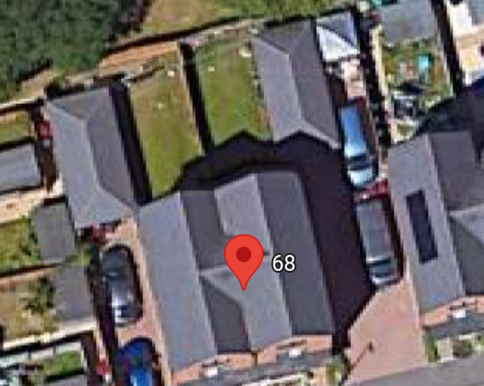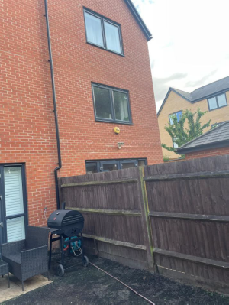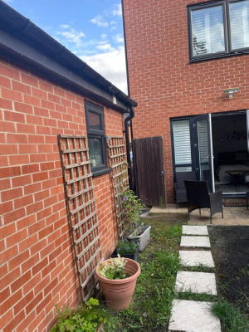
Google Photo Site Photos

PROPOSAL AND SUPPORTING INFORMATION
Planning permission is sought for the erection of a single-storey rear extension. The proposal comprises a rear extension across the width of the dwelling, with a depth of 4m and a height of 2.5m, enlargement of kitchen and dining area and introduction of a utility space

The proposal utilises materials to match the existing dwelling including brickwork and uPVC windows

Plans and Documents
Dated Nov 2025, Received 22/04/2026
Drawing No 68CA/24112025/Rev B: Proposed Plans and Elevations

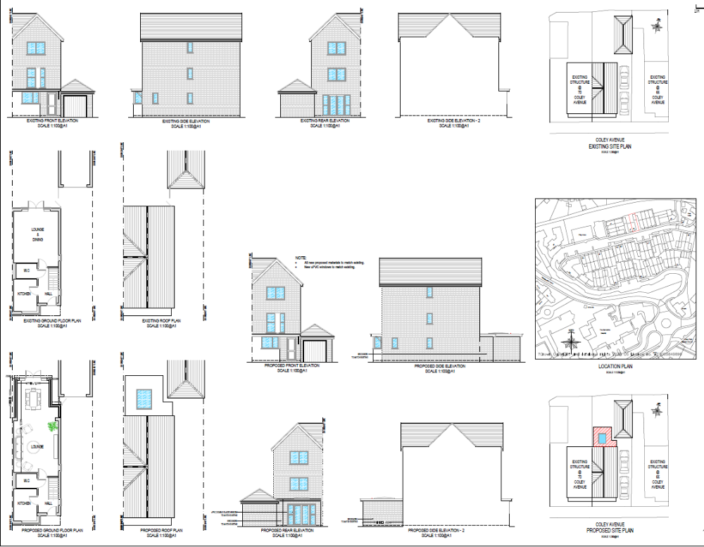

Existing and Proposed Plans and Elevations

RELEVANT PLANNING HISTORY
App Ref: 230793/HOU
Proposals: Garage conversion. Addition of PV panels and domestic EV point.
Decision: Approved
Date: 4th September 2023

CONSULTATIONS
A Site Notice was put up 19/12/2025
No letter of objection has been received.

Discussions with Agent.
The original submission had the extension right on the boundary with the adjoining property on No 70. The officer advised that the extension be pulled away from the boundary fence, to ensure that there are no negative impacts or encroachment on the adjoining property. This advice has been taken, and revised drawings were submitted by the agent, pulling the side of the extension 0.4m away from the boundary line.

Equality Act 2010:
In determining this application, the Council is required to have regard to its obligations under the Equality Act 2010. However, there is no indication or evidence (including from consultation on the application) that the protected groups identified by the Act have or will have different needs, experiences, issues and priorities in relation to this particular planning application. Therefore, in terms of the key equalities protected characteristics it is considered there would be no significant adverse impacts as a result of the development.

LEGAL AND PLANNING POLICY CONTEXT
Section 38(6) of the Planning and Compulsory Purchase Act 2004 requires that proposals be determined in accordance with the development plan unless material considerations indicate otherwise. Material considerations include relevant policies in the National Planning Policy Framework (NPPF) - among them the 'presumption in favour of sustainable development'. The following local and national planning policy and guidance is relevant to this application:

National Policy
National Planning Policy Framework
National Planning Practice Guidance

Reading Borough Local Plan (2019)
CC7 (Design and the Public Realm)
CC8 (Safeguarding Amenity)
H9 (House Extensions and Ancillary Accommodation)
H10 (Private and Communal Outdoor Space)

SPD
Design Guide to House Extensions SPD 2021

Local Plan Partial Update
The current version of the Local Plan turned five years old on 5th November 2024. The Local Plan was reviewed in March 2023 and around half of the policies in the plan are considered still up-to-date. However, the rest need to be considered for updating to reflect changing circumstances and national policy. A consultation version of the draft updated version of the Local Plan was published on 6th November 2024 and the submission draft submitted to the Planning Inspectorate on 9th May 2025 and the Examination was in February 2026.

Although there is a five-year period for carrying out a review of a plan after it is adopted, nothing in the NPPF or elsewhere says that policies automatically become out of date when they are five years old. It is a matter of planning judgement rather than legal fact whether a plan or policies within it are out-of-date. This will depend on whether they have been overtaken by things that have happened since the plan was adopted, either on the ground or through changes in national policy, for example.

Officer advice in respect of the Local Plan policies pertinent to this application is that they remain in accordance with national policy. The objectives of the policies listed above remain very similar in the draft updated Local Plan, and although at present they have some weight in the decision -making process the current policies can continue to be afforded weight in the appraisal below and are not considered to be ‘out of date’.

APPRAISAL

Character and Appearance
Policy H9 states that an extension to a house will be acceptable where it respects the character of the house in terms of scale, location, materials and design and respects the character and pattern of neighbouring properties and the street as a whole. Policy CC7 also sets out relevant considerations for design.

The proposed development comprises a single-storey rear extension which is subordinate in scale to the host dwelling and positioned to the rear where it would not be visible from the public realm. The proposed materials are indicated to match the existing dwelling, including brickwork and fenestration.

The scale and form of the extension are typical of residential rear additions and would not harm the character or appearance of the host dwelling or surrounding area.

Residential Amenity
Policy H9 states that an extension will be acceptable where it does not result in an overbearing impact on neighbours. Policy H10 seeks to ensure that the amenity of gardens and other outdoor areas are not compromised. Policy CC8 states an extension to a house will be acceptable where it will not cause a significant detrimental impact to the living environment of existing or new residential properties.

The proposed extension is single storey and located to the rear. It would not introduce overlooking or significant loss of privacy as there are no side windows proposed. Also, given its limited height and flat roof style, it is not considered that the proposal would result in an overbearing impact or unacceptable loss of light to neighbouring properties.

Whilst the proposal would reduce the depth of the rear garden, a sufficient and usable level of private amenity space would be retained.

CONCLUSION
The proposed development has been assessed as set out above and is considered to be acceptable on that basis, subject to the following conditions.

RECOMMENDATION: Grant

Recommended Conditions:
Approved Plans
Time Limit Standards
Materials As Specified
Roof Use Restriction

