DELEGATED APPLICATION REPORT
Ward: Whitley
App Ref: PL/26/0075 Full planning permission
Address: 100 LONGWATER AVENUE, READING, RG2 6GP
Proposal: Installation of two air source heat pumps.
Applicant: -
Received date: 23/01/2026
Target Decision date: 21/04/2026 (EXT)
Case Officer: Chukwudi Onwudinanti

1. SITE DESCRIPTION
The application site comprises an existing office building located within Green Park Business Park, accessed from Longwater Avenue. The wider area is characterised by large-scale commercial office buildings within a landscaped business park setting.

The building contains an existing flat roof with plant equipment including air handling units and chillers located within a louvred rooftop plant enclosure.

The surrounding area is commercial in character, with the nearest residential properties located at a significant distance from the site.

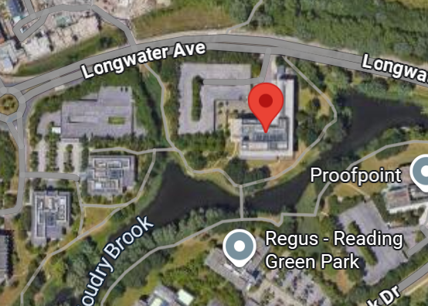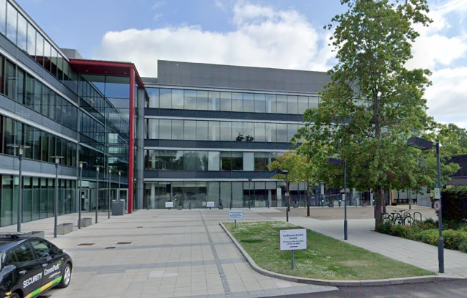
Google Photos

2. PROPOSAL AND SUPPORTING INFORMATION
Planning permission is sought for the installation of two air source heat pumps (ASHPs) on the roof of the building.

The proposal includes:

- Two ASHP units located on the rooftop
- Associated pipework at low level
- Installation within the existing plant screened enclosure

The proposed roof layout confirms that the units would be positioned within the established plant area and contained behind the existing plant screen.

The submitted elevations demonstrate that the proposed ASHP units would be located behind the existing louvred screen and would not project above it, thereby limiting visibility.

The submitted technical specification identifies the proposed plant as a Climaveneta reversible air source heat pump unit designed for outdoor installation.

Plans and Documents received 23/01/2026:

Cover Letter (Lichfields, dated 23 January 2026)
Drawing No: 02-00: Site Location Plan
Drawing No: 50-SA-200 Rev 03 - Existing Site Plan
Drawing No: 50-SA-201 Rev 04 - Proposed Site Plan
Drawing No: 50-RF-200 Rev 03 - Existing Mechanical Services Layout (Roof Level)
Drawing No: 50-RF-202 Rev 03 - Proposed Mechanical Services Layout (Roof Level)
Drawing No: 50-XX-200 Rev 03 - Existing Mechanical Services Elevation (North & West)
Drawing No: 50-XX-201Rev 03 - Proposed Mechanical Services Elevation (North & West)
Technical Specification – ASHP Unit

3. RELEVANT PLANNING HISTORY
Application Ref: 12/0502
Description: Demolition of the existing main entrance area of 200 and 250 Longwater Avenue and replacement with new glazed entrances; installation of new rooftop plant and solar panels; creation of a new bound gravel path; and minor landscaping works
Decision: Granted
Date: 11/09/2012

4. CONSULTATIONS
Site Notice was put up 13/03/2026
No objections have been received.

Internal Environmental Protection Standing Advice has been considered for this application, which states:
For new or upgraded mechanical plant (air conditioning, condensers, kitchen extraction, air handling units, change of use to A3/A4) where no noise assessment has been submitted

Applications which include noise generating plant when there are nearby noise sensitive receptors should be accompanied by an acoustic assessment carried out in accordance with BS4142:2014 A2019 methodology. The predicted specific sound level (LAeq,TR) (with reference to BS:4142) as measured at a point 1 metre external to the nearest noise-sensitive facade should be at least 10dB below the pre-existing background sound level, LA90,T when all plant/equipment (or any part of it) is in operation. The predicted rating level, LAr,Tr (specific sound level plus any adjustment for the characteristic features of the sound) as measured at a point 1 metre external to the nearest noise-sensitive façade (habitable window of a dwelling) shall not exceed the pre-existing background sound level, LA90,T when all plant/equipment (or any part of it) is in operation.

A noise assessment has not been submitted with the application and therefore EP cannot determine the likely noise impact of the proposal and whether the proposals are acceptable. EP therefore recommend refusal unless a noise assessment can be submitted and considered by us before the application is determined.

In this instance, it has not been considered that the application site has “nearby noise sensitive receptors”

Environment Comments.
We normally would need a noise assessment for this type of application, however due to the considerable distance from any residential property, in this instance it is not required. I would just include that.

5. LEGAL AND PLANNING POLICY CONTEXT
Section 38(6) of the Planning and Compulsory Purchase Act 2004 requires that proposals be determined in accordance with the development plan unless material considerations indicate otherwise. Material considerations include the National Planning Policy Framework (NPPF), including the presumption in favour of sustainable development.

National Policy and Guidance
National Planning Policy Framework
National Planning Practice Guidance

Reading Borough Local Plan (2019)
CC1: Presumption in Favour of Sustainable Development
CC3: Adaptation to Climate Change
CC7: Design and the Public Realm
CC8: Safeguarding Amenity
EN16: Pollution and Water Resources
EN17: Noise Generating Equipment

Equality Act 2010
In determining this application, the Council is required to have regard to its obligations under the Equality Act 2010. However, there is no indication or evidence (including from consultation on the application) that the protected groups identified by the Act have or will have different needs, experiences, issues and priorities in relation to this particular planning application. Therefore, in terms of the key equalities protected characteristics it is considered there would be no significant adverse impacts as a result of the development.

6. APPRAISAL

Design and Character
Policy CC7 requires development to be of high-quality design and to respect the character of the surrounding area.

The building already accommodates significant rooftop plant within a screened enclosure. The proposed ASHP units would be located within this established plant area and contained behind the existing louvred screen.

The proposed elevation drawings confirm that the units would not extend beyond the height of the existing screen and would therefore not introduce visually prominent features.

Given the commercial context and existing rooftop plant, the proposal would not result in harm to the character or appearance of the building or surrounding area.

Residential Amenity
Policy CC8 seeks to ensure that development does not result in unacceptable harm to the living conditions of nearby occupiers.
Policy EN16 seeks to ensure that development does not give rise to unacceptable levels of pollution, including land, water and air pollution, and requires that proposals incorporate appropriate mitigation where necessary.
Policy EN17 requires that development involving plant or equipment does not result in unacceptable noise impacts on surrounding uses

The proposal introduces mechanical plant that has the potential to generate noise. However, the site is located within a commercial business park, the nearest residential receptors are located at a considerable distance, and the plant is located within an existing screened enclosure

These combined factors reduce the likelihood of significant amenity impacts. Therefore, given the separation distance, the presence of existing rooftop plant and the screening of the proposed equipment, it is not considered that the proposal would result in unacceptable impacts in terms of noise, disturbance or outlook. Condition is attached to mitigate any noise impacts.

Climate Change and Sustainability
Policy CC3 supports development that contributes to mitigating climate change and improving energy efficiency.

The installation of ASHPs represents a low-carbon heating solution and forms part of a wider decarbonisation strategy for the Green Park estate.

The NPPF gives significant weight to the benefits of renewable and low-carbon energy development, including the retrofitting of existing buildings.

The proposal, therefore, carries significant positive weight in favour of the development.

7. CONCLUSION
The proposal has been assessed against the Reading Borough Local Plan and the NPPF.

The development:
- Is acceptable in principle (CC1)
- Strongly supports climate change objectives (CC3 / NPPF)
- Is acceptable in design terms (CC7)
- Potential amenity considerations relating to noise (CC8, EN16, EN17), will require conditions to ensure mitigation.

Overall, the proposal is considered acceptable subject to appropriate noise restricting conditions.

8. RECOMMENDATION

GRANT

Recommended conditions:
Time limit (standard)
Approved plan
Noise Restriction

Informatives:
Terms
Building Control
Complaints about Construction

