DELEGATED APPLICATION REPORT
Ward: Caversham
App Ref: PL/25/1741 Householder planning permission
Address: 9 THE MOUNT, CAVERSHAM, READING, RG4 7RU
Proposal: Erection of a single storey rear extension with associated fenestration and associated internal works
Applicant: Mr & Ms MR MAGUIRE & MS LANKESTER
Received date: 3/12/25
Target Decision date: 16/4/26 (EXT)
Case Officer: Chukwudi Onwudinanti

SITE DESCRIPTION

The application site is a detached dwelling located within a residential area along The Mount in Caversham. The surrounding area is characterised by detached dwellings set within relatively generous plots with varied architectural styles.

The application site itself occupies an irregular, tapering plot with a large rear garden area. The dwelling is set back from the highway and benefits from spacing to neighbouring properties.

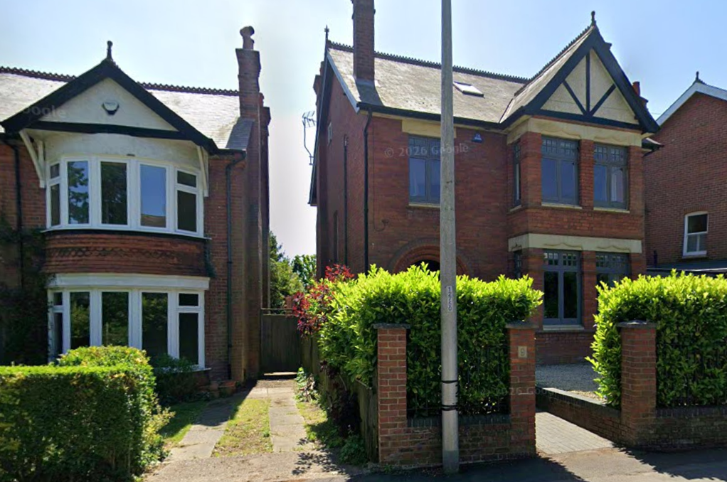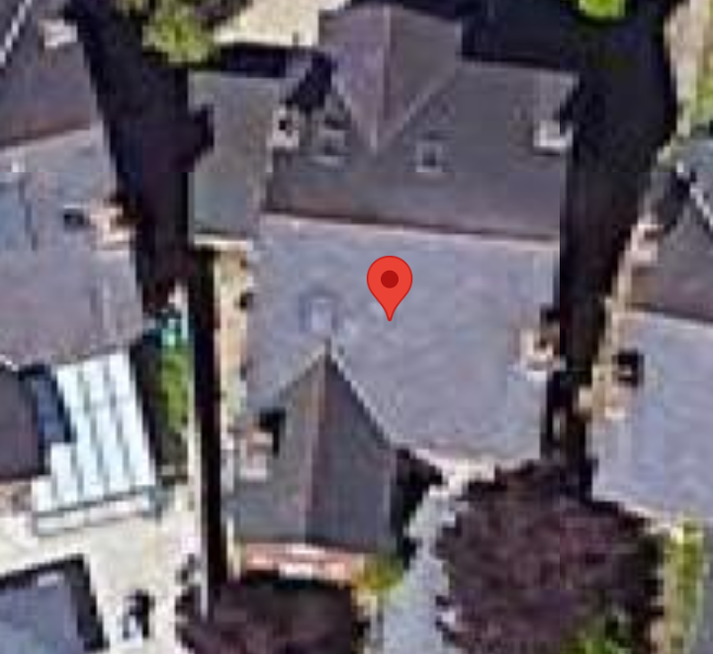
Google Map Photos

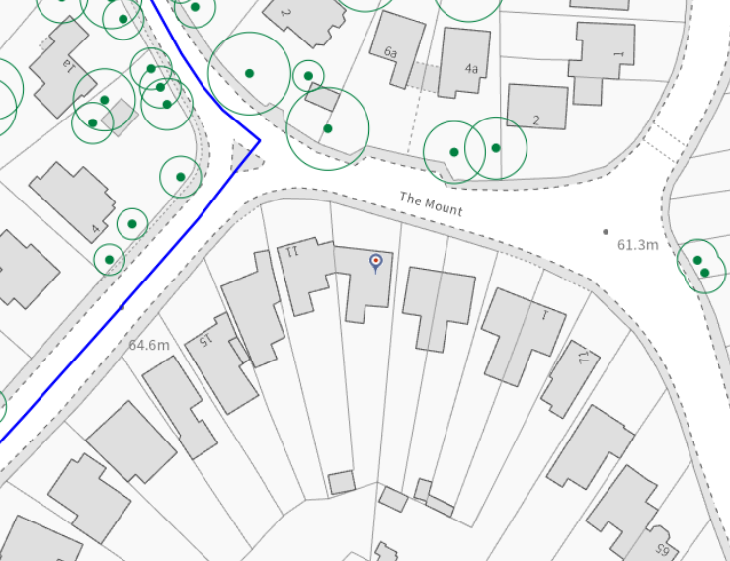
Location Details

PROPOSAL AND SUPPORTING INFORMATION

The application seeks planning permission for:

- Single storey rear extension measuring 2m deep, 3.7m wide and 3.4m high, ground to eaves.
- Associated fenestration changes
- Side facing glazed double doors (towards no. 7)
- Internal alterations

The proposal involves the enlargement of the ground floor to provide an open-plan kitchen/dining/living space to the rear of the dwelling.

External materials are proposed to match the existing dwelling, including facing red brickwork and grey slate roof tiles.

Plans and Documents
Dated Dec 2025, Received 03/12/2025

Drawing No A4/456/11: Proposed Block Plan
Drawing No A1/456/03: Details of Proposed Floor Plans
Drawing No A1/456/04: Details of Proposed Elevations
Drawing No A1/456/01: Details of Existing Plans
Drawing No A1/456/02: Details of Existing Elevations
Drawing No A4/456/10: Existing Block Plan
Drawing No A4/456/OS1: Site Location Plan

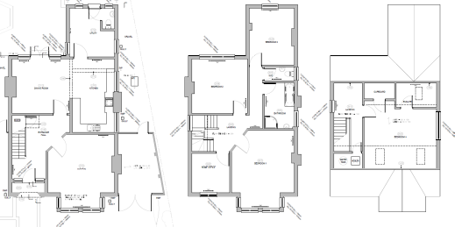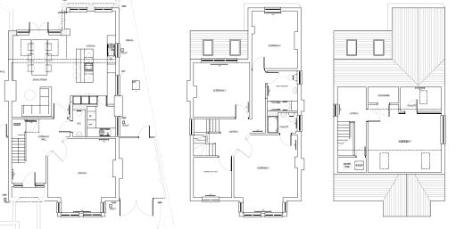
Existing Floor Plans Proposed Floor Plans

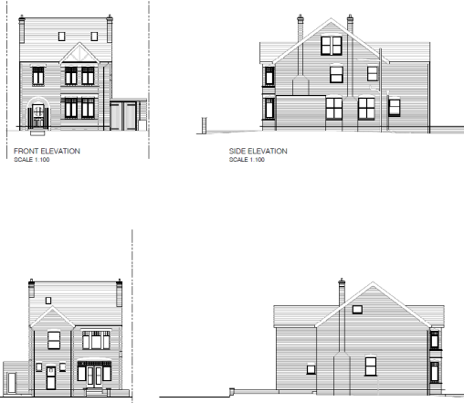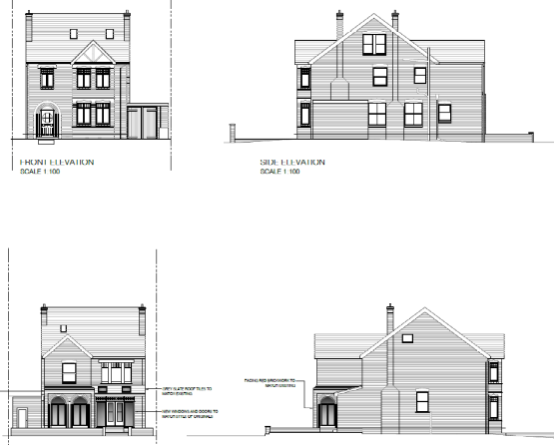

Existing Elevations Proposed Elevations

RELEVANT PLANNING HISTORY

None, relevant to this application.

CONSULTATIONS

A Site Notice was put up 19/12/2025
No letter of objection received.

Equality Act 2010:
In determining this application, the Council is required to have regard to its obligations under the Equality Act 2010. However, there is no indication or evidence (including from consultation on the application) that the protected groups identified by the Act have or will have different needs, experiences, issues and priorities in relation to this particular planning application. Therefore, in terms of the key equalities protected characteristics it is considered there would be no significant adverse impacts as a result of the development.

LEGAL AND PLANNING POLICY CONTEXT

Section 38(6) of the Planning and Compulsory Purchase Act 2004 requires that proposals be determined in accordance with the development plan unless material considerations indicate otherwise. Material considerations include relevant policies in the National Planning Policy Framework (NPPF) - among them the 'presumption in favour of sustainable development'. The following local and national planning policy and guidance is relevant to this application:

National Policy

National Planning Policy Framework
National Planning Practice Guidance

Reading Borough Local Plan (2019)

CC7 (Design and the Public Realm)
CC8 (Safeguarding Amenity)
H9 (House Extensions and Ancillary Accommodation)
H10 (Private and Communal Outdoor Space)

SPD

Design Guide to House Extensions SPD 2021

Local Plan Partial Update
The current version of the Local Plan turned five years old on 5th November 2024. The Local Plan was reviewed in March 2023 and around half of the policies in the plan are considered still up-to-date. However, the rest need to be considered for updating to reflect changing circumstances and national policy. A consultation version of the draft updated version of the Local Plan was published on 6th November 2024 and the submission draft submitted to the Planning Inspectorate on 9th May 2025 and the Examination was in February 2026.

Although there is a five-year period for carrying out a review of a plan after it is adopted, nothing in the NPPF or elsewhere says that policies automatically become out of date when they are five years old. It is a matter of planning judgement rather than legal fact whether a plan or policies within it are out-of-date. This will depend on whether they have been overtaken by things that have happened since the plan was adopted, either on the ground or through changes in national policy, for example.

Officer advice in respect of the Local Plan policies pertinent to this application is that they remain in accordance with national policy. The objectives of the policies listed above remain very similar in the draft updated Local Plan, and although at present they have some weight in the decision -making process the current policies can continue to be afforded weight in the appraisal below and are not considered to be ‘out of date’.

APPRAISAL

Character and Appearance

Policy H9 states that an extension to a house will be acceptable where it respects the character of the house in terms of scale, location, materials and design and respects the character and pattern of neighbouring properties and the street as a whole. Policy CC7 also sets out relevant considerations for design.

The proposed development comprises a single storey rear extension to the dwelling and as such would not be visible from the public realm. The scale and height of the extension remain subordinate to the main dwelling, and the use of matching materials ensures that it integrates with the existing building.

The proposal is considered to respect the character of the host dwelling and the surrounding area and is therefore compliant with Policies CC7 and H9.

It is considered therefore, that the proposal is in compliance with Policies CC7 and H9.

Residential Amenity

Policy H9 states that an extension will be acceptable where it does not result in an overbearing impact on neighbours. Policy H10 seeks to ensure that the amenity of gardens and other outdoor areas are not compromised. Policy CC8 states that development should not cause a significant detrimental impact to the living environment of existing or new residential properties.

The proposed extension is single storey and is located within a deep rear garden plot. Given its scale, position and limited depth, it is not considered that the development would result in a significant loss of light, overbearing impact or overlooking to neighbouring properties. There is aside window proposed on the side facing No 7, however as this window will be considerably pulled back from the fence and no direct window on the other side of the adjoining property, it is not considered that this will present any negative impacts on amenity.

Adequate private outdoor space would remain following the development.

The proposal is therefore compliant with Policies CC8, H9 and H10.

CONCLUSION
The proposed development has been assessed as set out above and is considered to be acceptable on that basis, subject to the following conditions.

RECOMMENDATION: Grant

Recommended Conditions:
Approved Plans
Time Limit Standards
Materials As Specified

