DELEGATED APPLICATION REPORT
Ward: Emmer Green
App Ref: PL/25/1763 Householder planning permission
Address: 14 HOLYROOD CLOSE, CAVERSHAM, READING, RG4 6PZ
Proposal: Single storey rear and side extension
Applicant: Mr & Mrs A Wheeler
Received date: 09/12/2025
Target Decision date: 17/04/2026 (EXT)
Case Officer: Chukwudi Onwudinanti

SITE DESCRIPTION

The application site is a two-storey semi-detached dwelling located within a residential cul-de-sac (Holyrood Close) in Caversham. The surrounding area is characterised by similar residential properties arranged in a consistent pattern with rear garden areas and off-street parking.

The site benefits from a private rear garden and driveway to the front providing parking. The application site is not located within a conservation area, and no Tree Preservation Orders (TPOs) affect the site. The proposal site is also elevated above the ground level of the adjoining road and properties on the other side of the road, which puts it at a vantage position.

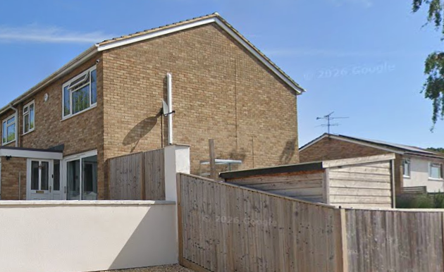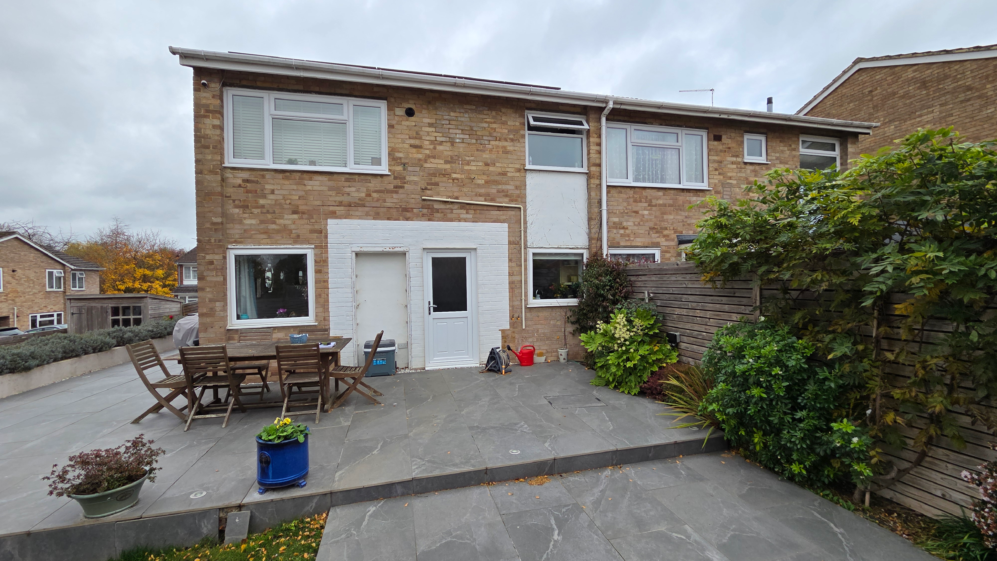
Google Photos (Nearest Tree Highlighted) Site Photos

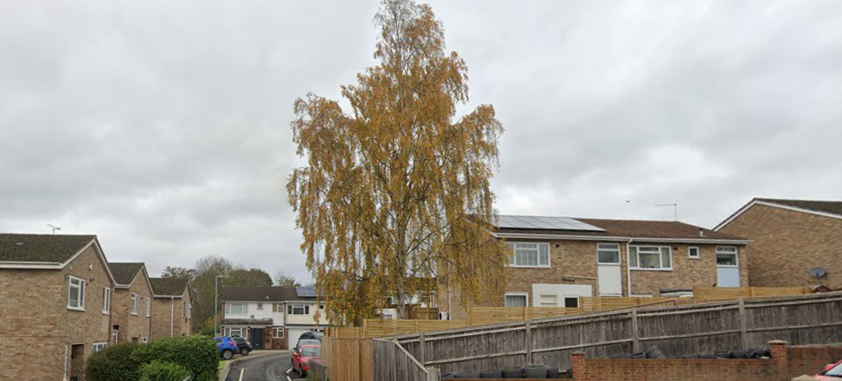
Google Photos

PROPOSAL AND SUPPORTING INFORMATION

Planning permission is sought for the erection of a single-storey side and rear extension with associated internal alterations.

The proposal includes:

- Wraparound single-storey extension to the side and rear, measuring 4m deep, 7.7m wide, stepped back from the adjoining property on the semi-detached pair by 1.8m. The height is approximately 3m, ground to eaves, with a hipped roof. The height is lower on one side of the extension due to the sloping ground level on the site.
- Enlargement of kitchen and dining areas
- Creation of additional ancillary accommodation including utility and home office
- External alterations including new windows and doors

Plans and Documents

Dated Dec 2025, Received 09/12/2025
Drawing No BA 0328 01: Existing Plans & Elevations
Drawing No BA 0328 03: Proposed Plans & Elevations
Arboricultural Report (BS5837)

Dated Dec 2025, Received 09/12/2025
Drawing No BA 0328 04 A: Site & Location Plan

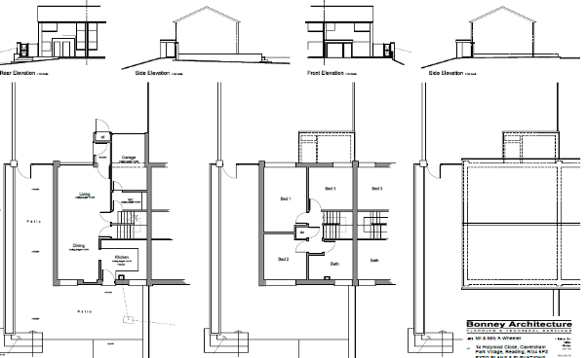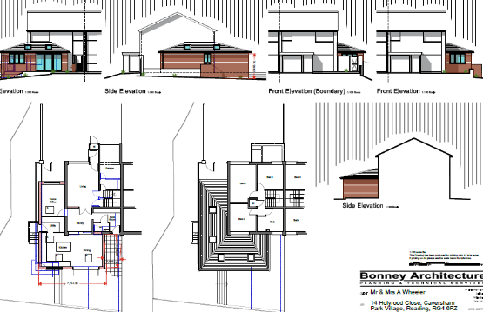
Existing Plans and Elevations Proposed Plans and Elevations

RELEVANT PLANNING HISTORY
None.

CONSULTATIONS
A Site Notice was put up 27/02/2026
No letter of objection received.

Trees / Arboriculture
The submitted BS5837 tree survey identifies one tree of moderate quality (Category B) adjacent to the site.

The report states:

- No Tree Preservation Order applies
- The site is not within a conservation area
- The tree can be retained subject to appropriate protection measures

Root Protection Areas (RPA) are identified and mitigation measures including protective fencing are put forward in the Tree Report.

Equality Act 2010:
In determining this application, the Council is required to have regard to its obligations under the Equality Act 2010. However, there is no indication or evidence (including from consultation on the application) that the protected groups identified by the Act have or will have different needs, experiences, issues and priorities in relation to this particular planning application. Therefore, in terms of the key equalities protected characteristics it is considered there would be no significant adverse impacts as a result of the development.

LEGAL AND PLANNING POLICY CONTEXT

Section 38(6) of the Planning and Compulsory Purchase Act 2004 requires that proposals be determined in accordance with the development plan unless material considerations indicate otherwise. Material considerations include relevant policies in the National Planning Policy Framework (NPPF) - among them the presumption in favour of sustainable development.

National Policy
National Planning Policy Framework
National Planning Practice Guidance

Reading Borough Local Plan (2019)
CC7 (Design and the Public Realm)
CC8 (Safeguarding Amenity)
H9 (House Extensions and Ancillary Accommodation)
H10 (Private and Communal Outdoor Space)
EN12 (Trees, Hedges and Woodland)

SPD
Design Guide to House Extensions SPD 2021

Local Plan Partial Update
The current version of the Local Plan turned five years old on 5th November 2024. The Local Plan was reviewed in March 2023 and around half of the policies in the plan are considered still up-to-date. However, the rest need to be considered for updating to reflect changing circumstances and national policy. A consultation version of the draft updated version of the Local Plan was published on 6th November 2024 and the submission draft submitted to the Planning Inspectorate on 9th May 2025 and the Examination was in February 2026.

Although there is a five-year period for carrying out a review of a plan after it is adopted, nothing in the NPPF or elsewhere says that policies automatically become out of date when they are five years old. It is a matter of planning judgement rather than legal fact whether a plan or policies within it are out-of-date. This will depend on whether they have been overtaken by things that have happened since the plan was adopted, either on the ground or through changes in national policy, for example.

Officer advice in respect of the Local Plan policies pertinent to this application is that they remain in accordance with national policy. The objectives of the policies listed above remain very similar in the draft updated Local Plan, and although at present they have some weight in the decision -making process the current policies can continue to be afforded weight in the appraisal below and are not considered to be ‘out of date’.APPRAISAL

Character and Appearance

Policy H9 states that an extension to a house will be acceptable where it respects the character of the house in terms of scale, location, materials and design and respects the character and pattern of neighbouring properties and the street as a whole. Policy CC7 also sets out relevant considerations for design.

The proposed development comprises a single-storey wraparound extension which is subordinate in scale and positioned to the side and rear of the dwelling. The extension would not be prominent within the street scene as it is stepped back from the frontline of the existing dwelling’ and would not disrupt the established pattern of development on the Principal Elevation but is much more visible on the right side of the dwelling, owing to the position of the site on a corner plot.

The submitted plans indicate that materials would match the existing dwelling and the design reflects the character of the host property. The proposal keeps the extension subservient to the original dwelling.

The proposal is therefore considered to comply with Policies CC7 and H9.

Residential Amenity

Policy H9 states that an extension will be acceptable where it does not result in an overbearing impact on neighbours. Policy CC8 states that development should not cause a significant detrimental impact to the living environment of existing or new residential properties.

The extension is single storey and located to the side and rear of the dwelling. It would not introduce unacceptable overlooking or loss of privacy and is not considered to result in an overbearing impact or unacceptable loss of light to the adjoining property on the other side of the semi. The extension is stepped away from the boundary with the adjoining property and the nearest window on that property is to the kitchen, so not a habitable room. There is no close adjoining property on the other side, as the property is on a corner plot, bounded on the other side by an empty plot and a road.

The proposal is therefore considered to comply with Policies CC8 and H9.

Private Amenity Space

Policy H10 seeks to ensure that adequate outdoor amenity space is retained. Whilst the proposal would reduce the size of the rear garden, a sufficient and usable level of private amenity space would remain.

The proposal complies with Policy H10.

Trees and Landscaping

Policy EN12 requires the protection and retention of existing trees where possible. The submitted arboricultural report confirms that one Category B tree is present and can be retained subject to appropriate protection measures during construction

Therefore, subject to a condition ensuring implementation of tree protection measures in accordance with BS5837:2012, the proposal is considered acceptable.

CONCLUSION
The proposed development has been assessed as set out above and is considered to be acceptable on that basis, subject to the following conditions.

RECOMMENDATION: Grant

Recommended Conditions:
Approved Plans
Time Limit
Materials to Match Existing
Tree Protection

