176 Northumberland Avenue,
Reading,
Berkshire,
RG2 7PU

PRELIMINARY ECOLOGICAL
APPRAISAL
December 2025
Dr.Jonty Denton (Chartered Ecologist) FRES FLS MCIEEM CECol

Prepared by
Dr. Jonty Denton BSc (Hons) D(Phil) FRES, FLS, MCIEEM, CEcol
31 Thorn Lane, Four Marks, Hampshire, GU34 5BX
Phone: (01420) 565647 mobile: 07385752793

The contents of this report were correct at the time of the site visit. The report is provided for the sole use of the named client and is confidential.

All rights in this report are reserved. No part of it may be reproduced or transmitted, in any form or by any means, electronic, mechanical, photocopying, recording or otherwise, or stored in any retrieval system of any nature, without our written permission. Its content and format are for the exclusive use of the addressee in dealing with this. It may not be sold, lent, hired out or divulged to any third party not directly involved in this situation without written consent.

EXECUTIVE SUMMARY
Consultant Chartered Ecologist Dr.Jonty Denton FRES FLS MCIEEM CEcol (Bat license: 2025-82187-CL17-BAT) was commissioned to produce a Preliminary Ecological Appraisal of 176 Northumberland Avenue Reading RG2 7PU (National Grid Reference SU719889).

The survey area was systematically walked and surveyed according to Phase 1 Habitat Survey criteria during daylight hours by Dr.Jonty Denton on 15th December 2025. Phase 1 Habitat Survey is a standardised system for classifying and mapping semi-natural vegetation and wildlife habitats in Great Britain. Vegetation is mapped in terms of standard habitat types as defined in the JNCC Handbook for Phase 1 Habitat Survey (2010).
The site is dominated by hard standing (block paved driveway concrete patios and paths and modified species poor grassland
There was no sign of any bat activity inside the property, and the unlined roof has no openings which bats could exploit; therefore, it has negligible potential for bats, and a phase 2 emergence survey is not recommended.

INTRODUCTION
Consultant Chartered Ecologist Dr.Jonty Denton FRES FLS MCIEEM CEcol (Bat license: 2025-82187-CL17-BAT) was commissioned to produce a Preliminary Ecological Appraisal of 176 Northumberland Avenue Reading RG2 7PU (National Grid Reference SU719889).

SETTING
The property is situated in a leafy suburban area south of Reading town centre. It is flanked by other semi-detached properties with small mature gardens, and the western end of the garden is a mixed hedge with an active cricket ground beyond (See figure 1).
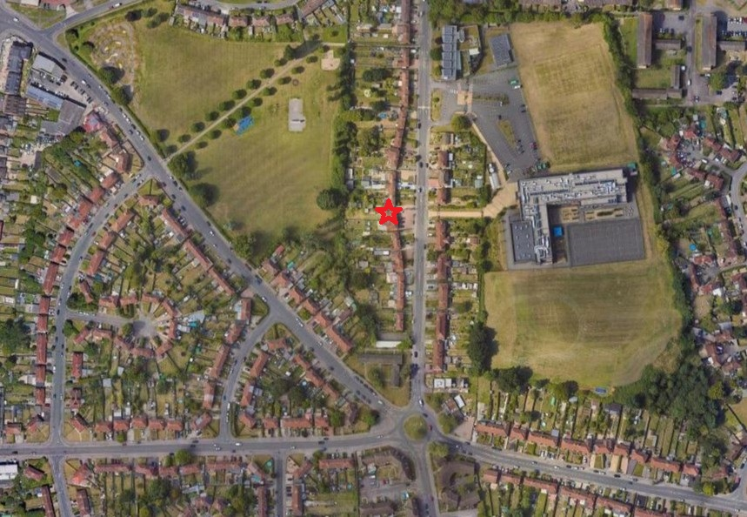
Figure 1. Site location. Courtesy of Google images

METHODS
UK Biodiversity Action Plan (UK BAP) Priority Habitats are also Habitats of Principle Importance (HPI) listed under The Natural Environment and Rural Communities Act 2006 Section 41 (NERC S41). These habitats do not receive statutory protection, but the S41 list is intended to provide guidance to decision-makers, e.g. those representing public bodies and local/regional authorities, in implementing their duty under Section 40 of the NERC Act to ‘…have regard to the conservation of biodiversity in England when carrying out their normal functions’.

Phase 1 Habitat Survey Methods
The survey area was systematically walked, and habitats mapped according to Phase 1 Habitat Survey criteria during daylight hours on 15th December 2025. Phase 1 Habitat Survey is a standardised system for classifying and mapping semi-natural vegetation and wildlife habitats in Great Britain. Vegetation is mapped in terms of standard habitat types as defined in the JNCC Handbook for Phase 1 Habitat Survey (2010).
In addition, habitats were appraised for their suitability to support protected or notable (UK Biodiversity Action Plan/Species of Principle Importance [S41]) species, e.g. breeding birds, badgers, bats, herptiles, stag beetle, that might be affected by the proposed development; in accordance with the ‘Guidelines for Baseline Ecological Assessment’ (IEA, 1995).
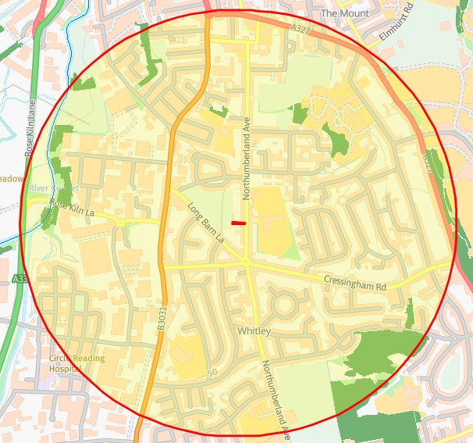
Figure 2. Priority habitats within 1000m. Courtesy of Magicmaps

Background Data Search
A desk-based assessment was carried out using the DEFRA MagicMap website https://magic.defra.gov.uk/MagicMap.aspx to identify all designated sites within 5km of the site and all other designated sites and protected species within 2km.
A search was made for information on statutory designated sites (often internationally and nationally important sites for ecology) and non-statutory designated sites (often important in a local context) within 1 km of the site boundary.

Invasive Non-native Species
Phase 1 habitat survey does not involve exhaustive surveying for any individual plant species, but if invasive plant species listed under Schedule 9 (Part II) of the Wildlife and Countryside Act 1981 (as amended), e.g. Heracleum mantegazzianum (Giant Hogweed), Impatiens glandulifera (Himalayan Balsam) or Reynoutria japonica (Japanese Knotweed), were seen during the normal course of the survey then they were noted.

PROTECTED SPECIES
Reptiles
All native British reptiles are protected under the Wildlife and Countryside Act (1981) from killing and injury. Sand Lizards and Smooth Snakes also receive additional protection under the Conservation (Natural Habitats &c) Regulations 2010 from intentional killing and injury and from intentional damage, destruction or obstruction of access to a place of shelter. All native UK reptiles are UK BAP Priority Species and SPI.

The site was assessed for its suitability to support reptiles. ie. Presence of structured habitats which receive direct insolation etc.

Amphibians
Great Crested Newts are protected under schedule 5 of the Wildlife and Countryside Act 1981 and of the Conservation (Natural Habitats &c) Regulations 2010 from intentional killing and injury and from intentional damage, destruction or obstruction of access to a place of shelter. In addition Great Crested Newts and Common Toads are UK BAP Priority species and SPI.

The suitability of aquatic and terrestrial habitat on the site and in the immediate vicinity was considered (where accessible), along with the habitat-connectivity between suitable habitat areas. Aerial photography and Ordnance Survey maps were examined for ponds or other suitable breeding habitat within 500 m of the site.

Badgers
Badgers are protected under the Protection of Badgers Act 1992, which makes it illegal to kill, injure or take a badger or to interfere with their setts; such as by the use of heavy machinery nearby.

An initial assessment was carried out to identify areas that might be used by badgers for commuting, foraging and sett-building within 30 m of the field. This involved a search for setts, foraging signs, paths (runs) and latrines.
Hedgehogs
The site was assessed for suitability for hedgehogs (refugia and foraging).

Birds
All wild birds are protected under Wildlife and Countryside Act 1981, as amended, from damage or destruction of their nest whilst in use or construction, some birds listed on Schedule 1 receive additional protection from disturbance during nesting.

The site was assessed for its potential for breeding birds as well as foraging and wintering use-age.
Bats
Bats are fully protected under the Wildlife and Countryside Act 1981, as amended, and also receive additional protection via The Conservation of Species and Habitats Regulations (2017) from intentional killing and injury and from intentional damage, destruction or obstruction of access to a place of shelter. It is an offence to kill or injure a bat or interfere with any roosting or resting site. A bat roost is interpreted as "any structure or place used for shelter or protection" whether or not bats are present at the time or not. Barbastelle Bats, Bechstein’s Bat, Noctule, Soprano Pipistrelle, Brown Long-eared Bat, Greater Horseshoe Bat and Lesser Horseshoe Bat are also UK BAP Priority Species and SPI.

Phase 1 Bat Survey Methods
The Daytime Bat Assessment / Phase 1 Bat Survey was undertaken in accordance with the Bat Conservation Trust Guidelines (Collins, 2023).
The Phase 1 Bat Survey was carried out and comprised of a daytime walkover of the site, internally and externally, to record evidence of any protected bat species.
Details of the survey methods are given below.
The property was investigated externally to identify potential bat access/egress locations and roosting areas such as gaps or holes between wooden cladding, roof tiles, fascias and soffits and to record direct evidence of bat presence such as droppings and urine staining. This was followed by a detailed investigation of all accessible internal spaces to record evidence of bat roosting activity such as droppings, feeding remains, live animals, corpses, urine staining and fur staining. The building was assessed as to its suitability for supporting roosting bats. The survey conformed to current Bat Conservation Trust guidelines (Bat Conservation, (2023) Bat surveys for professional ecologists: Good practice guidelines 4th edition).
The details of the assessment criteria used to determine the ecological value of on-site attributes is outlined below. During the Phase 1 survey the assessment criteria are based on the potential for the site to support the species considered. However, in many cases Phase 2 surveys will be required to confirm presence /absence of any bat species and hence the importance of a population at the site, therefore the assessment of value should be considered as provisional.
Where possible, a provisional assessment of potential will be made although this may well require Phase 2 surveys to confirm status.
High Potential- High potential buildings are those that have features highly suitable for use by roosting bats, including gaps around soffits, hanging tiles, extensive roof spaces etc. High potential buildings are often, but not always, buildings of more historic construction. Further Phase 2 surveys will be required to confirm the presence/absence of bats.
Moderate Potential- Moderate potential buildings have a moderate number of features that may be utilised by bats for roosting, these may include loose fascias, roof spaces etc. Further Phase 2 surveys are likely to be required to confirm the presence/absence of bats.
Low Potential- Low potential buildings are those that provide limited bat roosting potential although some features that may be utilised by bats may be present. Further Phase 2 surveys are likely to be required to confirm the presence/absence of bats.
No/Negligible Potential – These are buildings that are extremely unlikely to support roosting bats due to the absence of suitable features. Further Phase 2 surveys are unlikely to be required for buildings with negligible potential.

RESULTS

Invasive Non-native Species
No invasive species were present on or adjacent to the site.
Phase 1 Habitat Survey Results

Background Data Search
There are no designated site within 1km of the site. There are a few small isolated areas of woodland included on the priority habitats inventory within 1km to closest if 504m to the north (See figure 2).
The site lies outside the Nitrate Vulnerable Zone as defined by DEFRA 2017
Site description
The site is dominated by hard standing (block paved driveway concrete patios and paths) and vegetated garden (modified species poor grassland, small flower beds) (see figures 3-4).
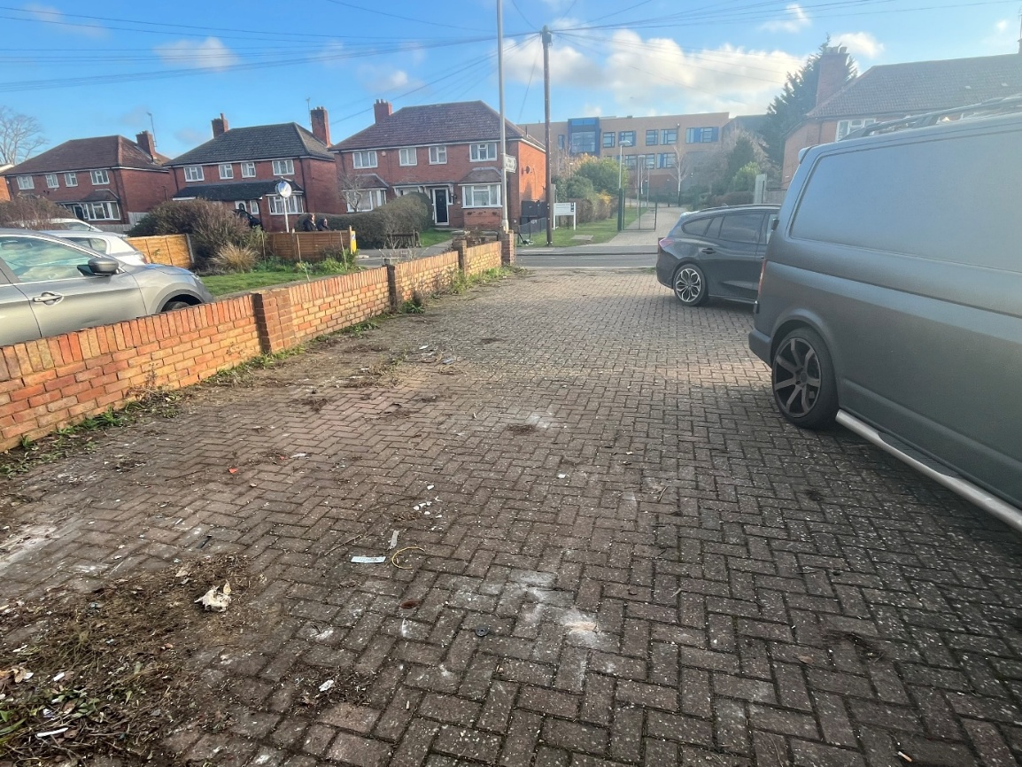
Figure 3. Looking east from front door

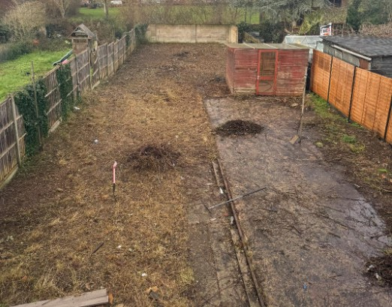
Figure 4. Looking west across back garden

PROTECTED SPECIES
Reptiles
All native British reptiles are protected under the Wildlife and Countryside Act (1981) from killing and injury. Sand Lizards and Smooth Snakes also receive additional protection under the Conservation (Natural Habitats &c) Regulations 2010 from intentional killing and injury and from intentional damage, destruction or obstruction of access to a place of shelter. All native UK reptiles are UK BAP Priority Species and SPI.

The site has no structured habitat and therefore has negligible potential for reptiles.

Amphibians
Great Crested Newts are protected under schedule 5 of the Wildlife and Countryside Act 1981 and of the Conservation (Natural Habitats &c) Regulations 2010 from intentional killing and injury and from intentional damage, destruction or obstruction of access to a place of shelter. In addition Great Crested Newts and Common Toads are UK BAP Priority species and SPI.

The nearest GCN return is from over 4m away in Spencer’s Wood, and there are no ponds on or within 500m of the site.
Amphibians such as Common Frog and Common Toad (UKBAP/SPI) may occur in the wider area.

Badgers
Badgers are protected under the Protection of Badgers Act 1992, which makes it illegal to kill, injure or take a badger or to interfere with their setts; such as by the use of heavy machinery nearby.

There were no signs of any badger activity on site and no signs of sett activity on or within 15m of the site boundary. However, badgers occur in the wider area.

Hedgehogs
The site has negligible potential for nesting hedgehogs in absence of structured habitats and debris piles.

Breeding Birds
All wild birds are protected under Wildlife and Countryside Act 1981, as amended, from damage or destruction of their nest whilst in use or construction, some birds listed on Schedule 1 receive additional protection from disturbance during nesting.

There was no sign of any bird nesting activity on or in the vicinity of the property.
Bats
The Daytime Bat Assessment / Phase 1 Bat Survey was undertaken in accordance with the Bat Conservation Trust Guidelines (Collins, 2023).
The Phase 1 Bat Survey was carried out on the 15th December 2025, and comprised of a daytime walkover of the site, internally and externally, to record evidence of any protected bat species.
According to the DEFRAs MagicMap, no EPS bat licences has been issued for properties within 1000m of the property. The area supports habitats suitable for most bat species
The structure was subject to a full Phase 1 bat survey outlined below.
Building assessment
The structure is a semi-detached house dating to late 20th Century. It has a hipped roof faced with cement tiles and a ground floor extension with matching tile faced parapet around a flat roof (see figures 5-6).
The loft was accessed via a hatch on the landing. The roof is unlined and the spaces has tangles of cobwebs with dust and fine seeds (birch, buddleja etc). The floor is lined with fibre glass insulation, and there was no sign of any bat activity within (see figures 7 and 8).
Trees
There are no mature trees within 25m of the property with any potential for bats.

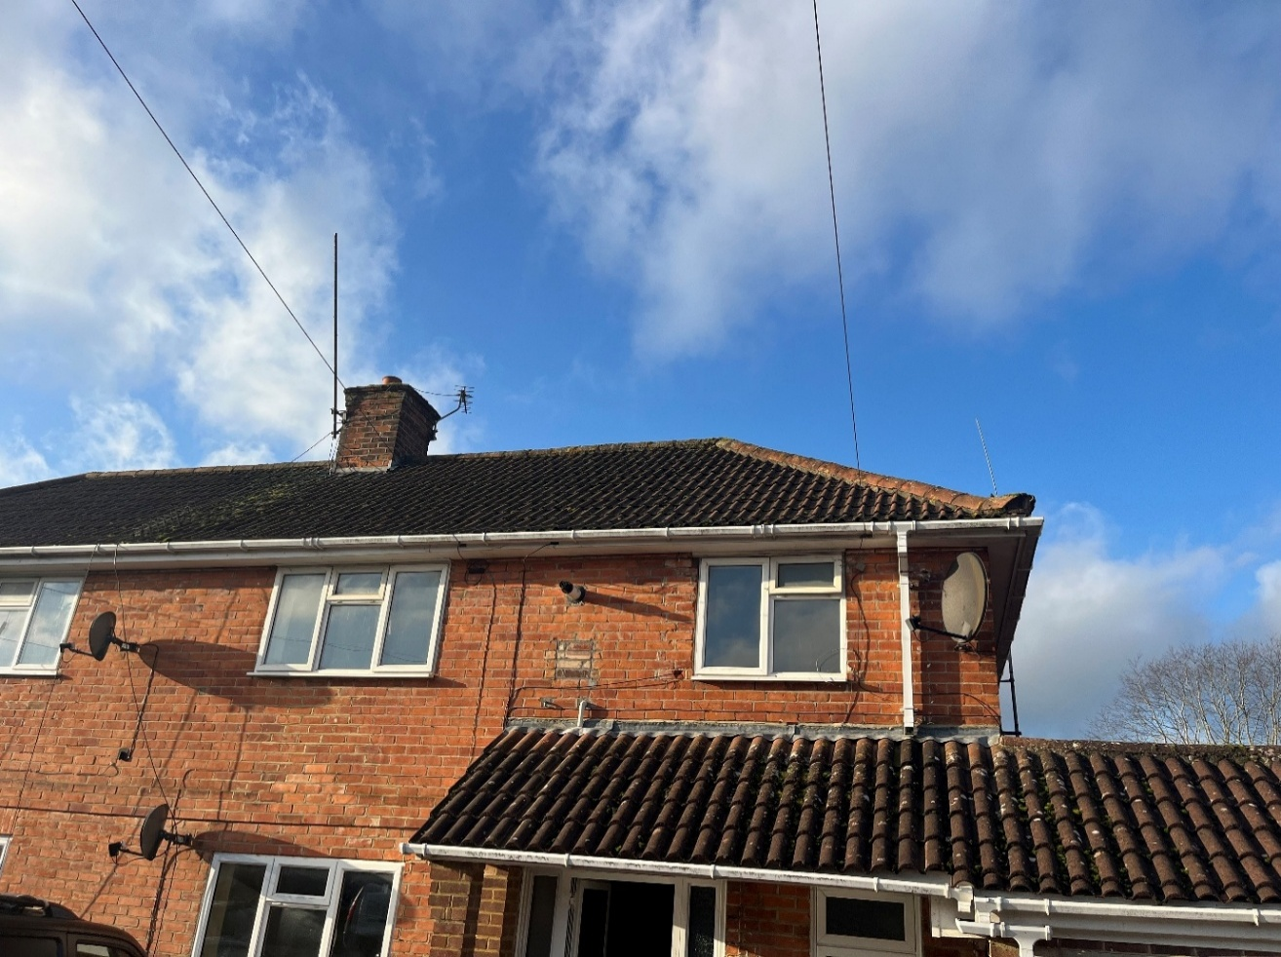
Figure 5. Western and southern elevations looking northeast:

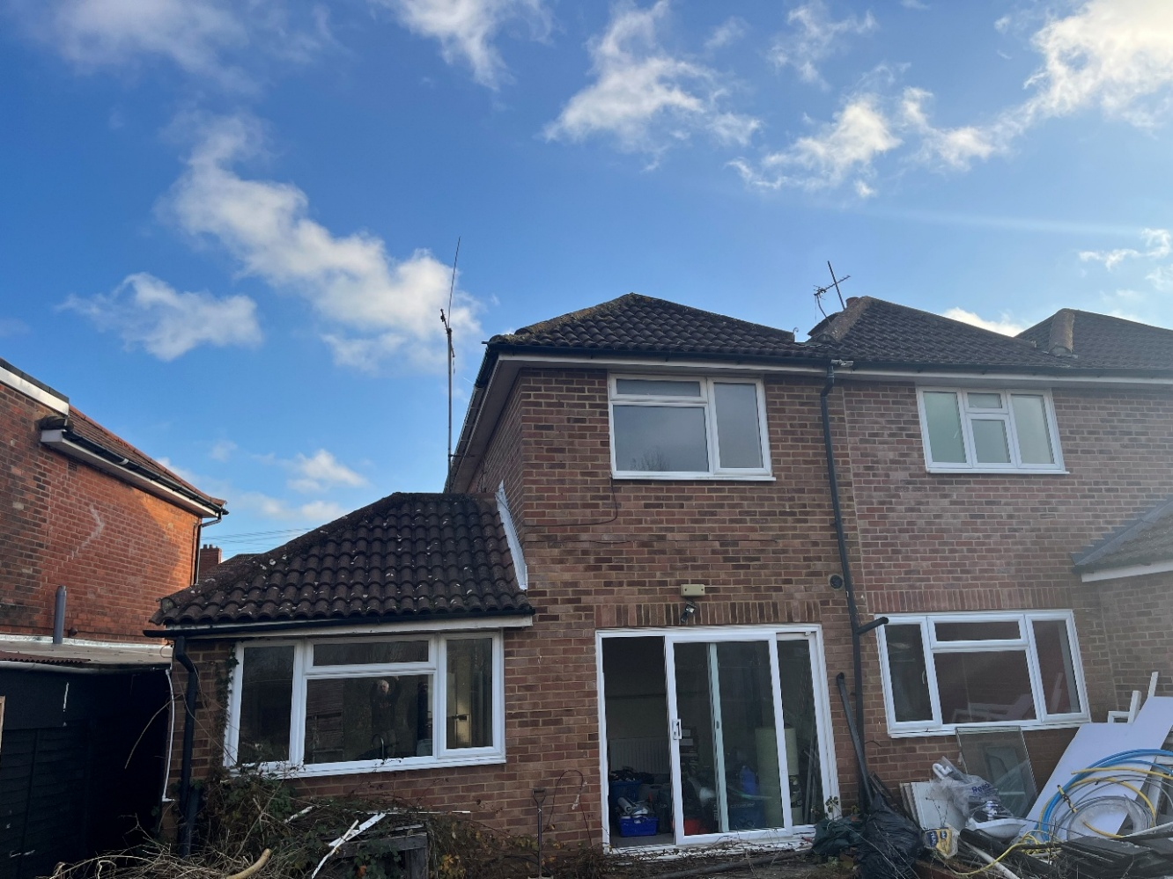
Figure 6. Eastern elevations looking northwest:

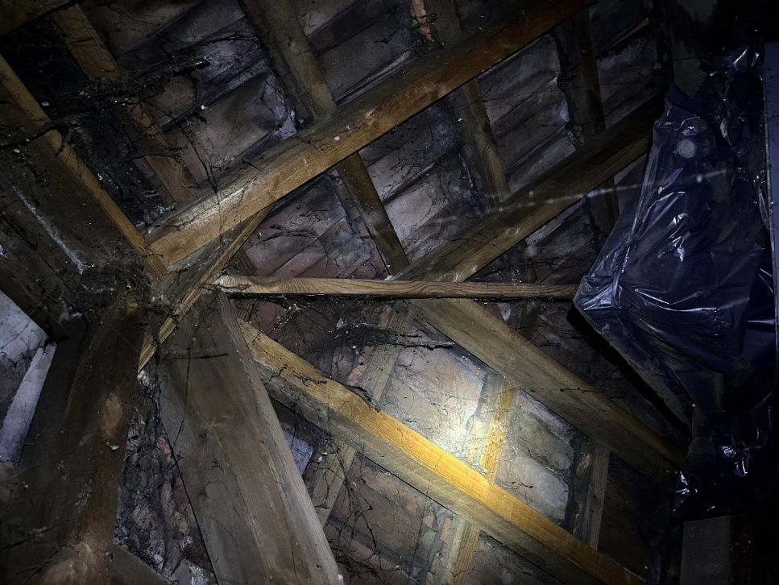
Figure 7. Roof interior
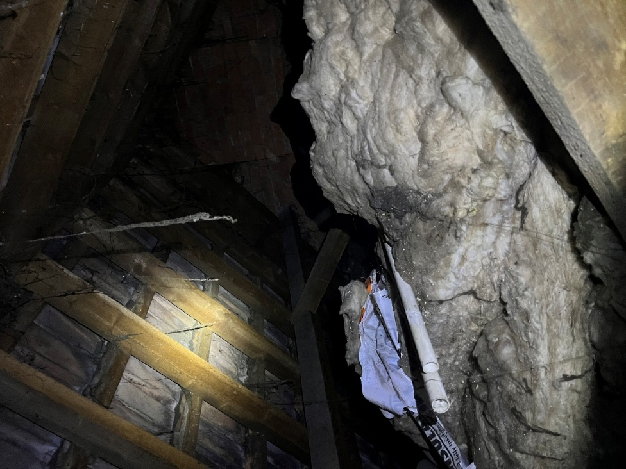
Figure 8. Loft floor looking south
EVALUATION, IMPACTS AND RECOMMENDATIONS
Phase 1 Habitat Survey
Protected Habitats
The proposed redevelopment does not fall on any UKBAP habitats. It would result in the loss of a small area of species poor amenity grassland. No impacts are envisaged for the designated sites and priority habitats in the vicinity of the site.
The trees in the adjacent hedgeline onsite are an irreplaceable habitat and therefore should be retained and root protection zones established.
Protected Species
Reptiles & Amphibians
The site has negligible potential for reptiles and common amphibians in the absence of structured habitats on site. The risk of GCN presence on site is very low and precautionary reasonable avoidance measures will ensure compliance with legal protection for this species.

Badgers
Badgers occur in the wider area, therefore good building practice should be followed (such as placing boards over holes or trenches overnight) to prevent animals being harmed during site works.

Hedgehogs
Hedgehogs could use the field boundary around the open amenity grassland area to the west as a corridor for movement.
Breeding Birds
Any removal of vegetation on or adjacent to the shelter should be undertaken outside of the bird nesting season, which is typically 1st March to 31st August.

If any works occur within the breeding bird season the area should be checked, ideally by an ecologist, and if any nesting birds are found there is a legal obligation to protect the affected area with a buffer zone of 10m until after the young have fledged.

Phase 1 Bat Survey
There was no sign of any bat activity inside the property, and the unlined roof has no openings which bats could exploit; therefore, it has negligible potential for bats, and a phase 2 emergence survey is not recommended.
In the unlikely event of any bats being found during demolition or construction, all work must stop immediately, and Natural England must be called. Additional information is available on the Bat Conservation Trust website at https://www.bats.org.uk/advice/imworking-on-a-building-with-bats/ive-found-a-bat-during-works.
New exterior lighting should be avoided, but if necessary for security purposes, then the latest updated lighting guidance note (GN08/23) should be followed. This is available at Guidance Note 8 Bats and Artificial Lighting | Institution of Lighting Professionals (theilp.org.uk) and supersedes all previous guidance.

Report Validity
Under current guidelines this report will be valid for up to 18 months; after which point a CIEEM registered ecologist may need to review and update the report’s validity.

REFERENCES
- CIEEM (2011) Professional Guidance Series 10: Guidance on metadata Standards: Reporting, sharing and archiving ecological data.
- Collins, J. (ed.)(2023) Bat Surveys for Professional Ecologists: Good Practise Guidelines (4th edn). The Bat Conservation Trust, London
- Communities and Local Government (2012) Technical Guidance to the National Planning Policy Framework. Department of Communities and Local Government, London.
- English Nature (2001). Great crested newt mitigation guidelines. English Nature, Peterborough.
- English Nature (2004) Reptiles: Guidelines for developers. English Nature, Peterborough.
- English Nature (2006) Wildlife and development. English Nature, Peterborough.
- Institute of Environmental Assessment (1995). Guidelines for Baseline Ecological Assessment. Institute of Environmental Assessment, London.
- JNCC (1998) Herpetofauna Workers’ Manual. JNCC, Peterborough.
- JNCC (2010) Handbook for Phase 1 Habitat Survey: A technique for environmental audit. JNCC, Peterborough
- Natural England (2009) Badgers and Development. A Guide to Best Practice and Licensing (Interim Guidance)
- Natural England (2011) Reptile mitigation guidelines. Natural England.
- ODPM (2005) Government circular: biodiversity and geological conservation – statutory obligations and their impact within the planning system. The Stationary Office.
- The British Standards Institution (2013) Biodiversity – Code of practice for planning and development. BSI Standards Limited.

