09/04/2026

Planning Application Ref: PL/26/0333
Officer: Matthew Burns
Application Type: Prior approval Part 3 Class MA: Commercial, business and
service uses to dwellinghouses
Address: THE GRANARY, 1A PATRICK ROAD, CAVERSHAM, RG4 8DD
Proposal: Change of use from Class E (offices) to C3 (dwelling
houses) to comprise 2 new dwellings. Prior Notification under Class MA, Part 3 of Schedule 2 of the Town and Country Planning (General Permitted Development) Order 2015.

This application is for change of use of a Class E building to create 2 x 2-bed self-contained flats (use class C3 - Residential).

The site is accessed from the B3345 Gosbrook Road and is located in Zone 2, Primary Core Area, of the Revised Parking Standards and Design SPD. This zone directly surrounds the Central Core Area and extends to walking distances of 2 kilometres from the centre of Reading. Typically, this zone is well served by public transport, with buses continuing either into or out of the Central Core Area via this zone.

Plans indicate that 2 on site parking spaces are to be provided on an area of existing hard standing, as illustrated below. Google images confirm an existing vehicle crossing and sliding gate, access protection markers are also in place.

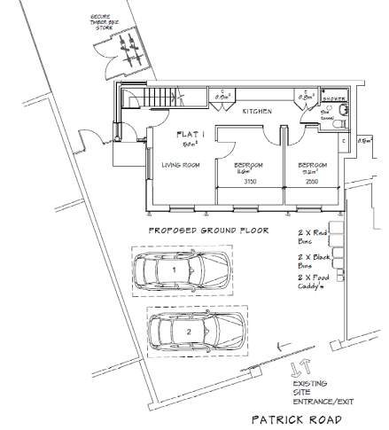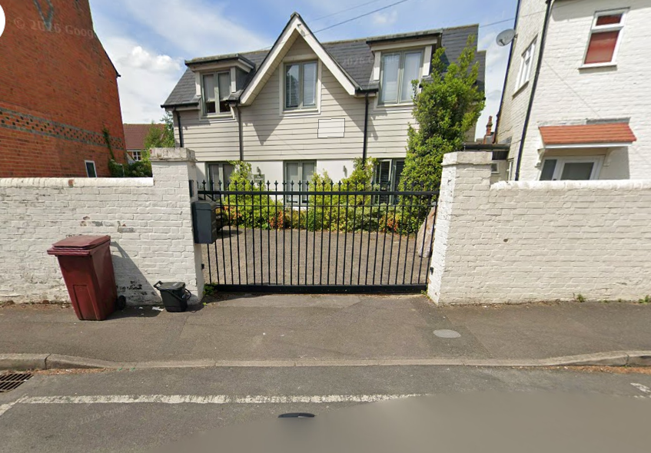

Parking is being provided in accordance with the Councils current Parking standards and Design SPD and therefore acceptable.

The Councils Residential Permit Parking Scheme operates in this area, therefore under the Borough’s current parking standards, this proposal would generate additional pressure for parking in the area, if this application is approved there should be an assumption that any future occupants of the proposed dwellings will not be issued with resident or visitor parking permits, this will ensure that the development does not harm the existing amenities of the neighbouring residential properties by adding to the already high level of on street car parking in the area.

In line with the Council’s adopted Parking Standards and Design SPD, each of the 1 and 2 bedroom unit should be provided with 0.5 secure cycle parking, however under GPD we would not comment on this.

Bin storage should comply with Manual for Streets and British Standard 5906: 2005 for Waste Management in Buildings and should be located no further than 10m from the access point of the site to avoid the stationing of service vehicles on the carriageway for excessive periods. It is recommended that the Councils Waste Management team be contacted to ensure the correct capacity of bins is provided.

There are no Transport objections to this permitted development application.

DC1 VEHICLE PARKING (AS SPECIFIED)
IF3 Highways
I13 Parking Permits

