DELEGATED APPLICATION REPORT
Ward: Church
App Ref: PL/25/1472 Householder planning permission
Address: 104 WINDERMERE ROAD, READING, RG2 7HR
Proposal: Proposed single storey rear extension and a front porch with garage demolished
Applicant: Mr Tanbir Abdul
Received date: 15/10/2025
Target Decision date: 10/04/2026 (EXT)
Case Officer: Chukwudi Onwudinanti

- SITE DESCRIPTION
The site is a semi-detached dwelling on the east side of Windermere Road, in a predominantly residential area. The original garage (as can be seen in the photo) has now been demolished (as confirmed by the agent via email 27th March 2026)

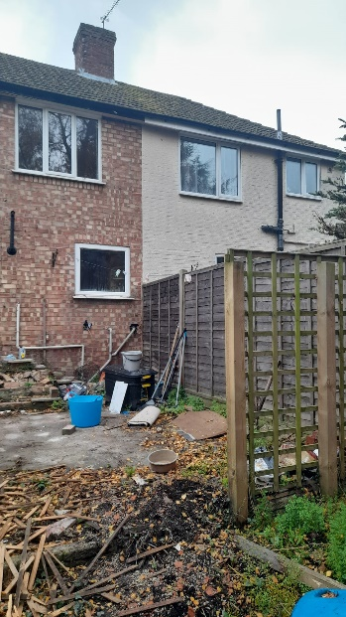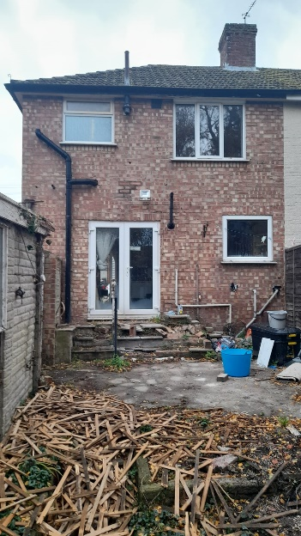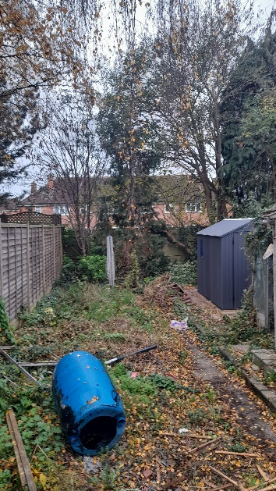

- PROPOSAL AND SUPPORTING INFORMATION
The amended proposal seeks planning permission for:
- A single storey rear extension measuring approximately 4.5m in depth, spanning the full width of the dwelling, with a height of approximately 2.6m to eaves and a flat roof form; and
- A front porch extension covering an area of approximately 2.9m², with a hipped roof design.
The proposal also includes associated external alterations including new doors and steps to the rear to address the level difference between internal floor level and garden.

Plans and Documents

Received 25/03/2026
Drawing No: P1676-01 Rev A– Location & Block Plan

Received 15/10/2025
Drawing No: P1676-02 – Existing Plans & Elevations

Received 02/04/2026
Drawing No: P1676-03 Rev B – Proposed Plans & Elevations

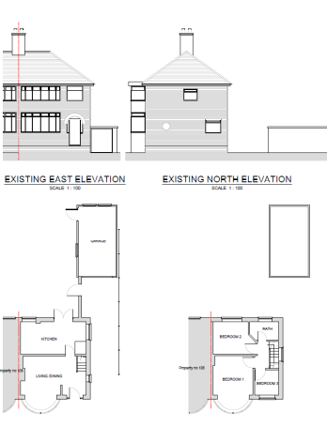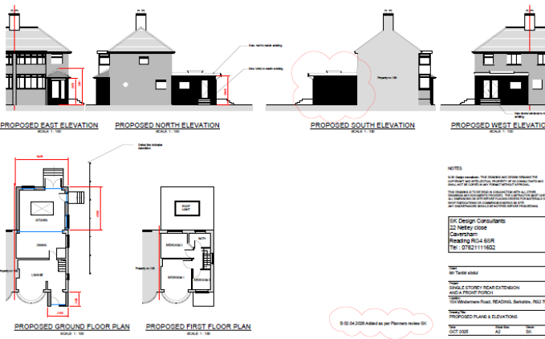
Existing Plans and Elevations Proposed Plans and Elevations

- RELEVANT PLANNING HISTORY

None

- CONSULTATIONS

A Site Notice was put up 07/11/2025

No neighbour comments have been received.

Natural Environment
Natural Environment advised that tree mitigation measures should be put forward.

Planning Officer Note: This has been provided by the agent, and conditions are attached to ensure compliance.

Discussions with the agent
Following officer concerns regarding the original scheme (which proposed a deeper rear extension of approximately 5.5m), the applicant was advised to reduce the scale of the extension to mitigate impacts on neighbouring amenity.

The scheme was subsequently amended to a 4.5m deep extension, which is considered to overcome the initial concerns.

Equality Act 2010:
In determining this application, the Council is required to have regard to its obligations under the Equality Act 2010. However, there is no indication or evidence (including from consultation on the application) that the protected groups identified by the Act have or will have different needs, experiences, issues and priorities in relation to this particular planning application. Therefore, in terms of the key equalities protected characteristics it is considered there would be no significant adverse impacts as a result of the development.

- LEGAL AND PLANNING POLICY CONTEXT
Section 38(6) of the Planning and Compulsory Purchase Act 2004 requires that proposals be determined in accordance with the development plan unless material considerations indicate otherwise. Material considerations include relevant policies in the National Planning Policy framework (NPPF) - among them the 'presumption in favour of sustainable development'. The following local and national planning policy and guidance is relevant to this application:

National Policy
National Planning Policy Framework
National Planning Practice Guidance

Reading Borough Local Plan (2019)
CC7 (Design and the Public Realm)
CC8 (Safeguarding Amenity)
H9 (House Extensions and Ancillary Accommodation)
H10 (Private and Communal Outdoor Space)

SPD
Design Guide to House Extensions SPD 2021

Local Plan Update
The current version of the Local Plan (adopted in November 2019) turned five years old on Tuesday 5th November 2024. The Local Plan was reviewed in March 2023 and around half of the policies in the plan are considered still up to date. However, the rest need to be considered for updating to reflect changing circumstances and national policy. A submission draft of the Local Plan was submitted on 9th May 2025 and the Examination held in February 2026.

Although there is a five-year period for carrying out a review of a plan after it is adopted, nothing in the NPPF or elsewhere says that policies automatically become “out of date” when they are five years old. It is a matter of planning judgement rather than legal fact whether a plan or policies within it are out-of-date. This will depend on whether they have been overtaken by things that have happened since the plan was adopted, either on the ground or through changes in national policy, for example.

Officer advice in respect of the Local Plan policies pertinent to this application is that they remain in accordance with national policy and that the objectives of those policies remain very similar in the draft updated Local Plan. Therefore, they can continue to be afforded weight in the determination of this planning application and are not considered to be ‘out of date’.

- APPRAISAL

Character and Appearance
Policy H9 requires extensions to respect the character of the host dwelling and surrounding area. Policy CC7 sets out broader design principles.
The proposed front porch is modest in scale, measuring approximately 2.1m by 1.4m with a hipped roof design. It is considered proportionate and sympathetic to the host dwelling and would not disrupt the established building line or street scene.
The amended scheme includes a 4.5m deep full width rear single storey flat roofed extension including a rear and side door and steps due to the difference between the internal floor level and surrounding ground level. By virtue of its location to the rear, it would not be visible from the public realm and, therefore, would not adversely affect the character of the wider street scene. The scale, form and materials are considered appropriate and consistent with the host dwelling.
Overall, the proposal is considered to comply with Policies CC7 and H9.

Residential Amenity
Policy CC8 and H9 require that development does not result in an unacceptable impact on neighbouring amenity.

The amended rear extension has been reduced to 4.5m in depth and would fall outside the 60-degree line when assessed against the neighbouring property at No. 106. As such, it would not result in a significant loss of daylight or sunlight. Due to its limited height (2.6m), the extension would not appear overbearing.

With respect to No. 102, the extension would be set approximately 1.8m from the boundary, and the demolition of the former garage reduces enclosure along this boundary. The proposed side-facing door and steps would face the neighbouring flank wall and would, therefore, not give rise to unacceptable overlooking or loss of privacy.

Sufficient private amenity space would remain, in accordance with Policy H10.

Subject to conditions regarding obscured windows and restriction the use of the flat roof it is considered that the scheme would be acceptable from an amenity perspective and accord with Policies H9, CC8 and H10.

- CONCLUSION
The proposed development has been assessed against the relevant policies of the Reading Borough Local Plan and the National Planning Policy Framework.

The scheme is considered to:

- Respect the character and appearance of the host dwelling and surrounding area;
- Avoid unacceptable impacts on neighbouring residential amenity; and
- Provide adequate outdoor amenity space.

The proposal is therefore considered to comply with Policies CC7, CC8, H9 and H10 of the Reading Borough Local Plan (2019).

- RECOMMENDATION: Grant

Recommended Conditions
- Time Limit (Standard 3 years)
- Approved Plans
- Materials to match existing dwelling
- Restriction on use of flat roof as a balcony or terrace
- Obscure glazing
- Tree protection / mitigation measures in accordance with submitted details

