DELEGATED APPLICATION REPORT
Ward: Whitley
App Ref: PL/25/1752 Full planning permission
Address: UNIT 7, READING GATE RETAIL PARK, READING, RG2 0QG
Proposal: Proposal for the installation twelve rapid electric vehicle charging stations and associated equipment within the car park of Reading Gate Retail Park, including three fully accessible rapid EV charging bays.
Applicant: Mr Jack Mulley
Received date: 05/12/2025
Target Decision date: 10/04/2026 (EXT)
Case Officer: Chukwudi Onwudinanti

Site Description, Surrounding Area and Background:

The application site is located within the car park of Reading Gate Retail Park, a large-format commercial retail park adjacent to the Select Car Leasing Stadium and accessed from the A33 relief road. The site comprises an extensive area of surface parking associated with retail uses. The surrounding area is characterised by commercial development and strategic transport infrastructure, including the A33 corridor.

The site does not lie within a conservation area and is not constrained by heritage designations.

The applicant has confirmed that the land owner has advised that a previous permission for EVCP approved under ref: PL/25/0282 will not be coming forward.

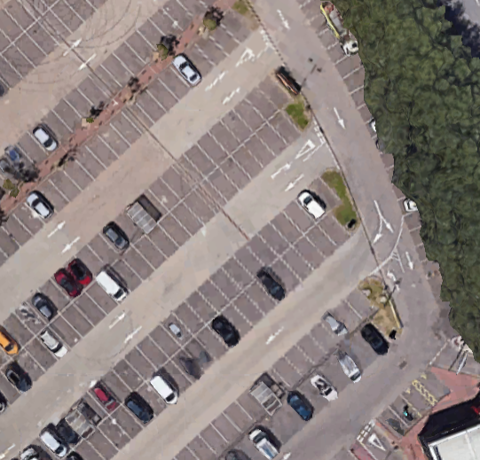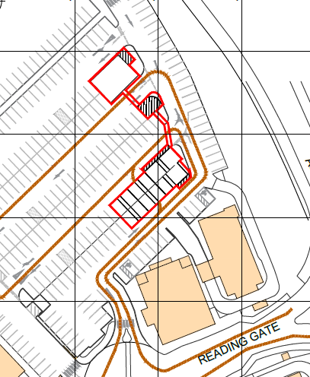
Google Earth image Proposed Block Plan

Proposal:

The application seeks full planning permission for the installation of EV charging infrastructure and associated electrical equipment.

The proposal includes:

- 12 rapid EV charging units (single and double arm)
- Substation (TR18 1000–1500kVA unit)
- Feeder pillar infrastructure
- Battery Energy Storage System (BESS) container
- CCTV infrastructure and ancillary equipment
- Reconfiguration of parking bays and associated works causing loss of 19 parking spaces

The infrastructure is to be located within an existing section of the car park.

Plans and other information considered:
As received 5th December 2025:
- Drawing no: 10796-0014_02 Rev A – Location and Block Plan
- Drawing No 10796 - 0014_01-PL Rev A - Planning Site Layout
- Drawing No 001_29 Rev A – BYD 160KW Charger
- Drawing No 001_30 Rev A – Substation- TR18-1000-1500KVA
- Drawing No 001_48 Rev A – 6’x6’ Slatted Fence Panel
- Drawing No 001_54 Rev C – Equipment Elevation
- Drawing No 001_58 Rev A – BYD 160KW Single Arm Charger
- Drawing No 001_11-03 Rev A – RMC 1250 (950) – With Roots
- Drawing No 001_59 Rev B - CCTV - Including Cabling Details (Underground)
- Drawing No 001_74 Rev A – ESS Unit (Container 960KW/2000KWH)
- Technical Specification - EVD160KU/CO1 Parameters of the Manual V4.0
- Flood Risk Assessment, Rev A, dated December 2025, prepared by Instavolt
- Planning Statement, prepared by Instavolt
- Technical Specification - EVD160KU/CO1 Parameters of the Manual V4.0
- Technical Specification - EVD160KU/C05 Parameters of the manual V1.0
- Planning Factsheet – Permitted Development & the ‘Planning Fallback’
- Planning Factsheet – Sustainable Transport and Transport Decarbonisation
- Planning Factsheet – Battery Storage
- Planning Factsheet – National EV Policy
- Planning Factsheet – Design and Access
- Planning Factsheet – National Policy on Renewable and Low Carbon Energy
- Planning Factsheet – Biodiversity Net Gain

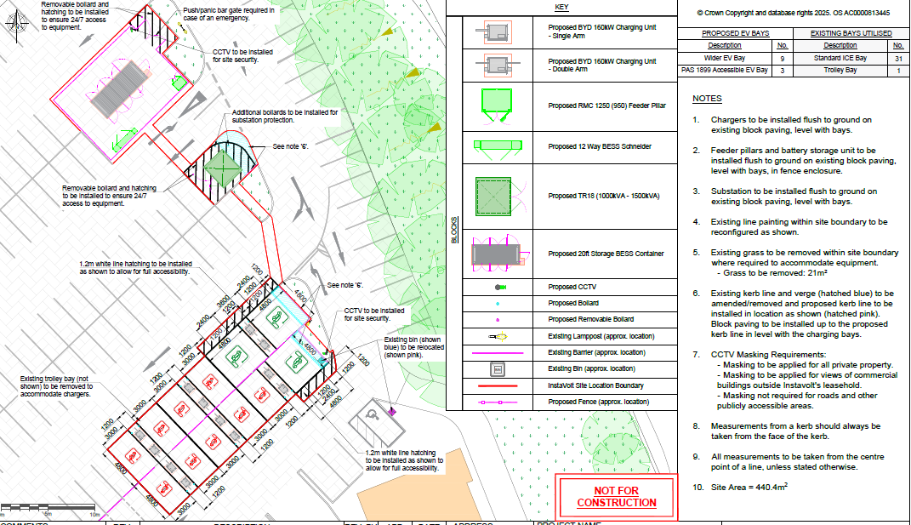
Proposed Site Plan

Relevant Planning History:

PL/25/0282 FUL
Proposal: Provision of Electric Vehicle Charging Bays, Associated Infrastructure and Associated Works
Decision: Approve
Date: 27/06/2025

Consultation Responses:

Site Notice was put up 19/12/2025. No representations have been received.

Transport –
The proposed development involves the installation of 12 no. rapid EV charging units and reconfiguration of parking bays resulting in the loss of 19 parking spaces. The works also include the provision of a substation enclosure, feeder pillars, and all associated infrastructure and groundworks required to facilitate the EV charging facilities.

Although the proposals will result in the loss of existing car parking spaces within the retail park, this reduction is considered minor within the context of the wider car park and will not materially impact the operational capacity of the retail park.

The installation of new electric vehicle (EV) charging infrastructure directly supports national and local policy objectives aimed at reducing carbon emissions, improving air quality, and encouraging the transition towards low-emission transport modes. Providing accessible, high-quality EV charging facilities will also future-proof the retail park by meeting increasing public demand for electric vehicle charging opportunities.

In this context, the small reduction in parking provision is justified by the significant contribution the scheme makes to promoting sustainable travel choices and supporting long-term environmental goals. Therefore, there are no transport objections to this application.

Relevant Planning Policy and Guidance and Legal Context

Section 38(6) of the Planning and Compulsory Purchase Act 2004 requires that proposals be determined in accordance with the development plan unless material considerations indicate otherwise.

Material considerations include the National Planning Policy Framework (NPPF), including the presumption in favour of sustainable development.

Adopted Reading Borough Local Plan (2019):

- CC1: Presumption in Favour of Sustainable Development
- CC7: Design and the Public Realm
- CC8: Safeguarding Amenity
- EN15: Air Quality
- EN16: Pollution and Water Resources
- EN17: Noise Generating Equipment
- EN3 / EN6: Green Infrastructure and Biodiversity
- TR3: Access, Traffic and Highway-Related Matters
- TR5: Car and Cycle Parking

Appraisal:

The main issues are considered to be:
- Principle
- Design and appearance
- Highways and parking
- Environmental matters – pollution, noise and flood risk

Principle of Development

The proposal relates to the installation of EV charging infrastructure and associated energy equipment within an existing retail park car park.

The site is previously developed land within an established commercial area. The proposal does not result in a change of use and supports sustainable transport infrastructure. Government policy strongly supports EV charging infrastructure and identifies the need for a significant increase in provision to meet national targets.

Furthermore, EV charging infrastructure can also be delivered under permitted development rights in certain circumstances, which is a material consideration.

The principle of development is, therefore, acceptable.

Design and appearance

Policy CC7 requires development to be of a high design quality appropriate to its context.

The proposal comprises functional infrastructure, including chargers, substation, feeder pillars and a battery storage unit.

The equipment is of a utilitarian appearance and modest scale, with chargers typically up to approximately 2–2.2 metres in height and the BESS container representing a standardised unit.
The site is located within a visually functional car park environment, and the introduction of such infrastructure would not be out of character.

The development would integrate with existing commercial infrastructure and would not result in harm to the visual amenities of the area.

The proposal, therefore, complies with Policy CC7.

Highways and parking

Policies TR3 and TR5 seek to ensure safe access and appropriate parking provision.

The proposal utilises existing parking spaces within the retail park and does not alter access arrangements.

Although a limited number of spaces would be reallocated and there will be a net loss of 19 parking spaces, there is no evidence that this would materially impact the operation of the retail park. As stated in Transport comments, the loss of parking spaces is adequately compensated by the provision of ECV charging places which supports National Policy.

It is also noted that permitted development rights allow EV infrastructure within parking areas without restriction on parking loss, which is a material consideration.

The proposal is, therefore, acceptable in highways terms.

Environmental Matters – Pollution, Flood Risk, Noise Pollution and Air Quality

The proposal does not generate emissions and would support the transition to zero-emission vehicles, thereby contributing positively to air quality.

There are no identified risks of land or water contamination. The proposal complies with Policies EN15 and EN16.

The Flood Risk Assessment confirms that the site lies within Flood Zone 3. However, the development is located on previously developed land and does not increase the impermeable area. There would be a small amount of below ground concrete, but this would not impact on the surface water runoff. There would be no increase in flood risk to the surrounding area.

The proposed infrastructure would be raised off the ground to increase flood resistance. Equipment in the feeder pillar would be at least 500mm above ground and there would be safety features built into the chargers which mean they would shut down in the event of a flood.

Noise

The development includes electrical infrastructure, including transformers and battery storage.
These elements are expected to operate at low noise levels and are located within a commercial environment adjacent to a major road. There are no nearby sensitive receptors likely to be adversely affected. Therefore, it would comply with Policy EN17.

Biodiversity

The development affects a negligible area of non-priority habitat and is, therefore, exempt from biodiversity net gain requirements.

RECOMMENDATIONS:
GRANT

Proposed conditions:
- TL1 – Time limit
- Materials As Specified
- AP1 – Approved plans
- Resultant Parking Spaces retention

Informatives:
- Standard T&Cs
- Positive and proactive statement

