DELEGATED APPLICATION REPORT
Ward: Whitley
App Ref: PL/26/0073 Full planning permission
Address: 100 BROOK DRIVE, READING, RG2 6UJ
Proposal: Installation of two air source heat pumps.
Applicant: Green Park Reading No.1 LLP
Received date: 23/01/2026
Target Decision date: 20/03/2026
Case Officer: Chukwudi Onwudinanti

1. SITE DESCRIPTION
The application site comprises an existing office building located within Green Park Business Park, accessed via Brook Drive off the A33. The wider area is characterised by large-scale commercial office buildings set within a landscaped business park environment.

The site contains an existing flat roof with plant equipment including air handling units and air-cooled chillers enclosed within louvred rooftop plant screens.

The surrounding area is commercial in character with no immediately adjoining residential properties. The nearest residential properties are located at a significant distance from the site.

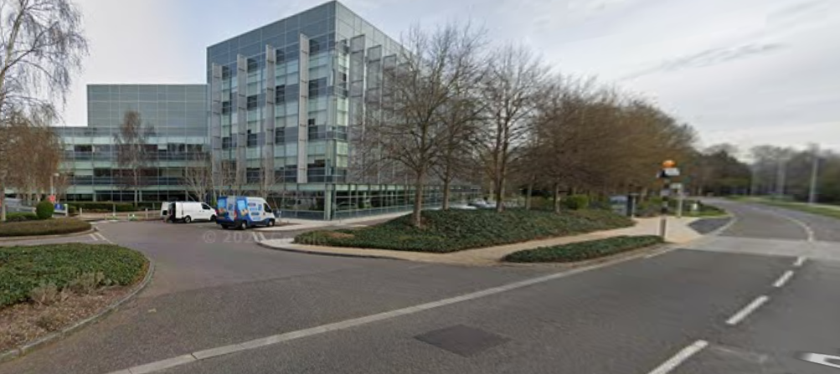
Google Photos

2. PROPOSAL AND SUPPORTING INFORMATION
Planning permission is sought for the installation of two air source heat pumps (ASHPs) on the roof of the existing office building.

The proposed development includes:

- Installation of two ASHP units on the rooftop
- Associated pipework located behind existing plant screens
- Integration of the plant within the existing rooftop plant enclosure

The submitted drawings demonstrate that the ASHP units would be located behind existing louvred plant screens and positioned alongside existing rooftop plant equipment.

The proposed elevation drawings indicate that the plant would be largely obscured from ground-level views by the existing screening and surrounding plant structures.

Plans and Documents received 23/01/2026:

Cover Letter (Lichfields, dated 22 January 2026)
Drawing No: 02-00: Site Location Plan
Drawing No: 50-SA-100 Rev 03 - Existing Site Plan
Drawing No: 50-SA-101 Rev 03 - Proposed Site Plan
Drawing No: 50-RF-100 Rev 03 - Existing Mechanical Services Layout (Roof Level)
Drawing No: 50-RF-102 Rev 01 - Proposed Mechanical Services Layout (Roof Level)
Drawing No: 50-XX-100 Rev 01 - Existing Mechanical Services Elevation 2 (South)
Drawing No: 50-XX-101Rev 01 - Proposed Mechanical Services Elevation 2 (South)
Technical Specification – ASHP Unit

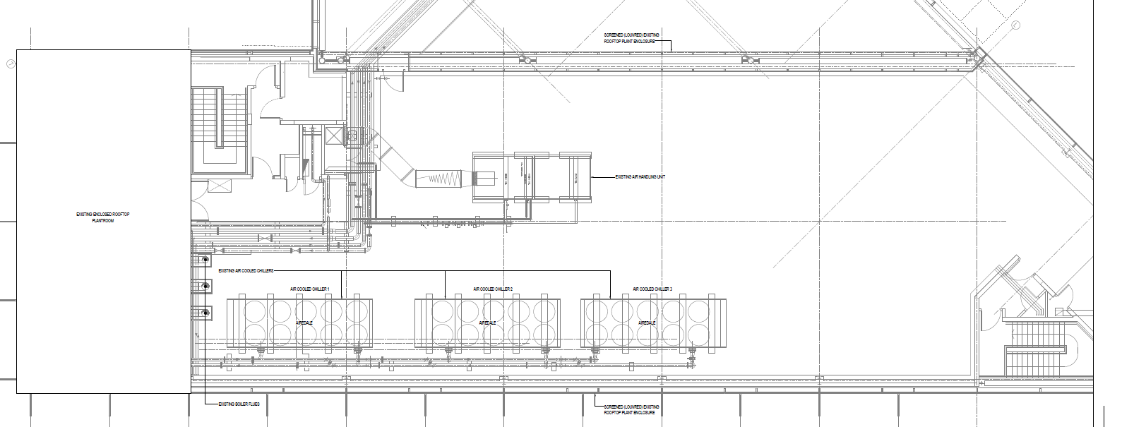
Existing Mechanical Services Layout

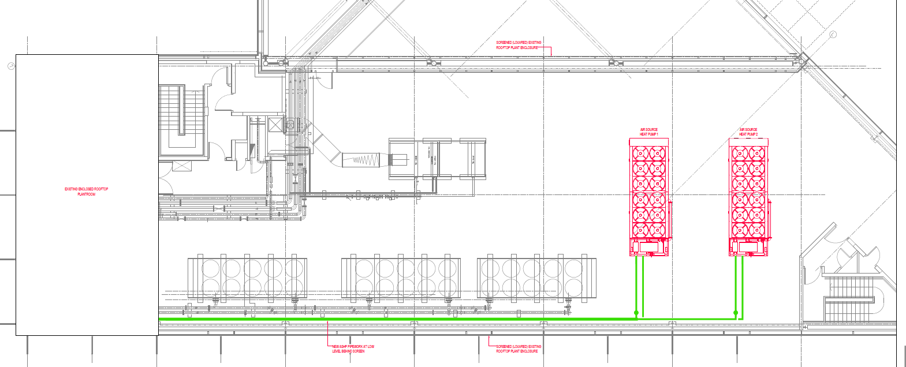

Proposed Mechanical Services Layout

3. RELEVANT PLANNING HISTORY
No relevant planning history that would materially affect the assessment of this application.

4. CONSULTATIONS

- Environmental Protection (noise)
EPA Standard Advice has been taken into consideration.

Site Notice was put up 13/3/2026
No public representations have been received.

Equality Act 2010
In determining this application, the Council is required to have regard to its obligations under the Equality Act 2010. However, there is no indication or evidence (including from consultation on the application) that the protected groups identified by the Act have or will have different needs, experiences, issues and priorities in relation to this particular planning application. Therefore, in terms of the key equalities protected characteristics it is considered there would be no significant adverse impacts as a result of the development.

5. LEGAL AND PLANNING POLICY CONTEXT
Section 38(6) of the Planning and Compulsory Purchase Act 2004 requires that proposals be determined in accordance with the development plan unless material considerations indicate otherwise. Material considerations include relevant policies in the National Planning Policy framework (NPPF) - among them the 'presumption in favour of sustainable development'. The following local and national planning policy and guidance is relevant to this application:

National Policy and Guidance
National Planning Policy Framework
National Planning Practice Guidance

Reading Borough Local Plan (2019)
CC1 – Presumption in Favour of Sustainable Development
CC3 – Adaptation to Climate Change
CC7 – Design and the Public Realm
CC8 – Safeguarding Amenity
EN16 – Pollution and Water Resources
EN17 – Noise Generating Equipment

APPRAISAL

Principle of Development
The proposal relates to the installation of plant equipment on an existing commercial building and does not involve any change of use.

The development supports the decarbonisation of an existing office building through the introduction of low-carbon heating infrastructure. This aligns with the objectives of Policy CC1 and CC3 and is strongly supported by national policy.

The principle of development is, therefore, acceptable.

Design and Character
Policy CC7 requires development to be of high-quality design and to respect the character of the surrounding area.

The proposed ASHP units would be located on the roof of the building within an established plant area. The building already accommodates significant rooftop plant including chillers and air handling equipment.

The proposed units would be positioned behind existing louvred plant screens and would not introduce prominent or visually intrusive elements beyond the established rooftop plant context.
The proposal would, therefore, not result in harm to the character or appearance of the building or wider business park.

Residential Amenity
Policy CC8 seeks to ensure that development does not result in unacceptable harm to the living environment of existing or future occupants.

The site is located within a commercial business park, and the nearest residential properties are located at a considerable distance (approximately 390 metres as indicated within the submission).

Therefore, given the separation distance, the presence of existing rooftop plant and the screening of the proposed equipment, it is not considered that the proposal would result in unacceptable impacts in terms of noise, disturbance or outlook.

Policy EN16 seeks to ensure that development does not give rise to unacceptable levels of pollution, including land, water and air pollution, and requires that proposals incorporate appropriate mitigation where necessary.
The proposed development comprises the installation of EV charging infrastructure within an existing hard-surfaced car park. The development:
- Does not introduce any significant pollutant-generating processes
- Does not involve the storage or discharge of hazardous substances
- Does not materially alter surface water drainage arrangements
The installation of EV infrastructure is inherently associated with reducing air pollution and improving environmental quality, which aligns positively with the objectives of Policy EN16.
Given the nature of the proposal, there are no identified risks to groundwater, surface water, or land contamination.it is considered that the proposal complies with Policy EN16 and carries positive environmental weight.
Policy EN17 requires that development involving plant or equipment does not result in unacceptable noise impacts on surrounding uses.
The proposal includes electrical equipment such as charging units and associated cabinets. These elements:
- Are typical of EV charging infrastructure
- Operate at low noise levels
- Are located within an established commercial environment adjacent to a major road (A33)
There are:
- No nearby sensitive residential receptors immediately affected
- No evidence that noise from the equipment would exceed acceptable thresholds
Given the context of an active retail park and surrounding road network, background noise levels are already elevated. The addition of EV charging equipment would not materially alter the acoustic environment.
A condition would be imposed to ensure that plant noise levels remain within acceptable limits in accordance with standard practice.

Climate Change and Sustainability
Policy CC3 supports development that enhances resilience to climate change and improves sustainability.

The proposal forms part of a wider decarbonisation strategy for the Green Park estate and introduces low-carbon heating infrastructure to an existing building.

This represents a significant positive weight in favour of the proposal and aligns with national policy which gives substantial weight to energy efficiency and low-carbon heating improvements.

CONCLUSION
The proposal has been assessed in accordance with the Reading Borough Local Plan and the National Planning Policy Framework.
It is considered that the development:

- Supports sustainable development and decarbonisation
- Is acceptable in design and visual terms
- Does not result in unacceptable harm to amenity

The proposal is, therefore, considered to comply with Policies CC1, CC3, CC7, CC8,EN16 and EN17 of the Reading Borough Local Plan (2019).

RECOMMENDATION
GRANT

Recommended conditions:
Time limit (standard)
Approved plans
Noise Restriction

Informatives:
Terms
Building Control
Complaints

