26/03/2026
Planning Application Ref: PL/26/0223
Officer: Catrin Davies
Application Type: Full planning permission
Address: 2A DONNINGTON GARDENS, READING, RG1 5LY
Proposal: Proposed change of use from existing single storey
office unit to a one-bedroom residential unit. There are no elevational changes proposed.
This application is for a change of use from Class E (Office) to create a 1 bedroom C3 residential unit.

The property is located in Donnington Gardens, which is a residential street with parking occurring on both sides of the street. The site is located within Zone 2, the primary core area but on the periphery of the central core area which lies at the heart of Reading Borough, consisting primarily of retail and commercial office developments with good transport hubs.

The property benefits from an off street parking area in front of the office unit that is accessed directly from Donnington Gardens. In accordance with the Councils current parking standards the property should be provided with 1 parking space. Submitted plan 25-008-03B (extract below) illustrates 1 parking space.

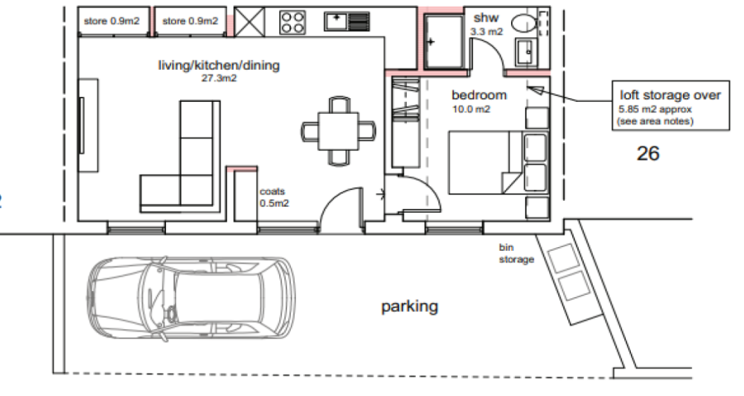

The area is served via an existing vehicle crossing and has access protection markers in place. Proposed provision is deemed acceptable. It is not permissible for any part of a vehicle to overhang the public highway. Such overhanging may constitute an obstruction of the public highway pursuant to the provisions of the Highways Act 1980.

The development site is located in an area designated as a Residents Parking Permit Area; Zone 13R. Under the Borough’s current parking standards, this proposal would generate additional pressure for parking in the area. Therefore, there should be an assumption that any future occupants of the proposed dwelling will not be issued with resident parking, or visitor permits which would be covered by condition and an informative applied. This will ensure that the development does not harm the existing amenities of the neighbouring residential properties by adding to the already high level of on street car parking in the area.

Cycle storage should be provided in accordance with the Councils current adopted standards. In a development of this nature this can be in a secure garden shed in a private amenity area. No cycle storage provision has bee illustrated. Revised plans required.

The applicant should ensure that the refuse storage provisions comply with the Council’s Waste Management Guidance which is available to view online. Bin storage has been located at the front of the site adjacent to the parking area, this location will allow for kerb side collection. The Councils waste and refuse department should be contact to ensure the correct capacity and type of bins are provided.

Given the location of the site a scaled down version of CMS would is recommended for this development.

In principle Transport do not have any objections to this application the site is in a highly sustainable location and unauthorised parking can be managed via the extensive restrictions in place.

C2 CONSTRUCTION METHOD STATEMENT (TO BE SUBMITTED)
DC1 VEHICLE PARKING (AS SPECIFIED)
DC6 CYCLE PARKING (TO BE APPROVED)
DC20 PARKING PERMITS 1
DC21 PARKING PERMITS 2
IF3 Highways
I13 Parking Permits

N. Hussain
Transport Development Control Advisor

