2 Bedford Road,
Reading,
RG4 7DS

PRELIMINARY ECOLOGICAL
APPRAISAL
February 2026
Dr.Jonty Denton (Chartered Ecologist) FRES FLS MCIEEM CECol

Prepared by
Dr. Jonty Denton BSc (Hons) D(Phil) FRES, FLS, MCIEEM, CEcol
31 Thorn Lane, Four Marks, Hampshire, GU34 5BX
Phone: (01420) 565647 mobile: 07935594093

The contents of this report were correct at the time of the site visit. The report is provided for the sole use of the named client and is confidential.

All rights in this report are reserved. No part of it may be reproduced or transmitted, in any form or by any means, electronic, mechanical, photocopying, recording or otherwise, or stored in any retrieval system of any nature, without our written permission. Its content and format are for the exclusive use of the addressee in dealing with this. It may not be sold, lent, hired out or divulged to any third party not directly involved in this situation without written consent.

EXECUTIVE SUMMARY
Consultant Chartered Ecologist Dr.Jonty Denton FRES FLS MCIEEM CEcol (Bat license: 2025-82187-CL17-BAT) was commissioned to undertake a Preliminary Ecological Appraisal of 2 Bedford Road, Reading, RG1 7HS (GR:SU707734).

The survey area was systematically walked and surveyed according to Phase 1 Habitat Survey criteria during daylight hours by Dr.Jonty Denton on the 16th February 2026. Phase 1 Habitat Survey is a standardised system for classifying and mapping semi-natural vegetation and wildlife habitats in Great Britain. Vegetation is mapped in terms of standard habitat types as defined in the JNCC Handbook for Phase 1 Habitat Survey (2010).
The site comprises developed land and hard standing. No priority habitats occur on site or within 400m. No habitat would be lost or changed as the new build falls on the existing building footprint.
The Provisional Roost Assessment / Phase 1 Bat Survey was undertaken in accordance with the Bat Conservation Trust Guidelines (Collins, 2023).
No evidence of bats was found within the property, and no openings which bats could exploit. Therefore, the property has negligible potential for bats and a phase 2 emergence survey is not recommended.

INTRODUCTION
Site Proposals
This is required for a planning application seeking to demolish the existing buildings and replacement with a block of flats on same footprint at 2 Bedford Road, Reading, RG1 7HS (GR:SU707734).

This section details the methods used during the Phase 1 survey undertaken of the site.
METHODS
Phase 1 Habitat Survey Methods
The survey area was systematically walked, and habitats mapped according to Phase 1 Habitat Survey criteria during daylight hours on 16th February 2026. Phase 1 Habitat Survey is a standardised system for classifying and mapping semi-natural vegetation and wildlife habitats in Great Britain. Vegetation is mapped in terms of standard habitat types as defined in the JNCC Handbook for Phase 1 Habitat Survey (2010).
In addition, habitats were appraised for their suitability to support protected or notable (UK Biodiversity Action Plan/Species of Principle Importance [S41]) species, e.g. breeding birds, badgers, bats, herptiles, stag beetle, that might be affected by the proposed development; in accordance with the ‘Guidelines for Baseline Ecological Assessment’ (IEA, 1995).
Phase 1 Bat Survey Methods
The Daytime Bat Assessment / Phase 1 Bat Survey was undertaken in accordance with the Bat Conservation Trust Guidelines (Collins, 2023).
The Phase 1 Bat Survey was carried out and comprised of a daytime walkover of the site, internally and externally, to record evidence of any protected bat species.
Details of the survey methods are given below.
The property was investigated externally to identify potential bat access/egress locations and roosting areas such as gaps or holes between wooden cladding, roof tiles, fascias and soffits and to record direct evidence of bat presence such as droppings and urine staining. This was followed by a detailed investigation of all accessible internal spaces to record evidence of bat roosting activity such as droppings, feeding remains, live animals, corpses, urine staining and fur staining. The building was assessed as to its suitability for supporting roosting bats. The survey conformed to current Bat Conservation Trust guidelines (Bat Conservation, (2023) Bat surveys for professional ecologists: Good practice guidelines 4th edition).
The details of the assessment criteria used to determine the ecological value of on-site attributes is outlined below. During the Phase 1 survey the assessment criteria are based on the potential for the site to support the species considered. However, in many cases Phase 2 surveys will be required to confirm presence /absence of any bat species and hence the importance of a population at the site, therefore the assessment of value should be considered as provisional.
Where possible, a provisional assessment of potential will be made although this may well require Phase 2 surveys to confirm status.
High Potential- High potential buildings are those that have features highly suitable for use by roosting bats, including gaps around soffits, hanging tiles, extensive roof spaces etc. High potential buildings are often, but not always, buildings of more historic construction. Further Phase 2 surveys will be required to confirm the presence/absence of bats.
Moderate Potential- Moderate potential buildings have a moderate number of features that may be utilised by bats for roosting, these may include loose fascias, roof spaces etc. Further Phase 2 surveys are likely to be required to confirm the presence/absence of bats.
Low Potential- Low potential buildings are those that provide limited bat roosting potential although some features that may be utilised by bats may be present. Further Phase 2 surveys are likely to be required to confirm the presence/absence of bats.
No/Negligible Potential – These are buildings that are extremely unlikely to support roosting bats due to the absence of suitable features. Further Phase 2 surveys are unlikely to be required for buildings with negligible potential.
Phase 1 Survey Equipment
During the Phase 1 survey the surveyor was equipped with 10 x 42 close focus binoculars and a high-powered torch.
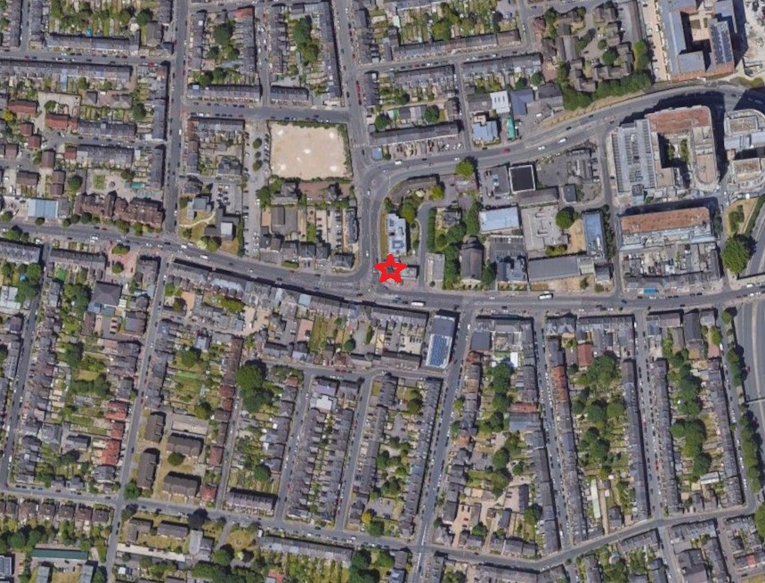
Figure 1. Site location. Courtesy of Google images

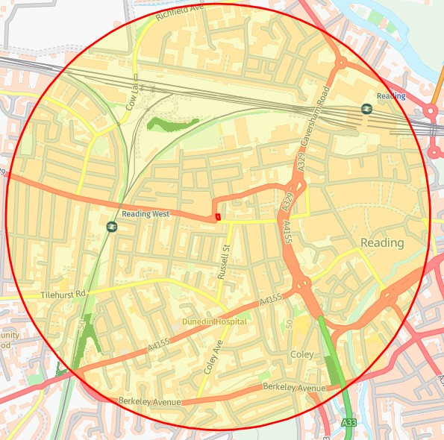
Figure 2. Priority habitats and species map. Courtesy of Magicmaps
Dark green= Deciduous woodland
RESULTS
Phase 1 Habitat Survey Results

Background Data Search
A desk-based assessment was carried out using the DEFRA MagicMap website https://magic.defra.gov.uk/MagicMap.aspx to identify all designated sites within 5km of the site and all other designated sites and protected species within 2km.
A search was made for information on statutory designated sites (often internationally and nationally important sites for ecology) and non-statutory designated sites (often important in a local context) within 1 km of the site boundary.
Sites with Statutory Designations
There are no statutory designated sites within 1km and just two small areas of priority habitat deciduous woodlands the closest is 438m to the north (see figure 2)
The site lies inside the Nitrate Vulnerable Zone as defined by DEFRA 2017.

SITE DESCRIPTION
The site is situated to the east of Bedford Road where it joins Oxford Road in central Reading (See figure 1). It is surrounded by developed land, (see figure 2). The site comprises a former public house and hard-standing (brick paving). The only vegetation is a buddleja bush growing out of south wall base and some pavement weeds at wall base (see figure 3)
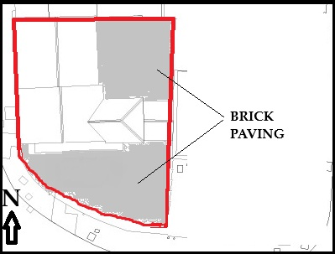
Figure 3. Habitat map

PROTECTED HABITATS
UK Biodiversity Action Plan (UK BAP) Priority Habitats are also Habitats of Principle Importance (HPI) listed under The Natural Environment and Rural Communities Act 2006 Section 41 (NERC S41). These habitats do not receive statutory protection, but the S41 list is intended to provide guidance to decision-makers, e.g. those representing public bodies and local/regional authorities, in implementing their duty under Section 40 of the NERC Act to ‘…have regard to the conservation of biodiversity in England when carrying out their normal functions’.

There are no priority habitats on site or within 400m.
PROTECTED SPECIES
Reptiles
All native British reptiles are protected under the Wildlife and Countryside Act (1981) from killing and injury. Sand Lizards and Smooth Snakes also receive additional protection under the Conservation (Natural Habitats &c) Regulations 2010 from intentional killing and injury and from intentional damage, destruction or obstruction of access to a place of shelter. All native UK reptiles are UK BAP Priority Species and SPI.

The site has negligible potential for common reptiles in the absence of any structured habitats.

Amphibians
Great Crested Newts are protected under schedule 5 of the Wildlife and Countryside Act 1981 and of the Conservation (Natural Habitats &c) Regulations 2010 from intentional killing and injury and from intentional damage, destruction or obstruction of access to a place of shelter. In addition Great Crested Newts and Common Toads are UK BAP Priority species and SPI.

According to MagicMap, the closest GCN return is from over 5km to the east. The site has negligible potential for amphibians in the absence of any structured habitats, and formidable barriers to dispersal in form of busy road network.

Badgers
Badgers are protected under the Protection of Badgers Act 1992, which makes it illegal to kill, injure or take a badger or to interfere with their setts; such as by the use of heavy machinery nearby.

No evidence of Badgers (holes, dung pits or push-throughs under fences) was found within the survey area.

Breeding Birds
All wild birds are protected under Wildlife and Countryside Act 1981, as amended, from damage or destruction of their nest whilst in use or construction, some birds listed on Schedule 1 receive additional protection from disturbance during nesting.

There was no sign of any bird nesting activity on or in the structure, and the site is entirely made up of hard standing/developed ground.

Bats
Bats are fully protected under the Wildlife and Countryside Act 1981, as amended, and also receive additional protection via The Conservation of Species and Habitats Regulations (2017) from intentional killing and injury and from intentional damage, destruction or obstruction of access to a place of shelter. It is an offence to kill or injure a bat or interfere with any roosting or resting site. A bat roost is interpreted as "any structure or place used for shelter or protection" whether or not bats are present at the time or not. Barbastelle Bats, Bechstein’s Bat, Noctule, Soprano Pipistrelle, Brown Long-eared Bat, Greater Horseshoe Bat and Lesser Horseshoe Bat are also UK BAP Priority Species and SPI.

Phase 1 Bat Survey Results
According to MagicMap, one EPS licence has been issued for Bats within 1000m of the site. No.2017-32379-EPS-MIT from a site 770m to south issued in 2017 covering common pipistrelles.
Bats – trees
There are no trees on or within 25m of the site.

Bats – building
Building Assessment
The property is a derelict former public house dating to early 20th Century with plain brick walls with a low-pitched slate roof. The slates are in good order with no gaps and the eaves closed off (see figures 4-5).
The roof is lined with felting which is in good order with no external daylight visible from within and there was no sign of any bat activity (see figure 6).
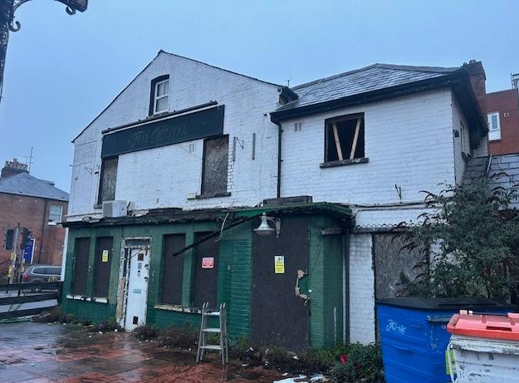
Figure 4. South elevation looking north

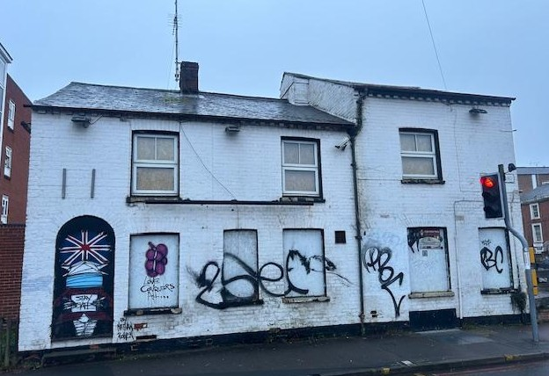
Figure 5. Western elevations looking east

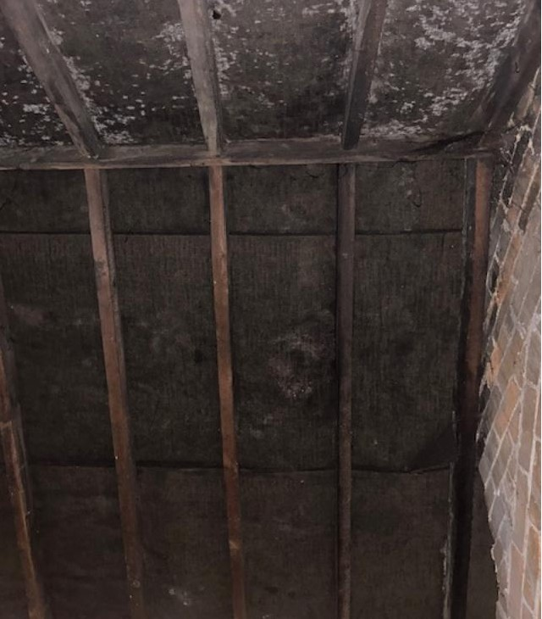
Figure 6. Loft void looking east

EVALUATION, IMPACTS AND RECOMMENDATIONS
Phase 1 Habitat Survey
Priority and protected Habitats
There are no priority habitats onsite or within 400m of the site. No habitat would be lost or changed as the new build falls on the existing building footprint.
Protected Species
Amphibians & Reptiles
The proposed site for the extension falls on hard standing with negligible potential for amphibians and reptiles.
Badgers
No badger activity was detected on site. Badgers are unlikely to occur in the area, but ity is good building practice should be followed (such as placing boards over holes or trenches overnight) to prevent animals being harmed during site works.
Breeding Birds
All birds, their nests and eggs are protected by Wildlife and Countryside Act (1981) under which it is an offence to intentionally kill, injure, disturb or take any wild bird. This legislation and its requirements should be highlighted in staff inductions, toolbox talks and signed by all contractors, operators, and sub-contractors.
Any removal of structures should be undertaken outside of the bird nesting season, which is typically 1st March to 31st August.

If any works occur within the breeding bird season the area should be checked, ideally by an ecologist, and if any nesting birds are found there is a legal obligation to protect the affected area with a buffer zone of 10m until after the young have fledged.

Phase 1 Bat Survey
The Daytime Bat Assessment / Phase 1 Bat Survey was undertaken in accordance with the Bat Conservation Trust Guidelines (Collins, 2023).
No evidence of bats was found within the property, and no openings which bats could exploit.
Therefore, the property has negligible potential for bats and a phase 2 emergence survey is not recommended.
In the unlikely event of any bats being found during demolition or construction, all work must stop immediately, and Natural England must be called. Additional information is available on the Bat Conservation Trust website at https://www.bats.org.uk/advice/imworking-on-a-building-with-bats/ive-found-a-bat-during-works.
New exterior lighting should be avoided, but if necessary for security purposes, then the latest updated lighting guidance note (GN08/23) should be followed. This is available at Guidance Note 8 Bats and Artificial Lighting | Institution of Lighting Professionals (theilp.org.uk) and supersedes all previous guidance.

REFERENCES
- Arthur, S., Hutchinson, J., Butterworth, T., Baker, J., & Potter, J. (2025) Small Sites Metric. 3.1.2. Natural England.
- CIEEM (2011) Competencies for species survey guidance documents.
- CIEEM (2011) Professional Guidance Series 10: Guidance on metadata Standards: Reporting, sharing and archiving ecological data.
- CIEEM (2011) Professional Guidance Series No 9: Guidance for Ecological Report writing.
- Collins, J. (ed.)(2023) Bat Surveys for Professional Ecologists: Good Practise Guidelines (4th edn). The Bat Conservation Trust, London
- Communities and Local Government (2012) Technical Guidance to the National Planning Policy Framework. Department of Communities and Local Government, London.
- DEFRA.
- English Nature (2001). Great crested newt mitigation guidelines. English Nature, Peterborough.
- English Nature (2004) Reptiles: Guidelines for developers. English Nature, Peterborough.
- English Nature (2006) Wildlife and development. English Nature, Peterborough.
- Institute of Environmental Assessment (1995). Guidelines for Baseline Ecological Assessment. Institute of Environmental Assessment, London.
- JNCC (1998) Herpetofauna Workers’ Manual. JNCC, Peterborough.
- JNCC (2004) Bat workers manual (3rd edition). JNCC, Peterborough.
- JNCC (2010) Handbook for Phase 1 Habitat Survey: A technique for environmental audit. JNCC, Peterborough
- Langton T. et al, (2001) Great Crested Newt Conservation Handbook. Froglife, Halesworth.
- Natural England (2009) Badgers and Development. A Guide to Best Practice and Licensing (Interim Guidance)
- Natural England (2011) Reptile mitigation guidelines. Natural England.
- Reason, P.F. and Wray, S. (2023). UK Bat Mitigation Guidelines: a guide to impact assessment, mitigation and compensation for developments affecting bats. Chartered Institute of Ecology and Environmental Management, Ampfield.
- The British Standards Institution (2013) Biodiversity – Code of practice for planning and development. BSI Standards Limited.

INTERNET RESOURCES
Google Maps: www.maps.google.co.uk
Magic Interactive Map: www.magic.gov.uk

