DELEGATED APPLICATION REPORT
Ward: Caversham
App Ref: PL/25/1379 Householder planning permission
Address: 28 WOODFORD CLOSE, CAVERSHAM, READING, RG4 7HN
Proposal: First floor side extension
Applicant: Mr & Mrs C Litten
Received date: 29/09/2025
Target Decision date: 17/02/2026 (EXT)
Case Officer: Chukwudi Onwudinanti

- SITE DESCRIPTION
The site is a two-storey detached dwelling on the northern side of the small cluster of residential dwellings off Woodcote Road. The area is characterised by similar dwellings on both sides of the loop that makes up the Close. It is located adjacent to the turning head of the road and is adjacent to a row of garages, which creates a separation to the nearest dwellings on that side.

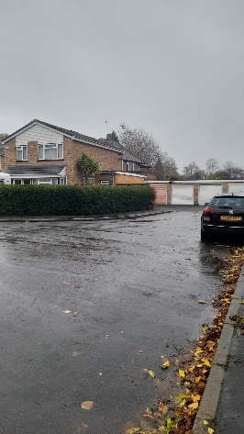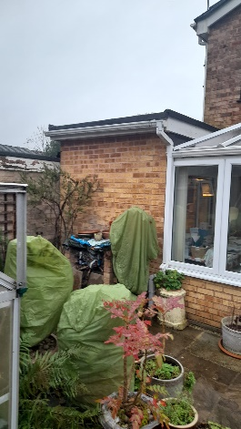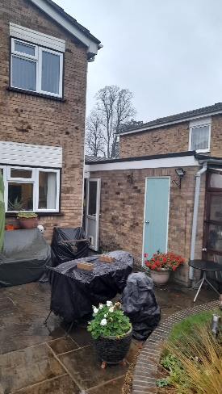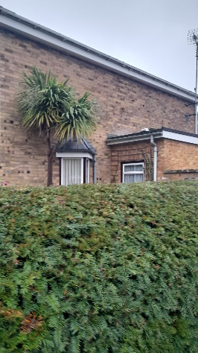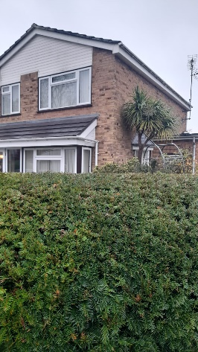
Site Photos (14/11/2025)

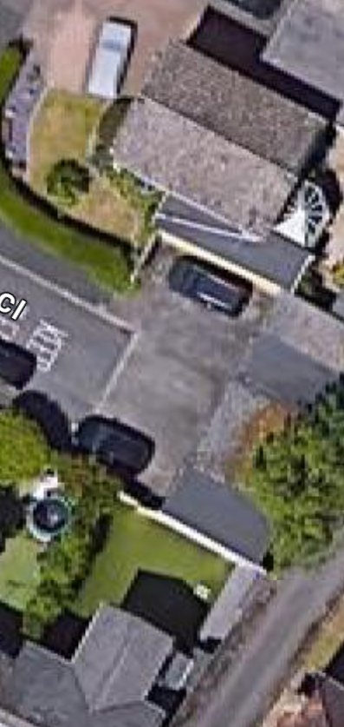
Google Aerial Photo (red arrow indicating location of proposed extension)

- PROPOSAL AND SUPPORTING INFORMATION

The proposal is for a first-floor side extension with a pitched roof with gable end. It would be 1.9m wide and 5.4m deep and would be set down from the existing roof. It would create a dressing area and ensuite to an existing bedroom.

Plans and Documents dated 23/09/2025, received 29/09/2025

Drawing No 7014:25:1: Plans and Elevations
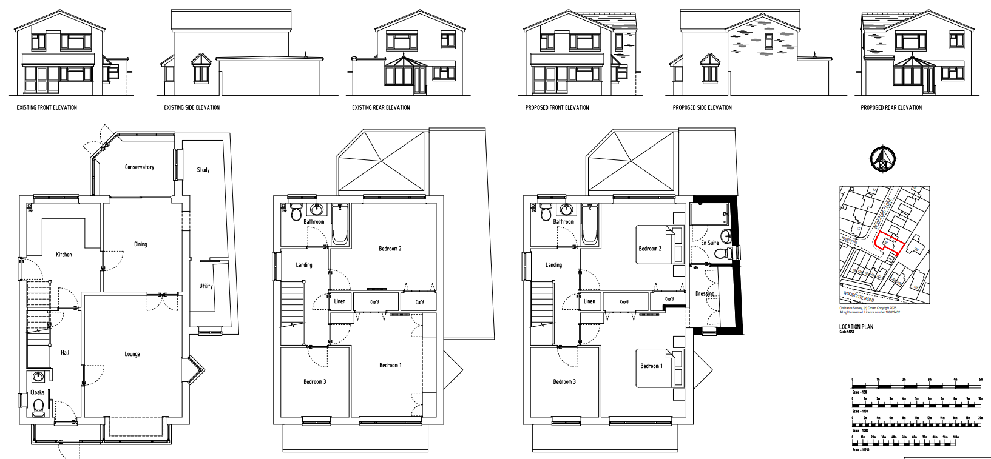
Plans and Elevations

- RELEVANT PLANNING HISTORY
None

- CONSULTATIONS

A Site Notice was put up 14/11/2025.

No letter of objection received.

Equality Act 2010:
In determining this application, the Council is required to have regard to its obligations under the Equality Act 2010. However, there is no indication or evidence (including from consultation on the application) that the protected groups identified by the Act have or will have different needs, experiences, issues and priorities in relation to this particular planning application. Therefore, in terms of the key equalities protected characteristics it is considered there would be no significant adverse impacts as a result of the development.

- LEGAL AND PLANNING POLICY CONTEXT
Section 38(6) of the Planning and Compulsory Purchase Act 2004 requires that proposals be determined in accordance with the development plan unless material considerations indicate otherwise. Material considerations include relevant policies in the National Planning Policy framework (NPPF) - among them the 'presumption in favour of sustainable development'. The following local and national planning policy and guidance is relevant to this application:

National Policy
National Planning Policy Framework
National Planning Practice Guidance

Reading Borough Local Plan (2019)
CC7 (Design and the Public Realm)
CC8 (Safeguarding Amenity)
H9 (House Extensions and Ancillary Accommodation)
H10 (Private and Communal Outdoor Space)

SPD
Design Guide to House Extensions SPD 2021

- APPRAISAL

Character and Appearance
Policy H9 states that an extension to a house will be acceptable where it respects the character of the house in terms of scale, location, materials and design and respects the character and pattern of neighbouring properties and the street as a whole in terms of scale, location, materials and design, and any important existing building line. Policy CC7 also sets out relevant considerations for design.

The proposed side extension would be an upward extension above the existing flat roof side extension. The roof covering is proposed such that the ridgeline is stepped down from the existing ridgeline on the host dwelling. The upward extension is stepped well away from the front line of the dwelling and as the ridgeline is stepped down, the extension has been designed such that it is sympathetic to the character of the dwelling and sufficiently subservient to the host dwelling.

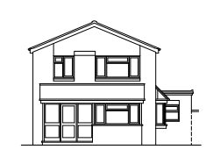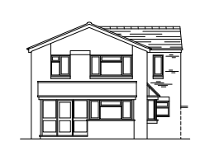
Existing front elevation Proposed Front elevation

Residential Amenity
Policy H9 states that an extension will be acceptable where it does not result in an overbearing impact on neighbours. Policy H10 seeks to ensure that the amenity of gardens and other outdoor areas are not compromised. Policy CC8 states an extension to a house will be acceptable where it will not cause a significant detrimental impact to the living environment of existing or new residential properties.

The proposed upward extension is to the side of the dwelling adjoining the detached garages on that side. There are no immediate adjoining properties on that side as the next dwelling on that side is separated by more than the width of six garages. This means that there are no adjoining properties that will be negatively impacted by the extension and the window to the side proposed will not be overlooking any properties on that side. The extension does not take any more part of the garden, so there is no impact on the amenity of the users of the dwelling.

- CONCLUSION
The proposed development has been assessed as set out above and is considered to be acceptable on that basis, subject to the following conditions.

- RECOMMENDATION: Grant
Recommended Conditions:
Approved Plans
Time Limit Standards
Materials To Match

