DELEGATED APPLICATION REPORT
Ward: Whitley
App Ref: PL/26/0144 Householder planning permission
Address: 61 AMBROOK ROAD, READING, RG2 8SJ
Proposal: Proposed front ground floor extension, side bay window, and side extension following demolition of existing storage
Applicant: Mr Kurt Shehu
Received date: 03/02/2026
Target Decision date: 31/03/2026
Case Officer: Chukwudi Onwudinanti

- SITE DESCRIPTION
The site is a semi-detached two storey dwelling on the southern side of Ambrook road, on the intersection with Greenfields Road.

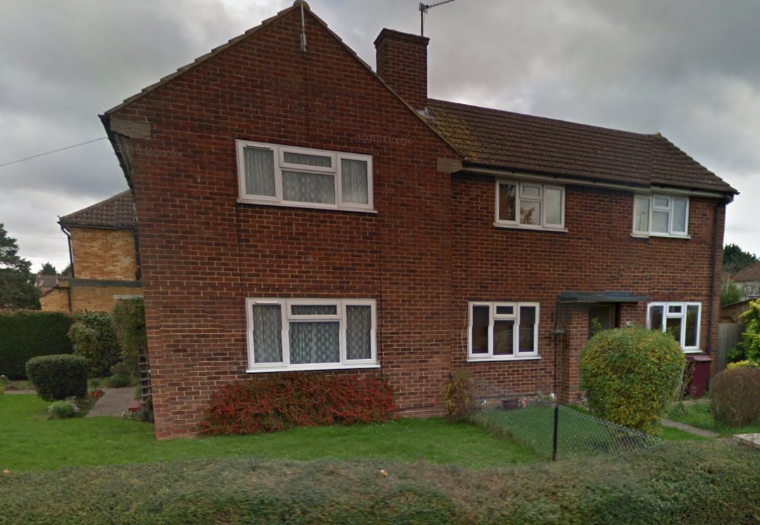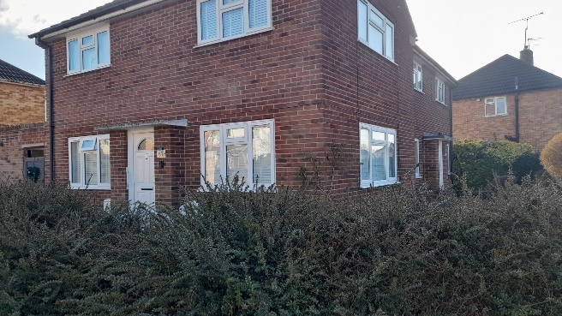

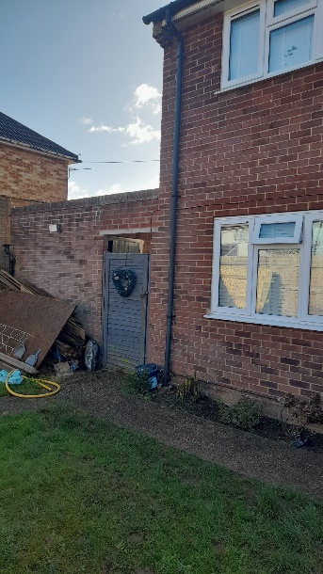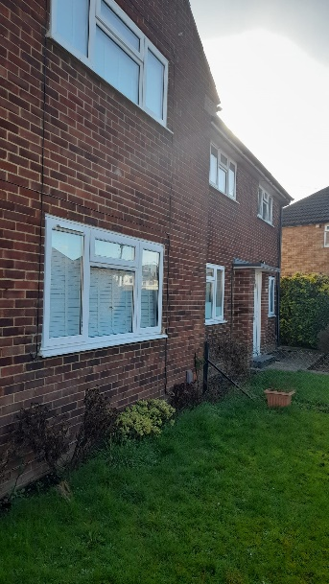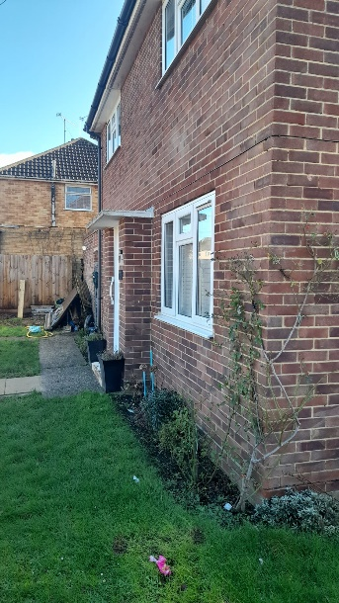

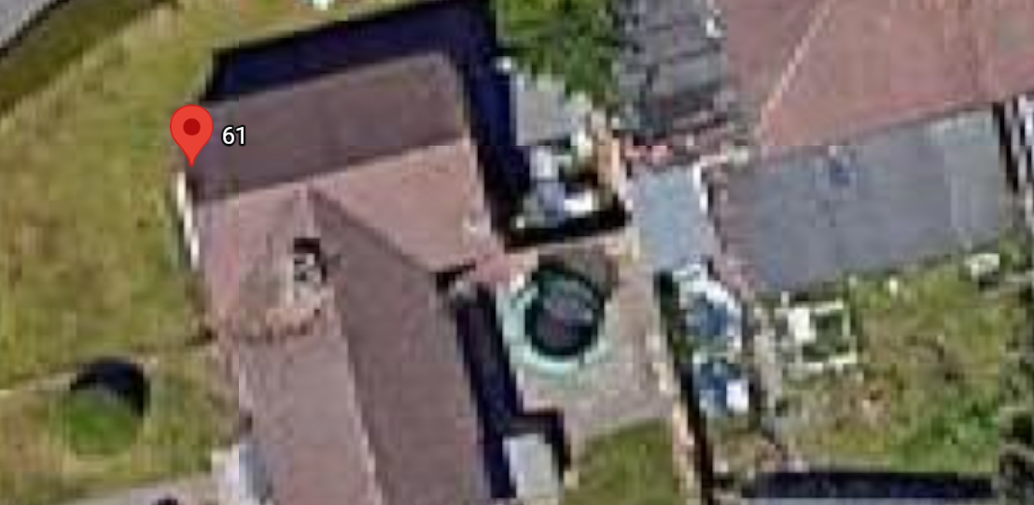

- PROPOSAL AND SUPPORTING INFORMATION
The proposal is for a front ground floor extension which increases the footprint on the ground floor forward by 1.8m across the full width of the existing dwelling. There is also a side extension of 2.8m depth and 4m width on the ground floor. This side extension takes up part of the garden space. A relocated garden area is proposed in the area of the existing storage space to be demolished. There is a proposed fence 1.6m high, surrounding this proposed garden area.

Plans and Documents dated 02/02/2026 received 03/02/2026
Location Plan
Drawing No 02: Existing Block Plan
Drawing No 03: Proposed Block Plan
Drawing No 02: Existing Ground Floor Layout
Drawing No 05: Proposed Ground Floor Plan
Drawing No 06: Existing Front and West Elevation
Drawing No 07: Proposed Front and West Elevation
Drawing No 08: Existing East and South Elevation
Drawing No 09: Proposed East and South Elevation

Existing
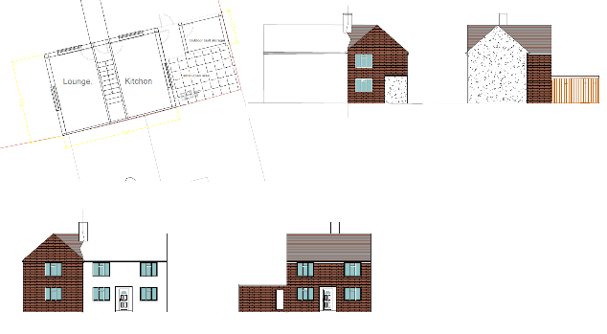

Proposed
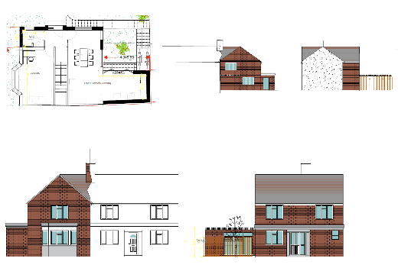

- RELEVANT PLANNING HISTORY
None

- CONSULTATIONS

A Site Notice was put up 16/02/2026

No letter of objection received.

Equality Act 2010:
In determining this application, the Council is required to have regard to its obligations under the Equality Act 2010. However, there is no indication or evidence (including from consultation on the application) that the protected groups identified by the Act have or will have different needs, experiences, issues and priorities in relation to this particular planning application. Therefore, in terms of the key equalities protected characteristics it is considered there would be no significant adverse impacts as a result of the development.

- LEGAL AND PLANNING POLICY CONTEXT
Section 38(6) of the Planning and Compulsory Purchase Act 2004 requires that proposals be determined in accordance with the development plan unless material considerations indicate otherwise. Material considerations include relevant policies in the National Planning Policy framework (NPPF) - among them the 'presumption in favour of sustainable development'. The following local and national planning policy and guidance is relevant to this application:

National Policy
National Planning Policy Framework
National Planning Practice Guidance

Reading Borough Local Plan (2019)
CC7 (Design and the Public Realm)
CC8 (Safeguarding Amenity)
H9 (House Extensions and Ancillary Accommodation)
H10 (Private and Communal Outdoor Space)

SPD
Design Guide to House Extensions SPD 2021

- APPRAISAL

Character and Appearance
Policy H9 states that an extension to a house will be acceptable where it respects the character of the house in terms of scale, location, materials and design and respects the character and pattern of neighbouring properties and the street as a whole in terms of scale, location, materials and design, and any important existing building line. Policy CC7 also sets out relevant considerations for design.

The proposal would alter the façade of the dwelling on both sides facing Ambrook Road and Greenfields Road. There is still the side extension aspect which would alter the side elevation on the ground floor. The front extension would bring it in line with the adjoining property on that side of Ambrook Road. This front extension is limited to the ground floor, with a flat roof. The bay window proposed on the side facing Greenfields Road is similar to the windows on dwellings within the immediate area.

Whilst these changes would alter the appearance of the dwelling to some extent, considering the fact that the dwellings on the street are of varied styles and some with similar extensions, the changes are not considered to be of a degree that would be unacceptable. This is more so as the existing dwelling is of a design that is unique within the environment.

Residential Amenity
Policy H9 states that an extension will be acceptable where it does not result in an overbearing impact on neighbours. Policy H10 seeks to ensure that the amenity of gardens and other outdoor areas are not compromised. Policy CC8 states an extension to a house will be acceptable where it will not cause a significant detrimental impact to the living environment of existing or new residential properties.

The extension to the side takes up some of the space used as the side garden, however this space is replaced with the demolition of the storage space. Therefore, the amenity space available remains relatively similar as the existing. The height of the side extension is limited to the ground floor, therefore, there would not be any overlooking or overshadowing impact on the adjoining property to the side.

Use of the roof will be restricted by way of condition.

- CONCLUSION
The proposed development has been assessed as set out above and is considered to be acceptable on that basis, subject to the following conditions.

- RECOMMENDATION: Grant
Recommended Conditions:
Approved Plans
Time Limit Standards
Materials As Specified
Use of Roof Restricted

