05/03/2026
Planning Application Ref: PL/25/1447
Officer: Catrin Davies
Application Type: Outline planning permission: Some matters reserved
Address: 19 PARKSIDE ROAD, READING, RG30 2BT
Proposal: The erection of four residential dwellings (phased) with
associated hard and soft landscaping and parking with the construction of a new access from Parkside Road and Kearsley Road following demolition of outbuildings (outline application considering access all other matters reserved (appearance, landscaping, layout, scale)
Version II
The application proposes to retain the existing dwelling and construct four additional dwellings within the garden area of No. 19.
In accordance with the adopted Parking Standards and Design SPD each dwelling would require 2 off road parking spaces. In addition to this existing parking provision would need to be retained for No19. Each parking space should be 2.5m wide by 5m long and have forecourt depths of 6m to ensure that spaces can be manoeuvred in and out of easily. Any garages or car ports would need to conform to the Councils adopted standards.

The proposed development will be accessed from both Parkside Road and Kearsley Road. Plots 1 and 2 will be accessed from Parkside Road, and plots 3 and 4 will be accessed from Kearsley Road.

Original Dwelling (No19)
The existing dwelling will continue to be accessed from Parkside Road via the northern access. Adequate space is available within the driveway for vehicles to park off-street. This arrangement is considered acceptable.
Plots 1 to 2
These plots will be serviced via a widened access from Parkside Rd. Visibility splays have been previously provided illustrating achievable site lines which are deemed acceptable given the 20mph restriction in place.

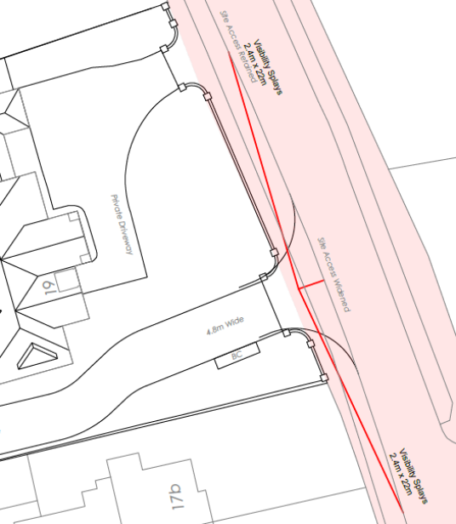

As previously advised the access will need to be 4.8m wide to accommodate vehicles entering and exiting the site. Submitted illustrative layout plan 22.19-021 (extract below) indicates a width of 4.8m; however, this measurement includes the 1.2m pedestrian footway, which is not acceptable.
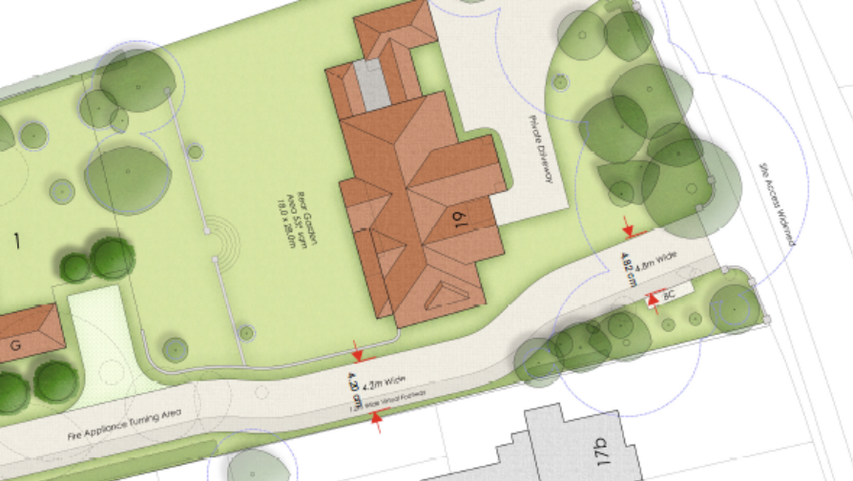

While a carriageway width of 4.2m may be acceptable over short distances, this does not include the required 1.2m pedestrian footway. Consequently, the carriageway would still need to be widened to 4.8m, which is not currently shown on the submitted plans.

The 4.8m width is required to accommodate the width necessary to allow for a refuse vehicle and a car to pass one another as illustrated from the extract below from Mfs 7.1

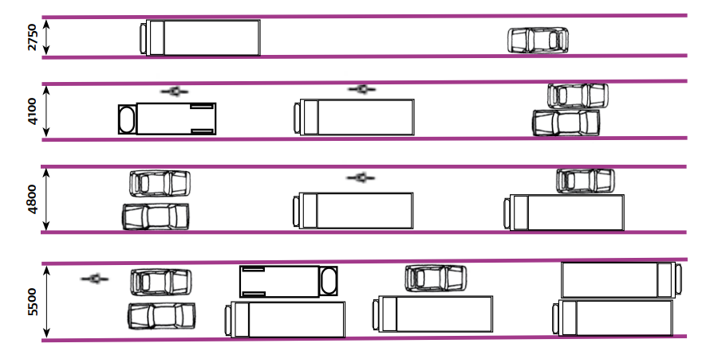

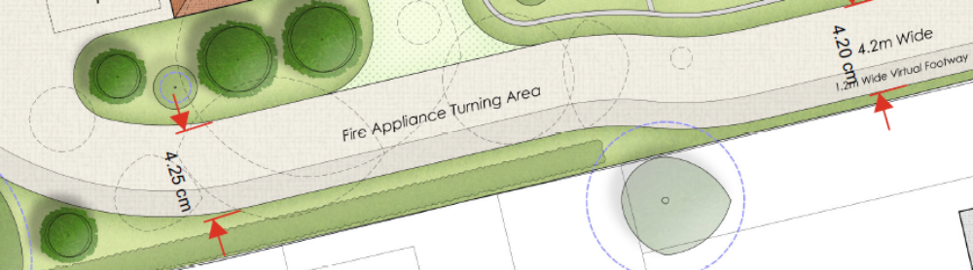

To clarify, the 1.2m pedestrian footway must be provided in addition to the required carriageway width along the entire access from Parkside Road. As previously advised, the pedestrian footway should extend to serve all properties within the development and should therefore be clearly illustrated on revised plans.

It should be noted that Manual for Streets (MfS):
Section 7.2.10 states:
Shared surfaces can cause problems for some disabled people. People with cognitive difficulties may find the environment difficult to interpret. In addition, the absence of a conventional kerb poses problems for blind or partially-sighted people, who often rely on this feature to find their way around. It is therefore important that shared surface schemes include an alternative means for visually-impaired people to navigate by.

Section 7.12
Consultation with the community and users, particularly with disability groups and access officers, is essential when any shared surface scheme is developed. Early indications are that, in many instances, a protected space, with appropriate physical demarcation, will need to be provided, so that those pedestrians who may be unable or unwilling to negotiate priority with vehicles can use the street safely and comfortably

Section 7.13
When designing shared surface schemes, careful attention to detail is required to avoid other problems, such as:
• undifferentiated surfaces leading to poor parking behaviour;
• vulnerable road users feeling threatened by having no space protected from vehicles; and
• the positioning and quantity of planting, street furniture and other features creating visual clutter

Section7.14
Subject to making suitable provision for disabled people, shared surface streets are likely to work well:
• in short lengths, or where they form cul-de-sacs
• where the volume of motor traffic is below 100 vehicles per hour (vph)
• where parking is controlled or it takes place in designated areas

The requirements of the Highways Authority are in line with national guidance as set out in MfS, however we have accepted the reduced number of pedestrian movements that would be generated by the development, hence why we have allowed for a reduced footway width of 1.2M thereby being reasonable in the assessment of the application. There needs to be a physical demarcation providing protection from vehicles.

Plots 3 & 4
Plans indicate dwellings to be provided with 2 parking spaces each (one in garage) accessed via an existing vehicle crossing from Kearsley Road.

Given the constrained nature of the access and the potential for vehicles to overrun adjacent land, the applicant should provide details of appropriate boundary treatment to prevent vehicles from encroaching onto neighbouring land.
A 4.2m wide access road is proposed and is considered acceptable. However, this width must be provided in addition to a 1.2m pedestrian footway, consistent with the requirement for Plots 1 and 2. The pedestrian footway should extend from the site entrance further into the development, as indicated below:

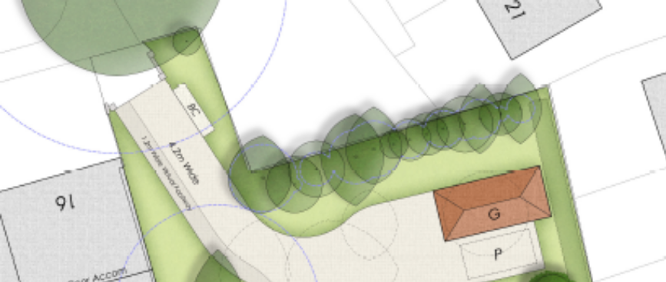

As previously advised, the Natural Environment Officer should be consulted to determine whether the proposed works may affect any adjacent trees.
All parking areas should be constructed using permeable materials to ensure that the development does not increase the surface water run-off from the site.

Electric Vehicle Charging
The Council’s Local Transport Plan 3 Strategy 2011 – 2026 includes policies for investing in new infrastructure to improve connections throughout and beyond Reading which include a network of publicly available Electric Vehicle (EV) charging points to encourage and enable low carbon or low energy travel choices for private and public transport. The Councils Local Plan was adopted in November 2019 and this includes a requirement at Policy TR5 for each new house to be provided with an electric charging point.

Refuse Collection

The applicant had initially stated that refuse vehicles would enter the site and a bin collection point was illustrated within the site as shown below in the extract from the tracking plans in the original Transport Statement dated October 2025.

Original Plan:

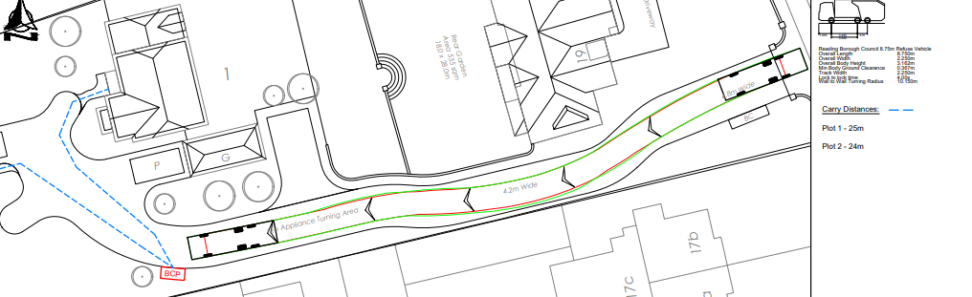

New plans in the recent/updated Transport Statement (Jan 2026) and submitted illustrative layout plan 22.19.0-21 identify the removal of the bin collection point within the site to areas adjacent to Parkside Rd and Kearsley Rd vehicle accesses as indicated in the extract below:

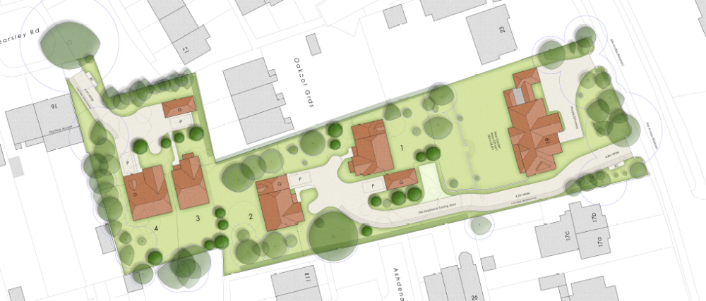

The bin collection point fronting Parkside Road will result in occupants from Plots 1 and 2 increasing the carrying distance to over 74m which is significantly more than the maximum carry distance of 30m. This would not be acceptable; Therefore, it is likely that a refuse vehicle would be required to enter and turn on site as was originally indicated by the applicant. Tracking plans will be required illustrating this manoeuvre without over running the pedestrian path.

Cycle Storage
In accordance with the adopted Parking SPD, each new dwelling will require a minimum of 2 cycle parking spaces for each C3 dwelling. In a development of this nature these can be provided in the private rear gardens of each dwelling.

N. Hussain
Transport Development Control Advisor

