27/02/2026

Planning Application Ref: PL/26/0196
Officer: Gary Miles
Application Type: Householder planning permission
Address: 7 ALDEBURGH CLOSE, EMMER GREEN, RG4 8UT
Proposal: Garage conversion to habitable accommodation, addition of rear glazed lean to.
Application will result in the loss of the double garage to provide ancillary accommodation and therefore the loss of 2 parking spaces
.
Submitted plans illustrate that 2 on site parking spaces are to be provided to mitigate the loss of the double garage, provision is in accordance with the Councils current adopted standards:

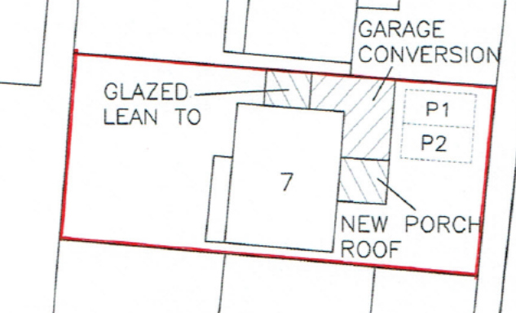

Proposed provision is deemed acceptable, no changes to the existing vehicle access arrangements are proposed.

DC1 VEHICLE PARKING (AS SPECIFIED)
IF3 Highways
I24 Do not damage the verge

N. Hussain
Transport Development Control Advisor

