PROPORTIONATE TREE IMPACT STATEMENT
8 Framlingham Drive, Reading, RG4 6RE
1. Introduction
This statement has been prepared in response to officer comments regarding the potential impact of the proposed development on nearby trees.
The proposal comprises a modest front extension and internal alterations as shown on planning drawings.

2. Existing Site Conditions
The area affected by the proposed extension currently comprises:
- existing hardstanding,
- paved forecourt area,
- previously compacted ground associated with driveway and access arrangements.
Site photographs demonstrate that the ground within the development footprint has been long established as surfaced external space and does not represent an undisturbed rooting environment. 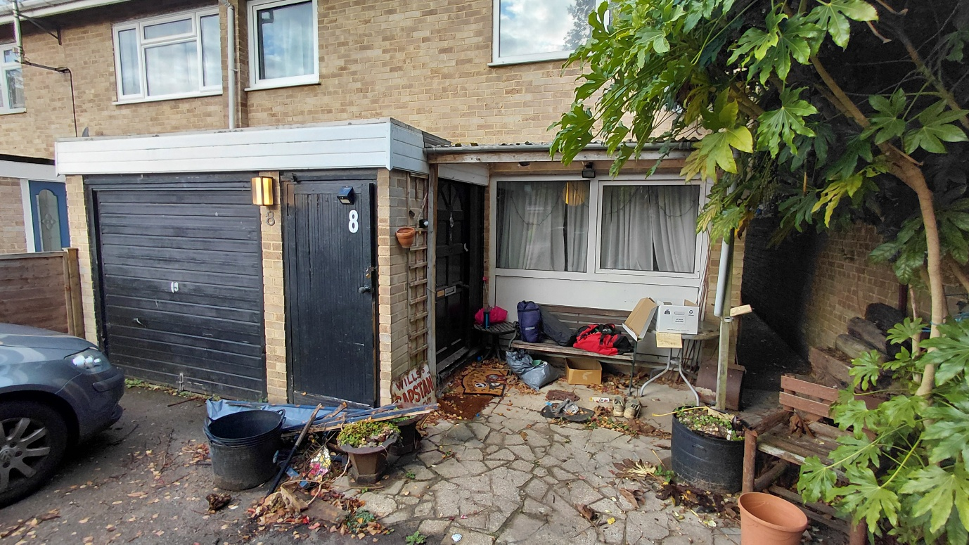

3. Existing Trees
Trees are located primarily along the site boundary and adjacent highway verge as illustrated on the Site Plan (Drawing FD-R00-PR-101).
These trees are separated from the proposed works by:
- existing hardstanding,
- boundary treatments,
- established built development.
No additional tree removal is proposed beyond that already indicated within the submitted drawings.

4. Assessment of Impact
The proposed extension:
- occupies an area already subject to ground disturbance;
- does not extend materially closer to trees than existing development;
- does not introduce new excavation into previously undeveloped soil.
Given the established hardstanding, any root presence within the footprint is likely to have already been limited or adapted to existing conditions.
Accordingly, the proposal is not expected to result in additional adverse impact to tree root protection areas beyond the existing baseline condition.

5. Construction Considerations
Construction will:
- be confined to the existing developed footprint where possible;
- avoid unnecessary excavation toward adjacent trees;

6. Conclusion
The proposed development represents a small-scale extension located on previously developed hardstanding and will not materially increase impacts upon nearby trees.
A full arboricultural assessment is therefore not considered necessary at this stage and any further tree protection measures could reasonably be secured by condition if required.

