CONSERVATION

Memo
To: Huimin Chen
From: Buju Can Cetin, Conservation Officer
Date: 06/02/2026
Re: Conservation Officer response
Application Number: PL/26/0099 AND PL/26/0101
Application Type: Householder Planning Application AND Listed Building Consent
Address: 41A WHITE HOUSE, 41 EASTERN AVENUE, READING, RG1 5RX
Proposal: Part single-storey and part two-storey rear extension, internal alterations, addition of new doors and windows, and the reinstatement of a garage. AND The proposed works include a part single-storey and part two-storey rear extension, internal alterations, addition of new doors and windows, and the reinstatement of a garage.

Summary
Clarification Required – Whilst no major concern is raised from the point of historic environment, further clarification and details are required to fully assess the impacts of the proposals on the Grade II listed building and the conservation area. The proposed development is acceptable in principle and has a very high likelihood of approval once details of some of the works are provided and agreed upon.

Relevant policies and legislation
From the point of view of the historic environment, the main statutory tests are set out within the Planning (Listed Buildings and Conservation Areas) Act 1990. Sections 16(2) and 66 require that special regard be given to the desirability of preserving listed buildings, their settings or any features of special architectural or historic interest which they possess.
Section 72(1) of the Planning (Listed Buildings and Conservation Areas) Act 1990 also requires the Council to pay special attention to the desirability of preserving or enhancing the character and appearance of designated Conservation Areas.

National Planning Policy and Guidance
The NPPF outlines government policy, including its policy in respect of the historic environment. Chapter 16 of the NPPF 'Conserving and enhancing the historic environment' sets out the Government's high-level policies concerning heritage and sustainable development.
Paragraph 207 states, “In determining applications, local planning authorities should require an applicant to describe the significance of any heritage assets affected, including any contribution made by their setting. “ Paragraph 208 says, “Local planning authorities should identify and assess the particular significance of any heritage asset that may be affected by a proposal (including by development affecting the setting of a heritage asset) taking account of the available evidence and any necessary expertise. They should take this into account when considering the impact of a proposal on a heritage asset, to avoid or minimise any conflict between the heritage asset’s conservation and any aspect of the proposal.”
Paragraph 212 of the NPPF requires that ‘when considering the impact of a proposed development on the significance of a designated heritage asset, great weight should be given to the asset’s conservation….’ And paragraph 213 says, ‘any harm to, or loss of, the significance of a designated heritage asset (from its alteration or destruction, or from development within its setting) should require clear and convincing justification’.
Paragraph 215 requires that ‘where a development proposal will lead to less than substantial harm to the significance of a designated heritage asset, this harm should be weighted against the public benefits of the proposal…’
National Planning Practice Guidance on Historic Environment provides context to the NPPF.

Local Planning Policy and Guidance
Policy EN1 ‘Protection and enhancement of the historic environment’ of the Reading Borough Local Plan sets out the Council’s aspirations for the historic environment. The policy requires that all proposals to protect and, where possible, enhance the significance of heritage assets and their settings, historic character and local distinctiveness of the area in which they are located. It echoes the NPPF by stating, “Proposals should seek to avoid harm in the first instance. Any harm to or loss of a heritage asset should require clear and convincing justification, usually in the form of public benefits”.
Applications which affect Listed Buildings are expected not to have an adverse impact on the elements that contribute to their special architectural or historic interest, including their settings.
Policy EN3 ‘Enhancement of conservation areas’ of the Reading Borough Local Plan (2019) requires that development proposals within Conservation Areas contribute positively to local character and distinctiveness. This policy further states “Positive consideration will be given to proposals which take opportunities to enhance the character of conservation areas. These may include:
- Reducing visual clutter caused by negative factors, such as poles and overhead wires, satellite dishes or unnecessary street furniture;
- Restoring original building features;
- Removing inappropriate additions or alterations to buildings;
- Protecting and encouraging the maintenance of green spaces and important trees, particularly where they are intrinsic to the history and character of the area;
- Improving signage and street furniture;
- Restoring or re-establishing appropriate paving, railings or walls;
- Sympathetic landscaping and planting;
- Improving or restoring green spaces, including front gardens, that are appropriate to the historic interest of a Conservation Area;
- Signage that reveals and promotes the Conservation Area and its boundaries;
- Interpretation panels to inform the public of the area’s historical significance.”
Policy EN6 ‘New development in a historic context’ also requires “New development will make a contribution to the historic character of the area by respecting and enhancing its architectural and visual qualities and considering how heritage considerations can influence the design of new development. When determining planning applications for new development, the following factors will be taken into consideration:
a. The positive contribution of the development to the existing historic townscape (scale, height, mass, proportion, plot size, street form, materials, significant vistas and views, and open space);
b. Sensitivity to historic context;
c. Reflection of borough-wide major heritage themes that contribute to local distinctiveness (e.g. patterned brickwork or former worker terraced housing);
d. Whether development promotes and/or improves access to previously undiscovered or neglected historic significance.”

Other Guidance
Historic England Advice Note 2 – Making changes to Heritage Assets illustrates the application of policies set out in the NPPF in determining applications for Planning Permission and Listed Building Consent.
English Heritage’s “Conservation Principles” provides policy and guidance for the “sustainable
management of the historic environment”.

Relevant heritage assets
The application site relates to an attractive semi-detached two-storey (and basement) Grade II listed Georgian building, 39 and 41, Eastern Avenue (39 and 41, Eastern Avenue, Non Civil Parish - 1248720 | Historic England) located to the east of Eastern Avenue. The site is also within the South Park Conservation Area with many buildings of townscape merit in its immediate area, as illustrated below.
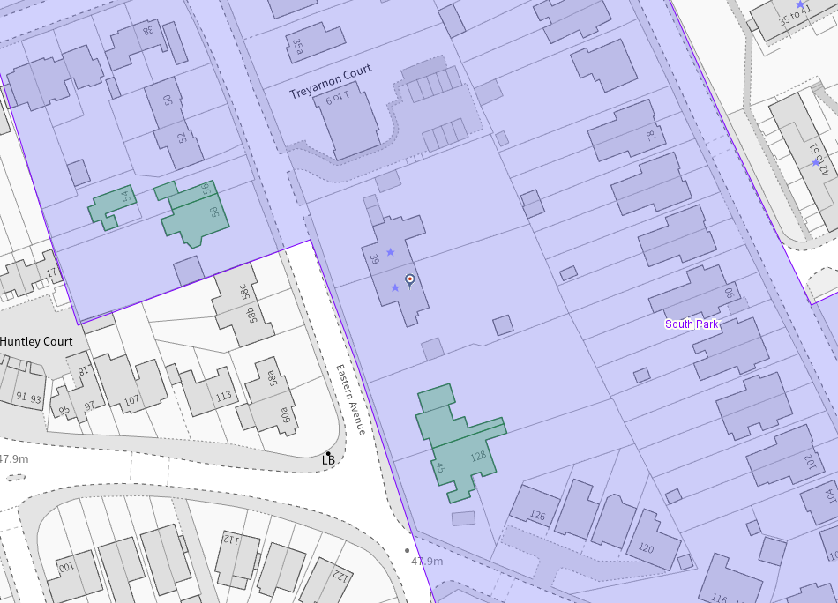
Application Site (red circled), listed buildings (starred), buildings of townscape merit (green), and conservation areas (light purple)

Significance of heritage assets
The NPPF defines significance as the “value of a heritage asset to this and future generations because of its heritage interest.”

The interest may be architectural or historic, as set out in the Town and Country Planning (Listed Building and Conservation Areas) Act 1990 Section 1.

“Significance derives not only from a heritage asset’s physical presence, but also from its setting.” (NPPF, 2023)

Historic England assesses significance in a similar manner, referring to evidential, historic, aesthetic and communal values of a place.

In addition to the Grade II listed buildings' historic and architectural interests of their own, their location and position within Reading, prime retail streets retaining historic frontages, have strong visual containment within the historic centre of the town.

The official listing entry of the subject listed building is read as follows.

“Overview
This list entry was subject to a Minor Amendment on 8 January 2026 to correct a typo in the description and to reformat the text to current standards
“Summary
This list entry was subject to a Minor Amendment on 8 January 2026 to correct a typo in the description and to reformat the text to current standards
SU 77 SW
17/610
READING
EASTERN AVENUE (East Side)
Nos 39 and 41 (White House chiropractic surgery)
Pair of semi-detached houses, no. 41 now surgery with flat above. 1845 (deeds) with C20 additions. Stuccoed brick, Welsh slate roof - two storeys, three bays with lower, set-back, side bays and an added lower bay to either end; rear range added 1923. Main range: narrow vertical recess divides properties; sashes with glazing bars in raised surrounds with ends of cills breaking forward on brackets; entrances at either end have internal porches with pilasters supporting entablature, narrow round-arched openings in return walls (no. 41's with Art Noveau glazing) and, inside, two steps up to door of four flush panels under overlight with glazing bars (porch of no. 39 has black and white marbled floor); hipped oversailing roof with central, brick, cross-ridge stack. Side wings have a sash on each floor, of 12 panes to ground floor and nine unequally-hung panes to first floor; roofs have hipped ends and brick stacks to rear. Additions to either side have monopitched roofs, the left one blind the right one with C20 1st floor oculus.
Interior: no.39 has panelled double-door between front and rear ground-floor rooms and open-string stair with moulding below treads, decorative newel and curtail to handrail.
Listing NGR: SU7336672781”.

The subject-listed building and its demi-detached pair, as described within the official entry, were constructed in 1845, and the building at No. 41 was altered in the 19th and 20th centuries, which is seen on the historic OS Maps.

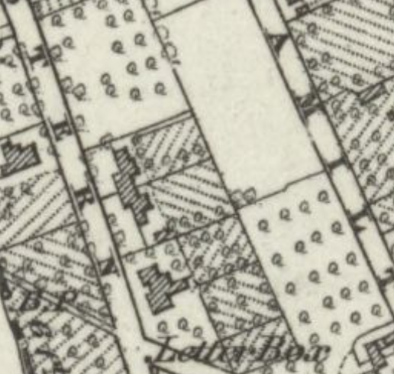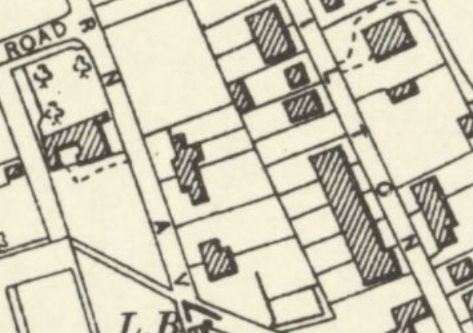
The Application Site on the OS Map of 1883 (Left) and on the OS Map of 1900 (Right): There were changes to the footprint to the rear (?) and the south eastern side

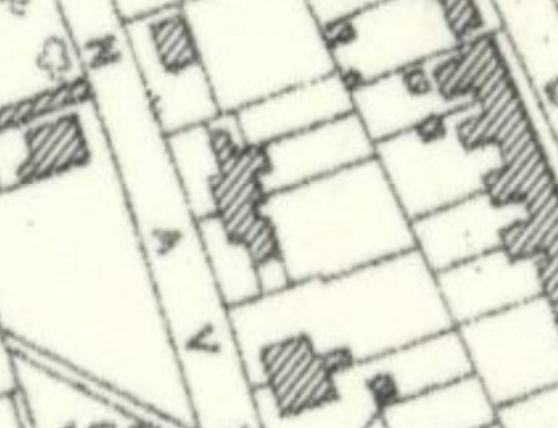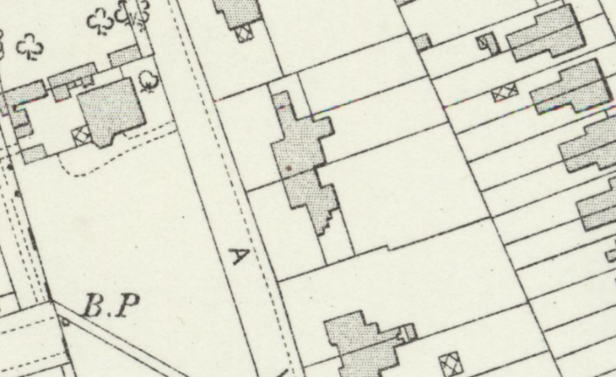
The Application Site on the OS Map of 1909 to 1910 (published in 1913) (Left) and on the OS Map of 1910 (published in 1912) (Right): Further changes to the footprint to the rear and the southeastern side, the later one appears the same in the 1930s

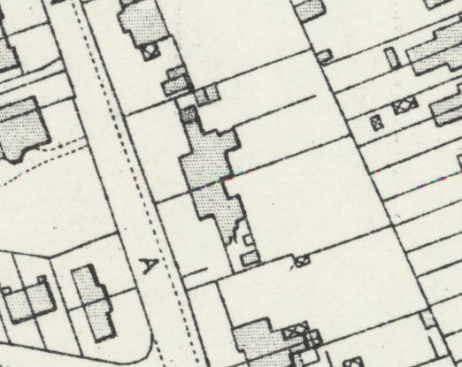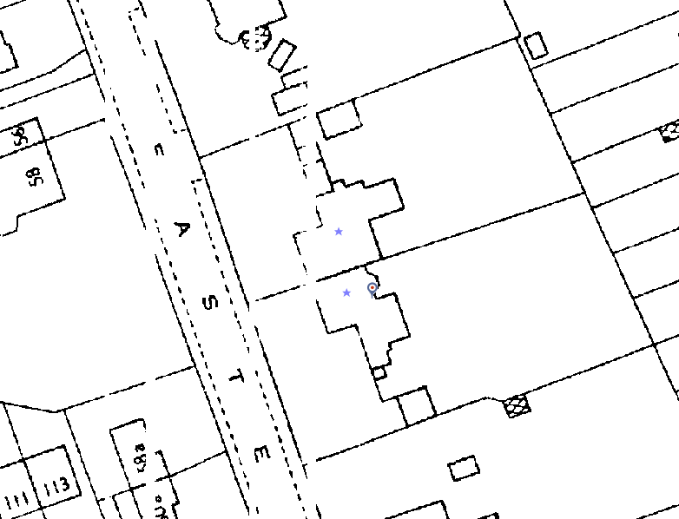
The Application Site on the OS Map of 1932 (published in 1934) (Left) and on the Council’s Historical Map of the 1950s (Right): Further changes to the footprint to the rear – a bay window in the 1950s, and the southeastern side

Although there is no clear information about the original footprint and layout of the property, given the alterations suggested by the official listing and historical maps, it can be concluded that the footprint of the 1950s could be considered original, given it can be dated before 1948.
However, it is noted that the planning history reveals that the property again went under some external and internal works in the 1960s due to its conversion of two flats. As such, the impact of the proposed works should be assessed in light of the original footprint of the 1950s, when the significance lies within it, and approved layout changes in the 1960s, when modern works can be spotted.
South Park Conservation Area is known for its sheer variety, exuberance and blending of the architectural styles of the mainly Victorian period, a large number of surviving boundary walls and railings and mature tree cover. Once the suburb of Reading, the application site and the subject listed building provide this suburban feeling by being one of three listed buildings in the conservation area. As such, the site constitutes an important place within the area.
The subject building with a modern single-storey rear extension appears to have a little alteration on its footprint and internal layout. 1987 being the date of listing of the property, after the permissions of the 1960s, the site can be considered as highly intact and original, although its detached garage was lost after the 1970s, as historic maps suggest. Therefore, a development for this site and listed building could be seen as an opportunity to enhance the significance of both by mitigating the negative features listed in the conservation area appraisal below:
“•Out of character flat developments and associated garage courts;
•Some detrimental changes to individual properties by way of additions and/or use of non-traditional materials;
•Loss of original brick walls and/or railings to create frontage parking plus some replacement of walls/railings with brick walls and/or timber fencing;
•Some walls/railings in need of repair;
•Whilst not inherently unattractive in itself, some overgrowth of railings with hedges; (…)”

Impact of proposal upon heritage asset(s)
The proposed works include the erection of a garage, single-storey and two-storey rear extensions and internal alterations to convert the building into a single dwelling house. In principle, the benefit of conversion would be highly supported by the Council and the submitted documents, including Heritage Statement, Design and Access Statement, and Structural Feasibility Report, are appreciated.
Regarding the proposed works as mentioned in the statements above, in the application form and submitted drawings, the assessment of the heritage impacts could be summarised as follows.
Works to the listed curtilage: The erection of a double garage would not create harm to the setting of the listed building due to its position and appearance, although it could be argued to have a considerable scale. The garage would be finished with render. However, there is no clear information about the material and colours of the proposed roof tiles and doors for the garage. Similarly, the proposed fencing between the main building and the garage appears acceptable; details are needed for these new elements as well. Likewise, the submitted Proposed Landscape Plan, which proposes a high percentage of soft landscaping for the listed curtilage that the Council supports for the historic environment, includes a raised patio, an outdoor seating area and a path in the rear garden, all of whose materials and details are required. The impact of works to the listed curtilage would probably create no harm to the setting of the listed building and significance of the conservation area, however, the Council cannot approve anything without material specifications.
Works in the basement: To introduce a guest bedroom, gym and plant room, the existing modern partitions would be removed, and two lightwells (and windows) would be inserted. As the submitted Structural Feasibility Report “The formation of the two lightwells does not raise any significant structural concerns at present. However, the architectural drawings currently lack detail regarding their size and position.” To fully assess the impacts of lightwells, section drawings with details are required. In addition, this report recommends “From a structural perspective, new lintels will be required over the openings, and new retaining structures will need to be added externally to form the well(s). At this stage, we would allow to use reinforced hollow blocks with a lightly reinforced concrete slab at its base.” From the conservation perspective and use of appropriate materials, reinforced hollow bricks would not be acceptable. There should be considered alternative materials that would support the traditional, breathable and reversible solutions. Therefore, there is a need for clarification and additional information for the basement works.
From the submitted drawings, I noted that the basement floors are to be lined with Rinzaffo MGN waterproof and breathable lime plaster. This is acceptable in principle. However, the details of the proposed system should also be submitted. The details of the proposed fenestration would also be required and could be conditioned; however, lightwells, being both structural and visual interventions, cannot be conditioned. Other works, such as floor, wall and ceiling finishes and solutions to damp problems, could also be included within the proposed works (or schedule of works) to avoid pre-commencement conditions.
Works to the ground floor: A new single-storey rear extension is proposed to the 1960s footprint, which would have the full width of the rear elevation, a flat roof and a contemporary appearance. Because this extension would enlarge the existing one, compared with the original footprint of the main house, its depth and characteristics, the extension would be the highest limit of non-original additions. Similarly, a two-storey rear extension, due to its position, scale, appearance and relationship with the main dwelling, could be considered subordinate or subservient. However, for this listed curtilage, as the new garage would also be constructed, again, it should be noted that the proposals would constitute a relatively large area and scale that, if they are approved, no further buildings or extensions should be approved for this curtilage. As such, I raise no objection to the proposed extensions. The Council welcomes no-dig construction to the extension. The details of the new walls and how they attach to the historic fabric of the rear are required. Details of all new internal and external joinery (an fenestration) should also be submitted.
Among the proposed internal works, a new open hallway, reinstatement of the balustrade of the staircase and reinstatement of a window to the side elevation would be beneficial only if the details of the stairs and the new window are appropriate to the significance of the building. Therefore, for most of the proposed works, details are required.
The proposed layout is considered beneficial as the circulation would reflect the original (and proposed use) and the hierarchy of the spaces, which would increase the legibility of the original floor plans. This is supported by the Council.
The proposed works for the secondary staircase to be boxed in and a new study room would have little harm; however, subject to the details of the new internal wall lining, removal of existing flooring and inserting a timber floor with insulation between joists as annotated on the drawings.
Works to the first floor: The new two-storey extension would result in little loss of rear wall/historic fabric. The proposed internal layout changes include the conversion of the existing kitchen into a bathroom, and partial removal of some internal walls would also cause some harm, but this harm would be at the lowest level. However, again, some details would be required for a full impact assessment of the proposed works.
To summarise, the details of the following must be submitted to the Council to complete the assessment of the proposed works and final judgement.
- Confirmation of all proposed external materials, including roof, wall finish and fenestration for the proposed extensions, fencing, paving and seating area in the listed curtilage. -This is necessary for both householder and LBC applications.
- A section drawing showing the relationship of the historic fabric & foundations, and proposed lightwells, together with the dimensions and materials, and impact assessment – Necessary for both HOU and LBC applications
- A section drawing showing the relationship of the historic external walls and new walls for the extensions, along with the materials – for LBC
- Details and materials for the proposed infilling of existing windows and door openings – for LBC
- A section drawing (and plan if necessary) showing the details and materials for enclosing the secondary staircase – for LBC
- Details for the proposed balustrades and alterations to the main staircase – for LBC
- Details and impact assessment of the proposed damp proofing in the basement – for LBC
The following can be conditioned if agreed with the agent/applicant (as pre-commencement conditions)
- All external and internal joinery details, including rooflights – for HOU and LBC
- All internal finishes for walls, ceilings and floors – for LBC
- Details for the proposed insulation of the study room – for LBC
- Details for the new internal walls – for LBC
- Details for the additional extractor system, pipework and rainwater goods – for HOU and LBC

Therefore, my conclusion is that further clarification and details are required to fully assess the impacts of the proposals on the Grade II listed building and the conservation area. The proposed development is acceptable in principle and has a very high likelihood of approval once details of some of the works are provided and agreed upon.
Addition – Notes from the recently submitted ‘Condition Survey Report of the Basement, Stable and Stucco’
I am happy with this report as it is comprehensive and includes many recommendations based on conservation principles for the repair of the historic fabric. For the stucco, I agree that testing might be required. Please note that sometimes removal of existing renders and coatings may result in further deterioration to the main building material behind them. In this case, it is a brick. There is a possibility that during the removal of the surfaces of bricks, their integrity may be affected. This should be considered and decided on for not only the external but also the removal of internal coatings.
Similarly, addressing the damp problems and suggesting solutions for the basement looks acceptable. However, because it is a ‘basement’, sometimes it is natural for this space to have some dampness, and this can also be the building's own/original environment, which could also be affected by the weather conditions or seasons. I understand that because this space would be converted into a habitable room and some of the damp problems stem from some interventions, I would not object to the proposed works. As I already mentioned above, the Council would require further details.
I noted that for some spaces, further investigations are recommended, such as the entrance lobby or the back room. I think the work in these areas would be decided following the investigations. Therefore, I recommend listing the proposed repairs and those after further investigations and analysis so that the Council can provide a proportionate response and consider other pre-commencement conditions.

Conservation response
No objections
No objections subject to conditions attached
Clarification required
Object

Contact details
Buju Can Cetin, Conservation Officer
Burcu.CanCetin@reading.gov.uk
0118 9373125

