DELEGATED APPLICATION REPORT
Ward: Caversham
App Ref: PL/25/1326 Householder planning permission
Address: 8 COPPERFIELDS, CAVERSHAM, READING, RG4 7PQ
Proposal: Proposed single rear and side, two storey rear and conversion of an existing loft to a habitable second floor
Applicant: Mr Haasin Khan
Received date: 18/09/2025
Target Decision date: 11/02/2026 (EXT)
Case Officer: Chukwudi Onwudinanti

- SITE DESCRIPTION
The site is a two-storey detached dwelling on the northern side of Copperfields Road, in a predominantly residential area, grouped around the cul-de-sac.

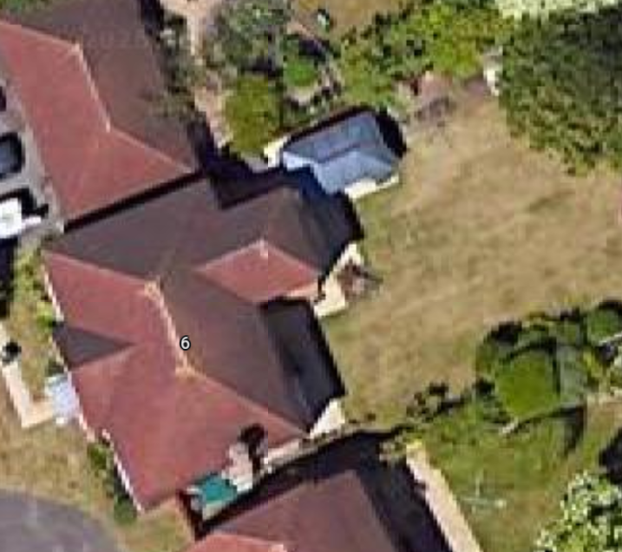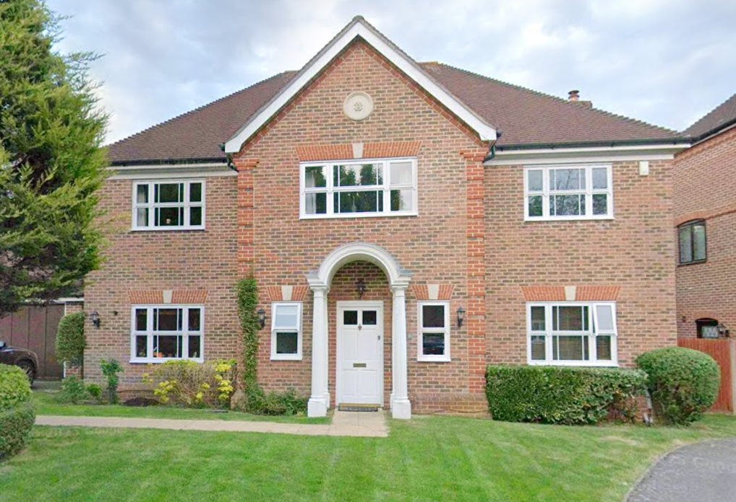
Google Photos
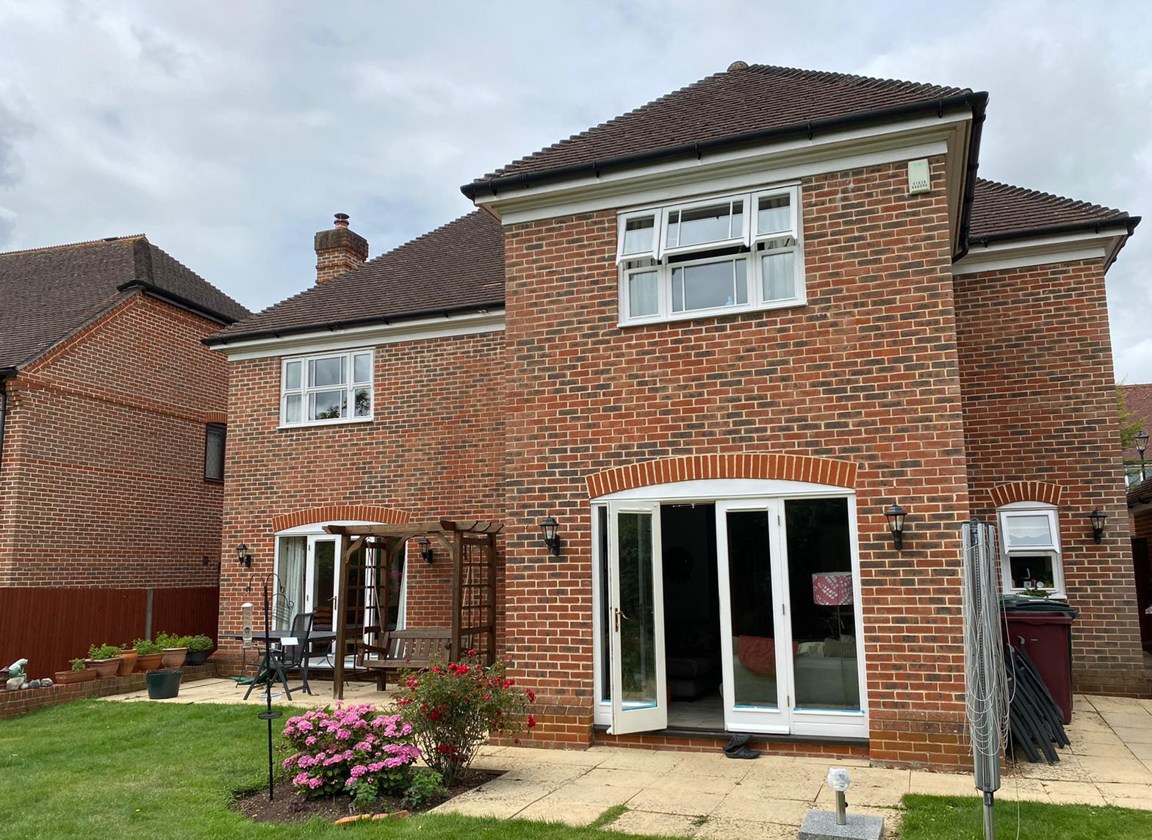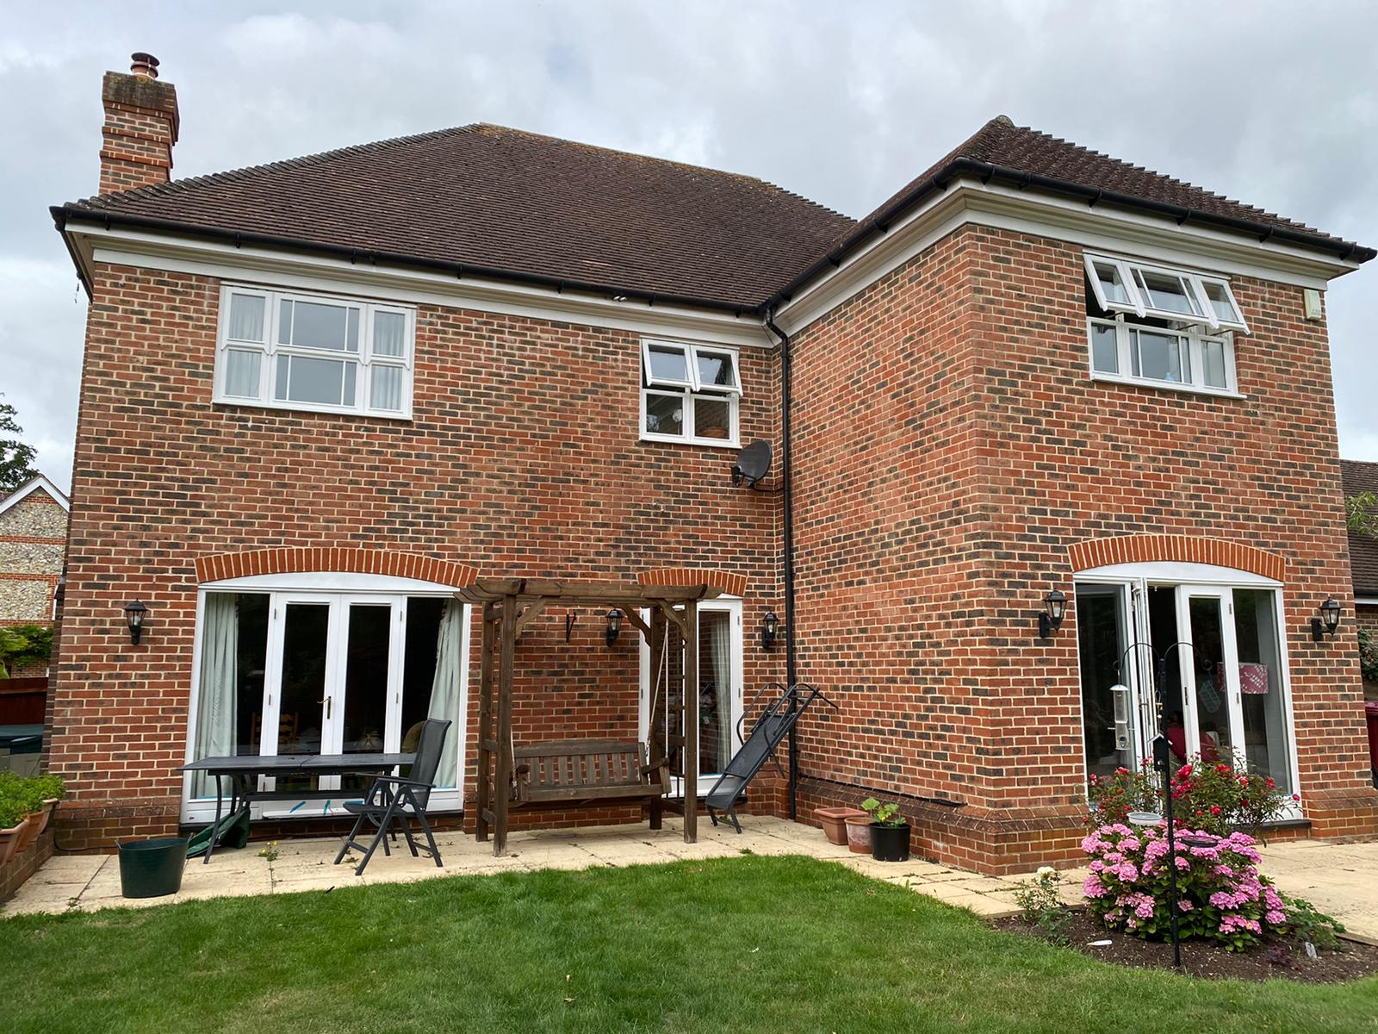
Site Photos

- PROPOSAL AND SUPPORTING INFORMATION
Proposal is for a single storey rear and side extensions (to fill up existing spaces to both sides of an existing 2 storey gable ended projection to the rear), two storey side and rear extension (to fill up one part of the space on the outrigger as on the ground floor), a slight increase to the roof space through extended the width of the ridge and introducing a part hipped, part gable roof form, and conversion of an existing loft to a habitable second floor. To the front there is proposed canopy projection over the front door. The footprint of the existing dwelling is increased but within the envelope.

Plans and Documents

Dated August 2021, Received 18/09/2025
Drawing No: 20083.B. PP-09: Block Plan
Drawing No: 20083.S. PP-09 Rev A: Location Plan
Drawing No: 20083.S. PP-01: Existing Ground Floor Plan
Drawing No: 20083.S. PP-02: Existing First Floor Plan
Drawing No: 20083.S. PP-03: Existing Elevations
Drawing No: 20083.S. PP-04: Proposed Ground Floor Plan
Drawing No: 20083.S. PP-05: Proposed First Floor Plan Draft 2
Drawing No: 20083.S. PP-06 Rev A: Proposed Second Floor Plan
Drawing No: 20083.S. PP-07: Proposed Elevations

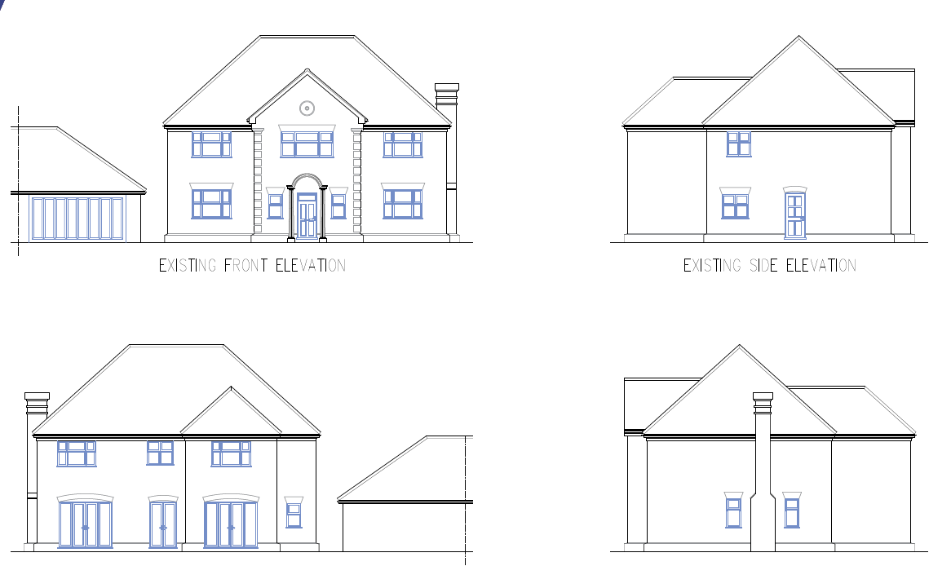

Existing Elevations
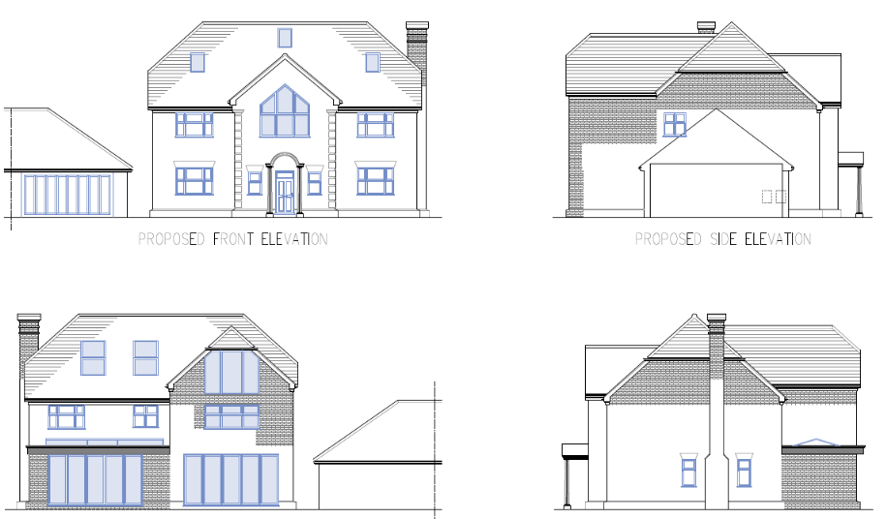

Proposed Elevations

- RELEVANT PLANNING HISTORY

Application Ref: PL/20/1830
Description: Part two, part single storey rear extension, loft conversion with rear dormer roof extensions and side extensions to garage to connect to main house.
Decision: Approved
Date: 15/10/2021

- CONSULTATIONS

A Site Notice was put up 03/10/2025

No letter of objections have been received.

Equality Act 2010:
In determining this application, the Council is required to have regard to its obligations under the Equality Act 2010. However, there is no indication or evidence (including from consultation on the application) that the protected groups identified by the Act have or will have different needs, experiences, issues and priorities in relation to this particular planning application. Therefore, in terms of the key equalities protected characteristics it is considered there would be no significant adverse impacts as a result of the development.

- LEGAL AND PLANNING POLICY CONTEXT
Section 38(6) of the Planning and Compulsory Purchase Act 2004 requires that proposals be determined in accordance with the development plan unless material considerations indicate otherwise. Material considerations include relevant policies in the National Planning Policy framework (NPPF) - among them the 'presumption in favour of sustainable development'. The following local and national planning policy and guidance is relevant to this application:

National Policy
National Planning Policy Framework
National Planning Practice Guidance

Reading Borough Local Plan (2019)
CC7 (Design and the Public Realm)
CC8 (Safeguarding Amenity)
H9 (House Extensions and Ancillary Accommodation)
H10 (Private and Communal Outdoor Space)

SPD
Design Guide to House Extensions SPD 2021

- APPRAISAL

Character and Appearance
Policy H9 states that an extension to a house will be acceptable where it respects the character of the house in terms of scale, location, materials and design and respects the character and pattern of neighbouring properties and the street as a whole in terms of scale, location, materials and design, and any important existing building line. Policy CC7 also sets out relevant considerations for design.

The proposal seeks to alter the roof style of the existing dwelling to accommodate a habitable space within the existing loft space. Rooflights are also proposed to be installed on the front slope, as well as on the rear roof slope.

Whilst these changes will cause the appearance of the roof of the dwelling to change it is not considered that these would be harmful to the character and appearance of the dwelling. There are other similar extensions within the immediate area and material to the assessment is that this is similar to, and indeed a ‘trimmed down’ version of, a previous approval for this dwelling.

The rear extensions on the ground floor to cover the whole width of the dwelling and the first floor aspect to cover part of the width is set such that the extensions do not project past the side line of the dwelling. This ensures that the character of the dwelling as viewed from the street scene, as well as the rear garden is not negatively impacted.

Residential Amenity
Policy H9 states that an extension will be acceptable where it does not result in an overbearing impact on neighbours. Policy H10 seeks to ensure that the amenity of gardens and other outdoor areas are not compromised. Policy CC8 states an extension to a house will be acceptable where it will not cause a significant detrimental impact to the living environment of existing or new residential properties.

The dwelling in this proposal is detached with a two-storey dwelling to one side and the detached garage to the other, separating the dwelling from the next adjoining property by the full width of the garage. Therefore, there is nothing proposed in this application that will impact negatively on the adjoining properties on both sides. There no side windows proposed, therefore there are no potential overlooking concerns.

- CONCLUSION
The proposed development has been assessed as set out above and is considered to be acceptable on that basis, subject to the following conditions.

- RECOMMENDATION: Grant
Recommended Conditions:
Approved Plans
Time Limit Standards
Materials To Match Existing
No New Openings
Use of Roof Restriction

