19/11/2025

Planning Application Ref: PL/25/1431
Officer: Louise Fuller
Application Type: Full planning permission
Address: 110 Norcot Road, Tilehurst, Reading, RG30 6BT
Proposal: Erection of a detached 2 bed bungalow with parking

The site is located on the classified C401 Norcot Road and is part of the Red Route. The site is located within Zone 3, Secondary Core Area, of the Council’s adopted Parking Standards and Design SPD. Typically, these areas are within 400m of a Reading Buses high frequency ‘Premier Route’, which provides high quality bus routes to and from Reading town centre and other local centre facilities.

Application is for the construction of a detached 2 bed bungalow on the side garden area of No110. This will result in the loss of garage parking for the existing dwelling.

In accordance with the Councils current Parking Standards and Design SPD the propsed 2 bedroom dwelling would require 2 parking spaces (rounded up from 1.5). Plans illustrate 2 parking spaces provided for the new dwelling; however the layout would require each vehicle to use the others parking space as a turning area, this therefore reduces the available parking to one. The existing dwelling would need 2 spaces, and these would need to be provided with on-site turning given that this would have been currently accommodated, this has not been illustrated on plans.

Submitted red line plan is up to the property boundary, there is a piece of third-party land between the house and the highway and therefore the applicant will need to confirm that access rights are available.

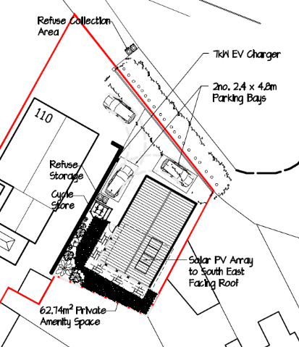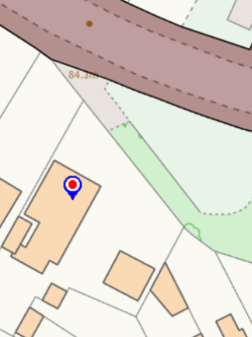

The applicant would need to demonstrate that the width of the access is a 4.1m going into the development, this can narrow once it has past no110.
Given that parking and layouts for both the existing dwelling and proposed do not conform to the Councils current parking standards and the access is not wide enough to accommodate 2 way vehicles from the carriageway past the existing dwelling to the proposed plot Transport do not support this application.

Reason for Refusal

The proposed layout fails to demonstrate that it complies with the Local Planning Authority’s standards in respect of vehicle parking. This could result in on-street parking/reversing movements on Norcot Road, adversely affecting road safety and the flow of traffic, and in conflict with local plan policies TR1 and TR3 of the Reading Local Plan 2019

N. Hussain
Transport Development Control Advisor

