DELEGATED APPLICATION REPORT
Ward: Caversham Heights
App Ref: PL/25/1405 Householder planning permission
Address: 10 SILVERTHORNE DRIVE, CAVERSHAM, READING, RG4 7NS
Proposal: Internal alterations and fenestration changes
Applicant: Roland and Julie Hoeller and Zambetti
Received date: 01/10/2025
Target Decision date: 05/02/2026 (EXT)
Case Officer: Chukwudi Onwudinanti

- SITE DESCRIPTION
The site is a chalet bungalow on the south side of Silverthorne Drive, in a predominantly residential area characterised by dwellings of mixed styles, bungalows and two storey dwellings.

- PROPOSAL AND SUPPORTING INFORMATION
Internal alterations and fenestration changes. The changes to fenestration are limited to the rear elevation.

Plans and Documents received 01/10/2025

Drawing no: 25/SDC/01, dated May 2025 - Existing Ground and First Floor Plans
Drawing no: 25/SDC/02, dated May 2025 - Existing and Proposed North West and North East Elevations [no change]
Drawing no: 25/SDC/03, dated May 2025 - Existing South East and South West Elevations
Drawing no: 25/SDC/04, dated May 2025 – Proposed Ground and First Floor Plans
Drawing no: 25/SDC/05, dated May 2025 – Proposed South East and South West Elevations
Drawing no: 25/SDC/06, dated May 2025 – Proposed Site and Location Plans
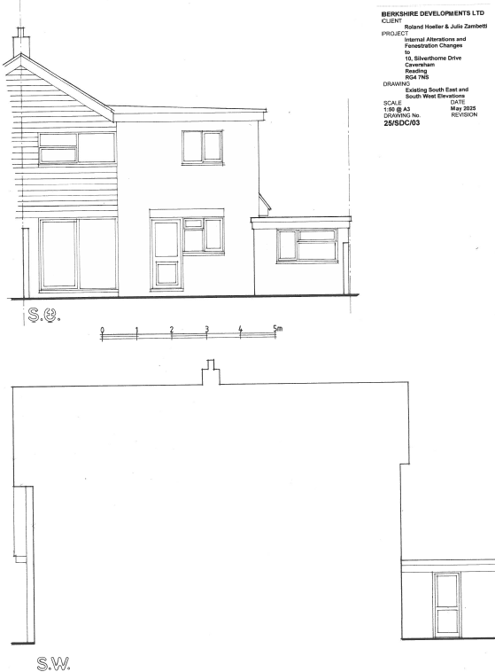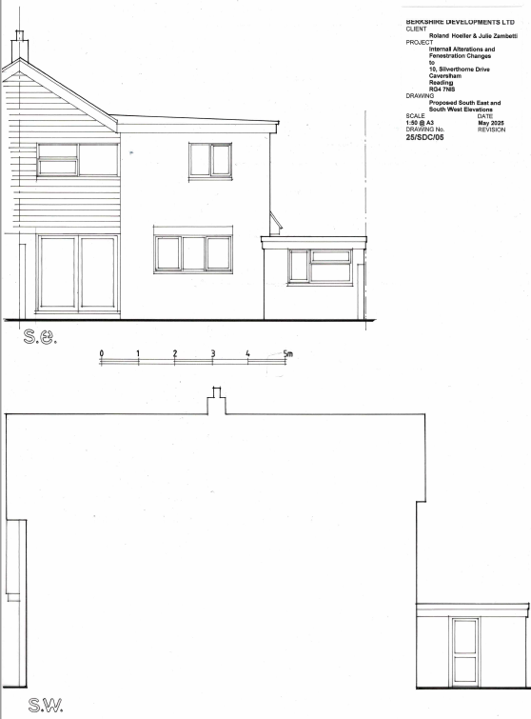
Existing South East and South West Elevation Proposed South East and South West Elevation

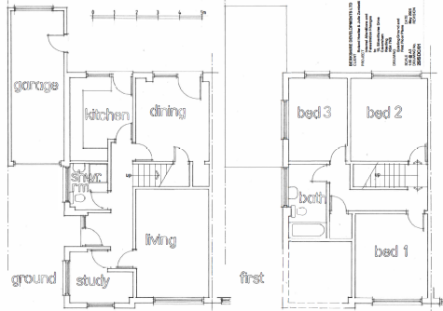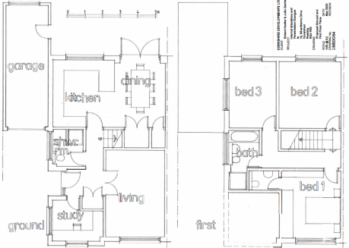

Existing Floor Plans Proposed Floor Plans
- RELEVANT PLANNING HISTORY
None

- CONSULTATIONS

A Site Notice was put up 16/10/2025

No letter of objection received.

Equality Act 2010:
In determining this application, the Council is required to have regard to its obligations under the Equality Act 2010. However, there is no indication or evidence (including from consultation on the application) that the protected groups identified by the Act have or will have different needs, experiences, issues and priorities in relation to this particular planning application. Therefore, in terms of the key equalities protected characteristics it is considered there would be no significant adverse impacts as a result of the development.

- LEGAL AND PLANNING POLICY CONTEXT
Section 38(6) of the Planning and Compulsory Purchase Act 2004 requires that proposals be determined in accordance with the development plan unless material considerations indicate otherwise. Material considerations include relevant policies in the National Planning Policy framework (NPPF) - among them the 'presumption in favour of sustainable development'. The following local and national planning policy and guidance is relevant to this application:

National Policy
National Planning Policy Framework
National Planning Practice Guidance

Reading Borough Local Plan (2019)
CC7 (Design and the Public Realm)
CC8 (Safeguarding Amenity)
H9 (House Extensions and Ancillary Accommodation)

SPD
Design Guide to House Extensions SPD 2021

- APPRAISAL

Character and Appearance
Policy H9 states that an extension to a house will be acceptable where it respects the character of the house in terms of scale, location, materials and design and respects the character and pattern of neighbouring properties and the street as a whole in terms of scale, location, materials and design, and any important existing building line. Policy CC7 also sets out relevant considerations for design.

The alterations proposed are largely interior changes and the fenestration charges are minor and limited to the rear. Therefore, the changes proposed do not affect the character of the dwelling to any significant degree.

Residential Amenity
Policy H9 states that an extension will be acceptable where it does not result in an overbearing impact on neighbours. Policy H10 seeks to ensure that the amenity of gardens and other outdoor areas are not compromised. Policy CC8 states an extension to a house will be acceptable where it will not cause a significant detrimental impact to the living environment of existing or new residential properties.

The changes do not affect the outdoor amenity of the dwelling, and the internal changes enhance the use of the internal spaces.

- CONCLUSION
The proposed development has been assessed as set out above and is considered to be acceptable on that basis, subject to the following conditions.

- RECOMMENDATION: Grant
Recommended Conditions:
Approved Plans
Time Limit Standards
Materials As Specified

