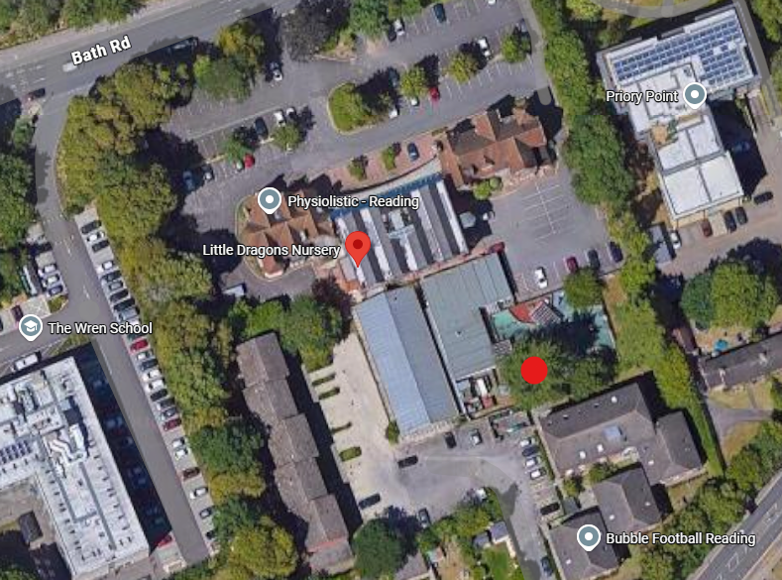
Site Address –
Little dragons Nursery, Bath Road, Reading, RG30 2BA

Tree – Cedar tree T45, TPO order number 99/06

Remove to ground level.
Reasons for removal –
Constant Pigeon poo causing high health risk to children. The entire area underneath and on top of play equipment is constantly covered in large piles of Pigeon poo. This can carry Cryptococcus which is toxic if breathed in or ingested. There are very young children at this school, and the parents and teachers are very concerned with this issue. There was a sad case of this in 2019.
I do not believe it is fair on the parents, teachers and especially the children to be around this when there are clearly visible signs of such mess. Young children are very vulnerable due to their nature of exploring!
The nursery has shown that they have tried every other avenue to avoid the removal of the tree, but this clearly hasn’t worked. They have spent over £20k on different options so far.
They have received a quote for daily cleaning which comes in at £235 per day, nearly £5k per month. They have paid a one clean for a parent’s ceremony at £1200. They also pay for Falconry at £2k per month. Our survey cost £1140 plus the works that we have done in the past including firegel, false birds and selected limb removal. None of the above have worked. The nursery cannot carry on paying these amounts for it not to work.
They have mentioned that they are willing to plant the same species at the land they own next to it.

Please find attached some photos of the tree for your reference.

