11/11/2025
Planning Application Ref: PL/25/1447
Officer: Catrin Davies
Application Type: Outline planning permission: Some matters reserved
Address: 19 PARKSIDE ROAD, READING, RG30 2BT
Proposal: The erection of four residential dwellings (phased) with
associated hard and soft landscaping and parking with the construction of a new access from Parkside Road and Kearsley Road following demolition of outbuildings (outline application considering access all other matters reserved (appearance, landscaping, layout, scale))”
The application proposes to retain the existing house and to construct 4 dwellings in the garden area of No19.

In accordance with the adopted Parking Standards and Design SPD each dwelling would require 2 off road parking spaces. In addition to this existing parking provision would need to be retained for No19. Each parking space should be 2.5m wide by 5m long and have forecourt depths of 6m to ensure that spaces can be manoeuvred in and out of easily. Any garages or car ports would need to conform to the Councils adopted standards.

The proposed development will be accessed from both Parkside Road and Kearsley Road. Plots 1 and 2 will be accessed from Parkside Road, and plots 3 and 4 will be accessed from Kearsley Road.

Original Dwelling (No19)
Accessed from Parkside Rd. It is proposed that the existing dwelling be retained and served by the existing northern access; There is sufficient space for vehicles to be parked on the drive. This is deemed acceptable.

Plots 1 to 2
These plots will be serviced via a widened access from Parkside Rd. Visibility splays have been provided illustrating achievable site lines which are deemed acceptable given the 20mph restriction in place.
A license to widen to access will be required from the Highways team.

Proposed Layout Visibility Splays
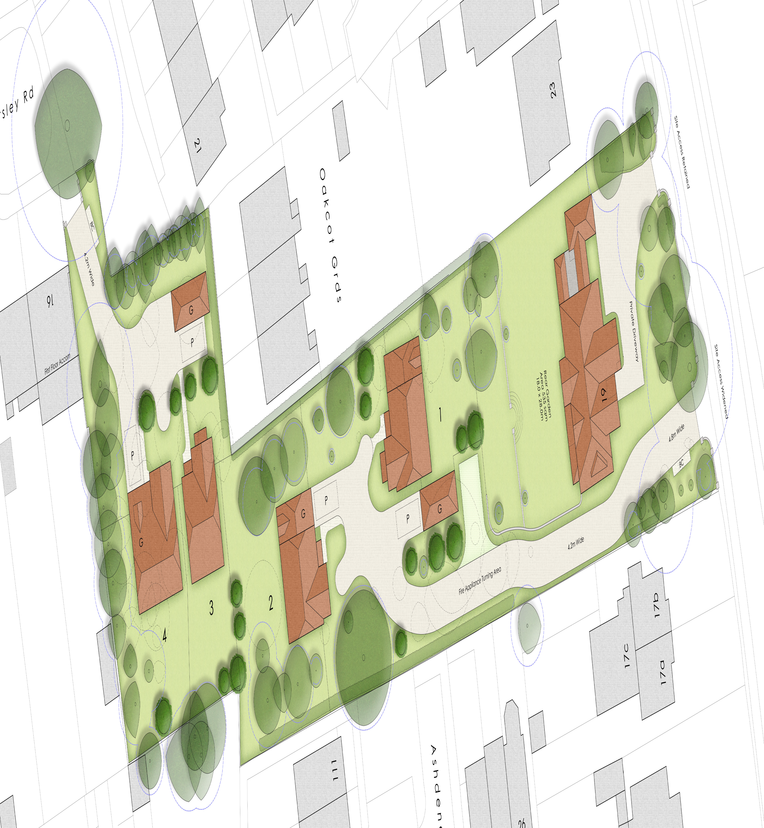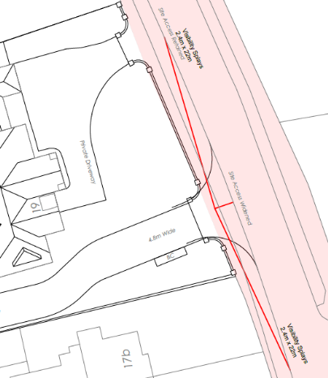
As previously advised the access will need to be 4.8m wide to accommodate refuse vehicles and cars entering and exiting the site, this has been illustrated on plans. A 1.2 m pedestrian route will also be required. It should be noted that Manual for Streets Section 7 states:

Shared surfaces can cause problems for some disabled people. People with cognitive difficulties may find the environment difficult to interpret. In addition, the absence of a conventional kerb poses problems for blind or partially-sighted people, who often rely on this feature to find their way around. It is therefore important that shared surface schemes include an alternative means for visually-impaired people to navigate by.

Plots 3 & 4
Plans indicate dwellings to be provided with 2 parking spaces each (one in garage) accessed via an existing vehicle crossing from Kearsley Road.

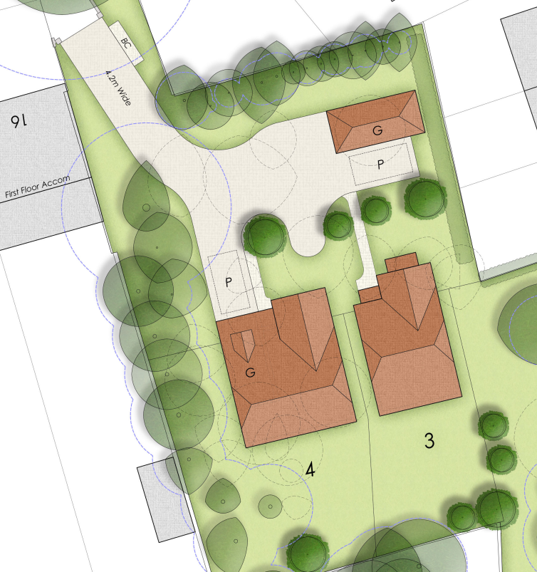

A 4.2m wide access road is proposed and is deemed acceptable. An on site turning area has been provided, however a 1.2m pedestrian footway leading into the site will be required as stated for the reasons for plots 1 and 2 above.

The Natural environment officer will need to be consulted to ascertain any impact on adjacent trees.

All parking spaces and forecourt depths must be provided in accordance with the Councils standards, this includes the required internal dimensions for garages.

All parking areas should be constructed in permeable materials so not to increase the surface water run-off from the site.

Electric Vehicle Charging
The Council’s Local Transport Plan 3 Strategy 2011 – 2026 includes policies for investing in new infrastructure to improve connections throughout and beyond Reading which include a network of publicly available Electric Vehicle (EV) charging points to encourage and enable low carbon or low energy travel choices for private and public transport. The Councils Local Plan was adopted in November 2019 and this includes a requirement at Policy TR5 for each new house to be provided with an electric charging point.

Refuse Collection

It is noted that refuse vehicles will enter into the site bit the refuse vehicles must be able to get within 15m of a bin collection point to avoid the stationing of service vehicles on the carriageway for excessive periods and should comply with Manual for Streets and British Standard 5906: 2005 for Waste Management in Buildings to avoid the stationing of service vehicles on the carriageway for excessive periods.

Cycle Storage
In accordance with the adopted Parking SPD, each new dwelling will require a minimum of 2 cycle parking spaces for each C3 dwelling. In a development of this nature these can be provided in the private rear gardens of each dwelling.

N. Hussain
Transport Development Control Advisor

