Planning Application Ref: PL/25/1688
Officer: Catrin Davies
Application Type: Full planning permission
Address: 83 CONNAUGHT ROAD, RG30 2UE
Proposal: Change of Use of dwelling (C3) to Residential Family Centre (C2)

The site is located on the corner of Connaught Rd and Prince of Wales Avenue and is located in Zone 2, Primary Core Area, of the Revised Parking Standards and Reading Design SPD. This zone directly surrounds the Central Core and extends to walking distances of 2 kilometres from the centre of Reading. This zone is well served by public transport, with buses continuing either into or out of the Central Core Area via this zone.

This application seeks a change of use from the existing 6 bedroom HMO to a mother and baby unit for up to 3 families.
There are no specific standards for the proposed use and in line with other historic C2 uses, Nursing home standards have been applied as the Highway Authority believe that this should be the standard that is required. Therefore, parking provision should be provided at a ratio of 1 per FTE staff & 1 per 4 residents. The applicant has stated that 1 member of staff will be on site 24 hrs a day, and a maximum of three staff. (pro rata to the number of occupants). 3 on-site parking spaces have been illustrated on submitted plans (see below).

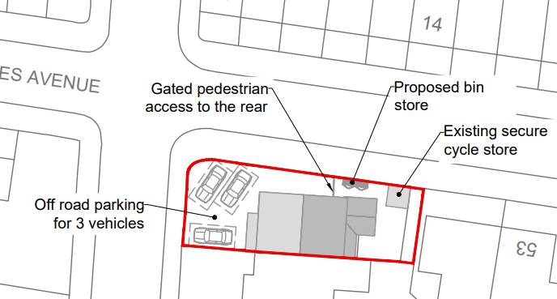

The vehicles illustrated are not independently accessible which was a requirement stated in the pre application transport comments, this layout would not be supported. Plans should illustrate 2 independently accessible parking spaces). Changes to the existing access are not proposed and would not be possible given the close proximity to the junction of Princes Wales Ave.

There are extensive parking restrictions in place in the surrounding area, no over spill parking could occur. Conditions and informatives would be applied to ensure future occupants would not be able to apply for visitor or resident parking permits.
Cycle storage has been illustrated at the rear of the site, however the type of storage has not been illustrated. In accordance with current standards 1 sheffield type stand should be provided in a secure and covered store.

Bin storage has been illustrated located at the side of the house. A collection point near the entrance needs to be provided to ensure kerb side collection can be undertaken. This should be fully accessible and not obstruct access to the parking area. The waste and recycling team contacted to ensure the correct number and type of bins are provided.

In principle there are no Transport objections to this application, however revised plans confirming the parking layout, vehicle access and cycle storage are required.

N. Hussain
Transport Development Control Advisor

