To: | Mr Nicholas Bundy  63 London Street, Reading, RG1 4PS | Application No: PL/25/1551  Application type: Full planning permission

Applicant: C/O Agent

Proposal: Proposed detached dwelling on land adjacent to 40 Heroes Walk

At: 40 HEROES WALK, READING, RG2 8TY

The above application was WITHDRAWN by the applicant on .

Date: 12/1/26 | 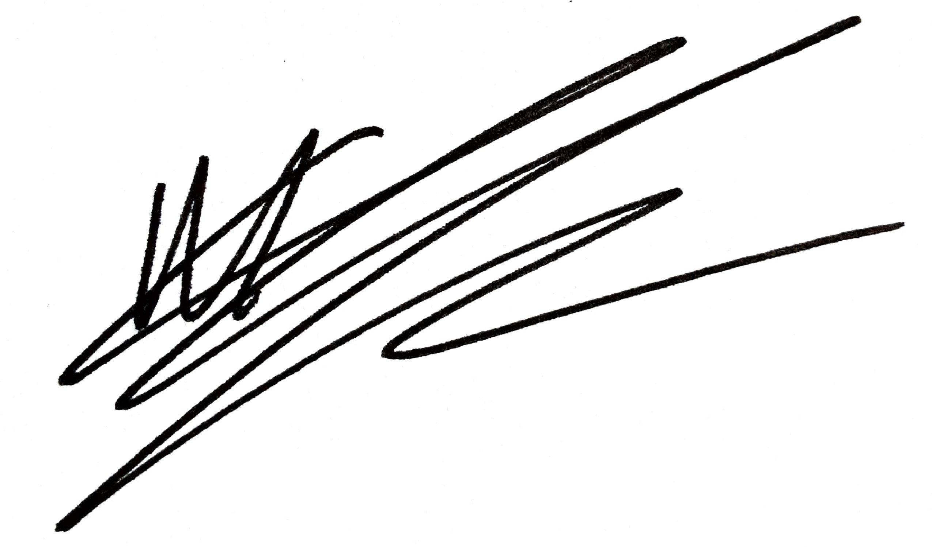
 | Acting Assistant Director, Planning, Transport & Public Protection

