Kendrick School Shed Safety Report
Date of site visit 19th December 2024
Attendees:
- Miss Gina Watson Senior H&S Advisor Reading Borough Council
- Mrs Iklim Joseph Network Manager and Premises Manager Kendrick School
- Mrs Isabelle Sandy School Business Manager Kendrick School
Background
Kendrick school has what they call their “Garden Shed” which is effectively an outbuilding onsite measuring approximately 6m in height (at the highest point) making an estimated cubic meterage of over 50m3. It is believed this structure was built in 1927, whereas the main building was built in 1877 and 1927. The building is a traditional pitched tiled roof, timber posts with infill panel to front, masonry wall to one side. Other side, and rear wall, are formed by the large masonry walls on the site. During the site visit on 19th December 2024 Iklim and Isabelle both confirmed the structure has no asbestos and no electrics within the building.
The structure is currently described by the school as unsafe with the potential for collapse and loose tiles and brick work. This is supported by a Structural Engineer Survey by Michael Aubrey Burrow Ltd dated 8th April 2024 who believes without the buttressing there would be a risk of collapse. The school wish to have the structure demolished, as recommended by the survey, and due to the cost of £20 - 25k to repair. Planning department at Reading Borough Council have expressed a wish for repair rather than demolition as the building is “curtilage listed” as forming part of the curtilage of the main school buildings and existing at the time of listing and in 1948. It therefore benefits from the same legal protections as the main building. For more information and background see Appendix A Timeline which outlines discussion, actions required and concerns.
Aim of the report
The aim of this report is to assess the safety concerns which relate to the unsafe structure known as the “Garden Shed”. This will cover 4 areas:
- Safety onsite
- Safety of pedestrians
- Safety of vehicles
- Safety of hirers
- Effect on Emergency Services access.
It will not cover the safety of the building as this has already been determined by the structural engineer.
Concerns / Condition of the Shed
- The shed is in very poor condition and has deteriorated further since first communication with Olakunle Obafemi on 1st February 2024
- There are currently no props being used to support the building.
- There is the potential for building collapse.
- There is the potential for falling bricks or tiles.
- The fencing erected is not in the appropriate location to safeguard those on site. However, the school has not widened this as the building resides in a narrow area and would impede Fire Services. It would also prevent access for vehicles to the carpark and pedestrians.
- There has been one accident – advised by Isabelle Sandy – whereby the Fire Service was unable to get to the incident and unable to get pass the “Garden Shed”

- Safety onsite
- As there are no supports / props to this building there is the potential for the building to collapse, as well as the potential for falling bricks or falling tiles. During the visit it was observed that some slates were precariously in place. It was advised by Isabelle Sandy and Iklim Joseph that no contractor was willing to put up any props / supports.
- The barriers restricting access near the building does not provide any protection for pedestrians, vehicles, and hirers onsite. The exclusion zone from the building is not extended far enough.
- This is not on an escape / evacuation route.
Conclusion: The building requires support to prevent it from collapsing, wherever possible. There should also be a wider exclusion zone to prevent injury to pedestrians (staff, pupils and hirers) and people in vehicles.
- Safety of pedestrians
- It was observed during the visit that many pupils walked pass the “Garden Shed” between lessons and this was a well-used thoroughfare. Isabelle Sandy and Iklim Joseph both advised that there is another route that doesn’t pass this building.
Conclusion: It is recommended that this thoroughfare is a designated no-go area, and the barriers are widened to deter access. Communication should also be sent to the whole school to advise of the dangers and the new exclusion zone.
- Safety of vehicles
- The thoroughfare is the only access to the small car park which is used by staff and contractors. This has 7-8 spaces.
- There is the potential for the building to either collapse onto vehicles or loose bricks and tiles to fall causing the driver to have an accident.
Conclusion: It is recommended that the carpark is closed, and access is prohibited. Communication should be sent to staff and contractors advising of this action.
- Safety of hirers
- The swimming pool is let out and hired out of school hours. This is on the thoroughfare route which passes the “Garden Shed”.
Conclusion: It is recommended that the hiring of the swimming pool ceases until the area is made safe by either repairing or demolishing the “Garden Shed”. Access should be blocked to the pool and a communication be sent to hirers advising of this decision.
- Effect on Emergency Services access.
- There is only one route for the Fire Brigade to access the site and this passes the “Garden Shed”.
- The width required for fire access is not less than 3.7m. The width available at the side of the Garden Shed is 4m 8cm at the narrowest point, which is above the 3.7m. However, this is on a corner and a recent incident which required Fire Brigade attendance showed that they were unable to pass the corner where the “Garden Shed” is located.
- The thoroughfare leads to the swimming pool, plant room, science laboratories, chemical store, and radiation storage areas. The local fire brigade will potentially need access to these areas in the event of a fire.
- It was advised by Iklim Joseph and Isabelle Sandy that they are in contact with the local Fire Service to determine what access needs are required in an emergency at the school.
Conclusion: It is recommended that the school continues to liaise with the Fire Service to determine access requirements on site in an emergency.
Conclusion and recommendations.
Based upon the site visit, assessment, and conclusions above we cannot guarantee the safety onsite in relation to pedestrians, drivers in vehicles and hirers within the vicinity of the “Garden Shed”. In conclusion the school is recommended to immediately take the following action:
- Provide support / props to the building wherever possible.
- Stop the use of the small carpark.
- Cancel any hiring of the swimming pool.
- Prevent access along the thoroughfare alongside the “Garden Shed”.
- Communicate all changes to those affected e.g. staff, pupils, hirers, contractors, etc.
- The school continues to liaise with the local Fire Service to determine access requirements for vehicles onsite.
This should be in place until the building is repaired or demolished.

Appendix A Timeline
31.01.24
Olakunle Obafemi (H&S Team) were contacted by Isabelle Sandy (School Business Manager) of Kendrick School had an unsafe shed onsite stating they have a “Garden Shed” which is in a very dilapidated state and they believe at serious risk of collapsing. The school stated it is not listed on Historical England as a listed building. Request to advise on the best course of action to take. This could involve a structural engineer to provide written evidence that it is ready for demolition. At the highest point it is deemed to be 6m making an estimated cubit meterage of over 50m3 and therefore requiring a demolition notice.
01.02.24
Olakunle Obafemi contacted Julie Williams (Planning at Reading Borough Council) confirming it is evident that the garden shed is in poor condition as shown in the photos (although I haven’t visited the site).
He asked - Is it likely that a demolition notice will be needed? See dimensions included in photos and Is it listed locally?
1.02.24
Stephen Vigar (Planning at Reading Borough Council) replied to Olakunle Obafemi stating the following:
We had an application ref. 230706 for listed building consent for demolition, but it was returned as not valid. The shed is “curtilage listed” as forming part of the curtilage of the main school buildings and existing at the time of listing and in 1948. It therefore benefits from the same legal protections as the main building.The school will need to make it safe (propping/fencing off etc) until they can get Listed Building Consent. Although we are likely to want to see it retained and repaired instead of demolished.
18.12.24
H&S Team contacted by Yvonne Mubanga (Strategic Property Services Manager, Corporate Property and Asset Management) asking if we were aware of the issue of an unsafe shed at Kendrick School.
18.12.24
Gina Watson (Senior H&S Advisor) asked Julie Williams, Stephen Vigar and Richard Eatough (Planning) to advise if this structure could be demolished.
18.12.24
Yvonne Mabunga provided information on actions the school is required to undertake in relation to this query. Advise provided was:
a Listed Building Consent needs to be obtained before any demolition.
- A thorough Condition Survey will need to be commissioned.
  - this will help present a case for demolition or repair.
  - That you have costs that are not economical should help advance a case for demolition.
  - we should have existing, as build drawings and an impact statement can be produced, with evidence from survey, as to the risk this presents to the school's operations and safety of staff and pupils.
  - We have used Clive Hudson's Conservation Structural Engineers to assess another of our listed buildings.
    - It may be easier if you ask them to provide you a quote: "David Evans" <devans@cliveha.co.uk>
  - Cliveden Conservation are also very good at coming up with resolutions- should it be that this is deemed repairable rather than to be demolished.
    - I note you may have quotes to repair- but it may be worth them coming in to do a no obligation quote: "David Bloxam" <DavidBloxam@clivedenconservation.com>
    - Let me know if you would like me to give a heads up to David.
    - They may be able to propose an interim stabilisation solution that frees up the space you need.
- Gina can in the meantime prepare a Health & Safety assessment report to support the Listed Building Consent application.
To support the case for demolition, the school must demonstrate:
- The serious health and safety risks posed by the shed.
- That the structure is beyond economic repair and stabilization is unfeasible.
- That demolition is in the public interest (e.g., safety of children and staff).
- Any efforts made to explore alternative options, such as repair or partial stabilization.
Supporting evidence (submitted as part of Listed Building Consent, will ideally include:
- Structural reports.
- Health and safety assessments.
- Photographs and historical information about the shed.
All this will only really take off in the New Year and I am happy to help with submitting the LBC application, once all evidence and documentation is ready. I will contact our Conservation officer, and it could be that Gina, you arrange a follow on visit site with her, in the New Year.
18.12.24
Reply to Gina Watson (H&S Team) from Stephen Vigar (Planning) stating that demolision had been previously rejected and communicated on 01.02.24
18.12.24
Gina Watson relayed the information from Stephen Vigar to Yvonne Mabunga. Yvonne Magunga replied that This means that the school may have to look at repairs, rather than demolition. The process I shared earlier still apply though. Getting a structural survey. previous application thrown out probably due to insufficient supporting information.
18.12.24
information from Yvonne Mabunga was relayed to Mrs Iklim Joseph Network Manager and Premises Manager Kendrick school by Gina Watson from the H&S Team.
19.12.24
School visit arranged between Gina Watson (H&S Team) and Mrs Iklim Joseph (Kendrick School)

Appendix B Photos of “Garden Shed”

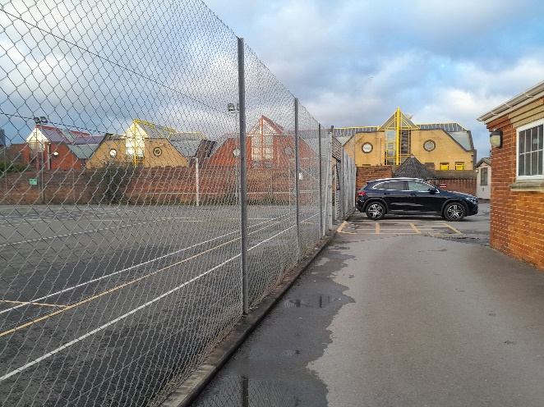 | 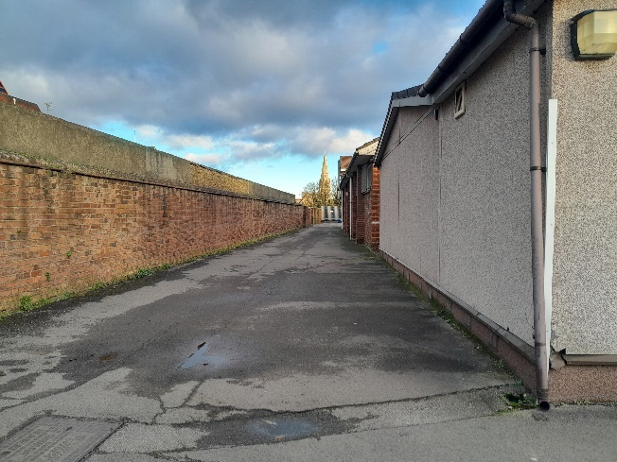
Area leading to Garden Shed showing Fire Assembly point in tennis courts | Thoroughfare leading to swimming pool away from Garden Shed
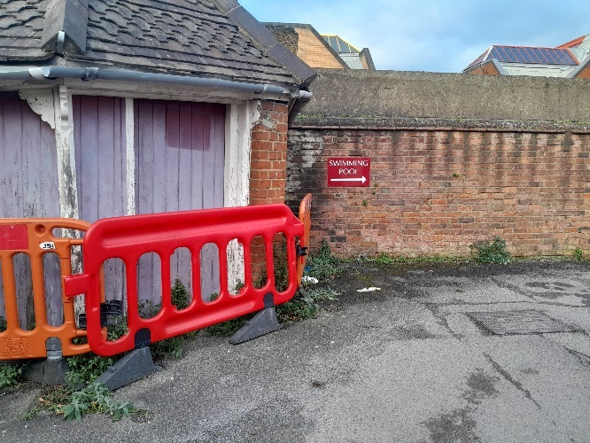 | 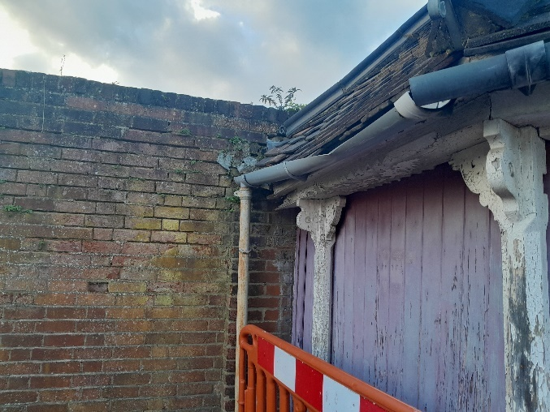
Fencing too close to structure | Eaves of structure showing damage
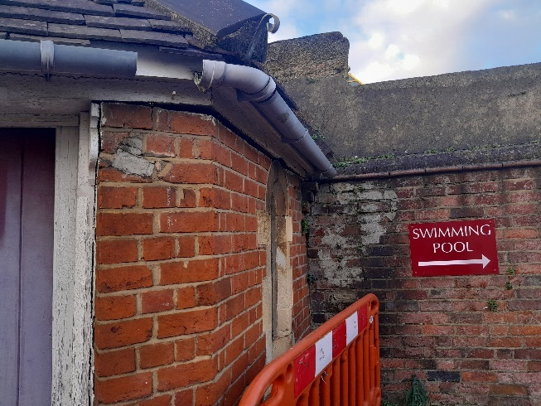 | 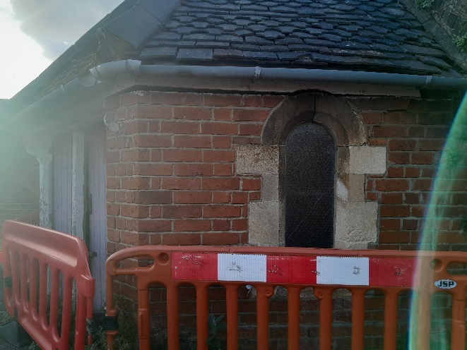
Damage to structure | Roof tiles slipped
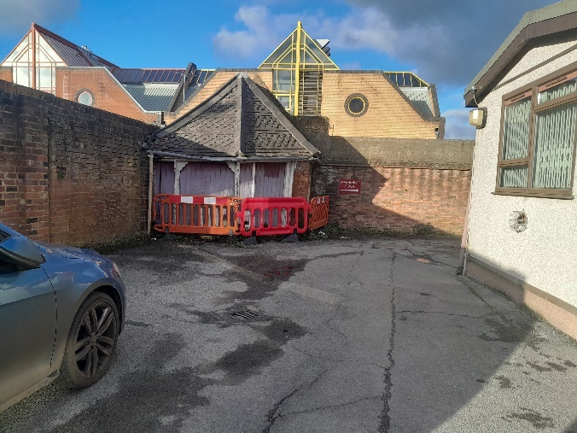 | 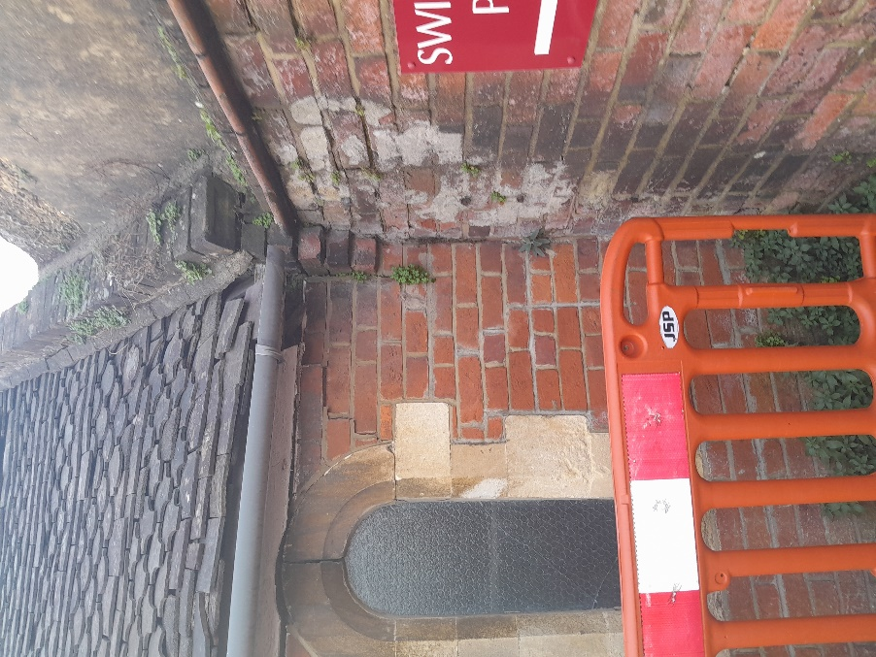
Picture of Garden Shed showing movement | Roof tiles in a precarious state
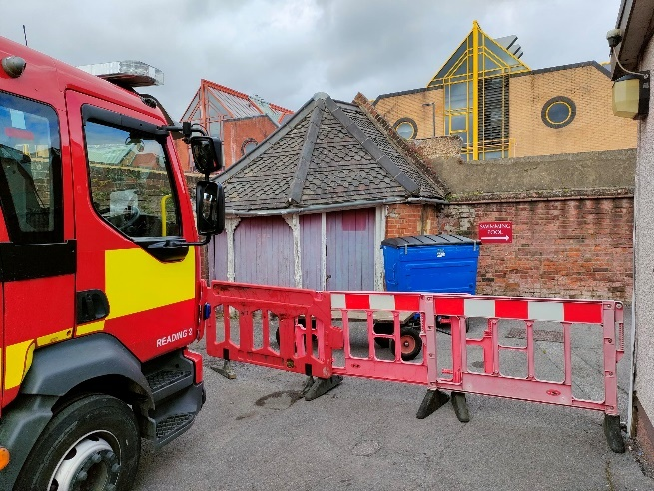 | 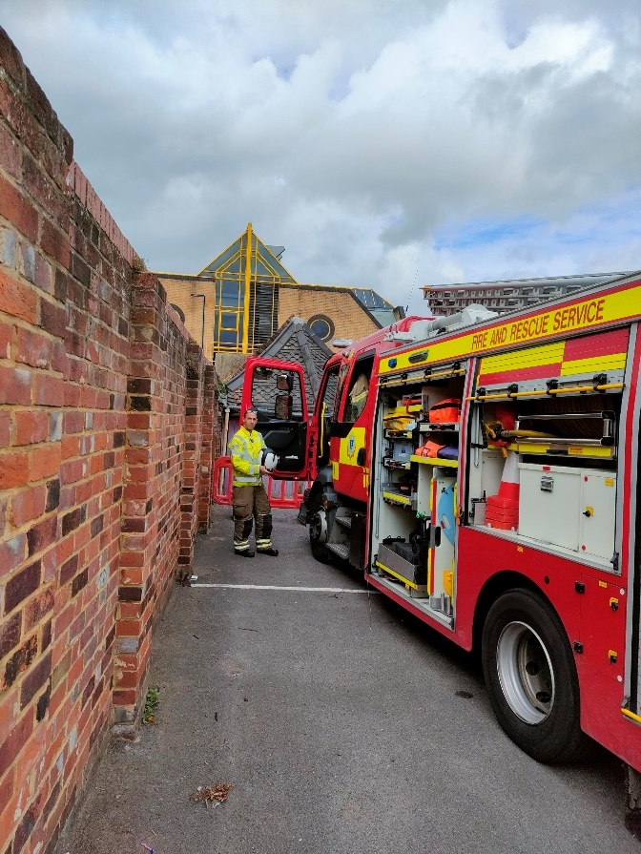
Photo of fire engine onsite unable to gain access | Photo of fire engine onsite unable to gain access

