Window Replacement
Information supporting Listed building Consent Application

General: Grade II listed Coachhouse originally built circa 1750
12 The Brookmill, Coley Park Farm, RG! 6DD

Existing:
- Developed in June 1986
- Front of Property:
    - Existing Description
  - 3 large archways at front of property, 2 of which were turned into windows, one turned into a porch. This note applies to the windows only
  - None of the windows are original
  - Some original wood remains in central archway but not the windows
    - Dimensions and condition:
  - 2 times 250cm wide x 250cm high to lowest point.. extra 15 cm to top of arch. Wood beyond repair
  - Middle archway 2.85 m wide – top wood plank beyond repair/ fallen. To be replaced like with like
  - Rear of Property
    - Existing Description
  - 2x windows RHS and LHS at Ground floor level
  - Patio/French doors/windows combined unit at Ground floor level
  - 3 windows on first floor. RHS and LHS the same size. Central window larger
    - Dimensions and condition:
      - Ground floor
        - RHS and LHS ground floor 135 cm high x 90cm wide
        - Middle patio door/window 246cm wide x 210cm high
      - First floor
        - RHS and LHS 90cm wide x 115 cm high
        - Central window 120cm wide x 130cm high
      - All windows and French door /patio unit timber beyond repair

Proposed:

- Windows for front of Property:
    - Proposed material: timber Iroka and Accoya timbers.
    - Proposed double glazing: All glazing would be Heritage standard clear toughened low E Argon filled with furniture line stamp finish. Thick profile, 4-16-4mm thickness
    - Proposed colour: Black
    - Other detail: 4 evenly spaced panes, non-opening, to match existing, clear glass, spacer bar to be black to match window frame colour. All existing detail will be replicated

  - Windows for rear of property
    - Proposed material: timber – finger jointed redwood
    - Proposed double glazing: slim profile, 4-10-4 mm for windows RE 1,2,3,4 and 6 (see below). Thick profile 4-16-4 thickness for French/ patio door unit RE 5 (see below)
    - Proposed colour: White/ off white
    - Other detail: openings to match existing, clear glass, spacer bar to be white to match the colour of the window frames, all existing detailing would be replicated. External patio door to handle to be kaba style bronze.

Front Elevation Existing:
Middle archway 2.85m wide. Top wood plank beyond repair/ fallen

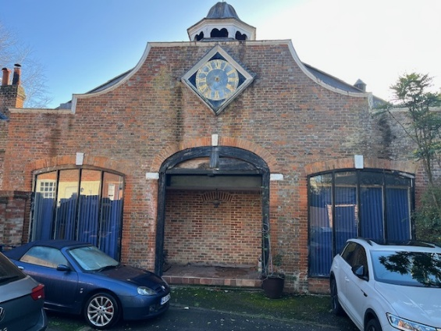
RHS arched window (FE 2) 250cm W x 250cm H. Single glazed. wood beyond repair
LHS arched window (FE 1) 250cm W x 250cm H. Single glazed. wood beyond repair

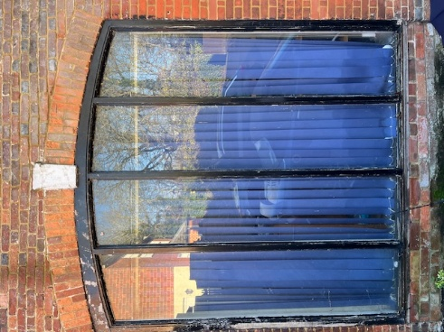
LHS Arched window FE.1:

Sill failed.
All wood beyond repair
Single glazed Softwood 1986

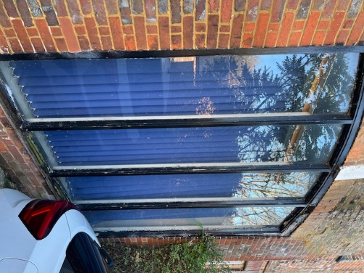
RHS Arched window FE. 2:
Sill failed.
All wood beyond repair
Single glazed Softwood 1986

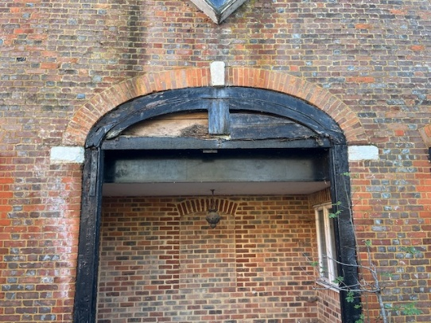
Central Archway
Some original wood remains. Top left crescent requires replacement.
Original sill beyond repair, fallen and requires replacement.

Rear Elevation Existing:

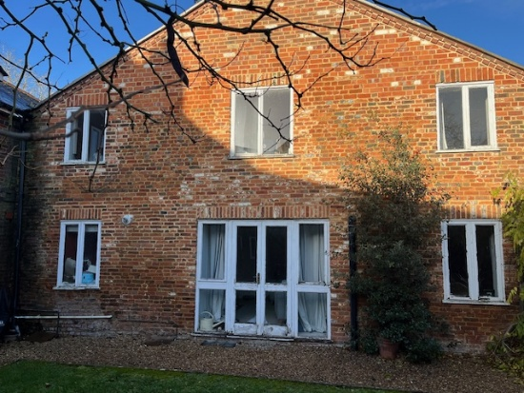
Ground floor Central patio door/ casement window arrangement softwood (RE 5)
Ground floor RHS standard casement softwood window (RE 6)
Ground floor LHS standard casement softwood window (RE 4)
1st floor RHS standard casement softwood window (RE 3)
1st floor LHS standard casement softwood window (RE 1)
1st floor Central standard casement softwood window (RE 2)

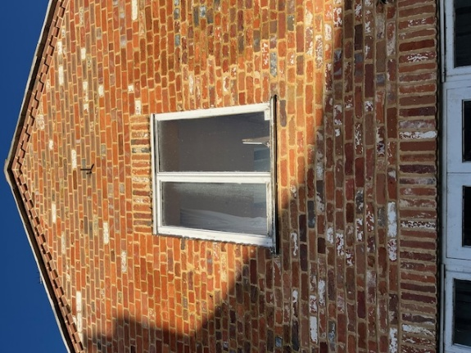
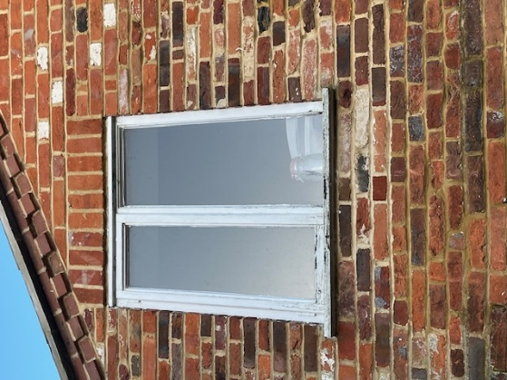
LHS RE 1 Central RE 2
Single glazed Single glazed
Casement Casement
Softwood Softwood

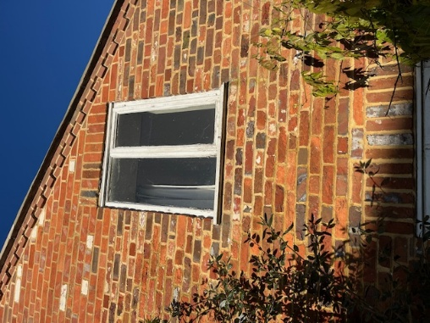
RHS RE3
Single glazed
Casement
Softwood

LHS RE 4 RHS RE6
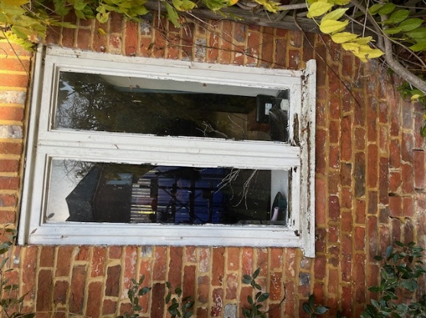
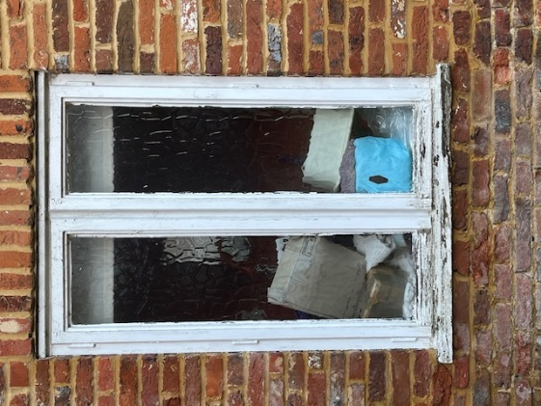

Central Patio door arrangement RE5
