Applicant: Mr Granville Orange

Proposal: Garden storage shed.

At: 14B THE WARREN, CAVERSHAM, READING

The above application was WITHDRAWN by the applicant on 16/12/25

Date: 16/12/25 | 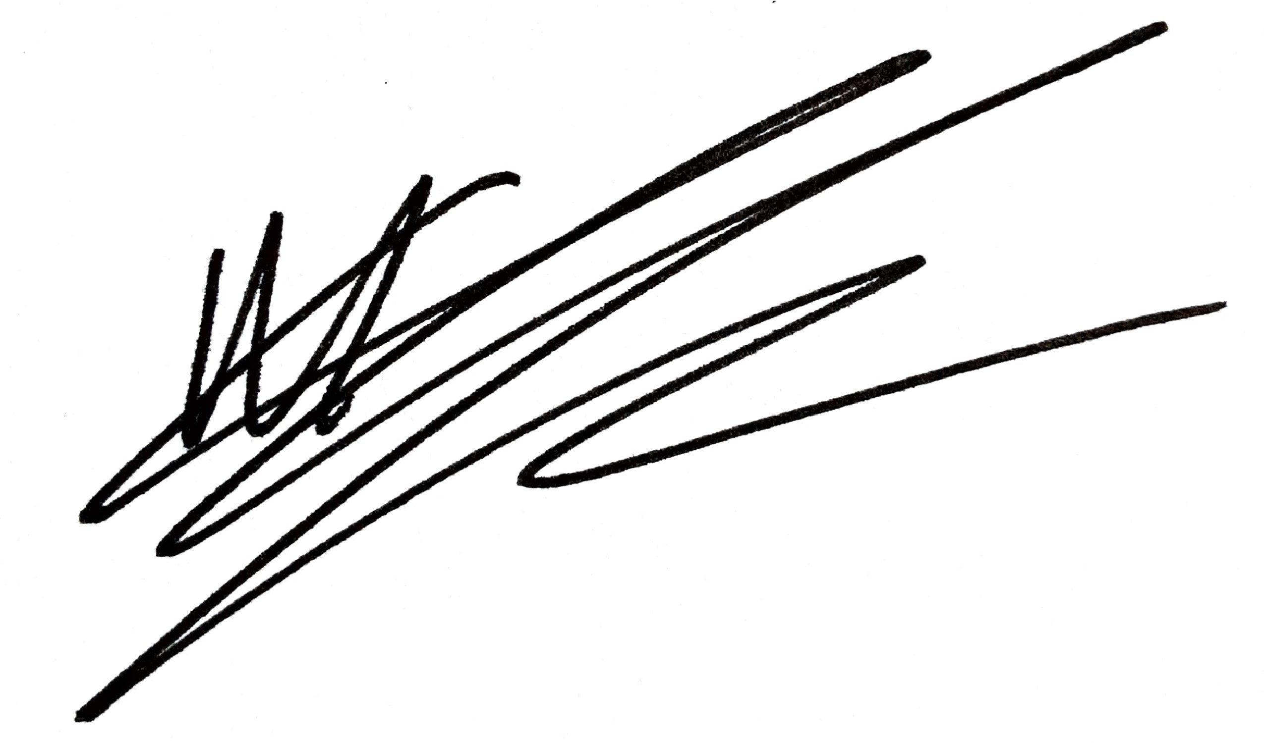
 | Acting Assistant Director, Planning, Transport & Public Protection

