14/11/2025
Planning Application Ref: PL/25/1471
Officer: Catrin Davies
Application Type: Full planning permission
Address: Land Adjacent 1 New Road, Reading, RG1 5JD
Proposal: Self build development for one detached dwelling with
associated hard and soft landscaping, new gates, parking and bin and cycle store.

This application is for the erection of a 2 bedroom detached dwelling. The site is located within Zone 2, the primary core area but on the periphery of the central core area which lies at the heart of Reading Borough, consisting primarily of retail and commercial office developments with good transport hubs. It is also on the Redlands conservation area.

In accordance with the adopted Parking Standards and Design SPD, the proposed dwelling would require 1 off road parking spaces

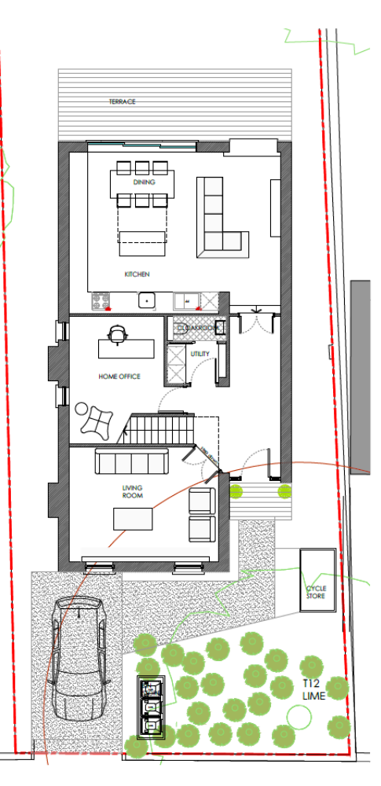

1 parking space is being provided on the front drive, access into the site will be via one entrance with wrought iron gates after partial removal of the boundary wall. Any gates will need to be set back a minimum of 5m from the public highway to avoid vehicles obstructing the highway. Revised plans required.

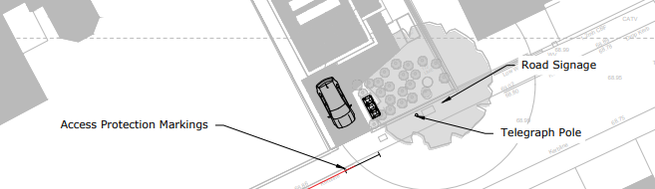

The introduction of a new vehicle crossing will result in the loss of a parking space within the residential/shared parking bays located outside the site. The applicant has confirmed that access protection parkers will be applied for to ensure the access is kept clear. Visibility splays of 2.4m x 25M (as illustrated above) will be provided for the new access which are deemed acceptable. The telegraph pole is more than a 1m from the location of the proposed access and is therefore deemed acceptable. The Council's Highways section will need be contacted to agree the access construction details and to grant a licence before any work is carried out within the highway.

The Council’s Local Transport Plan 3 Strategy 2011 – 2026 includes policies for investing in new infrastructure to improve connections throughout and beyond Reading which include a network of publicly available Electric Vehicle (EV) charging points to encourage and enable low carbon or low energy travel choices for private and public transport. The Councils Local Plan was adopted in November 2019 and this includes a requirement at Policy TR5 for each new house to be provided with an electric charging point. This has not been identified on submitted plans. It should be noted that installation of the charging point will need to conform with the latest building regulations. Revised plans required

The development site is located in an area where a residential parking scheme operates, therefore there should be an assumption that future inhabitants of the dwelling will not be eligible to apply for residents or visitor parking permits. This will be covered by the appropriate conditions and informatives.

In line with the Council’s adopted Parking Standards and Design SPD, the proposed dwelling should be provided with secure cycle storage. A storage area has been illustrated at the front of the property, for reasons of security it is recommended that this should be relocated in the rear private garden.

Bin storage has been identified on plans located at the front of the site, this location will allow for kerb side collection which would be reflective of provision for the residents on New Road.

Please ask the applicant to submit revised plans illustrating EV charging point and location of gates.

N. Hussain
Transport Development Control Advisor

