29/10/2025
Planning Application Ref: PL/25/1307
Officer: Catrin Davies
Application Type: Full planning permission
Address: HAWK COTTAGES, SILVER STREET, READING
Proposal: Detached single storey dwelling with private amenity space

The site is a former garden to 1 Hawks Cottage that is now under separate ownership. It currently houses several small built structures that are proposed to be removed to construct a single detached 2 bedroom dwelling. Proposed plan below:

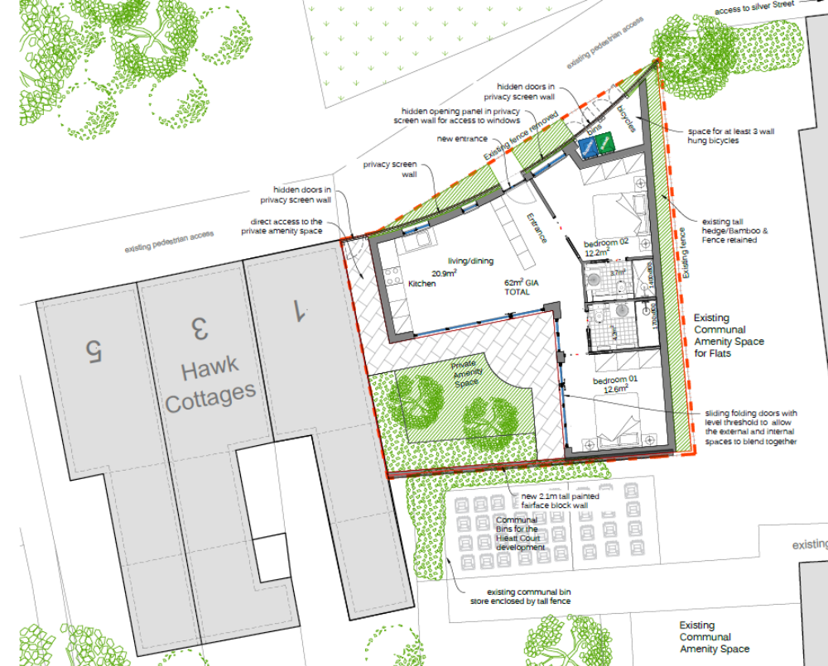

The site is located in Zone 2, Primary Core Area, of the Revised Parking Standards and Design SPD. This zone directly surrounds the Central Core Area and extends to walking distances of 2 kilometres from the centre of Reading. In accordance with the adopted Parking Standards and Design SPD, the development would be required to provide a parking provision of 1 space per 1-2 bedroom unit. However, the proposal provides no off-street parking. Although there exists some unrestricted parking on Silver Street, the area is predominantly residents’ permit parking. Consequently, given the additional demand likely to be created by the proposal, it is a realistic prospect that the development would lead to additional parking on Silver Street. This was also stated in Appeal Ref: APP/E0345/A/14/2219723. The Highway Authority are concerned that the proposed development does not provide for any car parking which would result in the increased use of the currently unrestricted on street parking bays located 43m to the south of the site where a high proportion of parking already occurs.

The development site is located in an area where the Councils Residential Parking Permit Scheme operates. Under the Borough’s current parking standards there should be an assumption that any future occupants of the proposed dwelling will not be issued with resident or visitor parking permits. This will ensure that the development does not harm the existing amenities of the neighbouring residential properties by adding to the already high level of on street car parking in the area.

Cycle storage should be provided in accordance with the Councils current standards and in a development of this nature this can be located in a secure garden shed within a private amenity area.

The Councils refuse tram should be contacted to ensure the correct type and capacity of bins are provided and agree access arrangements.

Reason for refusal:

The proposed layout fails to demonstrate that it complies with the Local Planning Authority’s standards in respect of vehicle parking. This could result in on-street parking on Silver Street, adversely affecting road safety and the flow of traffic, and in conflict with local plan policies TR1 and TR3 of the Reading Local Plan 2019.

N. Hussain
Transport Development Control Advisor

