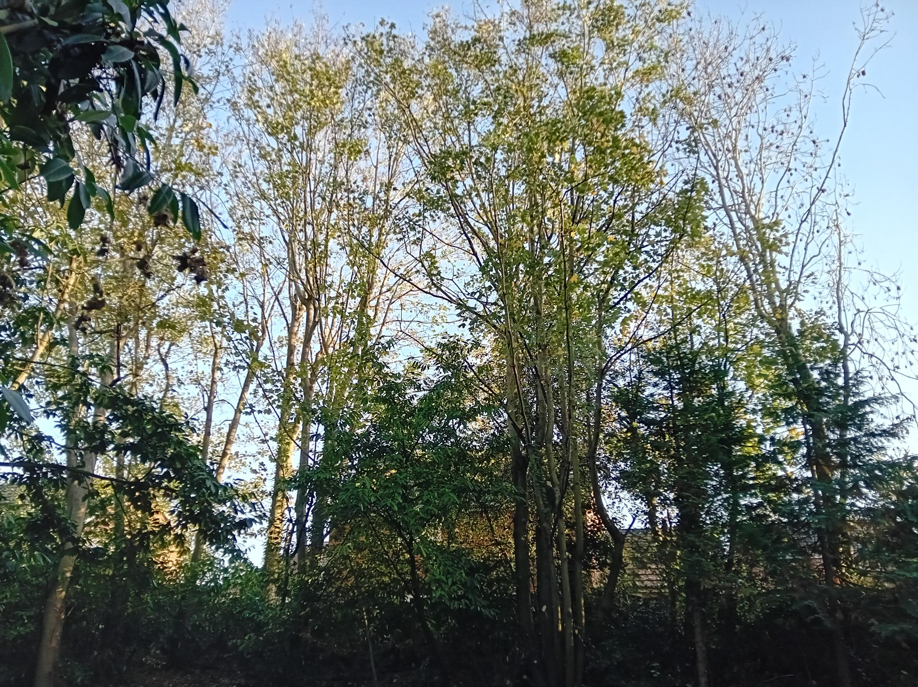
Sycamore: Reduce Coppice Reduce
Other, evergreen species (Conifers, Laurel) - fell
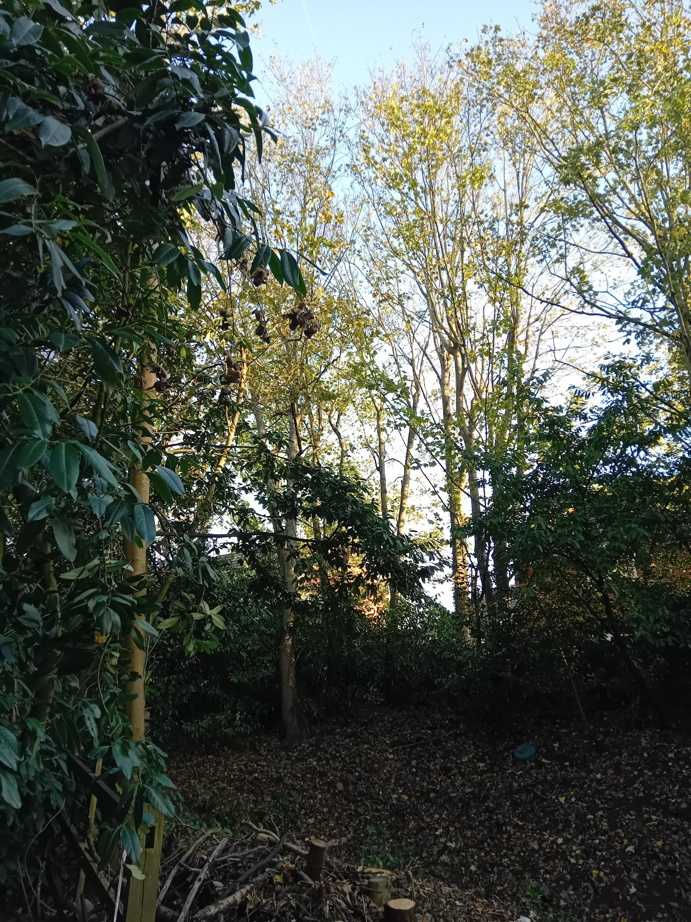
Sycamore: reduce height to previous reduction points - example indicated above.
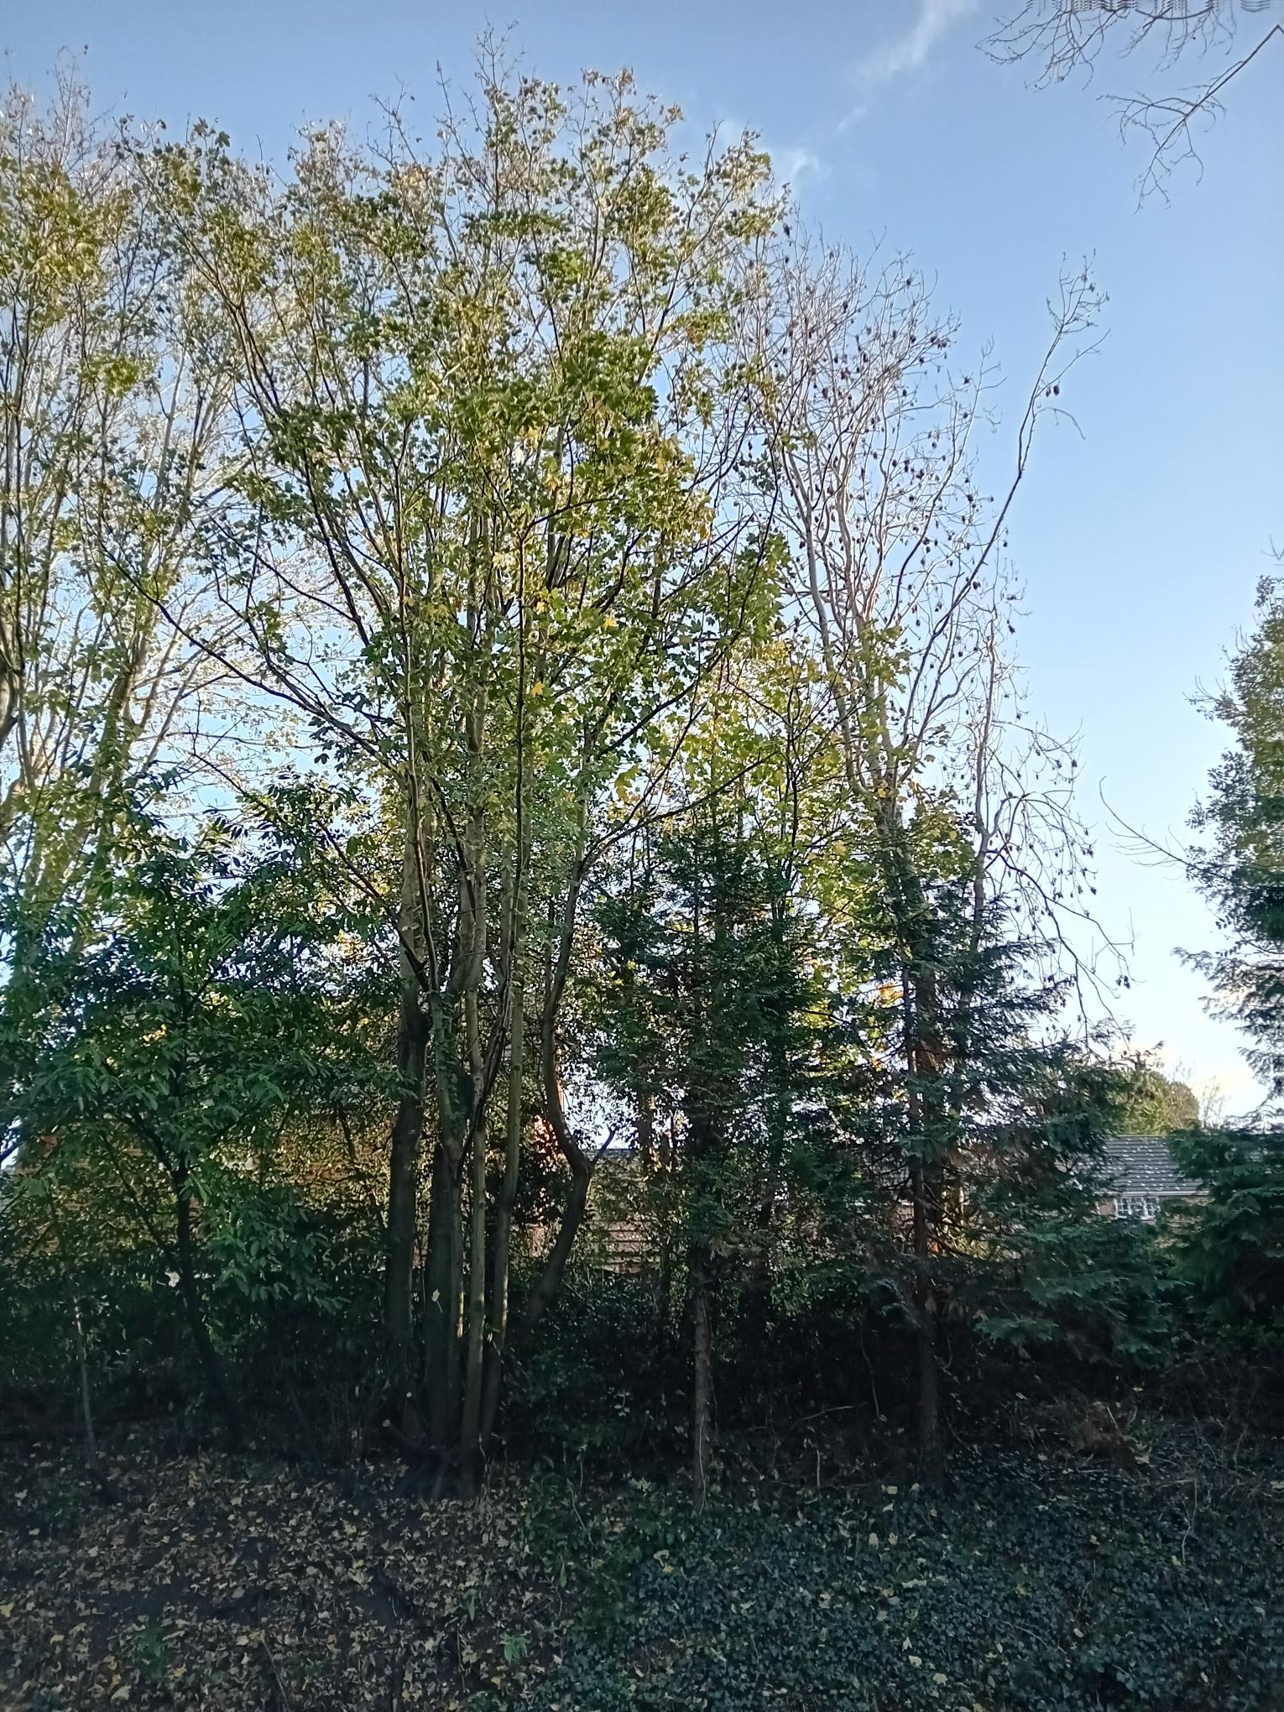
Large multi-stem Sycamore – Coppice;
Other Sycamore: reduce height to previous reduction points - example indicated above.
PL/25/0044
Emmbrook Court
17/11/25
