11/11/2025
Planning Application Ref: PL/25/1500
Officer: Marcelina Rejwerska
Application Type: Full planning permission
Address: 11 NEWCASTLE ROAD, READING, RG2 7TN
Proposal: Change of use from a dwelling (Class C3) to a 7-
person house in multiple occupation (Sui Generis)
and associated works.

The site is located in Zone 2, Primary Core Area, of the Revised Parking Standards and Design SPD. This zone directly surrounds the Central Core Area and extends to walking distances of 2 kilometres from the centre of Reading. Typically this zone is well served by public transport, with buses continuing either into or out of the Central Core Area via this zone.

In accordance with the adopted Parking Standards and Design SPD, the development would be required to provide parking provision of 0.25 parking spaces per bedroom. This equates to a total of 2 car parking spaces for the development. Plans illustrate parking for 2 vehicles in the front garden area following the creation of additional tarmac driveway parking following the removal of metal gates and installation of an EV charger. The dropped kerb is to be widened to facilitate the proposed parking layout.

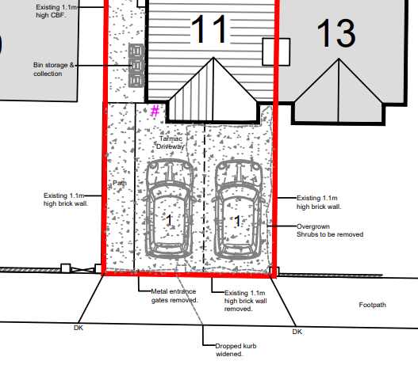

There is a telegraph pole on the property boundary with No 13 which has not been illustrated on plans and a utility cover in the footway. The extended access must have a minimum distance of 1m from the telegraph pole which will need to be illustrated on plans. A license will be required to undertake all works on the public highway, this includes the widening of an existing dropped kerb and reinforcing (if required) of the footway, this would be for Highways to determine. Should the telegraph pole require relocating then the cost would be fully met by the applicant.

Water run-off from private property onto the public highway is not permitted. An appropriate method of drainage needs to be provided within the property curtilage including the use of suitable permeable surfacing materials.

Bin storage has been illustrated at the side of the property; this will need to be brought out to the property boundary to allow for kerb side collection. The storage location must not block access to parking spaces.
The Councils waste and recycling team should be contacted to ensure the correct capacity and type of bins are provided for the HMO.

Please ask the applicant to submit revised plans illustrating bin collection area and location of the telegraph pole in relation to the widened access.

N. Hussain
Transport Development Control Advisor

