External Materials @ Elgar Road
Main brick: Ibstock Brunswick - Wilton Yellow.
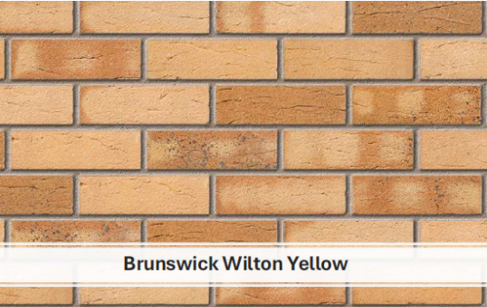
Feature brick: Ibstock – Cheddar Golden.
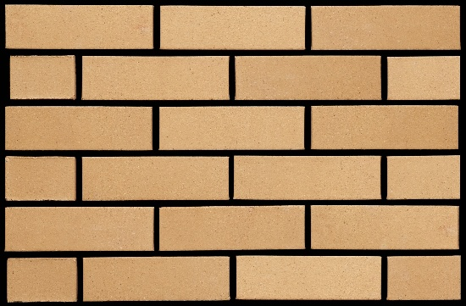
Roof tiles: Redland Renown Concrete Tiles in Slate Grey.
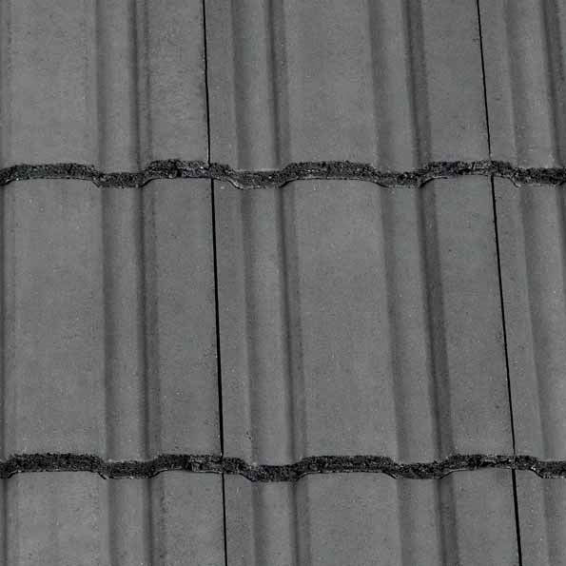
Marshalls Priora Permeable block paving Charcoal
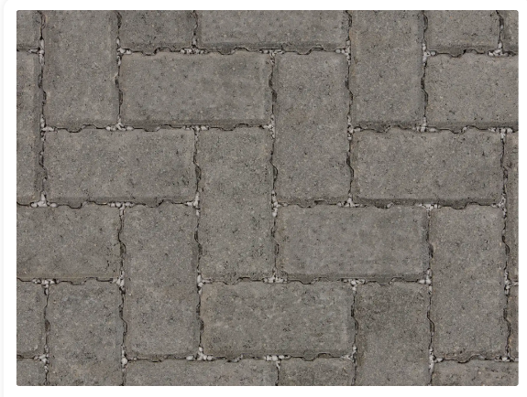

Revision A – Feature brick style updated – 04/11/25

