DRAFT Supplementary Information – Revision 1
Schedule of works and methodology

Introduction
This Schedule of Works and Methodology is submitted, at the request of the planning officer, in support of Planning Application PL/25/1216 and Listed Building Consent Application PL/25/1227 at 79 Baker Street, Reading.

Proposed Canopy Roof
- Excavate and install mass concrete pier foundations for the two new timber posts. Bottom of piers to be taken down to a level avoiding imposing additional ground pressure on the adjacent existing drainage pipes.
- Remove existing concrete coping from top of rear brick wall to garage and install timber wall plate on dpc, adequately anchored to the top of the brickwork.
- Install timber posts and canopy roof framing. Roof to be braced with rigid plywood sarking board.
- Install roof underlay, battens and natural slate roof covering.
- Install horizontal cladding timber to rear and sides of canopy.
- Fit stainless steel PV panel fixings to rafters using Genius Roof Solutions, SolarFlash Slate Refit system SolarFlash® Slate Refit (For existing slate roofs) – Genius Roof Solutions

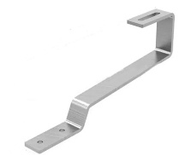 | 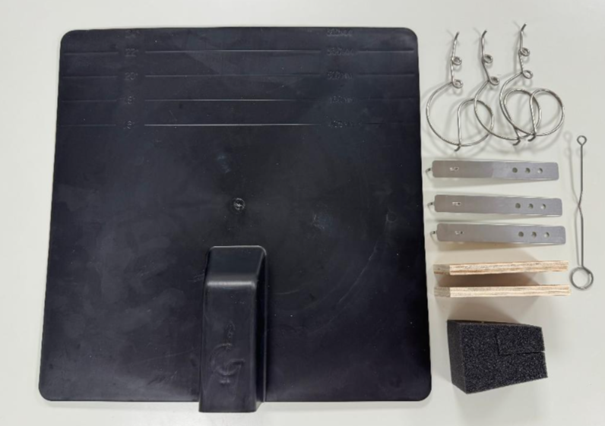
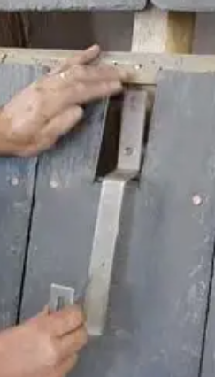 | 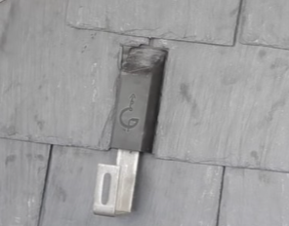
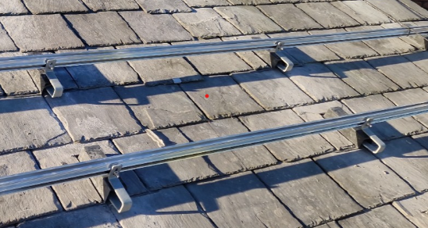
Examples from Genius Roof Solutions website

- Fit solar panels with pigeon protection.
- TOPCON Solar panels (all black, including panel edges), manufactured by ‘Exiom Solutions’ ( Home - Exiom Solution ) and installed by ‘Infinity Renewables’ ( https://infinity-renewables.com ).

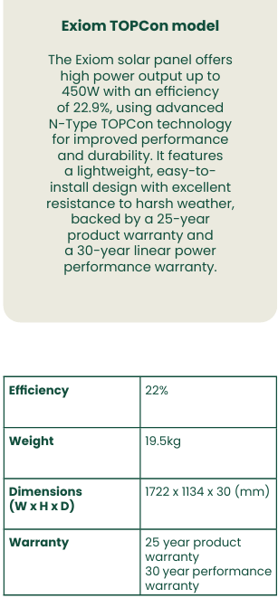

- Install rainwater guttering and downpipe, discharging to existing surface water drainage gully.

Main Roof
- To avoid additional load to the exiting roof rafters, solar PV panels to the main roof will be supported on additional new roof rafters and timber framing, fitted internally between the existing rafters.
- Install new roof rafters and timber framing.
- Erect scaffolding for safe access to rear main roof slope.
- Fit stainless steel PV panel fixings to new rafters using Genius Roof Solutions, SolarFlash Slate Refit system, as described for the canopy roof.
- Fit solar panels with pigeon protection. Solar panels as described for canopy roof.

